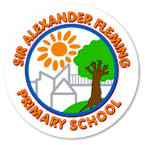
Our Vision for Mathematics in the Early Years
We fundamentally believe that all children are capable of thinking mathematically and making progress in their learning. It is our aim that all children develop positive, ‘can do’ attitudes towards mathematics and feel successful as mathematicians.
The teaching of mathematics at Sir Alexander Fleming Primary School and Nursery must ensure that all children make progress and acquire foundational knowledge which will support them in their future learning. This knowledge is based on the skills of counting, subitising and ordinality and practitioners are informed by research in this area.
We know that our children come to nursery with varying degrees of mathematical experiences. We recognise this and provide more experiences for children who require it. We work with parents in order to develop their understanding of the three crucial aspects named above.
We recognise that mathematics is everywhere! We plan for it explicitly in direct teaching, through routines and the environment and through high quality interactions with adults during play. We utilise every moment and turn it into a mathematical moment!
We know that understanding, using and applying mathematical language is crucial for children to make progress. We use consistent, technical and everyday, vocabulary to teach mathematics. Adults equip children the power of noticing and discussion as a strategy to enable them to make connections between what they already know and how they can tackle mathematical problems and challenges. Adults are skilled at modelling, questioning and posing challenges for children. Gesture is a huge part of good mathematical teaching.
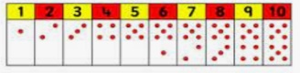
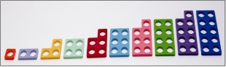
The way mathematics is presented to children is important. Puppets, games, songs, routines and activities are the vehicles through which mathematics is taught here. We use manipulatives of both models and images in order to develop children’s conceptual understanding. We believe that this should never stop and children need this to continue throughout their journey at our school.
Ordinality
Is . . . the capacity to place numbers in sequence.
Children must know . . .
The order of numbers and the reason for this order. (The relationship between numbers.)
We teach it through . . .
Games using number tracks.
Staircase arrangements.
Spacial reasoning.
Subitising
Is . . . perceptual (the recognition of quantities without counting)
Is . . . conceptual (the recognition that numbers are made from sub-groups – linked to composition)
Children must know . . .
To be able to recognise quantities of up to 6. To understand how five is made of other numbers.
We teach it through . . .
A range of representations; numicon, Hungarian dice, five and ten frames, fingers, random representations.

Counting
Is . . . saying number names in order. Counting a group and having an understanding of one to one correspondence and cardinality.
Children must know . . .
To label each thing with a number. That the last number is the total.
We teach it through . . .
Counting anything! Sounds, objects and images.
Songs and rhymes.
