**MS An EYFS Citizen will know, remember or do . . .**

N To use the toilet with increasing independence.

Recognise when they need the toilet.

Use the toilet/ sinks appropriately.

Put their coat on and attempts to do their zip up.

Can use a spoon, knife and fork, sometimes needing help.

Able to make a choice between two activities and play with this for a few minutes.

Can request help by showing or using simple words/ sentences.

R Use the toilet independently, usually being dry throughout the day.

Put their coat on, doing up the zip and other clothing – aprons, PE shorts.

Use eating equipment, often without spilling and keeping themselves clean

Sustain their interest in an activity of their own choosing for longer periods, sometimes showing a high level of engagement.

Can communicate their needs and wants, asking for help from others.

**MR An EYFS Citizen will know, remember or do . . .**

N Be able to leave their caregiver.

Play with others showing and saying their ideas. Take turns and share with adult support.

Through their play, they show their interest in other children.

Begin to ask for help through actions or words.

To know the names of adults and other children within the class.

R To express their needs and wants to other children appropriately using words and actions.

Name a friend and enjoy playing with them

To take turns and share resources with other children

To ask adults for help.

Personal, Social, Emotional Development

**Making Relationships, Managing Self, Self-regulation**

**SR An EYFS Citizen will know, remember or do . . .**

N To identify three basic emotions; happy and not happy (sad), angry/ cross. To begin to identify these in others/ characters.

Can sit quietly at appropriate times.

To follow simple adult requests, with modelling.

To follow simple rules which are repeated daily.

Begins to take turns and share resources with adult help.

R To join in with the routine of the day with a simple verbal request or action.

To identify more complex emotions such as shock, excitement.

To follow an adult request, sometimes with more than one part and understands the reason for this request.

Can state some of the school rules, adhere to these and begin to explain why these rules are in place.

To play with another child sharing and taking turns with resources with increasing independence.

**Key Texts**





An EYFS Citizen will say . . .

An EYFS Citizen will say . . .

An EYFS Citizen will say . . .

Toilet, wee, pooh, zip, up, down, knife,

fork, spoon, cut, safe, not safe, hurt,

play, do this

On my own, apron, on, coat, top,

trousers, clean, choose, I want, I need, help

Happy, not happy, sad, listen, angry,

rule, safe, good sitting

Angry, hungry, shocked, excited,

feeling, safe, my turn, your turn, share,

because, together, next, after

Mummy, daddy, nanny, Miss Reese, play,

my turn, you, other children’s names

Your turn, share, Can I . . .? It’s my turn,

friend, help

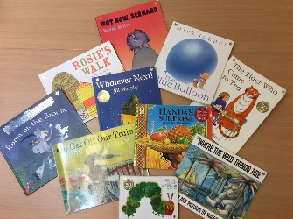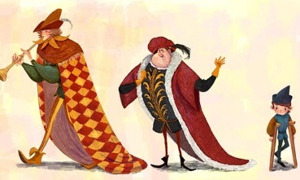

Fairy-tales (Goldilocks, The Big Bad Wolf, The PiedPiper) and nursery rhymes (Blind Mice, Wee Willie Winkie)

All books in the reading spine

**Key Texts**

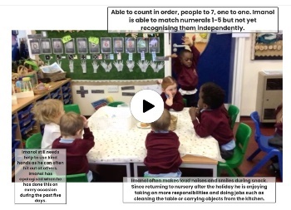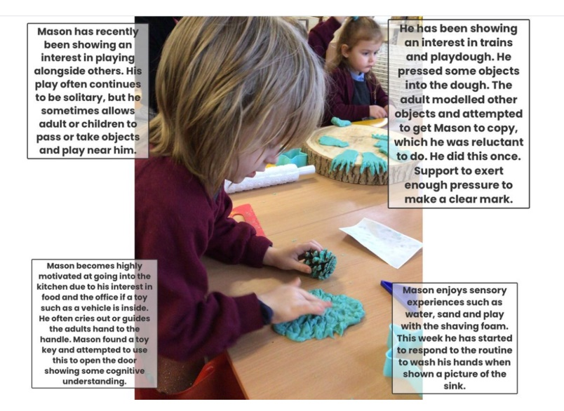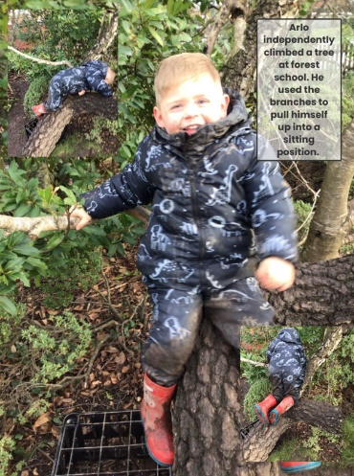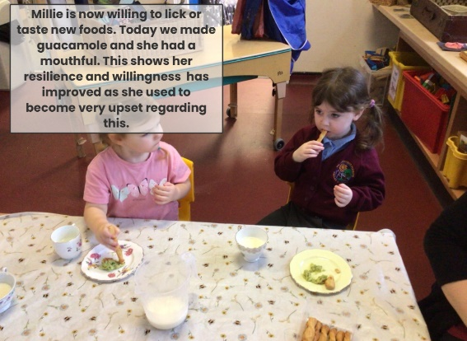

**Evidence of children’s learning**

The EYFS Statutory Framework highlights that there is no need for formal recording of children’s learning in the EYFS, especially as this can detract from teaching and high quality interactions.

Adult’s record significant moments on some occasions. Adult’s ensure they know their children well and can talk about what they do and say.

Adult’s know the curriculum is being implemented as they hear children using the target language and children show their knowledge through play.

Sometimes a celebration of learning is displayed on walls, linked to texts.

Some evidence will be recorded on Seesaw, as follows.

The PSHE Co-ordinator will see small group, whole class and playful discussions taking place.

They will see high expectations of staff and feel our warm, caring philosophy.

**EYFS citizens will be taught PSHE through . . .**

* **The Environment**

Secure and safe; children have the self-confidence to be themselves and show what they can do

Emotions tent

Emotions stones, flashcards, communication fans, story books

A range of families and scenarios in small world and role-play

* **High quality interactions**

Adults modelling appropriate behaviour, articulating emotions, articulating and modelling coping with social situations, drawing out ways to respond and react to others, helping others, listening to and asking about one another

* **Expectations** to participate in all aspects of the curriculum; small group, carpet sessions, PE, forest school.

A learning community/ community learning contract. Children learn from other children. Children are *not* empty vessels!

* **Routines**

School values

Class rules/ behaviour management system

N Snack-time; waiting, patience, taking turns, talking, using ‘riskier’ equipment such as china cups/ knives, support self-care by wiping mouths etc.

Toilet routines; regular reminders, timers, sequencing pictures

Now and next to support choices, develop perseverance

* **Focus on key texts**
* **Through themed learning/ topics**

Autumn – U is for Unique; a sense of belonging, sharing their own interests, people who are important to them

Spring – C is for Community; understanding their place within the local community, listening to other people’s experiences, jobs and way of life

Summer – A is for Alive; Philosophy for children - exploring human nature, what it is to be human