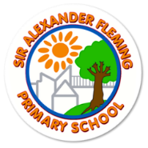
Physical Development and PE in the EYFS
PD forms part of the prime areas of learning and is broken into two parts. Every moment is an opportunity to move in our classrooms!
lead to
Gross Motor Movements | Fine Motor Movements
An EYFS mover will know:  - Balance on one foot for a few seconds.  - Imitates simple movements.  - Pedals a tricycle.  - Begins to balance on a beam with alternative feet placed one in front of the other.  - Can pull themselves up onto equipment and climb down again.  - Catch a large and small ball.  - Throws a ball, beginning under arm throws.  - Rides on a balance bike.  - Kicks a ball with increasing power. Beginning to aim at a target. Starting to stop it using their foot.  - Can travel in ways such as crawling, running, tiptoeing, jumping, skipping and running.  R  - Jumps in place with two feet together.  - Balance and hop on one foot.  ELG-  Negotiate space and obstacles safely, with consideration for themselves and others;  Demonstrate strength, balance and coordination when playing;  Move energetically, such as running, jumping, dancing, hopping, skipping and climbing.  An EYFS mover will say:  Kick, catch, throw, ball, bike, foot, wobbly, up, down, climb, crawl, run, walk, tiptoe, jump  Balance, hop, swing, hang, feet, skip  Opportunities in continuous provision:  Outdoor play; PD area of the playground; provision planned each half term. Bikes, sports equipment, skills focus, steps, balance beam, tunnel, stepping stones, parachute games.  Large scale construction blocks.  Forest School; manoeuvring around a challenging terrain, tree climbing, rolling logs etc.  Water and sand play; pouring, shovelling  The mud kitchen  Woodwork area; sawing, hammering  Changing clothes in the role-play area  Opportunities through routines:  Nursery rhymes, songs and stories with actions.  Directed Opportunities:  Squiggle while you wiggle in N and R (the wriggle part!) Dancing.  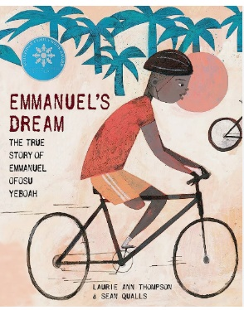  Sequence of lessons in adventure time linked to previous half terms PE coverage.  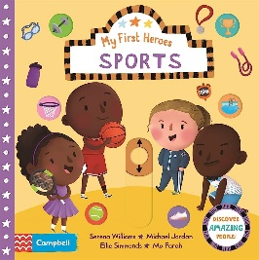  P.E in N and R  Specific Interventions:  Cool Kids  Key Texts:  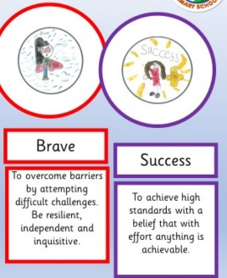  Be Successful Like Mo Farrah  Be Brave Like Emmanuel Ofosu Yeboah | An EYFS mover will know:  N  - Copy a circle and line.  - Roll a sausage of dough.  - Balance a tower of blocks.  - To put pieces into an inset jigsaw.  - Shows an increasing preference for a dominant hand.  - Can copy a circle, line, cross, wavy line and swirl.  - Copies letters in their name. Not formed accurately, but readable.  - Threads small and large objects.  - To join together pieces of a jigsaw.  - Begins to cut along paper using scissors; cuts out undetermined shapes.  - Can cut items safely with a knife.  - Uses tools such as a rolling pin purposefully.  R  - Use a dominant hand.  - Cuts paper and card using scissors.  - Writes their name and lots of other words.  - Build models using joining techniques.  - Completes a jigsaw with many pieces.  - Use a rolling pin to flatten dough and can cut out a shape effectively.  - Begins to use a variety of objects using a range of materials.  - Can thread items into string independently.  - Begins to use other tools such as knives, hole punches, paintbrushes with increasing independence.  ELG-  Hold a pencil effectively in preparation for fluent writing – using the tripod grip in almost all cases; can form most letters accurately.  Use a range of small tools, including scissors, paintbrushes and cutlery safely; Begin to show accuracy and care when drawing.  An EYFS mover will say:  Draw, colour, block, marks, writing, playdough, roll, jigsaw, cut, scissors, wiggly, line, zig-zag  Use the handwriting patter.  Name, rolling pin, dough, build, join, stick  Opportunities in continuous provision:  Using tools in the junk modelling area  Mark-making areas  Mathematics resources; threading, jigsaws, interlocking puzzles  Construction  Art Studio; exerting effects using media  Small parts  Water and sand play; pouring, shovelling  Woodwork area  Malleable area  Opportunities through routines:  Finger songs/ plays  Directed Opportunities:  Squiggle while you wiggle in N and R (the squiggle part!) Mark-making.  Disco Dough in R – Strengthening hand muscles.  Cookery

We adopt the 3 pillars in the EYFS. There is a great focus on movement and active participation as the starting blocks. Children are given opportunities to apply their knowledge in a range of contexts and ultimately apply this in play, games and forest school.
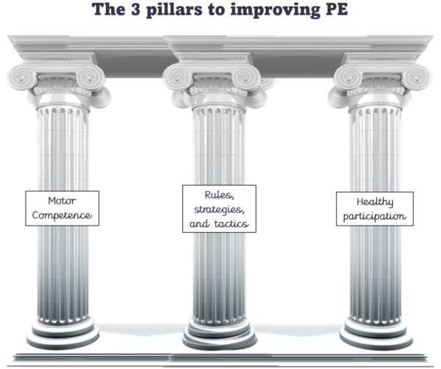
Applying in
Contexts
(rules, strategies and tactics)
Movement
(motor competance)
Engagement
(healthy participation)

Physical development is a huge part of continuous provision (Adventure Time). The Common Play Behaviours document makes reference to gross and fine motor skills, for example scissor use in the junk modelling area and using tools in the art studio.
Planning takes account of children of ranging abilities and how to adapt teaching for emerging, mid and high level movers.
Adventure Time planning allows for practise and challenge:

Safety and risk-taking are apart of the curriculum for PD. They are continually discussed.
They also form part of the PSED curriculum.
PD Focus: To hit a ball using a bat.
Vocabulary: Hit, bat, ball, aim, up, out
Fine / gross motor focus: GM
Adults: Support children to increase or decrease challenge by changing equipment, space and others
Progression of skills:
Emerging - To tap a light balloon/ ball using their hand.
To tap a balloon using a paper plate.
Mid-level- To hit a ball upwards on a tennis bat. To hit a ball with a tennis bat, outwards. (Hold to hold effectively.) One child throwing and one hitting.
High-level- To hit a ball to another child. (To do this repetitively.)

