Reading Scrutin

**Evidence of children’s learning**

The EYFS Statutory Framework highlights that there is no need for formal recording of children’s learning in the EYFS, especially as this can detract from teaching and high quality interactions.

Adult’s record significant moments on some occasions. Adult’s ensure they know their children well and can talk about what they do and say.

Adult’s know the curriculum is being implemented as they hear children using the target language and children show their knowledge through play.

Sometimes the sequence of learning is displayed on walls.

Some evidence will be recorded on Seesaw.

The Science Co-ordinator will see small group, whole class and playful discussions taking place. Science takes place during every forest school session.

Understanding the World

**The Natural World**

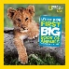



**Key Texts**

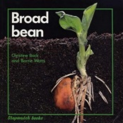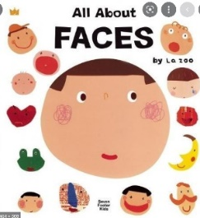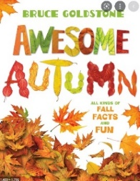

Forest School Diaries

Forest School Sessions

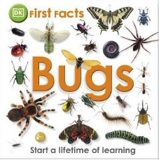

Animals in the Small World Area

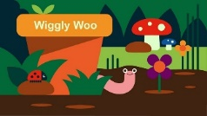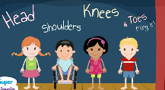

Songs

Routines; toilet, snack, dressing, PE

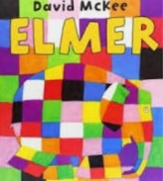

**Autumn Term U is for Unique**

**Animals including humans:** Exploring Teeth, Naming parts of our face/ bodies, human lifecycle – When I was a baby

**Materials:** Junk modelling, (Homes) The Three Little Pigs

**Plants:** Seasons – autumn leaves/ the signs of autumn

**Spring Term C is for Community**

**Animals:** Farm animals

**Materials:** Ice and water/ Textures (Art)

**Plants:** Seasons – trees in winter and spring/ the signs of spring

**Summer Term A is for Alive**

**Animals:** Zoo animals (N) Safari animals (R) Minibeasts

**Plants:** How do plants grow?

Book Area/

Reading Spine

**Science opportunities**

**in our environment**

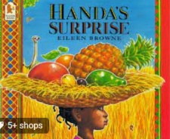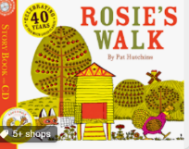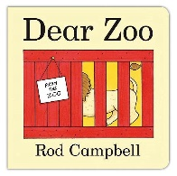

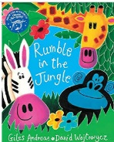

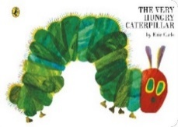

Nursery Rhymes

Seasons depicted in a timeline of the year/

enhancements to Role-play Area

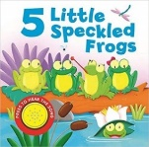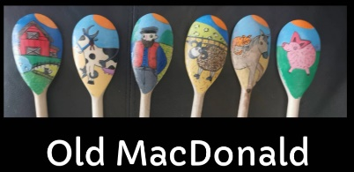

Mud Kitchen

Sand Area

Water Play

Malleable Play

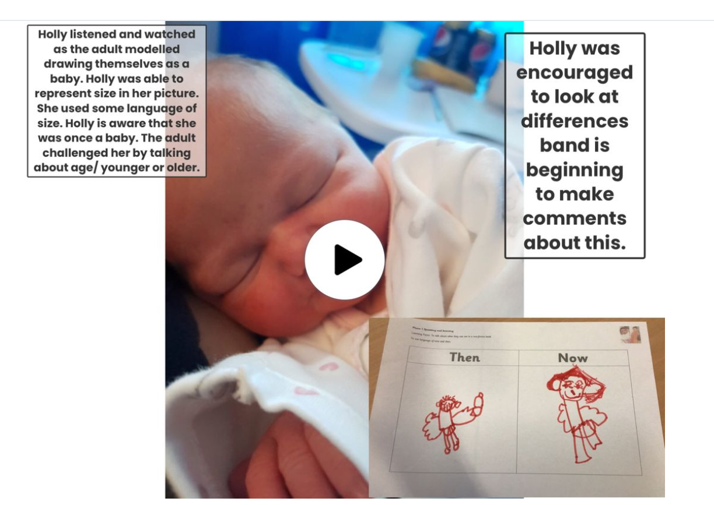

**Plants**

**EYFS Scientists will know . . .**

N To know that seeds can grow.

To know some of the things a seed needs in order to grow; water.

Notice what is happening to the weather in Autumn, Winter Spring, Summer.

R To know that seeds need water, light and soil in order to grow.

To make some simple comparisons between the four seasons.

**Materials**

**EYFS Scientists will know . . .**

N

The names of four natural materials.

Materials can be used to build and make.

That materials can feel different.

R

The names of six natural materials and two man-made.

To know that some materials are better for certain purposes – cardboard for a door.

Some features of materials; hard or soft.

How ice is made.

**Animals Including Humans**

**EYFS Scientists will know . . .**

N The names of four basic features on their head.

The names of four basic body parts.

That they are a child. That they will change over time. That they were a baby.

To name 6 farm animals and their features.

To recognise and name a worm, spider and ant.

To know the names of 3 common household pets; cat, dog, rabbit.

To know that living things move.

R The name of eight features of their face.

The names of 8 features of their body.

The difference between a baby and a child. The difference between a child and a grown-up.

The names of six animals found on a farm and some of their features.

The names of six safari animals and their features.

That a caterpillar changes into a butterfly.

To know the names of 5 common household pets and recognise three ways in which they can be cared for.

To be able to name at least 6 African animals and describe their features.

To recognise and name a woodlouse, caterpillar and butterfly.

**An EYFS Scientist will say . . .**

N ears, nose, mouth, eyes, head, shoulders, knees, toes, arm, legs, fingers Hot, sun, rain, sky, grow, seed, water, mud, cow, pig, sheep, chicken, goat, horse, lamb, wool, horn, snout, worm, spider, ant, legs, wiggle, crawl, climb, summer, cat, dog, rabbit Cold, snow, hard, empty, ice, dark, bird

R chin, cheek, eyebrow, eyelash, back, neck, hips Warm, cloud, spring, summer, autumn, winter, different, same, water, light, soil, zebra, elephant, lion, rhino, hippo, giraffe, stripes, hooves, trunk, mane, woodlouse, caterpillar, butterfly, spin, pet, hamster, Frosty, icy, icicles, Robin, Blackbird, Pigeon, bare

bird