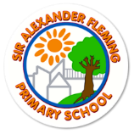
Sir Alexander Fleming Nursery and Primary School
Curriculum Overview for the Academic Year: 2023-2024 The Hive
Subject area | Autumn 1 | Autumn 2 | Spring 1 | Spring 2 | Summer 1 | Summer 2
ENGLISH | Narrative: Familiar settings  Poetry: poems on a theme  Non-fiction: Instructional writing | Narrative: Fantasy  Non-Fiction: Persuasive
Quality Texts | Stuck by Oliver Jeffers  Monster poems | Bedtime – Eleanor Farjeon  The bear and the piano
MATHEMATICS | Number  Place Value (Numicon)  Addition and subtraction  Shape  Working towards- mental calculation (daily)
Other skills to develop | Memory games  Non-verbal reasoning

