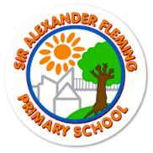
Sir Alexander Fleming Primary School
Curriculum Overview for the Academic Year: 2023-24 Year 1
Class theme | A is for Animals |  | W is for What if… |  | A is for Alive
Subject area | AUTUMN TERM 1 | AUTUMN TERM 2 | SPRING TERM 1 | SPRING TERM 2 | SUMMER TERM 1 | SUMMER TERM 2
ENGLISH | Forest School Diaries  Narrative –Helicopter stories  Cross curricular labels and phrases | Forest School Diaries  Narrative –Helicopter stories  Cross curricular labels and phrases | Poetry – Humorous  Narrative – Traditional Tales and Fables | Non-fiction – Instructions  Narrative – Stories on a theme | Poetry – Poems on a Theme: Nature  Narrative – Fairy Tales | Non-fiction – Letters and Postcards  Narrative – Modern Fiction
Quality Texts | Hickory Dickory Dock  Humpty Dumpty  Five Minutes Peace (Jill Murphy)  Rosie’s Walk (Pat Hutchins)  Mrs Armitage On Wheels (Quentin Blake)  Harvey Slumfenburger’s Christmas Present |  | If You Should Meet a Crocodile (Tig Thomas)  The Three Little Pigs  Don’t Let the Pigeon Stay Up Late! (Mo Williams)  Supertato (Paul Linnet and Sue Hendra)  Superworm (Julia Donaldson) |  | Nature Poems  I am the Seed that Grew the Tree (Fiona Waters)  Cinderella  Billy Goats Gruff  Dear Green Peace  Ed Vere Stories
MATHEMATICS | Place Value (within 10)  Addition and Subtraction (within 10)  Shape  Place Value (within 20) |  | Addition and Subtraction (within 20)  Place Value (within 50)  Length and Height  Weight and Volume |  | Multiplication and Division  Fractions  Position and Direction  Place Value (within 100)  Money  Time
SCIENCE | Animals, including Humans  Seasonal Changes:  Autumn  Tree Identification  Deciduous and Evergreen  Changes in day length |  | Everyday Materials  Seasonal Changes:  Autumn to Spring | Investigations focus | Plants  Seasonal Changes:  Spring and Summer
COMPUTING | Networks  Technology around us | Creating media  Digital painting | Creating media  Digital photography | Programming B Programming quizzes | Data handling  Branching Databases  (science link) | Creating Media  Publishing  (Writing link)
GEOGRAPHY | Our school, our area (Telford)  Which parts of my local area could be improved?  OR  Do the school ground encourage wildlife?  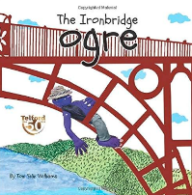 |  | Seasons and weather  How does the weather influence our lives?  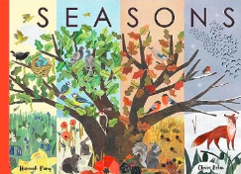  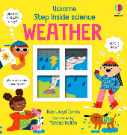 |  | 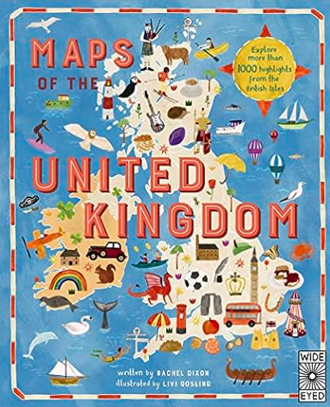  Our place in the world  What are the human and physical features of the country we live in?
HISTORY | 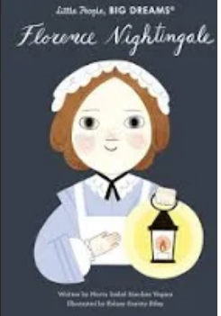  Does Nelly Spindler does a memorial like Florence Nightingale has?  Famous Person |  | Local Study - Ironbridge  How has the way we cross the River Severn changed?  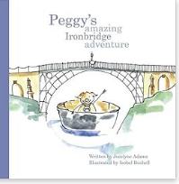 |  | Making History – Tim Peake  Is Tim Peake a British hero?  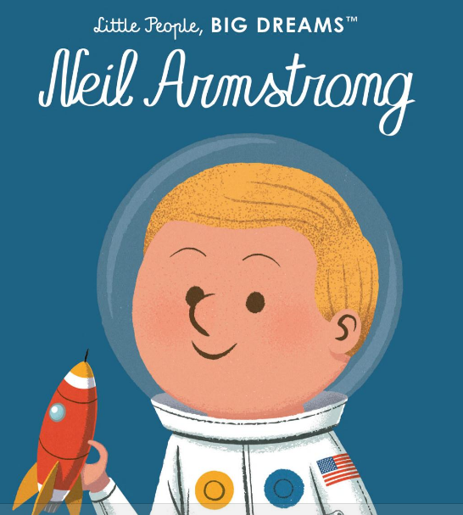
ART AND DESIGN | Colour |  | Form |  | Printing
DESIGN & TECHNOLOGY | Mechanisms – Making a Moving Storybook |  | Structures – Constructing a Windmill |  | Food – Fruit and Vegetables
MUSIC | Hey You! | Rhythm in the Way we Walk and Banana Rap | In the Groove | Round and Round | Your Imagination | Reflect, Rewind and Replay
PHYSICAL EDUCATION | Invasion games | Invasion Game Ball Skills | Dance | Outdoor Adventurous Activities/Teambuilding | Striking & Fielding Games | Athletics
RE | Stories of Creation  Creation and Thanksgiving  How do Christians say thank you? | Find out about Christian and Islamic buildings | Questions that Puzzle Us  What’s the most puzzling thing we can think of? | Questions that Puzzle Us  Mysteries | Stories of Creation  Stories about the beginning of the Earth | Special Stories
FRENCH | Me & You/ Colours, kites & photos | Christmas, songs & rhymes | Animals & songs/ Birthdays | Planting Time | All at Sea | Exploring stories & song
PSHE | Being Me in My World | Celebrating Difference | Dreams and Goals | Healthy Me | Relationships | Changing Me

