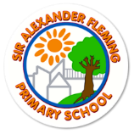
Sir Alexander Fleming Primary School
Curriculum Overview for the Academic Year: 2023-2024 Year 2
Class Theme | The world around me |  | Who’s the king of the castle? |  | Ready, steady, grow!
Subject area | AUTUMN TERM 1 | AUTUMN TERM 2 | SPRING TERM 1 | SPRING TERM 2 | SUMMER TERM 1 | SUMMER TERM 2
ENGLISH | Non-fiction: Instructions  Poetry: poems on a theme  Narrative: Familiar settings | Non-Fiction: Persusive  Narrative: Fantasy | Poetry language and imagery.  Narrative: Stories on a theme | Non-Fiction: Recounts  Narrative: Fables | Narrative: Stories by the same author  Poetry: poems by the same author | Non-fiction: persuade  Narrative: Quests
Quality Texts | Not now Bernard  Cook book | Poems about the green and blue  The bear and the piano | Tin Forest  1066 and all that | Look inside castle  Hansel and Gretel | Gorilla  The rainmaker danced | Dear Earth  Lost and found
MATHEMATICS | Number  Place Value  Addition and subtraction  Mental calculation daily | Statistics  Multiplication and division  Measurement: money  Mental calculations daily | Statistics  Geometry  Fractions  Mental calculations daily | Fractions  Time  Mental calculations | Measure-Height and length  Position and direction  Mental calculations | Measurement  Mental calculations
SCIENCE | Animals, including humans  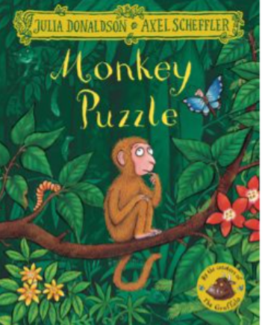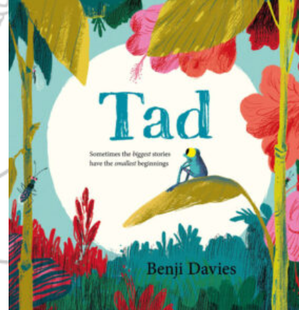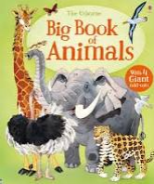 |  | Uses of everyday materials  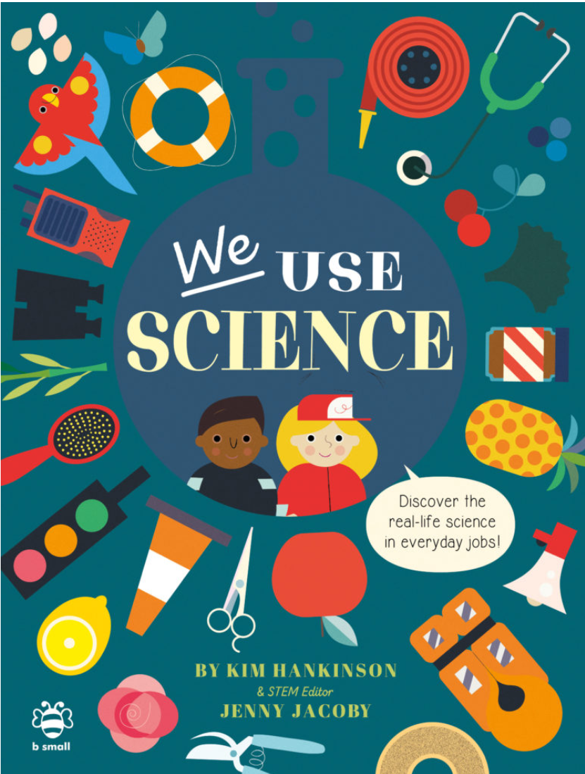 |  | Plants  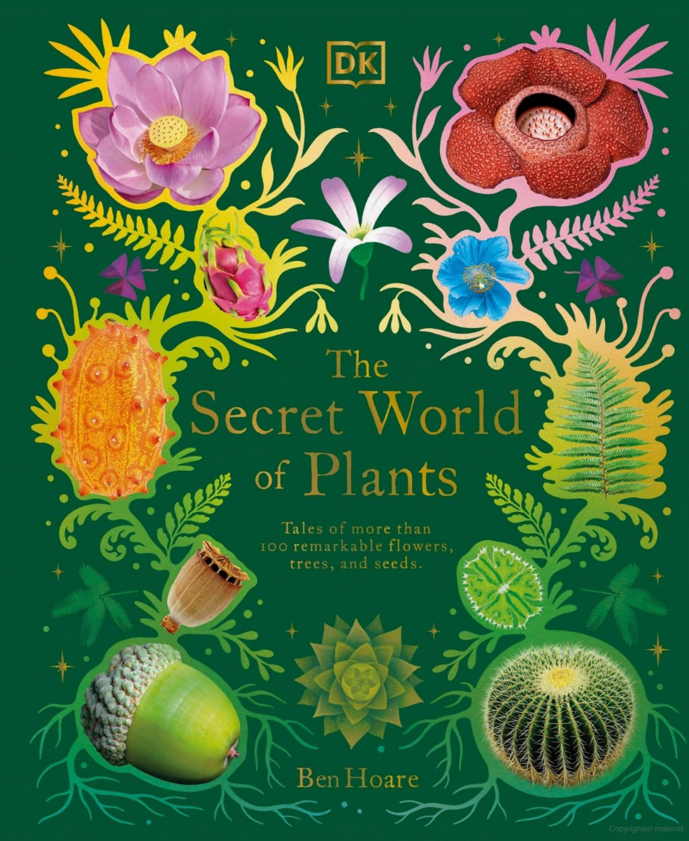 | Living things and their habitats  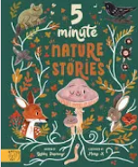
GEOGRAPHY |  | Hot and cold countries  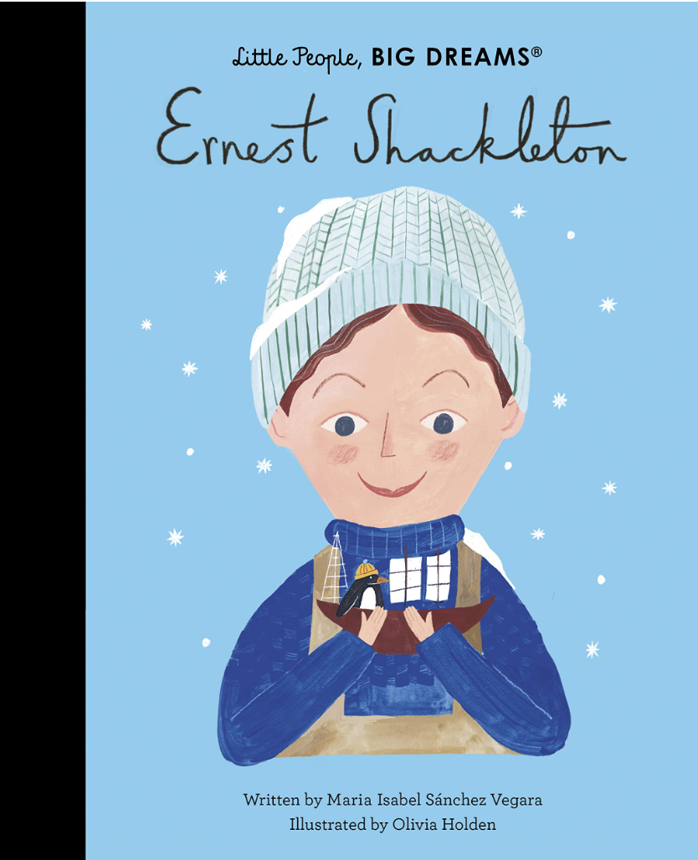 | Geographical skills and fieldwork  Warwick Castle  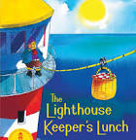 |  | Coasts  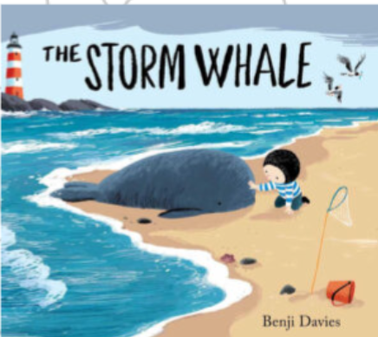
HISTORY | Changes within living memory:  How has shopping changed since my great grandparents was a child?  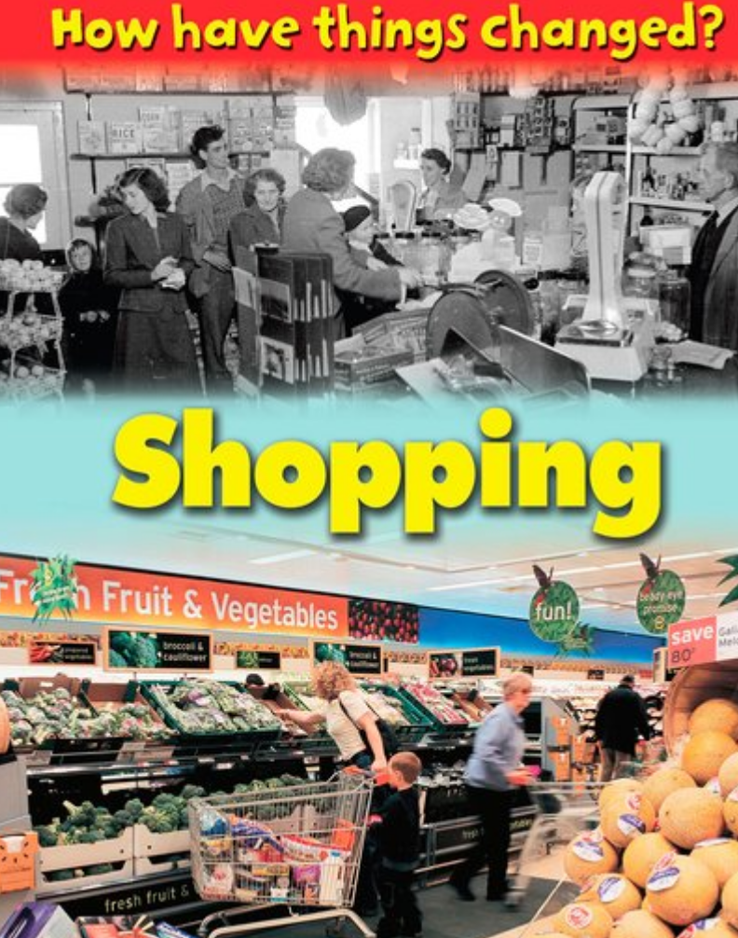 | Significant events this term:  Bonfire Night  Remembrance Day | Events beyond living memory:  Kings, Queens and castles  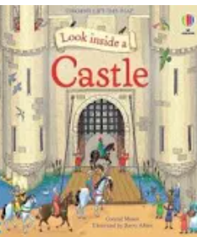 |  | Significant Events:
ART AND DESIGN | Van Gogh  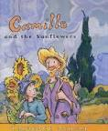 |  | Matisse  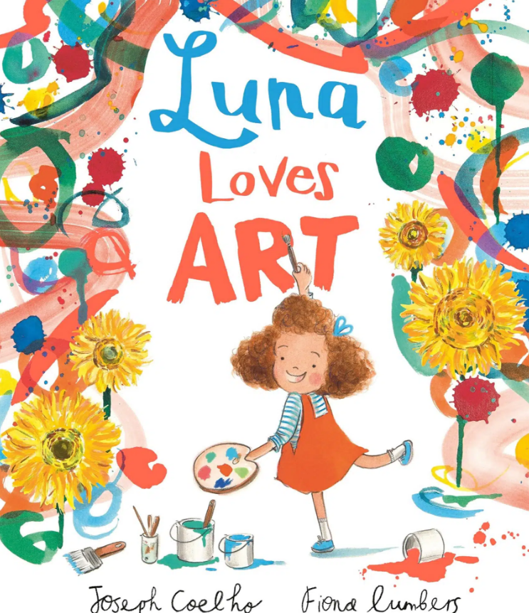 |  | Yayoi Kasama  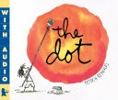
DESIGN & TECHNOLOGY | Cooking – grating, slicing, peeling  Hygiene and health  Measure and weight  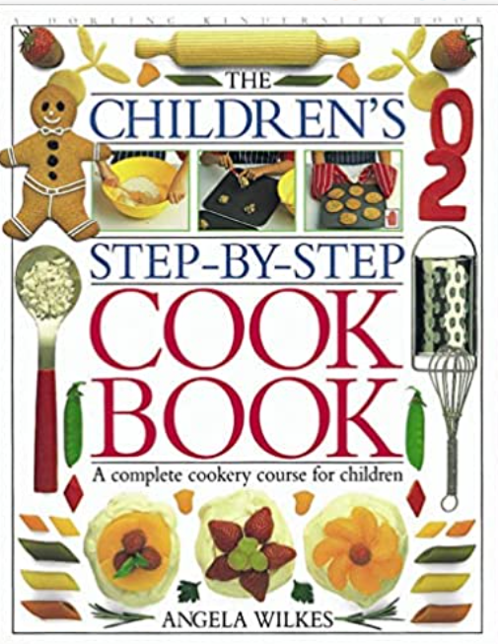 |  | Mechanisms  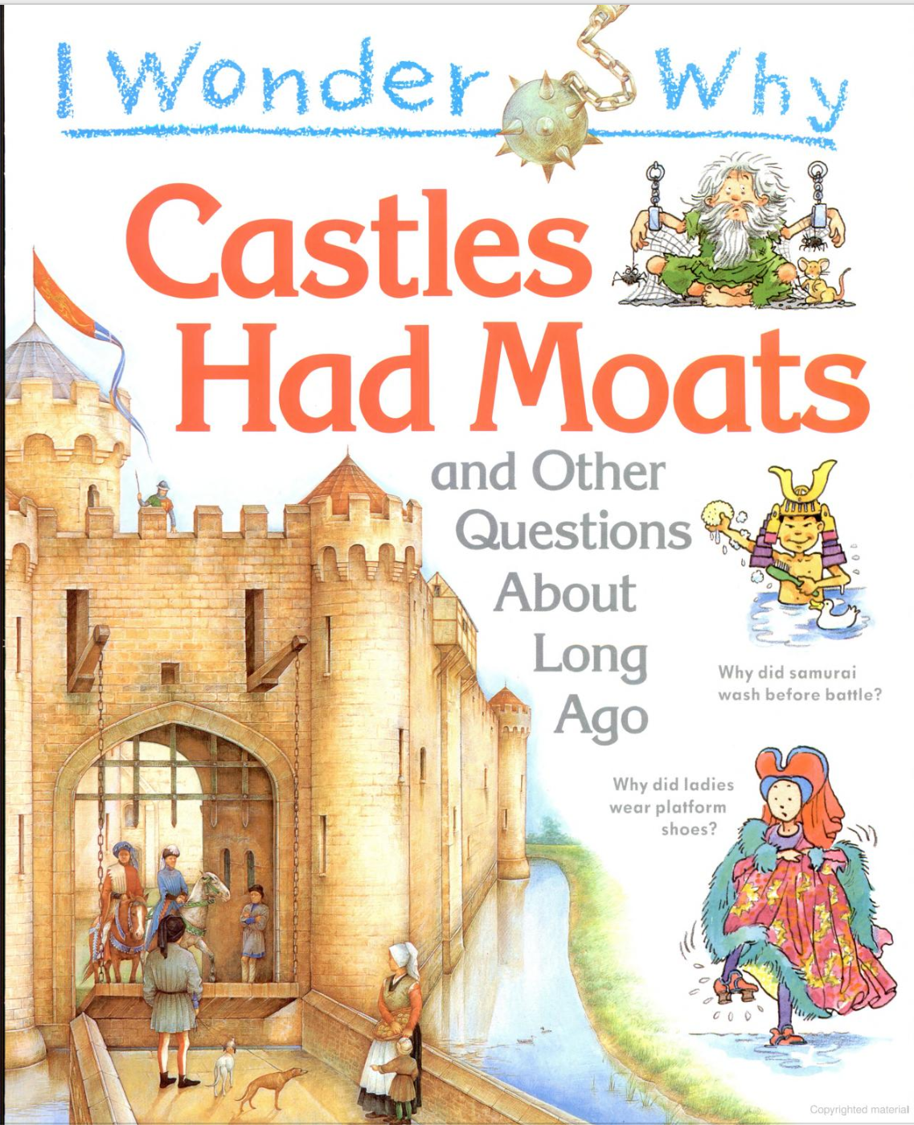 |  | Textiles
COMPUTING | 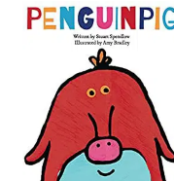  Information technology around us- recognise uses, use technology purposefully, use technology safely.  Significant events this term:  Internet safety day  Anti-bullying  National Coding week |  | Robot Algorithms-use logical reasoning, create and debug.  Creating Media-digital photography-using technology, recognising common uses. |  | Pictograms-using technology, using technology safely.  Making Music- using techonology
MUSIC  Charanga | Hands, feet & heart  South African Music- Finding the pulse, rhythms, singing, playing instruments, improvising, composing, performing. | Ho! Ho! Ho!  Festivals and Christmas-Finding the pulse, pitch, rhythms, singing, playing instruments, improvising, composing, performing. | I want to play in a band  Playing together in a band-Finding the pulse, rhythms, singing, playing instruments, improvising, composing, performing. | Zoo time  Reggae- Finding the pulse, rhythms, singing, playing instruments, improvising, composing, performing. | Friendship song  Pop-Finding the pulse, rhythms, singing, playing instruments, improvising, composing, performing. | Reflect, rewind & replay- consolidation unit.
PHYSICAL EDUCATION | Invasion Game Ball Skills  Sending & Receiving  Attcking & Defending | Gymnastics Floor/ Apparatus | Dance | Outdoor Advenyurous Activities | Striking & Fielding Games | Athletics
PSHE  Jigsaw | Being Me!  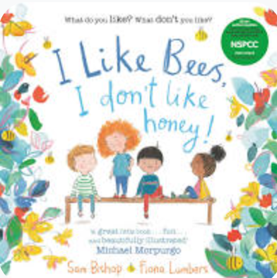 | Celebrating differences.  Significant events this term:  Anti-bullying  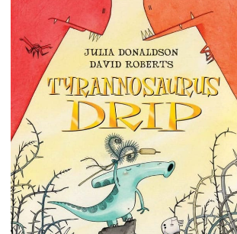 | Dreams & goals  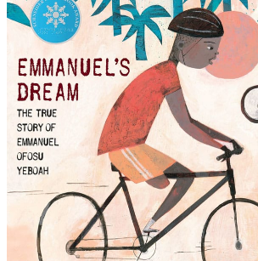 | Healthy Me  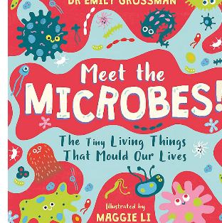 | Relationships  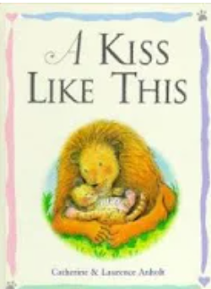 | Changing Me
RE | Respect for everyone-Christianity, Islam, Judaism  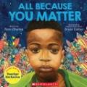 | Symbols of Belonging  What is a symbol?  Islam  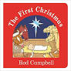 | Holy Books  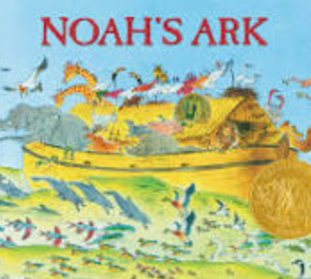 | Symbols of Belonging  Easter and Eid  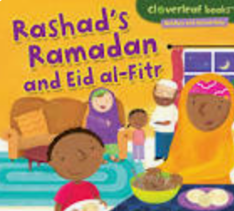 | Community project – church leader  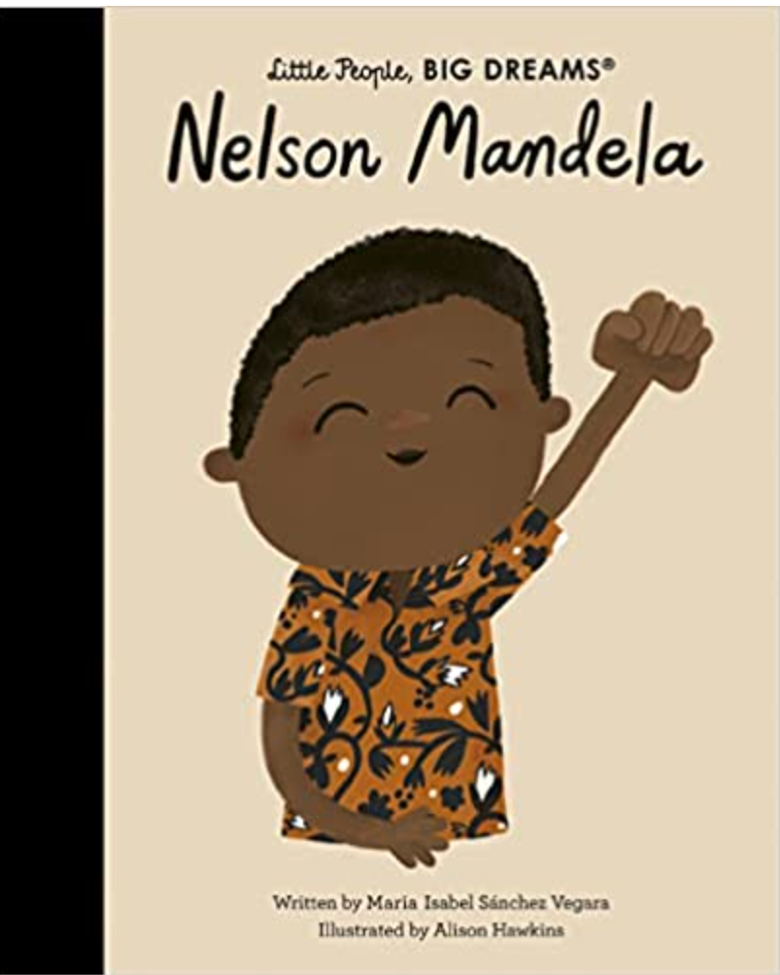 | Beginning to Learn from Islam  Islamic stories at school

