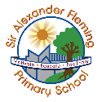
Sir Alexander Fleming Primary School
Science Curriculum Overview 2023/24
Year | Autumn 1 | Autumn 2 | Spring 1 |  | Spring 2 | Summer 1 |  | Summer 2
Reception  / 1 | Understanding the world  Science/ The Natural World: Animals including humans: Exploring Teeth, Naming parts of our face/ bodies, human lifecycle – When I was a baby  Materials: Junk modelling, (Homes) The Three Little Pigs  Plants: Seasons – autumn leaves/ the signs of autumn  Does everything change in the Autumn?  PD  To begin able to manage my basic hygiene and personal care. |  | Understanding the world  Science/ The Natural World: Animals: Farm animals  Materials: Ice and water/ Textures (Art)  Plants: Seasons – trees in winter and spring/ the signs of spring  Does everything change in the Winter? |  |  | Understanding the world  Science/ The Natural World: Animals: Zoo animals (N) Safari animals (R) Minibeasts  Plants: How do plants grow?
1 | Animals, including Humans  Seasonal Changes:  Autumn  Tree Identification  Deciduous and Evergreen  Changes in day length  One Year with Kipper (Mick Inkpen) Snail Trail (Ruth Brown) Superworm (Julia Donaldson & Axel Scheffler) |  | Everyday Materials  The Great Paper Caper  (Oliver Jeffers)  Who Sank the Boat  (Pamela Allen)  The Story of Cinderella  (Walt Disney)  Seasonal Changes:  Autumn to Spring | Investigations focus  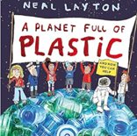 |  | Plants  Seasonal Changes:  Spring and Summer  Tree: Seasons Come, Seasons Go (Patricia Hegarty and Britta Teckentrup) A Little Guide to Wild Flowers (Charlotte Voake) The Things That I LOVE about TREES (Chris Butterworth) Harry’s Hazelnut (Ruth Parsons)
2 | Animals, including humans  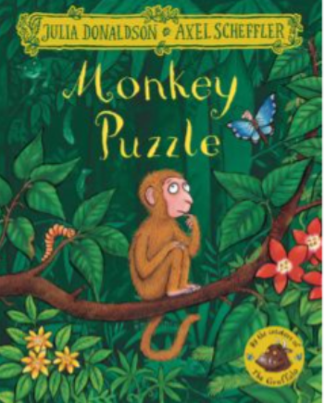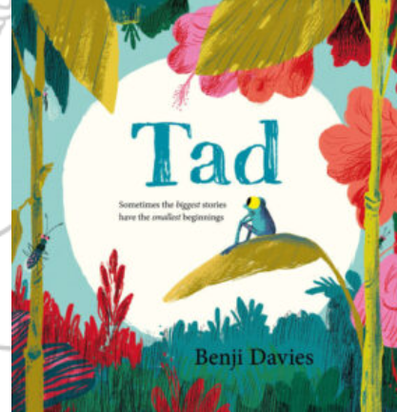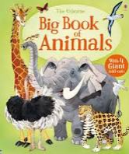  The Gruffalo (Julia Donaldson) Meerkat Mail (Emily Gravett) Tadpole's Promise (Jeanne Willis and Tony Ross) |  | Uses of everyday materials  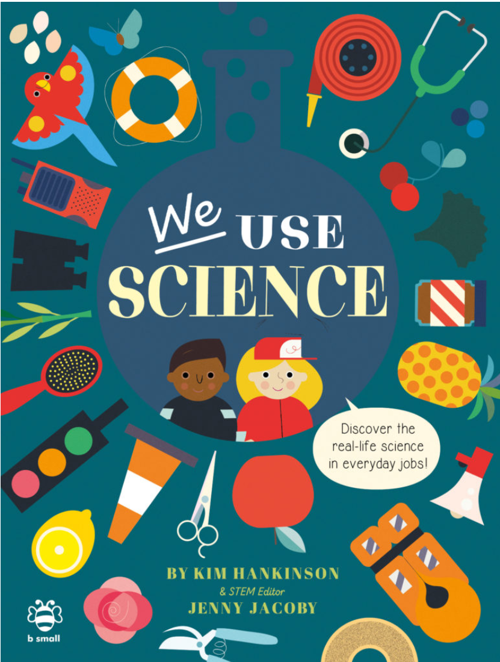  The Tin Forest (Helen Ward) Traction Man (Mini Grey) Three Little Pigs (Lesley Sims) |  |  | Plants  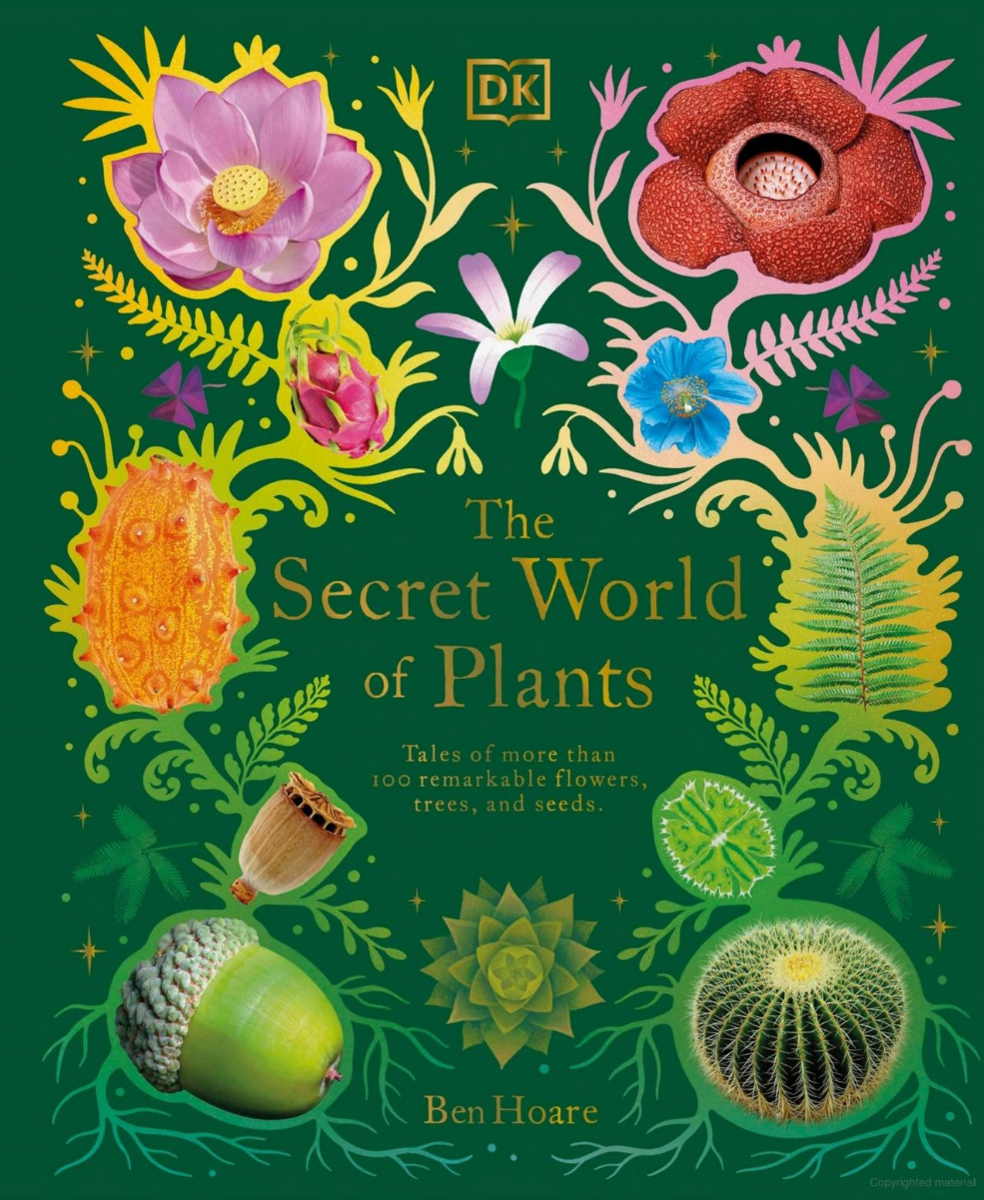  The Tin Forest (Helen Ward) Jack and the Beanstalk (Richard Walker) Ten Seeds (Ruth Brown) A Seed Is Sleepy (Dianna Aston) | Living things and their habitats  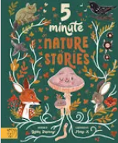  The Gruffalo (Julia Donaldson) Meerkat Mail (Emily Gravett) No Place Like Home (Jonathon Emmett)
3 | Rocks  The Pebble in My Pocket (Meredith Hooper) Stone Girl, Bone Girl (Laurence Anholt) The Street Beneath My Feet (Charlotte Guillain & Yuval Zommer) | Investigation Focus | Animals Including Humans  The Story of Frog Belly Rat Bone (Timothy Basil Ering) Funnybones (Janet and Allan Ahlberg) I Will Never Not Ever Eat a Tomato (Lauren Child) Goldilocks and the Three Bears (Samantha Berger) |  | Forces and Magnets  The Iron Man (Ted Hughes) Mrs Armitage: Queen of the Road (Quentin Blake) Mr Archimedes’ Bath (Pamela Allen) | Plants  The Hidden Forest (Jeannie Baker) George and Flora’s Secret Garden (Jo Elworthy) |  | Light  The Owl Who Was Afraid of the Dark (Jill Tomlinson) The Dark (Lemony Snicket) The Firework-Maker's Daughter (Philip Pullman)
4 | Living things and their habitats  The Vanishing Rainforest (Richard Platt) The Morning I Met a Whale (Michael Morpurgo) Journey to the River Sea (Eva Ibbotson) | Electricity  Until I Met Dudley (Roger McGough) Oscar and the Bird: A Book about Electricity (Geoff Waring) Electrical Wizard: How Nikola Tesla Lit Up the World (Elizabeth Rusch) | Sound  Horrid Henry Rocks (Francesca Simon) Moonbird (Joyce Dunbar) The Pied Piper of Hamelin (Natalia Vasquez) |  | States of matter  Once Upon a Raindrop: The Story of Water (James Carter) Sticks (Diane Alber) | Animals including humans/ investigation focus.  Human Body Odyssey (Werner Holzwarth) Crocodiles Don't Brush Their Teeth (Colin Fancy) Wolves (Emily Gravett
5 | Forces  c.c. maths – statistics  c.c. DT  The Enormous Turnip (Katie Daynes) Leonardo's Dream (Hans de Beer) The Aerodynamics of Biscuits (Clare Helen Welsh) | Earth and Space  Book – Dr Maggie’s Tour of the Solar System  The Skies Above My Eyes (Charlotte Guillain & Yuval Zommer) George’s Secret Key to the Universe (Lucy and Stephen Hawking with Christophe Galfard) The Way Back Home (Oliver Jeffers) | Properties of materials  Itch (Simon Mayo) Kensuke's Kingdom (Michael Morpurgo) The BFG (Roald Dahl) |  | Investigation focus | Living Things and Their Habitats – c.c. maths – statistics  The Land of Neverbelieve (Norman Messenger) Mummy Laid an Egg (Babette Cole) |  | Animals, Including Humans  Hair in Funny Places (Babette Cole) Giant (Kate Scott) You're Only Old Once! (Dr. Seuss)
6 | Evolution and inheritance  One Smart Fish (Christopher Wormell) The Molliebird (Jules Pottle) Our Family Tree (Lisa Westberg Peters) | Animals including humans  Pig-Heart Boy (Malorie Blackman) Skellig (David Almond) A Heart Pumping Adventure (Heather Manley) | Electricity  Goodnight Mister Tom (Michelle Magorian) Blackout (John Rocco) Hitler's Canary (Sandi Toksvig) |  | Light  Letters from the Lighthouse (Emma Carroll) The Gruffalo’s Child (Julia Donaldson) The King Who Banned the Dark (Emily Haworth-Booth) | Living things and their habitats  Beetle Boy (M G Leonard) Insect Soup (Barry Louis Polisar) Fur and Feathers (Janet Halfmann) |  | Investigation focus

