Assembly
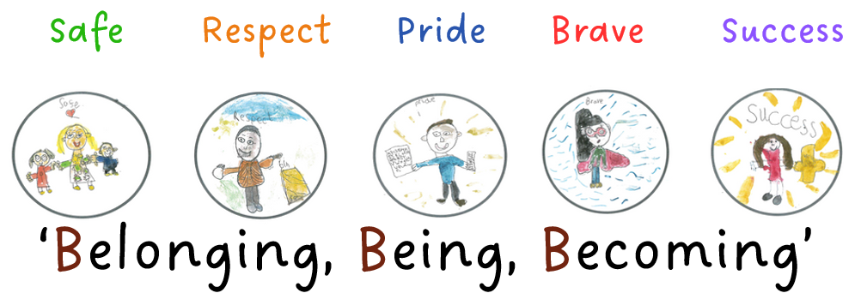
Our Assembly offer enables pupils to:
- Become responsible, respectful and active citizens
- know the difference between right and wrong
- know the consequences of their behaviour and actions
- have the knowledge and respect for different faiths, feelings and values
- enhance pupils’ spiritual, moral, social and cultural development
- create an environment where children feel safe and where bullying, harassment, discrimination etc is not tolerated
- know how to keep themselves safe including online
- understand protected characteristics, promoting equality and diversity
- be prepared for their adult lives
- support children with how to engage in society
Monday @ 8.50am | Tuesday @ 2.45pm | Wednesday | Thursday @ 8.50am | Friday @ 8.50am  Celebration  Values: Pride and Success
Themed Assembly | Reading Assembly | Class Reflection | Singing / Music appreciation | Celebration / Class Assembly
Assemblies

Assembly Rota Autumn 1 2023
Date (WB) | Music Genre | Monday @ 8.50am | Tuesday @ 2.45pm  Reading Assembly | Thursday @ 8.50am  Singing / Music appreciation | Friday @ 8.50am  Celebration  Values: Pride and Success
5.9.23 | Ska | PD DAY | International Literacy Day (08.09)  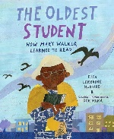 | LH - Years 1,2,3 | Theme: Our School Values / Motto – KT  Value of the Month: Respect  To include:  Values, FBV  Behaviour curriculum focus: Uniform
11.9.23 | R ‘n’ B | Theme: Let’s Celebrate Books (Roald Dahl Day) – KR  PSHE – being me in the World - SV  To include:  Values, FBV  Behaviour Focus: Moving around school | Great British Beach Clean (15.09-24.09)  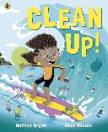 | LH - Years 4,5,6 | Theme: International Day of Democracy – HDS  Fundamental British Value: democracy  To include:  Values, FBV
18.9.23 | Pop Music | Theme: How do we build character? KT  To include:  Values, FBV  Behaviour Focus: Lining Up | National Coding Week  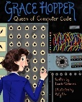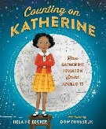 | LH - Years 1,2,3 | Year 5 Assembly & ECadets – Focusing on Staying Safe Online  Parents invited
25.9.23 | Classical / Baroque | Theme: European Day of Languages – VH / RH  Fundamental British Value: mutual respect and tolerance  To include:  Values, FBV  Behaviour Focus: Respectful Manners | European Day of Languages (26.09)  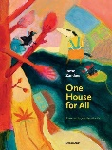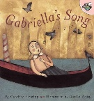 | LH - Years 4,5,6 | Theme: Celebration of our Teaching Assistants Day - KT  Value of the Month: Brave
2.10.23 | Boy Bands | Theme: Black History Month – TJ  Fundamental British Value: mutual respect and tolerance  To include:  Values, FBV  Behaviour Focus: ready to learn | National Poetry Day (05.10)  World Space Week (04.10-10.10) | LH - Years 1,2,3 | PD DAY – Friday 6th October
9.10.23 | Legendary Women of Music | Theme: How is our school a safe place? – KT  To include:  Values, FBV  Behaviour Focus: Playtime Behaviour | World Mental Health Day (10.10)  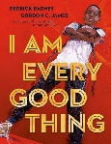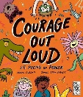 | LH - Years 4,5,6 | Year 4 Harvest / Charity Assembly  Fundamental British Value: mutual respect and tolerance  Parents invited
16.10.23 | Brit-Pop | Theme: How do we keep ourselves safe in school? – LPigg  To include:  Values, FBV  Behaviour Focus: Assembly | International Day for the Eradication of Poverty (17.10)  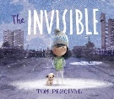 | LH - Years 1,2,3 | Celebration Assembly  - KT
23.10.23 | Blues | Theme: International Artists Day (Oct 25th) – KC  Recycle Week – JR  To include:  Values, FBV  Behaviour Focus: Dining Room | World Cities Day (31.10)  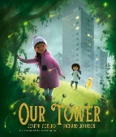 | LH - Years 4,5,6 | Year 6 Black History Month Assembly  Fundamental British Value: mutual respect and tolerance  Parents Invited

Assembly Rota Autumn 2 2023
Date (WB) | Music Genre | Monday @ 8.50am | Tuesday @ 2.45pm  Reading Assembly | Thursday @ 8.50am  Singing / Music appreciation | Friday @ 8.50am  Celebration  Values: Pride and Success
6.11.23 | Punk / Pop Punk | PD DAY | Christmas Carol – 9.15ish  Remembrance Day (11.11) | LH - Years 1,2,3 | Year 3 Remembrance Assembly  Value of the Month: Safe KT  Parents Invited
13.11.23 | Rock ‘n’ Roll / Rockabilly | Theme: PSHE link: Celebrating Difference - SV  Diwali – Festival of Lights LL  Fundamental British Value: mutual respect and tolerance  Behaviour Focus: Behaviour outside school | Anti-Bullying Week | LH - Years 4,5,6 | Theme: Identifying talents and being special - EB  Celebration Awards  To include:  Values, FBV
20.11.23 | Northern Soul | Theme: Anti-Bullying – SV & School Council  Fundamental British Value: Rule of Law  To include:  Values, FBV  Behaviour Focus: Presentation in books | World Children’s Day (20.11)  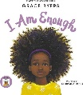 | LH - Years 1,2,3 | Year 2 Anti-Bullying Assembly  Parents Invited
27.11.23 | Dance Music | Theme: Inclusivity – LPigg  Fundamental British Value: mutual respect and tolerance  To include:  Values, FBV  Behaviour Focus: Attendance and punctuality | International Day for the Abolition of Slavery (02.12)  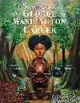 | LH - Years 4,5,6 | Theme: Online Safety and ECadets – JL  To include:  Values, FBV
4.12.23 | Metal | Theme: What is Hannukah? – LL  Fundamental British Value: mutual respect and tolerance  To include:  Values, FBV  Behaviour Focus: communal areas | International Day for Persons with Disabilities (03.12) | LH - Years 1,2,3 | Celebration Awards - KT
11.12.23 | Show Tunes | Christmas Performances | Human Rights Day (10.12)  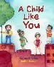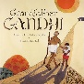 | LH - Years 4,5,6 | Christmas Performances
18.12.23 | Christmas songs | Christmas Performances | International Migrants Day (18.12)  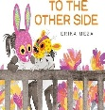 | LH - Years 1,2,3 | House Singing Competition
Assembly Rota Spring 1 2024
Date (WB) | Music Genre | Monday @ 8.50am | Tuesday @ 2.45pm  Reading Assembly | Thursday @ 8.50am  Singing / Music appreciation | Friday @ 8.50am  Celebration  Values: Pride and Success
8.1.24 | Gospel | Theme: Dreams and Goals / New Year Resolutions / Value of month: Kindness  Subject: PSHE  Led by: SV  To include:  Values, FBV  Behaviour Focus: Uniform | World Braille Day (04.01) KR | LH - Years 4,5,6 | No assembly
15.1.24 | Rock | Theme: Why is the word God special to Christians?  Subject: RE  Led by: LL  To include:  Values, FBV  Behaviour Focus: Moving around school | Martin Luther King Jr Day (15.01) KT  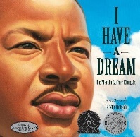 | LH - Years 1,2,3 | Martin Luther King Day – TJ  Fundamental British Values: Mutual respect and Tolerance / individual liberty  Celebration Assembly
22.1.24 | Girl Power! | Theme: RSPB Big Garden Birdwatch  Subject: Science / Geog / OL  Led by: JR  To include:  Values, FBV  Behaviour Focus: Lining Up | International Day of Education (24.01) LP  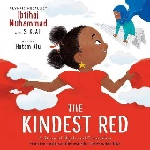 | LH - Years 4,5,6 | Year 1 Class Assembly – LH Judaism focus  Celebration Assembly
29.1.23 | Disco | Theme: The start of man’s sadness  Subject: RE  Led by: LL  To include:  Values, FBV  Behaviour Focus:  Respectful Manners | LGBT+ History Month (01.02-29.02)  KR  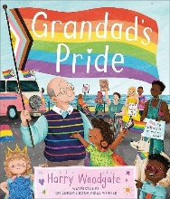 | LH - Years 1,2,3 | ECadets / Internet Safety Day assembly – JL  Link to FBV: Fundamental British Values: Rule of law / Mutual respect and Tolerance / individual liberty  Celebration Assembly
5.2.24 | Rap / Hip Hop | Theme: Children’s mental health week ‘My voice matters’  Subject:PD  Led by: LP  To include:  Values, FBV  Behaviour Focus:  Ready to learn | Rosa Parks Day (04.02)  KR  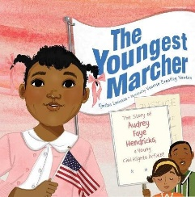 | LH - Years 4,5,6 | Chinese New Year – LL  Celebration Assembly

Assembly Rota Spring 2 2024
Date (WB) | Music Genre | Monday @ 8.50am | Tuesday @ 2.45pm  Reading Assembly | Thursday @ 8.50am  Singing / Music appreciation | Friday @ 8.50am  Celebration  Values: Pride and Success
19.2.24 | Country Music | Theme: Healthy Me  Subject: PSHE  Led by: SV / LPe  To include:  Values, FBV  Behaviour Focus: Playtime | Years 1,2,3  International Day of Women and Girls in Science (11.02) KT  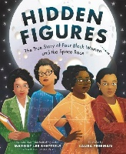  FBV: Tolerance / Individual liberty / Mutual Respect /Rule of Law / Democracy | LH - Years 4,5,6 | Celebration Assembly
26.2.24 | K Pop | Theme: Women’s History Month  Subject: History  Led by:TJ  To include:  Values, FBV  Behaviour Focus: Assembly | Years 4,5,6  International Day of Women and Girls in Science (11.02) KT  FBV: Tolerance / Individual liberty / Mutual Respect /Rule of Law / Democracy | LH - Years 1,2,3 | Nursery Class Assembly  &  Celebration Assembly
4.3.24  Ghanaian Independence Day  Wednesday | EMO | Theme: Ghanaian Independence Day & Value of the Month: Equality  Subject: History  Led by: EB/HDS  To include:  Values, FBV  Behaviour Focus: Dining Room | Years 1,2,3 KR  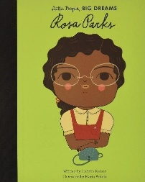  FBV: Tolerance / Individual liberty / Mutual Respect /Rule of Law / Democracy | LH - Years 4,5,6 | Theme: International Women’s Day  Subject: Equality  Led by: RB / EJ  &  Celebration Assembly
11.3.24 | Legendary Bands | Theme: British Science Week (link to Women)  Subject: Science  Led by: EB/ER  To include:  Values, FBV  Behaviour Focus:  Behaviour outside school | Years 4,5,6 - LP  Neurodiversity Celebration Week  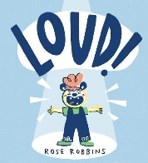  FBV: Tolerance / Individual liberty / Mutual Respect | LH - Years 1,2,3 | Year R Class Assembly  &  Celebration Assembly
18.3.24  Early Bird Week | Soul | Theme: What can we do to keep ourselves safe?  Subject: School Values  Led by: SV & School Council  To include:  Values, FBV  Behaviour Focus:  Attendance and punctuality | Years 1,2,3 - LP  FBV: Tolerance / Individual liberty / Mutual Respect | LH - Years 4,5,6 | Celebration & Attendance / Easter Bonnet parade and raffle

Assembly Rota Summer 1 2024
Date (WB) | Music Genre | Monday @ 8.50am | Tuesday @ 2.45pm  Reading Assembly | Thursday @ 8.50am  Singing / Music appreciation | Friday @ 8.50am  Celebration  Values: Pride and Success
8.4.24 | Opera | Theme: Relationships &  Value of the Month: Successful  Subject: PSHE  Led by: SV  To include:  Values, FBV  Behaviour Focus: Uniform | Years 1,2,3 KT  World Art Day (15.04)  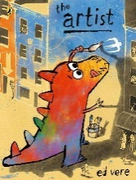 | LH - Years 4,5,6 | Celebration Assembly  Attendance Awards for Spring Term  KT
15.4.24 | Funk | Theme: Earth Day  Subject: Geography /OL / Science  Led by: JR, EJ  To include:  Values, FBV  Behaviour Focus:  Moving around school | Years 4,5,6 KR  (22.04.02)  FBV: Tolerance / Individual liberty / Mutual Respect | LH - Years 1,2,3 | Year 4 Assembly  &  Celebration Assembly
22.4.24 | Power Ballads | Theme: Secrets to Success  Subject: Values  Led by: KR  To include:  Values, FBV  Behaviour Focus:  Lining up | Years 1,2,3 KR  International Dance Day ( 29.4)  FBV: Tolerance / Individual liberty / Mutual Respect | LH - Years 4,5,6 | Celebration Assembly KT
29.4.24  BRITISH  VALUES  WEEK | Reggae | Theme: British Values  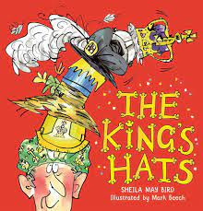  Subject: Values  Led by: KT  To include:  Values, FBV  Behaviour Focus:  Respectful manners | Years 4,5,6 KT  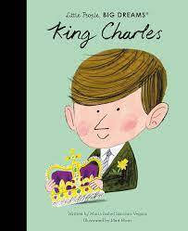  FBV: Tolerance / Individual liberty / Mutual Respect / Rule of Law / Democracy | LH - Years 1,2,3 | Year 5 Assembly  (British Values)  &  Celebration Assembly
6.5.24  BRITISH  VALUES  WEEK | Electronic | No Assembly  Bank holiday  Behaviour Focus:  Ready to learn | Years 1,2,3 - KT  FBV: Tolerance / Individual liberty / Mutual Respect | LH - Years 4,5,6 | Year 3 Assembly  Celebrating David Attenborough’s birthday  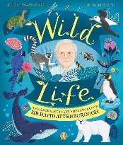  Value of the Month: Responsibility
13.5.24 | Legendary Men of Music | No Assembly  SATS  Behaviour Focus:  Playtime Behaviour | Years 4,5,6 KR  International Day of Families (15.5)  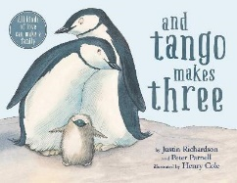 | No Assembly  SATS | No Assembly  SATS
20.5.24 | Ambient / Instrumental | Theme: World Day of Cultural Diversity  Subject: Values  Led by: LP  To include:  Values, FBV  Behaviour Focus:  Assembly | Years 1,2,3 KT  World Day for Cultural Diversity (21.05)  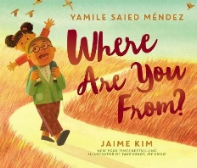 | LH - Years 1,2,3 | Celebration Assembly KT

Assembly Rota Summer 2 2024
Date (WB) | Music Genre | Monday @ 8.50am | Tuesday @ 2.45pm  Reading Assembly | Thursday @ 8.50am  Singing / Music appreciation | Friday @ 8.50am  Celebration  Values: Pride and Success
3.6.24 | World Music | Theme: Changing Me &  Value of the Month: Safe  Subject: PSHE  Led by: SV  To include:  Values, FBV  Behaviour Focus: Dining Room | Years 1,2,3 KT  Empathy Day (06.06)  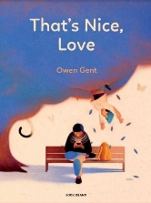 | LH - Years 4,5,6 | Celebration Assembly  KT
10.6.24 | Techno | Theme: Celebrating differences  Subject: Pride Month  Led by: KT  To include:  Values, FBV  Behaviour Focus:  Behaviour outside school | Years 4,5,6 KR  Gypsy, Roma and Traveller History Month (01.06-30.06)  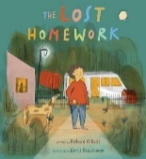  FBV: Tolerance / Individual liberty / Mutual Respect | LH - Years 1,2,3 | Year 2 Assembly  &  Celebration Assembly
17.6.24 | Grunge | Theme: World Refugee Day  Subject: Diversity  Led by:  To include:  Values, FBV  Behaviour Focus:  Presentation in books | Years 1,2,3 KR  World Refugee Day  (20.6.24)  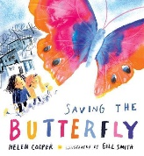  FBV: Tolerance / Individual liberty / Mutual Respect | LH - Years 4,5,6 | Theme: Windrush Day (22.06) HDS  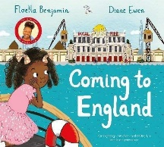
24.6.24  Early Bird Week | ‘One Hit’  Wonders | Theme: Being safe!  Bullying  Subject: Values  Led by: SV & School Council  To include:  Values, FBV  Behaviour Focus:  Attendance and punctuality | Years 4,5,6 KT  Gypsy, Roma and Traveller History Month (01.06-30.06)  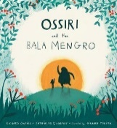  FBV: Tolerance / Individual liberty / Mutual Respect / Rule of Law / Democracy | LH - Years 1,2,3 | Year 1 Assembly  &  Celebration Assembly
1.7.24 | Grime | Theme: Being safe!  Scenarios  Subject: Values  Led by: SV & School Council  To include:  Values, FBV  Behaviour Focus:  Communal Areas | Years 1,2,3 – KT  Founding of the NHS (05.07)  FBV: Tolerance / Individual liberty / Mutual Respect | LH - Years 4,5,6 | ECadets Assembly – Staying Safe – JL/JA
8.7.24 | Psychedelic | Theme: Value of the Month: Embracing Change  Subject: Values  Led by: KR  To include:  Values, FBV  Behaviour Focus:  Playtime Behaviour | Years 4,5,6 KR  Malala Day (12.07)  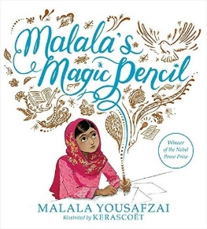 | LH - Years 1,2,3 | Celebration and Attendance Assemblies KT
15.7.24  Y6 play to parents  Tues, Wed |  | Theme: Olympic Games (26.07-11.08)  Subject: PE  Led by: EB,RB  To include:  Values, FBV  Behaviour Focus:  Behaviour | Years 1,2,3 KT  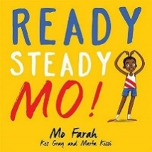 | LH - Years 4,5,6 | End of year leaving assembly – Year 6 team

