

Sir Alexander Fleming Primary School and Nursery

PE and Sports Funding

Reviewed: 29.1.24

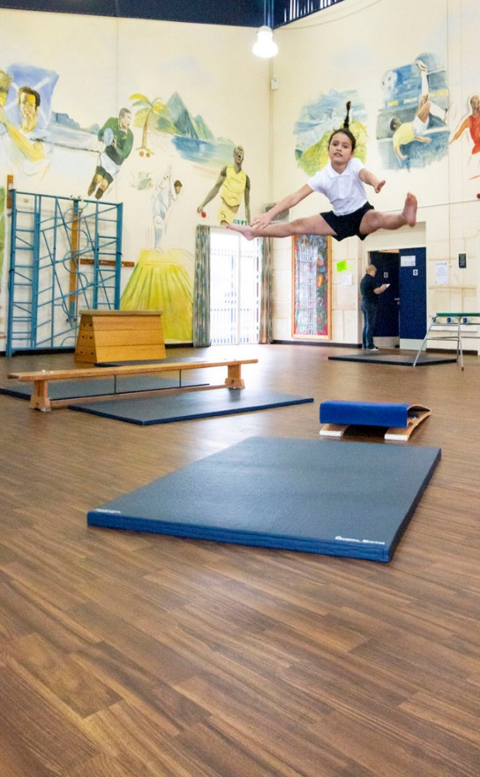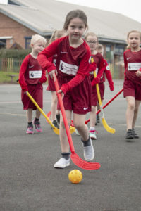

Written: 24.10.23

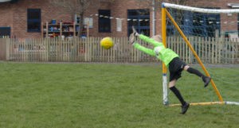

Sir Alexander Fleming Primary School Key Notes:

**PE funding received: £19,190** 3rd May 2023 (latest)



The Primary PE and sport premium guidance, outlines **5 key priorities** that funding should be used towards.

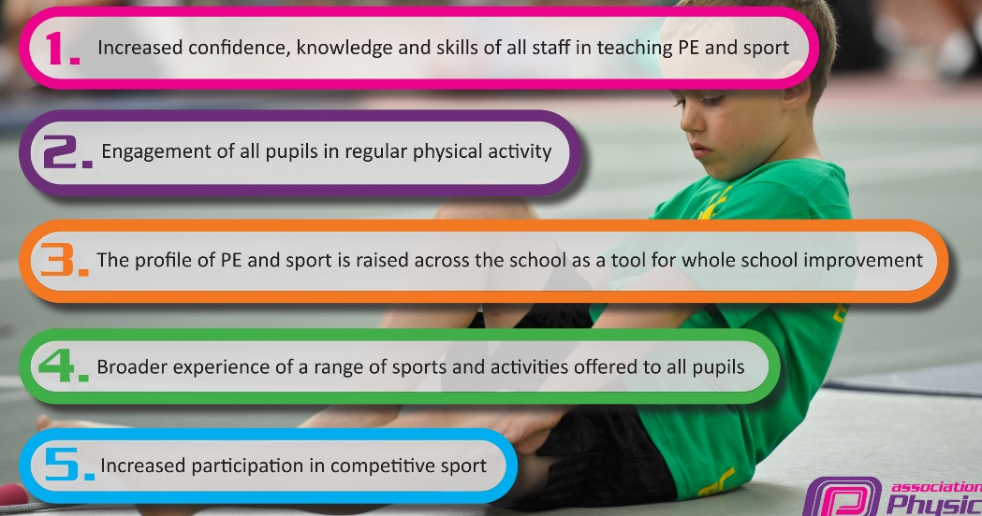

The school development plan outlines these key priorities for the school’s PE provision:

* **Improve confidence of staff towards the teaching of PE.**
* **Raise the profile of PE across the school through incentives, sports awards, house competitions, website, and assemblies.**
* **To provide sporting opportunities for all children of all abilities in a wider range of sports.**
* **To link PE with other subjects across the school-maths, science and PSHE.**
* **To support adaptive teaching so that all children can access and enjoy PE.**

**All funding must be spent by 31st July 2024.**

**Review of last year’s spend and key achievements (2022-2023)**

|  |  |  |
| --- | --- | --- |
| **Activity/Action** | **Impact** | **Comments** |
|  | See sports review 2022-2023 written by RB. | |

**Key priorities and Planning**

|  |  |  |  |  |
| --- | --- | --- | --- | --- |
| **Action – what are you planning to do** | **Who does this action impact?** | **Key indicator to meet** | **Impacts and how sustainability will be achieved?** | **Cost linked to the action** |
| Introduce high-quality lunchtime sport activities for pupils, led by trained sports leaders. | Lunchtime supervisors,  Year 5 and 6 pupils,  teaching staff/coach - as they need to lead the activity.  pupils – as they will take part. | Key indicator 2 -The engagement of all pupils in regular physical activity – the Chief Medical Officer guidelines recommend that all children and young people aged 5 to 18 engage in at least 60 minutes of physical activity per day, of which 30 minutes should be in school.  Key indicator 4: Broader experience of a range of sports and activities offered to all pupils.  School development plan priority 2 and 3. | More pupils meeting their daily physical activity goal, more pupils encouraged to take part in PE and Sport Activities.  Year 6 pupils have experience as PE coaches and teachers.  Better behavior outside during lunch time due to additional structure. | £600  To buy new lunch time specific equipment to be kept in a separate shed for the sports leaders. (£148.13 + monster kick about provided resources)  CPD training for PE leads and training for sports leaders.  Sports leader bands. (£27.12)  Getset4pe lunch time activities. (£550) |

|  |  |  |  |  |
| --- | --- | --- | --- | --- |
| To provide additional CPD for teachers and PE leads. | Primary generalist teachers. | Key Indicator 1: Increased confidence, knowledge, and skills of all staff in teaching PE and sport.  Key indicator 5: Increased participation in competitive sport.  School development plan: 1 and 4 | Primary teachers more confident to deliver effective PE supporting pupils to undertake extra activities inside and outside of school, including teaching water safety and swimming and as a result improved % of pupil’s attainment in PE.  Staff meetings  (one per half term)  Staff training with local authority | £1000 for 2 teachers to undertake CPD.  New Pe scheme with videos and in detail plans. (Getset4PE £550) |
| Invest in a new and improved PE scheme to support the quality and progressiveness of PE throughout school. | Teachers- a highly structured PE lesson plan with supportive materials to support confidence when delivering PE.    TA’s- To access the lesson plan and staff meetings in order to support lessons and SEN children.    Pupils- high quality, progressive and sequenced lessons linked to interests.  Subject leads- documentation support and progressive planning. | Key indicator 1- Increased confidence, knowledge, and skills of all staff in teaching PE and sport.  School development plan 1, 4 and 5. | Primary teachers more confident to deliver effective PE supporting pupils to undertake extra activities inside and outside of school.  Pupils benefit from higher quality lessons. | £550 for GetSet4PE |
| To increase the number of pupils able to swim 25m, swim all 4 strokes confidently or perform self-rescue. | Pupils in Year 3,4,5 and 6 who can access swimming lessons in the school on-site pool. | Key indicator 1- Increased confidence, knowledge, and skills of all staff in teaching swimming through watching a qualified coach.  Key indicator 4: Broader experience of a range of sports and activities offered to all pupils. (Swimming accessed at a younger age)  School development plan 3 and 5 | More pupils able to access swimming at a younger age.  Increased water confidence.  More children can perform life saving.  More children can competently swim all 4 strokes.  More children can swim 25m confidently.  Continued next year. | £6836 for aqualympic Swimming Pool and 1 X qualified swimming instructor. |
| To increase participation in competitive sport for all children. | All pupils in school  SEND children  Less active children. | Key indicator 5: Increased participation in competitive sport.  Key indicator 4: Broader experience of a range of sports and activities offered to all pupils.  SPD: 2 and 3 | Greater opportunity for pupils to access competitive sport.  Sporting opportunities for all children with registers for participation. | Coaches and minibus cost to competitive competitions.  £6,000  Medals  Certificates  Trophies |
| To raise the profile of sport throughout school. | All pupils.  SEN pupils.  Staff (teachers and TA’s) | Key indicator 3: The profile of PE is raised across school.  Key indicator 2 -The engagement of all pupils in regular physical activity.  Key indicator 4: Broader experience of a range of sports and activities offered to all pupils. (Swimming accessed at a younger age)  SDP: 2,3 and 4 | National sports week  -Sports day  -Sport research person  -cross curricular learning  -national sporting competition awareness  -active lives campaign  -celebration of national achievements  Sport awards and celebrations-  Intra-house competitions  Medals, certificates and trophies to celebrate | £800  Sports board to display news (£5.87)  Sports lanyard  Trophies  Medals  Certificates  Sport weekly  3 X adults to Shropshire Cricket Awards Ceremony for Primary School of the Year Award.  Sports trips to football ground. |
| To support the participation of the lowest 20% in PE and provide adaptive equipment for SEND children. | Less active children  SEND children | Key indicator 2 -The engagement of all pupils in regular physical activity – the Chief Medical Officer guidelines recommend that all children and young people aged 5 to 18 engage in at least 60 minutes of physical activity per day, of which 30 minutes should be in school.  Key indicator 4: Broader experience of a range of sports and activities offered to all pupils.  SDP: 3 and 5 | All pupils accessing PE. (equal opportunities)  Develop a life-long love for PE and a healthy diet. Support a healthy lifestyle.  Adaptive teaching and resources for all children to participate. | £500 specialist adaptive equipment.  Spare PE kit in school to encourage participation.  Change4life  Active lives survey |

**Key achievements 2023-2024**

This template will be completed at the end of the academic year and will showcase the key achievements schools have made with their Primary PE and sport premium spending. (To be completed July 2023)

|  |  |  |
| --- | --- | --- |
| **Activity/Action** | **Impact** | **Comments** |
| National Sports week  (Whole school cross curricular learning)  Sports Day  Intra-house competitions  Increased teacher led PE lessons  Increased swimming numbers  Cross Curricular learning |  |  |

**Swimming Data**

Meeting National Curriculum requirements for swimming and water safety.

Priority should always be given to ensuring that pupils can perform safe self-rescue even if they do not fully meet the first two requirements of the National Curriculum programme of study.

|  |  |  |
| --- | --- | --- |
| **Question** | **Stats:** | **Further context**  **Relative to local challenges** |
| What percentage of your current Year 6 cohort can swim competently, confidently and proficiently over a distance of at least 25 meters? | 29%  14/48 | 29% -  -Our children have not had sufficient swimming lessons of high quality over previous years  -no local access to pool for additional lessons |
| What percentage of your current Year 6 cohort can use a range of strokes effectively? | 45%  22/48 | Children benefitted from 2X45 minute lessons a week for 6 weeks with a qualified swimming instructor in groups of 10. |

|  |  |  |
| --- | --- | --- |
| What percentage of your current Year 6 cohort are able to perform safe self-rescue in different water-based situations? | 67%  32/48 | Children could successfully perform a range of floats, tread water and swim to the nearest side. |
| If your schools swimming data is below national expectation, you can choose to use the Primary PE and sport premium to provide additional top-up sessions for those pupils that did not meet National Curriculum  requirements after the completion of core lessons. Have you done this? | No | Possibility Summer 2024 |
| Have you provided CPD to improve the knowledge and confidence of staff to be able to teach swimming and water safety? | Yes | Teaching assistants able to observe a  Qualified swimming instructor that was paid for. |

Signed off by:

|  |  |
| --- | --- |
| Head Teacher: | Katy Tomlinson |
| Subject Leader or the individual responsible for the Primary PE and sport premium: | Emily Brown  Ross Broderick |
| Governor: | Matt Downes-Ward |
| Date: | 4.11.23 |