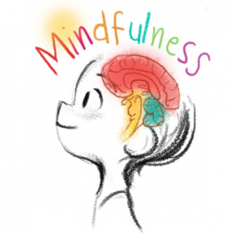
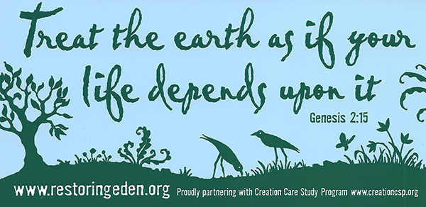
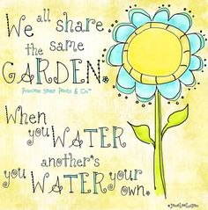
Early Years Foundation Stage
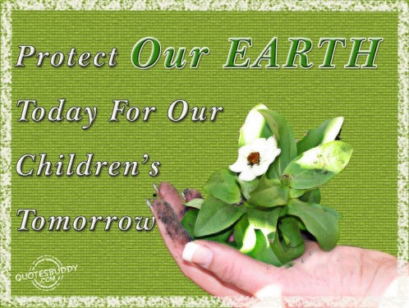
Curriculum Overview
Spring
A is for Alive
Hypothesis
Adults recognise that some children are highly motivated when playing in the outdoor area. This trend has continued this year, however we have a cohort of children who have experienced the Pandemic and ‘stayed at home’ for a considerable portion of their lives. Therefore, plans have been made to give children high-quality, outdoor experiences in order to have the greatest impact on children’s learning. Staff recognise through CPD opportunities that children’s movements are crucial and are closely linked to attainment in writing. Gross and fine motor movements will be enhanced through outdoor play. A trend in our data shows that staff need to improve outcomes for PPG boys. Outdoor play will address this group. This project theme may include many ‘boy-friendly’ topics, which are also very stimulating for all the children within our setting. It is also the summer term and children will be naturally curious about the changes occurring within the season. By, ‘going green’ and considering living things staff have planned to address children’s spiritual, moral, social and cultural needs.
Provocation
The seasonal changes occurring act as the greatest provocation this term. Both children’s natural curiosity and adults steering children to notice the natural world will form the basis for learning. In order to develop our parent partnerships further children will plant a seed at school and begin to nurture it, later taking this home to develop their recall and ensure our families understand and compliment children’s learning at home. We will also draw on the pets that children have in order to spark excitement, develop caring citizens and ensure learning is meaningful to our children.
Big Ideas
Living organisms; plants, flowers, insects, animals, humans. Life-cycles.
Care for the environment.
Animal habitats; African animals. The study of Africa.
Growth and decay.
Herbs.
Being self-sufficient. Food. Cultural foods.
The human body; bodily functions.
Sport and movement.
Change.
Young animals. Caring for living things; pets.

Spiritual, Moral, Social and Cultural Considerations
Exploring Nature; Natural phenomenon.
Caring for the environment; considering how our actions effect the environment.
Respect for living things.
Showing curiosity at the world around them.
Being a good citizen.
Contributing to the community; community gardens.
The therapeutic and spiritual aspects of the outdoors.
Mindfulness.
Healthy lifestyles; eating and fitness.
The universal topics of life and death.

Cultural Capital
Spring/ Summer at Forest School
Local/ Community Gardens
The Safari Park
The Farm
Visitors
Pets/ RSPCA
Exotic Zoo

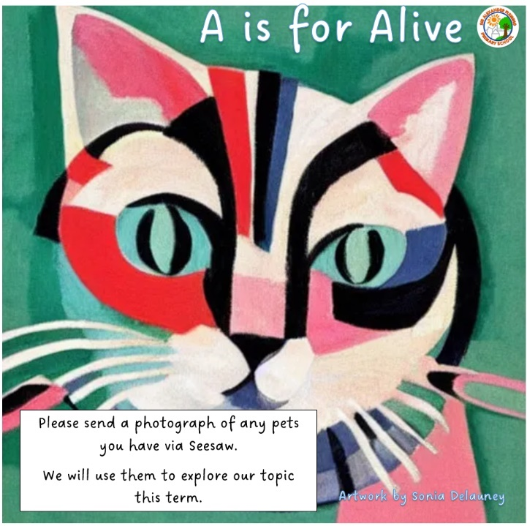
Communication and language
Listening, attention and understanding
Children will know . . .  (Knowledge) | How we will deliver this . . .  (Pedagogy)  SEE COMMON PLAY BEHAVIOUR PROGRESSION ALSO
N  - Listen with interest to songs, rhymes and stories for an increased period. They will join in with words and actions.  - They will know an increasing number of nursery rhymes and songs from memory. They make comments about them and answer simple questions such as, what and how questions.  - Listen to others one to one and in small groups, responding by joining in, talking or acting.  R  - Listen attentively and respond to what they hear with relevant questions, comments and actions when being read to and during whole class discussions and small group interactions;  - Make comments about what they have heard and ask questions to clarify their understanding;  - Hold conversation when engaged in back-and-forth exchanges with their teacher and peers.  Y1  - Engage in a reciprocal conversation with others; one to one, small group and during whole class discussions.  - Recall a story with many parts orally.  - Know a variety of song and know more complicated poetry by heart. | - Daily timetable ensures opportunities for a range of scenarios in which children must listen and respond.  - Children are encouraged to ask for resources such as board games and jigsaws – not always on offer to them.  - Nursery rhyme time every day continued; displayed so children can see the bank of rhymes they know.  - Weekly song focus. Enhancements made to indoor music area – the elements/ a listening centre.  - Story time daily; planned with key themes and ideas for children to make connections.  - Theatre role-play in CP – outdoors. Song and Rhymes displayed/ resourced.  - Role-play area/ small world area evoking discussion.  - Themed enhancements which meet interests of children/ curriculum topics/ focus for learning.  - Communication areas; tents, soft furnishing.  - All adults engaging in high quality interactions at all time.  - Forest school to develop curiosity.  - Talk Boost, Neli intervention taking place for selected children.  - Using aspects of Listen with Lucy during small group sessions (N)

Speaking
Children will know . . . | Children will say . . . | How we will deliver this . . .
N  - Use sentences, sometimes connecting two ideas.  - Begin to learn new words rapidly and remember ones previously learnt. Begin to use these in their play.  - Talk about things they can see or experiences they are having. Begin to talk about pevious events with the use of prompts/ scaffolds such as pictures and photographs.  R  - Use more complex sentences and begin to give reasons and justification for their ideas.  - Use words to connect ideas.  - Respond to others appropriately, adding to the theme/ topic being discussed.  - To talk about experiences and feelings that are not always tangible.  Y1  - Express ideas and feelings using full sentences.  - Offer more detail when prompted.  - Keep conversations going by making comments and asking questions. | Nouns, talk about things they can see.  “I got one of those.”  “I liked the slide.”  But, and, because  (Adjective)  Maybe, perhaps, what about, I think, so, then | - High quality interactions; all staff  - Helicopter stories (at least once a week for all children)  - A weekly nursery rhyme  - Story time daily  - Stories used in numbers and patterns sessions  - Environment considerations; high quality role-play, small world and construction areas  - Home challenge; to inspire talking about what they know – send a photograph of a place that is special to you.  - Neli (R), Talk Boost (N)

Physical Development
Gross-motor
Direct teaching (PE lessons) – Games, Striking and Fielding (Y1 – Rounders), Athletics
Children will know . . . | Children will say . . . | How we will deliver this . . .
N  PROCEDURAL  - Run, beginning to adjust speeds  - Jump from a flat surface to another flat surface, landing on two feet.  - I am beginning to explore a range of ball skills.  - I am beginning to negotiate space safely.  - I can explore movement skills.  DECLARATIVE  - To participate eagerly  - I am beginning to take turns with others. I am beginning to understand how I feel in different situations.  - I follow instructions with support. I play games honestly guided by the rules with support.  R  PROCEDURAL  - Run at different speeds  - Jump from standing position  - I use ball skills with developing competence and accuracy.  - I use movement skills with developing balance and co-ordination.  DECLARATIVE  - To cope with not always winning  - I can negotiate space safely with consideration for myself and others.  - I follow instructions involving several ideas or actions.  - I play co-operatively, take turns and encourage others.  - I play games honestly with consideration of the rules.  - I show an understanding of my feelings and can regulate my behaviour.  Y1  PROCEDURAL  - Run at different speeds, lengths and in different directions.  - Use a standing start to jump for distance and for height.  - Throw an object with one hand  - Explore footwork patterns  - Throw a variety of objects with one hand in different ways  - Stop and send a variety of objects  - Copy basic actions with control  - Sometimes stop a ball using a feet or stick  - Catch a ball using two hands  - Send a ball in a the direction of another person by striking or throwing  - Work with a partner to pass and receive a ball  DECLARATIVE  - Begin to use simple tactics.  - Work effectively with a partner | Catch, throw, ball, run, safe, rules, stop  space speed direction score points partner jump land aim safely lose win team pass  bowl bowler fielder fielding hit overarm out ready position track underarm batting batter | - Access to a planned physical development activity outdoors daily.  - Weekly PE for N, Reception, Y1  - Healthy Movers activities  - Squiggle while you wiggle  - Daily mile for R and Y1  - Access to bikes and tricycles  - Forest school provision

Fine-motor
Children will know . . . | Children will say . . . | How we will deliver this . . .
N  - Shows an increasing preference for a dominant hand.  - Can copy a cross, wavy line and swirl.  - Copies letters in their name. Not formed accurately, but readable.  - Threads small and large objects.  - To join together pieces of a jigsaw.  - Begins to cut along paper using scissors; cuts out undetermined shapes.  - Can cut items safely with a knife.  - Uses tools such as a rolling pin purposefully.  R  - Hold a pencil effectively in preparation for fluent writing – using the tripod grip in almost all cases; can form most letters accurately.  - Use a range of small tools, including scissors, paintbrushes and cutlery safely; Begin to show accuracy and care when drawing.  Y1  - Applies knowledge of safety in everything that they do/ tools they use.  - Builds models using a variety of techniques.  - Cuts out shapes from paper with accuracy.  - Colour/ shades using different pressure to create an effect.  - Forms upper and lower case letters. | Draw, colour, block, marks, writing, playdough, roll, jigsaw, cut, scissors, wiggly, line, zig-zag  Use the handwriting patter.  Name, rolling pin, dough, build, circle, join, stick  Model, construction, 2D shapes, letter names and phonemes, shade, dark, light, lever, move, froggy fingers | - Malleable area provision  - Junk modelling provision  - Woodwork area  - A writing area in every class base  - Access to the Art Studio daily  - Expressive Art and Design Project

Personal, Social and Emotional Development
Self-regulation
Children will know . . . | Children will say . . . | How we will deliver this . . .
N  - To identify three basic emotions; happy and not happy (sad), angry/ cross. To begin to identify these in others/ characters.  - Can sit quietly at appropriate times such as during carpet sessions, during small group.  - To follow simple adult requests.  - To follow simple rules which are repeated daily and recall these. To know that rules keep them safe.  - Take turns and share resources sometimes independently.  - Can usually accept when routines change or when needs cannot be met immediately.  R  - Show an understanding of their own feelings and those of others, and begin to regulate their behaviour accordingly;  - Set and work towards simple goals, being able to wait for what they want and control their immediate impulses when appropriate;  - Give focused attention to what the teacher says, responding appropriately even when engaged in an activity, and show an ability to follow instructions involving several ideas or actions.  Y1  - To identify a range of emotions in themselves and others and regulate their behaviour accordingly.  - To immediately follow a direct adult request and understand the reasons for the request. Able to articulate/ justify rules. Sometim,es does not need the adult to make the request, acts independently.  - To set themselves goals and work towards them.  - To wait their turn for equipment, resources or within a game independently.  - To play a competitive game independently, ensuring the rules are being followed. | Happy, not happy, sad, listen, angry, rule, safe, good sitting  Angry, hungry, shocked, excited, feeling, safe, my turn, your turn, share, because, together, next, after  Taking turns, patient, persevere, independent, goal, achieve | - Daily small group sessions in N  - Carpet sessions in N and R  - Class behaviour management system  - Rewards, praise  - Adult modelling  - Adults supporting behaviour during open door sessions – encouraging children to play together, take turns, make choices  - Adults articulating/ scaffolding ability to self-regulate/ inhibit actions  - Snack time/ planned activities to encourage turn taking, patience  - Stories about diversity/ showing diverse characters to support understanding of respect.  - Home challenge – to listen to others and their experiences  - Emotions in stories – reading spine

Managing self
Children will know . . . | Children will say . . . | How we will deliver this . . .
N  - To use the toilet with increasing independence.  - Recognise and communicate when they need the toilet.  - Wash hands with some help.  - Do up the zip on their coat.  - Can use a spoon, knife and fork, often without help.  - Make a choice regarding their play and sustain interest in it for 5 minutes or more.  - Can request help by using simple words/ sentences.  R  - Be confident to try new activities and show independence, resilience and perseverance in the face of challenge;  - Explain the reasons for rules, know right from wrong and try to behave accordingly;  - Manage their own basic hygiene and personal needs, including dressing, going to the toilet and understanding the importance of healthy food choices.  Y1  - To change their clothing independently.  - To use equipment safely, without direct supervision. To articulate how to be safe.  - To take care of their basic hygiene needs independently. | Toilet, wee, pooh, zip, up, down, knife, fork, spoon, cut, safe, not safe, hurt, play, do this  On my own, apron, on, coat, top, trousers, clean, choose, I want, I need, help  Equipment, independent | - Weekly PE sessions  - Access to Open Door – art studio, sports equipment (See open door plan)  - Times to change; art, forest school, PE  - Scheduled times to go to the toilet, adults supporting and removing support as necessary  - Routines in place to support toileting – timers, encouragement, links with health visitors, visual timetable,  - Building relationships – adults are here to help, modelling asking and giving help, praising children who help others  - Class behaviour management system  - Mascots; Puppets/ historical figures linked to school values  - Adults articulating/ modelling self-care; discussing what clothing should be worn outside on a cold day etc.  - Daily shared snack in N, rolling snack in R, playtime snack Y1

Building Relationships
Children will know . . . | Children will say . . . | How we will deliver this . . .
N  - To seek out a key adult for comfort, help or to share in an experience.  - Play with others showing and saying their ideas. Listen to others ideas and respond to them. Take turns and share sometimes independently.  - To have significant friends that they can name.  R  - Work and play cooperatively and take turns with others; Form positive attachments to adults and friendships with peers;  - Show sensitivity to their own and to others’ needs and express these appropriately.  Y1  - To suggest ways forwards in order to take account of theirs and others needs and wants. | Mummy, daddy, nanny, Miss Reese, play, my turn, you, other children’s names  Your turn, share, Can I . . .? It’s my turn, friend, help  Kind, together, Are you ok?, Do you need help? Problem, what about . . . | - In all areas of provision  - Sharing and talking about their experiences – home challenge  - Open Door sessions – planned to encourage collaboration  - Books – morals  - Role-play area

Literacy
Comprehension
Children will know . . . | Children will say . . . | How we will deliver this . . .
N  SUBSTANTIVE  - To retell parts of stories they know well.  - To talk about what is happening in rhymes, songs and stories by using the pictures and understanding the words.  - To know characters from basic fairytales and talk about what they do.  DISCIPLINARY  - To look through books independently and with others showing interest in stories they know well.  - To begin to answer how and why questions about stories/ books.  R  SUBSTANTIVE  - Demonstrate understanding of what has been read to them by retelling stories and narratives using their own words and recently introduced vocabulary.  - Use and understand recently introduced vocabulary during discussions about stories, non-fiction, rhymes and poems and during role-play.  DISCIPLINARY  - Anticipate key events in stories; through using inference and prediction based on images and what they already know.  Y1  SUBSTANTIVE  - Know a variety of fairy tales, be familiar with a range of fiction books.  - Know that non-fiction books give information.  DISCIPLINARY  - Retell stories and narratives using their own words. Be able to answer a variety of questions about stories.  - Make predictions and inferences and begin to give a reason for these. | Book, story, song, nursery rhymes, words in rhymes  Once upon a time, next, because  One day, night, perhaps, maybe, I think, because | - Focus stories –Reading Spine in place  - Focus rhymes planned out, daily.  - Role-play; books  - Small world  - A weekly story at forest school  - Helicopter stories (once a week)  - Small group story focus weekly (N)  - Orally using Rainbow Readers in N, R  - Rainbow Reading in Y1 (Guided Reading)

Word Reading
Children will know . . . | Children will say . . . | How we will deliver this . . .
N  SUBSTANTIVE  - To hear some initial sounds in words/ names of others.  DISCIPLINARY  - To orally blend three sounds together when an adult says them – CVC word  R  SUBSTANTIVE  - Know set 1-2 GPCS and some set 3  - To read CVC words, simple captions and simple sentences, using the GPCs taught including some digraphs, including some alternative graphemes.  DISCIPLINARY  - Sound out and blend GPCs to read words and sentences.  - Read for fluency; understanding simple sentences they have read.  Y1  SUBSTANTIVE  - To read words and sentences using the GPCs taught (all taught digraphs including some alternatives and split digraphs – set 1-3)  DISCIPLINARY  - Read more with increasing fluency. | Is for . . ., sound  Letter, sound, phoneme  - Introduce some alternative spellings for vowels.  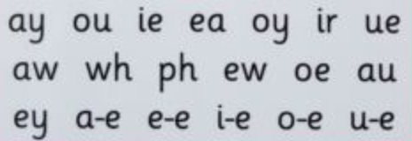  42 letter sounds and alternative spellings | - Phase 1 teaching in N  - Jolly Phonics scheme, discrete teaching daily  - Independent readers  - Home reading focus - seesaw  - Reading application at forest school  - Rainbow reading in Y1/ decodable book

Writing
Children will know . . . | Children will say . . . | How we will deliver this . . .
N  SUBSTANTIVE  - Know print gives meaning in a range of scenarios.  - Knows letters in their first name.  DISCIPLINARY  - Give meaning to a distinctive range of marks that they make.  - Copy the letters from their name.  R  SUBSTANTIVE  - GPCs in set 1-3 and some in set 3  - They can write their name, using letters which are mostly formed accurately.  - They can form the single letters and some digraphs they have been taught.  - Write CVC words, captions and simple sentences using the GPCs taught, which can be read by others.  DISCIPLINARY  - How to segment.  - How to write words and sentences.  Y1  SUBSTANTIVE  - They can write phonetically decodable, detailed sentences using the GPCS taught, including some alternative digraphs.  - They use finger spaces consistently.  - They begin to use full stops.  - They have an awareness of capital letters.  DISCIPLINARY  - Write for a range of purposes. | Words to represent the meaning of marks.  GPCS taught – step 2 secure, some of step 3  Sound-talk, segment  Word, sentence  Alternative, phoneme, full stop, letter, story, label, finger space, capital letter  Which grapheme? | - Jolly Phonic scheme; discrete teaching daily  - Forest School diary in Writing journal (R)  - English lessons (Y1)  - An adult allocated task in open door each week  - Writing resource area in all classrooms and outdoors

Mathematics
Number
Children will know . . . | Children will say . . . | How we will deliver this . . .
N  - To count out up to five objects from a larger set reliably.  - To recognise sets of 1, 2 and 3 objects.  - To compare two groups saying when one has more, fewer or the same.  - To say the number names 1-5 in order forwards and backwards.  - To know a number can represent a quantity and the number changes when an object is added or removed.  - To know that numbers have an order and the number that comes after and before 1-4.  R  - Build numbers to ten and beyond  - Count patterns beyond 10  - Adding more  - Taking away  - Doubling and sharing  Y1  - Place value within 100.  - Multiplication and division; counting in twos | 1, 2, 3, 5, 5, 5-1, how many, more, same, stop, count  1-20, teen numbers, add, take away, subtract, equals, double, share  0-100, equation, multiplied, divided | - Number songs and rhyme (1 x focus a week, at least)  - Discrete teaching in Numbers and Patterns (White Rose  - An adult allocated to outdoor maths each week.  - Number resource area in all classrooms and outdoors

Numerical patterns
Position, Shape and Pattern
Children will know . . . | Children will say . . . | How we will deliver this . . .
N  - To complete insert puzzles independently.  - To begin to attempt a framed or non-framed jigsaw puzzle.  - To know 3 basic 2D shape names and be able to match and sort 2D shapes.  R  - To select and rotate shapes to fill a given space, justifying why a shape would or wouldn’t fit.  - To match a given arrangement of shapes and objects.  - They understand that shapes can be combined and separated to make new shapes.  - Children should copy, continue and create a widening range of repeating patterns and symmetrical constructions.  - Children explore and investigate relationships between numbers and shapes.  Y1  - Describe turns  - Describe position – left and right  - Describe position forwards and backwards  - Above and below  - Ordinal numbers | Next to, turn, here, there, fits  Shape, turn it around, curved, straight, up, down, on top, side, corner, move  Full turn, half turn, quarter turn, left right, forwards, backwards, above, below, first, second, third, fourth, fifth, sixth, steps | - Discrete white Rose teaching  - Access to construction areas and puzzles/ jigsaws  - Open door – Mathematics enhancements  - Symmetry – butterflies  - Pattern – art MTP

Understanding the World
People and Communities
Enquiry Question – What are the similarities and differences between where we live and Africa? (In particular Ghana)
Children will know . . . | Children will say . . . | How we will deliver this . . .
N  SUBSTANTIVE  - To know the name of the school.  - Ghana and Africa are places far away from the UK.  - Africa is a hot place.  - Some animals that live in Africa.  DISCIPLINARY  - To identify some key features of a place.  - Begin to understand interconnectedness between places.  R  SUBSTANTIVE  - To know that they live in the UK  - To know school it is in Telford.  - Ghana is in Africa.  - To recognise the Ghanaian flag.  - 6 animals native to Africa.  - Africa is hotter than the UK.  - To know about similarities and differences in relation to places.  - To talk about the features of their own immediate environment and how environments may change from one another.  - To identify geographical and similarities through stories, experiences and videos.  DISCIPLINARY  - To understand interconnection between places  - To have an understanding of cultural diversity  - To enquire and be curious about places  Y1 Geography  SUBSTANTIVE  - To know the names and location of the four countries of the UK.  - To name the four capital cities in the UK and identify key characteristics of these capital cities.  - To know and name the location of the UK’s surrounding seas.  - To know the names and location of the world’s seven continents and five oceans.  - To name and locate the UK’s surrounding seas.  DISCIPLINARY  - To understand the similarities and differences through studying the human and physical geography of a small area of the UK and a contrasting non-European country.  - To further develop cultural awareness. | Sir Alexander Fleming Primary School, Africa, far away, hot, place, animals  UK, Telford, Ghana, in, flag, hotter, zebra, elephant, lion, rhino, hippo, giraffe  Country, continent, ocean, globe, Northern Ireland, Scotland, Wales, England | - Books; Handa’s Surprise, non-fiction, Emmanuel’s Dream, Ghanaian Goldilocks  - Small world animals and habitats  - Role-play; masks and African materials  - Videos/ photographs of a range of places in Africa  - Exploring African objects and artefacts  - Visit to the Safari Park (R)

The Natural World
Enquiry Question – What is alive?
How do plants grow?
Children will know . . . | Children will say . . . | How we will deliver this . . .
N  SUBSTANTIVE  - Notice what is happening to the weather in Spring/ Summer.  - To know that living things move.  - To name 6 farm animals and their features.  - To recognise and name a worm, spider and ant.  - To know that seeds can grow.  - To know some of the things a seed needs in order to grow; water.  - To know the names of 3 common household pets; cat, dog, rabbit.  DISCIPLINARY  - Compare plants and trees using everyday language.  - Observe changes over time.  - Compare and sort plants using simple characteristics; green leaves/ brown leaves etc.  - Ask questions about plants and trees.  - Predict what will happen to a seed.  R  SUBSTANTITIVE  - Describe the changes that are happening in Spring/ Summer.  - To make some simple comparisons between the four seasons.  - To begin to talk about the impact of spring/ summer on animals and plants.  - To know that seeds need water, light and soil in order to grow.  - To be able to name at least 6 African animals and describe their features.  - To recognise and name a woodlouse, caterpillar and butterfly.  - To know the simple sequence in a lifecycle of a butterfly.  - To know the names of 5 common household pets and recognise three ways in which they can be cared for.  DISCIPLINARY  - Compare plants and trees using everyday language.  - Observe changes over time, describing these.  - Sort plants using increasingly complex characteristics; long stalk, shorter stalk etc.  - Ask and begin to answer questions about plants and trees.  - Predict what will happen to a seed and evaluate if their prediction was accurate verbally.  Y1  SUBSTANTIVE  - Know that plants grow from seeds/bulbs.  - Know that plants need light and water to grow and survive.  - Know that plants are important.  - Know that we can eat lots of plants.  - Know the name of common wild and garden plants.  - Know the basic structure of common flowering plants and trees.  - Know that days are longer and warmer in the summer.  - Know that animals need a variety of food to help them grow, repair their bodies, be active and stay healthy.  - Know and name a variety of commons animals (including fish, amphibians, reptiles, birds and mammals).  - Know and name the structure of common animals.  - Know and name a variety of animals that are carnivore, herbivore and omnivore.  DISCIPLINARY  - Identify common plants and trees  - Compare plants and trees in greater detail, drawing of knowledge of features  - Observe, talk about and predict changes over time.  - Group/sort plants and trees by a greater range of features  - Draw and label plants and trees.  - Ask questions (that can be investigated or researched). | Hot, sun, rain, sky, grow, seed, water, mud, cow, pig, sheep, chicken, goat, horse, lamb, wool, horn, snout, worm, spider, ant, legs, wiggle, crawl, climb, summer, cat, dog, rabbit, seed, grow, tall, water, soil  Warm, cloud, spring, summer, autumn, winter, different, same, water, light, soil, zebra, elephant, lion, rhino, hippo, giraffe, stripes, hooves, trunk, mane, woodlouse, caterpillar, butterfly, spin, pet, hamster, bird different, same, light, change  tail, wing, claw, fin, scales, feathers, fur, beak, fish, amphibian, reptile, bird, mammal, herbivore, omnivore, carnivore  Names of wild plants, garden plants, flowering plants, trees, leaf, flower, blossom, petal, fruit, berry, root, blub, seed, trunk, branch, stem, bark, stalk, vegetable, deciduous, evergreen | - Visit to the Farm/ Safari Park  - Small world play – farm and Africa  - RSPCA visit  - Exotic Zoo visit  - Forest School Sessions.  - Non-fiction books – Seasons, Broad Bean, Earthworms  - Books - The Selfish Giant, Oscar Wilde  Adam and Eve  Noah’s Ark  Jack and the Beanstalk  The Hungry Caterpillar  Goodbye Mog  Handa’s Surprise  Framer Duck  Flip, flap farm  Jasper’s Beanstalk  Tree  Superworm  Rhymes; Mary, Mary quite Contrary  In and out of the merry bluebells.  - Magnifying glasses, keys, hunts  - Planting seeds; cress, broadbeans, sunflowers

Past and Present
Enquiry Question: Who is the King of England?
Children will know . . . | Children will say . . . | How we will deliver this . . .
N  SUBTANTIVE  - The name of the current King of England.  - To know that the King was a Prince in the past.  DISCIPLINARY  - Talk about events in their own experiences and that of others that are important to them.  - Recall facts about a figure.  R  SUBSTANTIVE  - The name of a significant historical figure and two key facts about their life.  - To begin to sequence three images of King Charles from a child, young man and now.  DISCIPLINARY  - Recognise the difference between past and present in their own and others’ lives.  - Describe an event or family member from their past that is important to remember.  - Use stories to encourage children to distinguish between fact and fiction.  Y1  SUBSTANTIVE  - Describe a significant person from the past.  - Describe changes in their own lives.  - Recognise a difference between past and present.  - Label timelines with past, present, older and newer.  - Ask questions about the past.  - Use words and phrases such as long time ago, recently, decades and centuries.  DISCIPLINARY  - Describe a significant person from the past.  - Recognise a difference between past and present.  - Look at evidence and find answers about the past. Use artefacts, pictures, stories, online sources and databases to find out about the past.  - Find answers to simple questions about the past. | Now, will, soon, King Charles, Prince, past  Next, grown-up, adult, change, bigger, taller, older, son, Queen, mother, Palace, Monarchy, Duke of Edinburgh, House of Windsor  Earlier, last year, in the past, present day, in the future, already happened, remember, similar, different, historian, local | - Books about King Charles  - Be proud like King Charles  - Knowing key facts about his family, place of residence by looking at videos, images and artefacts.

Expressive Arts and Design
Creating with Materials
Children will know . . . | Children will say . . . | How we will deliver this . . .
N PRINTING  SUBSTANTIVE  - To explore rubbings  - To print with a variety of objects – plus hands, feet and found materials  - To print with block colours  DISCIPLINARY  - Recognise that prints are made by transferring an image from one surface to another.  R PATTERN  SUBSTANTIVE  - To create repeating patterns  - To observe and create irregular painting patterns  - To explore simple symmetry  DISCIPLINARY  - Understand that patterns can be found in our natural environment.  - Understand that we can use patterns to create our own artwork.  Y1 PRINTING  SUBSTANTIVE  - Create patterns and pictures by printing from objects using more than one colour.  - Develop impressed images  - Relief printing – string, card  - Print with a growing range of objects  DISCIPLINARY  - Understand prints are made by transferring an image from one surface to another.  - Understand relief prints are made when we print from raised images (plates). | Print, pattern, repeat, rub, explore, press.  Repeat, same, paint, natural.  Print, pattern, relief printing, impress printing, roller, ink, polystyrene tile, scrape, layer. | - Ablade Glover; landscapes  - Rubbing natural materials  - Printing using green leaves and hammers  - Symmetry through butterflies  - Pattern of African animals  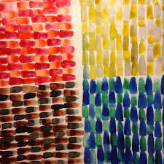  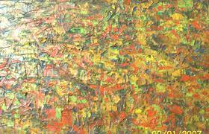  - Sonia Delaunay

DT
Children will know . . . | Children will say . . . | How we will deliver this . . .
N  SUBSTANTIVE  - I can use a spoon to mix and stir without making much mess.  DISCIPLINARY  - I can make choices when making and designing.  - Choose the resources they need for their chosen activities.  R  SUBSTANTIVE  - I can join a range of materials in a variety of ways, safely.  - I can use tools to squeeze and knead materials for a purpose.  - Begin to know the importance for good health of a healthy diet.  DISCIPLINARY  - I select a method based on the purpose/ properties of materials/ function.  - I can consider the user/ consumer when designing and making.  - Share creations explaining processes used.  Y1  SUBSTANTIVE  - Understand and use basic principles of a healthy and varied diet to prepare dishes, including how fruit and vegetables are part of The eat well plate.  DISCIPLINARY  - Draw on their own experience to help generate ideas.  - Suggest ideas and explain what they are going to do.  - Identify a target group for what they intend to design and make.  - Make their design using appropriate techniques.  - With help measure, mark out, cut and shape a range of materials | Spoon, stir, mix, bowl, steady, choose  Texture, tools, product, structure, design.  Design, product, model, equipment, evaluate, peel, cut, grate, mix, mould, mock –up, levers, sliders, cut, join, sew, ingredient. | - Design and make a seeded flapjack project.  - Design and make a birdfeeder project using Woodwork area.

Being Imaginative
Children will know . . . | Children will say . . . | How we will deliver this . . .
N  SUBSTANTIVE  - Sing songs and nursery rhymes they can remember.  - Act out significant events in a story/ rhyme they know.  DISCIPLINARY  - To dress up meaningfully.  - To act in the role of another character.  - Join in with adults and children singing songs and rhymes.  R  SUBSTANTIVE  - Sing many songs, nursery rhymes and poems they know with accuracy. (See Music Overview)  - To apply some of their knowledge from other experiences and use this is their role play, for example the names and features of African animals in small world play.  - To recognise old tunes in new songs.  DISCIPLINARY  - Create parts of their own narrative – innovating part of a story or song.  Y1  SUBSTANTIVE  - Sing a range of songs and nursery rhymes from memory, showing understanding through drama/ the way they act. (See music overview.)  DISCIPLINARY  - To say and write their own story. | Words from nursery rhymes/ songs/ stories they know. (See Reading/ Poetry Spine)  Show, song, nursery rhyme, clap  Words from nursery rhymes/ songs/ stories they know. (See Reading/ Poetry Spine)  Once upon a time, tickets, ladies and gentlemen  Words from nursery rhymes/ songs/ stories they know. (See Reading/ Poetry Spine)  Performance, audience, applause | - Theatre area outdoors; updated with growing nursery rhymes taught.  - Role play area – Garden Centre  - Helicopter stories (1 x a week)  - Forest school story telling  - Songs for routines  - Songs for concepts

SUMMER TERM Review/ Evaluation
How do we know that the curriculum is being implemented?
How do we know children are making progress?
Which areas need more focus? Do children need repetition?

