Assembly Offer at Sir Alexander Fleming Nursery and Primary School
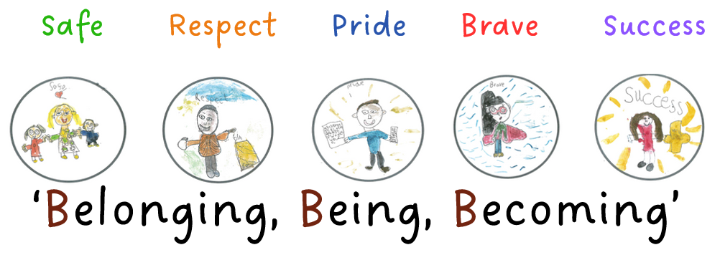
Our Assembly offer enables pupils to:
- become responsible, respectful and active citizens
- know the difference between right and wrong
- know the consequences of their behaviour and actions
- have the knowledge and respect for different faiths, feelings and values
- enhance pupils’ spiritual, moral, social and cultural development
- create an environment where children feel safe and where bullying, harassment, discrimination etc is not tolerated
- know how to keep themselves safe including online
- understand protected characteristics, promoting equality and diversity
- be prepared for their adult lives
- support children with how to engage in society
Where possible our assemblies will make reference to: school values, Fundamental British Values, SMSC, Protected Characteristics and our Behaviour Curriculum
Monday @ 8.45am | Tuesday @ 8.45am | Wednesday @ 8.45am | Thursday @ 8.45am | Friday @ 8.45am  Celebration  Values: Pride and Success
Themed Assembly | Personal Development  Assembly | Reading Assembly | Singing / Music appreciation | Celebration / Class Assembly
Assemblies
15 mins max

Assembly Rota Autumn 1 2024
Date | Music Genre | Monday @ 8.45am  Themed Assembly | Tuesday @ 8.45am  Personal Development | Wednesday @ 8.45am  Reading Assembly | Thursday @ 8.50am  Singing / Music appreciation | Friday @ 8.45am  Celebration  Values: Pride and Success
2.9.24 | Ska | PD DAY | PD DAY | International Literacy Day (08.09)  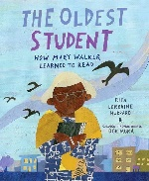  Years 4,5,6  KR | JR - Years 1,2,3 | Theme: Welcome back, Our School Values / Motto / behaviour and mentors – KT  Value of the Month: Respect  Behaviour curriculum focus: Uniform
9.9.24 | R ‘n’ B | Theme: Let’s Celebrate Books (Roald Dahl Day) – KR  PSHE – being me in the World - SV  Behaviour Focus: Moving around school | Head Boy / Girl speeches to the school  Children to vote on the way out….  Fundamental British Value: Democracy  KT | Great British Beach Clean (15.09-24.09)  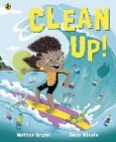  Years 1,2,3  KT | JR - Years 4,5,6 | RockKidz  Self-esteem
16.9.24 | Pop Music | Theme: How do we build character?  Head Boy/Girl presentation  House Captains  Vice Captains  KT  Behaviour Focus: Lining Up | Importance of Attendance  What do we do to support attendance? | National Coding Week  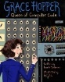  Years 4,5,6  JA | JR - Years 1,2,3 | Year 6 Assembly Focusing on Staying Safe Online  Parents invited
23.9.24 | Classical / Baroque | Theme: How is our school a safe place? – KT  Behaviour Focus: Playtime Behaviour  Telford and Wrekin  Music Assembly  @ 2.30pm | Theme:‘Safe’ / PANTS  SV and Safeguarding Board  Fundamental British Value: mutual respect and tolerance  Behaviour Focus: Respectful Manners | European Day of Languages (26.09)  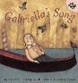  Years 1,2,3  EJ | JR - Years 4,5,6 | Year 5 Assembly Focusing on Staying Safe Online  Parents invited
30.9.24 | Boy Bands | Theme: Black History Month – TJ  Value of the Month: Brave  Fundamental British Value: mutual respect and tolerance  Behaviour Focus: ready to learn | What does GOOD learning look like?  How do you know you have done well?  Behaviour in school – Pride/Success  KT | World Space Week (04.10-10.10)  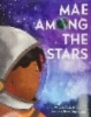  Years 4,5,6  EB and Science Technicians | JR - Years 1,2,3 | Year 4 Assembly Focusing on Staying Safe Online  Parents invited
7.10.24 | Legendary Women of Music | Theme: How is our school a safe place? – KT  Behaviour Focus: Playtime Behaviour | Behaviour in school at playtime and lunchtime – Brave  KT | World Mental Health Day (10.10)  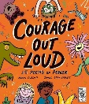  Years 1,2,3  LPi | JR - Years 4,5,6 | Year 3 Assembly Focusing on Staying Safe Online  Parents invited
14.10.24 | Brit-Pop | Theme: Recycling Week  JR  Behaviour Focus: Assembly | Behaviour in school – Bullying  What happens?  SV and school council | International Day for the Eradication of Poverty (17.10)  Years 4,5,6  KT | JR - Years 1,2,3 | Year 2 Assembly Focusing on Staying Safe Online  Parents invited
21.10.24 | Blues | Theme: International Artists Day (Oct 25th)  KC  Behaviour Focus: Dining Room | Year 6 Black History Month Assembly  Fundamental British Value: mutual respect and tolerance  Parents Invited | World Cities Day  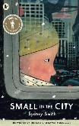  Years 1,2,3  HDS | JR - Years 4,5,6 | Year 1 Assembly Focusing on Staying Safe Online  Parents invited

Assembly Rota Autumn 2 2024
Date | Music Genre | Monday @ 8.45am  Themed Assembly | Tuesday @ 8.45am  Personal Development | Wednesday @ 8.45am  Reading Assembly | Thursday @ 8.50am  Singing / Music appreciation | Friday @ 8.45am  Celebration  Values: Pride and Success
4.11.24 | Punk / Pop Punk | PD DAY | Theme: PSHE link: Celebrating Difference – SV  Diwali – Festival of Lights LL  Fundamental British Value: mutual respect and tolerance  Behaviour Focus: Behaviour outside school | Remembrance Day (11.11)  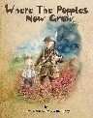  Years 4,5,6  KR | JR - Years 1,2,3 | Celebration Assembly & Autumn 1 attendance awards KT
11.11.24 | Rock n’ Roll | Year 3 Remembrance Assembly  Parents Invited | Bullying  SV and school council | Anti-Bullying Week  Years 1,2,3  SV | JR - Years 4,5,6 | Year 2 Anti-Bullying Assembly  Parents Invited
18.11.24 | Northern Soul | Theme: Anti-Bullying – SV & Safety Squad  Fundamental British Value: Rule of Law  Behaviour Focus: Presentation in books | Safeguarding Board  KT | World Children’s Day (20.11)  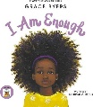  Years 4,5,6  JL | JR - Years 1,2,3 | Theme: Identifying talents and being special - EB  Celebration Awards  To include:  Values, FBV
25.11.24 | Dance Music | Theme: Inclusivity – LPigg  Fundamental British Value: mutual respect and tolerance  Behaviour Focus: Attendance and punctuality | Online Safety  -Digital Leaders  JA | International Day for the Abolition of Slavery (02.12)  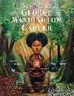  Years 1,2,3  ER | JR - Years 4,5,6 | Year 4 Harvest Assembly  Parents Invited
2.12.24 | Metal | Theme: What is Hannukah? – LL  Fundamental British Value: mutual respect and tolerance  Behaviour Focus: communal areas | Racism  KT and Safeguarding Board | International Day for Persons with Disabilities (03.12)  Years 4,5,6  LP | JR - Years 1,2,3 | Year 5 Christmas Assembly  Parents Invited
9.12.24 | Show Tunes | Christmas Performances | Christmas Performances | Pantomime in Hall  Snow White | JR - Years 4,5,6 | Christmas Performances
16.12.23 | Christmas songs | Christmas Performances | Christmas Performances | Christmas Performances | JR - Years 1,2,3 | House Singing Competition

Assembly Rota Spring 1 2025
Date | Music Genre | Monday @ 8.45am  Themed Assembly | Tuesday @ 8.45am  Personal Development | Wednesday @ 8.45am  Reading Assembly | Thursday @ 8.50am  Singing / Music appreciation | Friday @ 8.45am  Celebration  Values: Pride and Success
6.1.25 | Gospel | Theme: Dreams and Goals / New Year Resolutions / Value of month: Kindness  Subject: PSHE  Led by: SV  Behaviour Focus: Uniform | Emergency Services  KT | Dreams and Goals  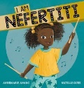  Years 1,2,3  KT | JR - Years 4,5,6 | Importance of Attendance &  Attendance Awards
13.1.25 | Rock | Theme: Why is the word God special to Christians?  Subject: RE  Led by: LL  FBV: Tolerance / Individual liberty / Mutual Respect  Behaviour Focus: Moving around school | Why do we need the Police?  KT | Martin Luther King Jr Day (15.01)  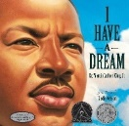  Years 4,5,6  TJ | JR - Years 1,2,3 | Year 1 Class Assembly
20.1.25 | Girl Power! | Theme: RSPB Big Garden Birdwatch  Subject: Science / Geog / OL  Led by: JR  Behaviour Focus: Lining Up | Who would we call? (scenario based)  KT | International Day of Education (24.01)  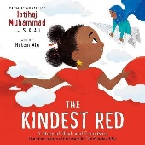  Years 1,2,3  LPg | JR - Years 4,5,6 | Year R  Assembly
27.1.25 | Disco | Theme: Hollocaust Memorial Day  Subject: History  Led by: TJ  FBV: Tolerance / Individual liberty / Mutual Respect /Rule of Law / Democracy  Behaviour Focus:  Respectful Manners | Stranger Danger  - getting lost  KT | LGBT+ History Month (01.02-29.02)  Years 4,5,6  KR | JR - Years 1,2,3 | Chinese New Year – LL  FBV: Tolerance / Individual liberty / Mutual Respect
3.2.25 | Rap / Hip Hop | Theme: Children’s mental health week ‘My voice matters’  Subject:PD  Led by: LP  Behaviour Focus:  Ready to learn | How can you stay mentally healthy?  KT | Rosa Parks Day (04.02)  Years 1,2,3  LPer | JR - Years 4,5,6 | Nursery Assembly
10.2.25 |  | Whole School Singing Assembly  JR | Theme: Digital Leaders – Internet Safety Day (11.2.25)  Subject:PD  Led by: JA and Dig Le | The Promise  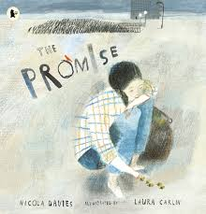  Years 4,5,6  KT | No singing assembly | Hive / Den Assembly

Assembly Rota Spring 2 2025
Date | Music Genre | Monday @ 8.45am  Personal Development | Tuesday @ 8.50am  Themed | Wednesday @ 2.45pm  Reading Assembly | Thursday @ 8.50am  Singing / Music appreciation | Friday @ 8.45am  Celebration  Values: Pride and Success
24.2.25 | Country Music | Theme: Healthy Me  Subject: PSHE  Led by: SV / LPe  Behaviour Focus: Playtime | Being safe  KT | Years 4,5,6  International Day of Women and Girls in Science (11.02) EB  FBV: Tolerance / Individual liberty / Mutual Respect /Rule of Law / Democracy | JR - Years 1,2,3 | Celebration Assembly
3.3.25 Ghanaian Independence Day  Thursday | K Pop | Theme: Women’s History Month  Subject: History  Led by: TJ  FBV: Tolerance / Individual liberty / Mutual Respect /Rule of Law / Democracy  Behaviour Focus: Assembly | Safety with household items  KT | Years 1,2,3  International Day of Women and Girls in Science  EB  FBV: Tolerance / Individual liberty / Mutual Respect /Rule of Law / Democracy | Theme: Ghanaian Independence Day & Value of the Month: Equality  Subject: History  Led by: HDS  FBV: Tolerance / Individual liberty / Mutual Respect /Rule of Law / Democracy  Behaviour Focus: Dining Room | World Book Day
10.3.25  British Science Week | EMO | Theme: British Science Week  ‘Change and Adapt’  Subject: Equality  Led by: RB / EJ | Medicine safety KT | Years 1,2,3 JL  Link to Science Week  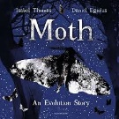  FBV: Tolerance / Individual liberty / Mutual Respect /Rule of Law / Democracy | JR – Years 4,5,6 | Theme: International Women’s Day  Subject: Equality  Led by: RB / EJ
17.3.25 | Legendary Bands | Theme: Digital Leaders  Subject: Computing  Led by: JA and Digital Leaders  Behaviour Focus:  Behaviour outside school | Cleanliness – washing hands  KT | Years 4,5,6 - LP  Neurodiversity Celebration Week  FBV: Tolerance / Individual liberty / Mutual Respect | JR - Years 1,2,3 | Year 1 Class Assembly
24.3.25 | Soul | Theme: World Water Day  Subject: Geog  Led by: EJ  Behaviour Focus:  Attendance and punctuality | Respecting toilets KT | Years 1,2,3 - LP  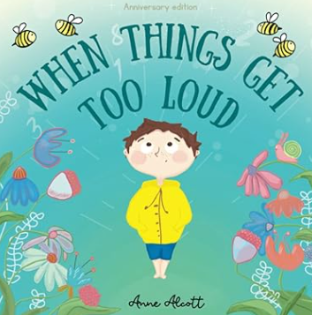  FBV: Tolerance / Individual liberty / Mutual Respect | JR - Years 4,5,6 | Year 4 Class  Assembly
31.3.25 | Opera | No assembly – Mothers’ Day celebration | Brushing teeth  KT | Years 4,5,6 -  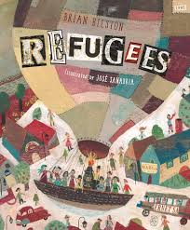 | JR - Years 1,2,3 | Year 2 Class Assembly
7.4.25 | Funk | Whole School Singing Assembly | Headlice and nits KT | Years 1,2,3 – | No singing assembly | Celebration & Attendance / Easter Bonnet parade and raffle
Assembly Rota Summer 1 2024
Date | Music Genre | Monday @ 8.45am  Personal Development | Tuesday @ 8.45am  Themed assembly | Wednesday @ 2.50pm  Reading Assembly | Thursday @ 8.45am  Singing / Music appreciation | Friday @ 8.45am  Celebration  Values: Pride and Success
28.4.25 | Power Ballads | Theme: Relationships  Value of the Month: Successful  Subject: PSHE  Led by: SV  Behaviour Focus: Uniform | Protect your skin - sun safety KT | Years 1,2,3 KC  World Art Day (15.04)  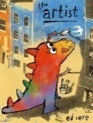 | JR - Years 4,5,6 | Celebration Assembly  Attendance  Awards for Spring Term  KT
5.5.25 | Reggae | Theme: Earth Day  Subject: Geography /OL / Science  Led by: JR, EJ  Behaviour Focus:  Moving around school | Stay hydrated  KT | Years 4,5,6 LL  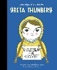  FBV: Tolerance / Individual liberty / Mutual Respect | JR - Years 1,2,3
12.5.25 | Electronic | No Assembly  SATS | No Assembly  SATS | No Assembly  SATS | No Assembly  SATS | No Assembly  SATS
19.5.25  BRITISH VALUES | Legendary Men of Music | Theme: British Values  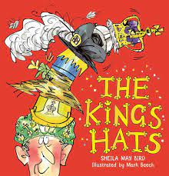  Subject: Values  Led by: KT  Behaviour Focus:  Respectful manners | World Bee Day  JR | Years 4,5,6 KT  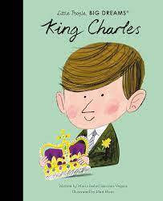  FBV: Tolerance / Individual liberty / Mutual Respect / Rule of Law / Democracy | JR - Years 1,2,3 | Year 5 Assembly  (British Values)
26.5.25  BRITISH VALUES | Ambient / Instrumental | Theme: British Values  Subject: Values  Led by: KT  Behaviour Focus:  Respectful manners | Car Safety - KT How to put a seatbelt on | Years 1,2,3 - EJ  FBV: Tolerance / Individual liberty / Mutual Respect | JR - Years 4,5,6 | Year 3 Assembly  Celebrating David Attenborough’s birthday  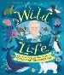  Value of the Month: Responsibility
13.5.24 | World Music | Theme: Secrets to Success  Subject: Values  Led by: KR | Being a global citizen KT | Years 4,5,6 SV  International Day of Families (15.5)  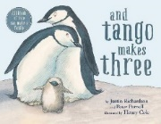 | JR - Years 1,2,3
20.5.25 | Techno | Theme: World Day of Cultural Diversity  Subject: Values  Led by: LP  Behaviour Focus:  Assembly | Dog Safety KT | Years 1,2,3  World Day for Cultural Diversity (21.05)  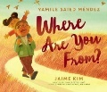 | JR - Years 4,5,6 | Celebration Assembly KT

Assembly Rota Summer 2 2025
Date | Music Genre | Monday @ 8.45am  Themed Assembly | Tuesday @ 8.45am  Personal Development | Wednesday @ 8.45am  Reading Assembly | Thursday @ 8.45am  Singing / Music appreciation | Friday @ 8.45am  Celebration  Values: Pride and Success
2.6.25 | World Music | Theme: Changing Me &  Value of the Month: Safe  Subject: PSHE  Led by: SV  Behaviour Focus: Dining Room |  | Years 1,2,3  Empathy Day (06.06) | JR - Years 4,5,6 | Celebration Assembly  KT
9.6.25 | Techno | Theme: Celebrating differences  Subject: Pride Month  Led by: KT  Behaviour Focus:  Behaviour outside school |  | Years 4,5,6  Gypsy, Roma and Traveller History Month (01.06-30.06)  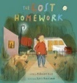  FBV: Tolerance / Individual liberty / Mutual Respect | JR - Years 1,2,3 | Year R Class Assembly
16.6.25 | Grunge | Theme: World Refugee Day  Subject: Diversity  Led by:  Behaviour Focus:  Presentation in books |  | Years 1,2,3  World Refugee Day  (20.6.24)  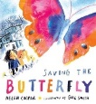  FBV: Tolerance / Individual liberty / Mutual Respect | JR - Years 4,5,6 | Theme: Windrush Day (22.06) HDS  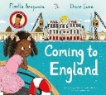
23.6.25  Early Bird Week | ‘One Hit’  Wonders | Theme: Being safe!  Bullying  Subject: Values  Led by: SV & School Council  Behaviour Focus:  Attendance and punctuality |  | Years 4,5,6  FBV: Tolerance / Individual liberty / Mutual Respect / Rule of Law / Democracy | JR - Years 1,2,3 | Nursery Class Assembly
30.6.25 | Grime | Theme: Being safe!  Scenarios  Subject: Values  Led by: SV & School Council  Behaviour Focus:  Communal Areas |  | Years 1,2,3  Founding of the NHS (05.07)  FBV: Tolerance / Individual liberty / Mutual Respect | JR - Years 4,5,6 | Digi Leaders and JA  Online Safety Assembly
7.7.25 | Psychedelic | Theme: Value of the Month: Embracing Change  Subject: Values  Led by: KR  Behaviour Focus:  Playtime Behaviour |  | Years 4,5,6  Malala Day (12.07)  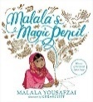 | JR - Years 1,2,3 | Celebration and Attendance Assemblies KT
14.7.25 |  | Theme: Olympic Games (26.07-11.08)  Subject: PE  Led by: EB,RB  Behaviour Focus:  Behaviour |  | Years 1,2,3  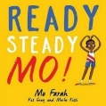 | JR - Years 4,5,6 | End of year leaving assembly – Year 6 team

