

**Sir Alexander Fleming Primary School and Nursery**

**Fire Safety Policy**

Reviewed September 2024

Next Review September 2025



**Aims**

It is the overall aim of Sir Alexander Fleming Primary School to minimise the risks to pupils staff and employees which may arise from fire. This will be achieved by working together to ensure precautions are taken to avoid fires occurring and by ensuring that procedures for minimising the effects of an outbreak of fire and evacuating the premises are in place.

**Overall Responsibility for Fire Safety Matters**

The Headteacher is appointed as the fire safety manager for the school and will have overall responsibility for fire safety matters at the school. She will co-ordinate the implementation of fire safety measures, ensure that staff and pupil training takes place and monitor the standard of fire precautions maintained. She will also ensure that a fire evacuation drill is undertaken early in each term, that fire action notices are kept up to date and that fire safety equipment is being maintained.

**The School Fire Procedure**

Notices displaying the school fire procedure will be displayed at each fire alarm call point and will be of the standard form.

**Responsibility of all School Staff**

All school staff are responsible for maintaining a high standard of fire precautions in areas under their control or influence. In particular, staff should ensure that they are fully aware of the fire procedure. They should ensure that door vision panels and fire exits are kept clear and fire doors are kept shut. They should also ensure that pupils for whom they are responsible are informed of the fire procedure.

**Fire Risk Assessment**

The school will carry out a fire risk assessment for each of its floors. The fire risk assessments identify who will be at risk if there is a fire, where people may be working and who else may be at risk, either in the premises or nearby, such as members of the public, visiting contractors, etc., and where these people are likely to be located.

The fire risk assessment will be reviewed and amended on a one year cycle to see if it is either no longer valid or if any changes are planned, such as:

* any structural changes (alterations to the layout of the premises, erection of partitions,
* refurbishment etc.) which may affect the spread of fire;
* any change to the use of the premises which may affect the risk rating;
* any change to work processes or work equipment which may introduce new fire hazards; any change to the numbers of people using the premises to ensure that escape routes
* can accommodate the numbers safely.

**Fire Training and Evacuation Drills**

Training will be provided every two years for all permanent full time school staff in fire safety and the school fire procedure, including training in the practical use of fire extinguishers. Specific training will be organised for fire safety managers, both on appointment and at least every two years with an external Fire Safety training provider e.g. Telford and Wrekin who have passed Safety 1 Fire Protection Training, this includes two members of HNS SLT. All staff, whether temporary or permanent, will have the fire procedure explained to them, together with information on the location of the fire alarm call points, the sound of the fire alarm and the location of the escape routes, exits and assembly points. It is the responsibility of the fire safety manager to ensure this instruction is given in accordance with the Checklist in appendix B.

The fire safety manager will also ensure that all fire safety records are maintained and are available for inspection by any enforcement authority. The fire safety manager will provide a written report to the Governing Body on a termly basis.

**Fire and lockdown drills** take place every term. Details are recorded and notes made of any problems which needing remedying.

* **In the case of a fire**, the first requirement is for staff to ensure the safe evacuation of all persons from the building to the safe places indicated on the fire procedures notices. Building should NOT then be re-entered until it has been confirmed that it is safe to do so.
* The Fire Brigade will be summoned by the Senior Administrator or in their absence by Assistant Administrator
* All attendance registers will be properly marked for the morning and afternoon sessions.
* A roll call will be taken when all have reached the place of safety**.**
* All visitors/contractors report their presence on site to reception and sign the ‘Visitors’ book and ensure they are familiar with the fire precautions**.** Reception staff must remind visitors to read the emergency arrangements.
* In the event that anyone by reason of any sort of disability or special need on the premises would be unable to evacuate the building without assistance a Personal Emergency Evacuation Plan will be drawn up, agreed with them if possible and implemented.
* Staff or others taking after school clubs must ensure they are familiar with the fire  
  precautions.
* The school premises are organised in such a way as to ensure that adults and children can circulate in a safe manner.
* All access routes will be maintained in a safe condition and be free from obstructions. So far as reasonably practicable any hole, slope, uneven or slippery surface which is likely to cause a person to slip, trip or fall preventing them getting out of the building safety will be repaired.
* Drills to practice evacuation of the playground and field will take place every term.

**Personalised Emergency Evacuation Plans (PEEPs)**

In the case of any person using the site having a condition that may prevent them from evacuating quickly and safely, the school will devise a PEEP for that person.

**Maintenance of Fire Doors, Fire Exit Doors, Fire Equipment and Systems**

Fire extinguishers, fire alarm systems and emergency lighting are maintained under a central contract administered by professional consultants. However, SAF will carry out the following tests on the systems and precautions between maintenance visits:

|  |  |  |
| --- | --- | --- |
| System | Frequency | Method of test |
| Fire Alarm | Weekly | Test key operation of different call point each week in rotation |
| Fire Alarm | Daily | Visual check of panel for fault indications |
| Emergency Lighting | Monthly | Operation of test switch or circuit breaker and check that light illuminates |
| Fire extinguishers, hose reels, fire blankets etc | Weekly | Check that seals are intact, equipment has not been removed or tampered with and annual inspection and maintenance is in date. |
| Fire doors | Weekly | Check that doors are closing fully and where fitted, latches are operating |
| Corridors, escape routes and Fire Exit Doors | Daily | Check exit doors are unlocked and that escape routes are free of obstruction |
| Fire Exit Doors | Weekly | Check that doors are opening freely and that emergency exit fittings are operating correctly. |

**Appointment and Duties of Fire Marshals**

The school will appoint a number of teaching or administrative staff as fire marshals one of which will be appointed as senior fire marshal. These staff will have responsibility for ensuring that all areas of the school have been evacuated and that this is reported to the senior fire marshal in charge of the evacuation (see appendix a). Marshalls will use the ‘Sweep Plan’ (appendix F). to ensure that all areas of the school are checked. Sweep Plans will be attached to the wall at the start of the zone. This map will allow the Marshalls to see where they are going, which rooms they have to check. If a room is not clear or the fire is in that room/ area then this will give the Marshall the precise knowledge to pass on the Fire Safety Manager who can then relay this to the Fire Rescue Services.

**Raising the alarm**

In the event of alarm failure a hand bell will be rung in order to raise the alarm. A handbell will be kept in the main office.

**Calling the Fire Brigade**

It is the school policy that the fire brigade will be called on any confirmed outbreak of fire. The school’s Office Manager is responsible for calling the fire brigade when the alarm is sounded.

Where the alarm is raised by the school’s automatic smoke detection the school office/ secretary will call the fire brigade if a fire is confirmed, or within 60 seconds of the alarm being raised if a false alarm is not confirmed.

**Meeting the Fire Brigade**

The fire safety manager is responsible for ensuring that one member of staff is available to meet the fire brigade on arrival and in their absence there is a member of staff to deputise for them.

**Events Taking Place Out of School Hours Such as School Plays or External Lettings**

Where events are organised outside normal school hours, or by outside organisations, it is the responsibility of the member of staff organising the event or arranging the letting to ensure that the Fire Safety Manager is consulted and appropriate precautions including arrangements for evacuation and calling the fire brigade are put in place. The fire safety manager may impose specific restrictions on the type of letting or activity the number of persons involved and the number and layout of any seating. It is particularly important to consider whether a public entertainment licence will be needed for the events being organised. Where a licence is required, the licensing officer may specify particular requirements as a condition of the licence and these conditions will have to be met (appendix C).

**Notices**

All fire exit routes will be signed by clear signs with directional arrows.

**Records**

The following records will be kept by the SAF School Business Manager, with the exception of the Practice Fire Evacuation Drill which will be kept by the Headteacher.

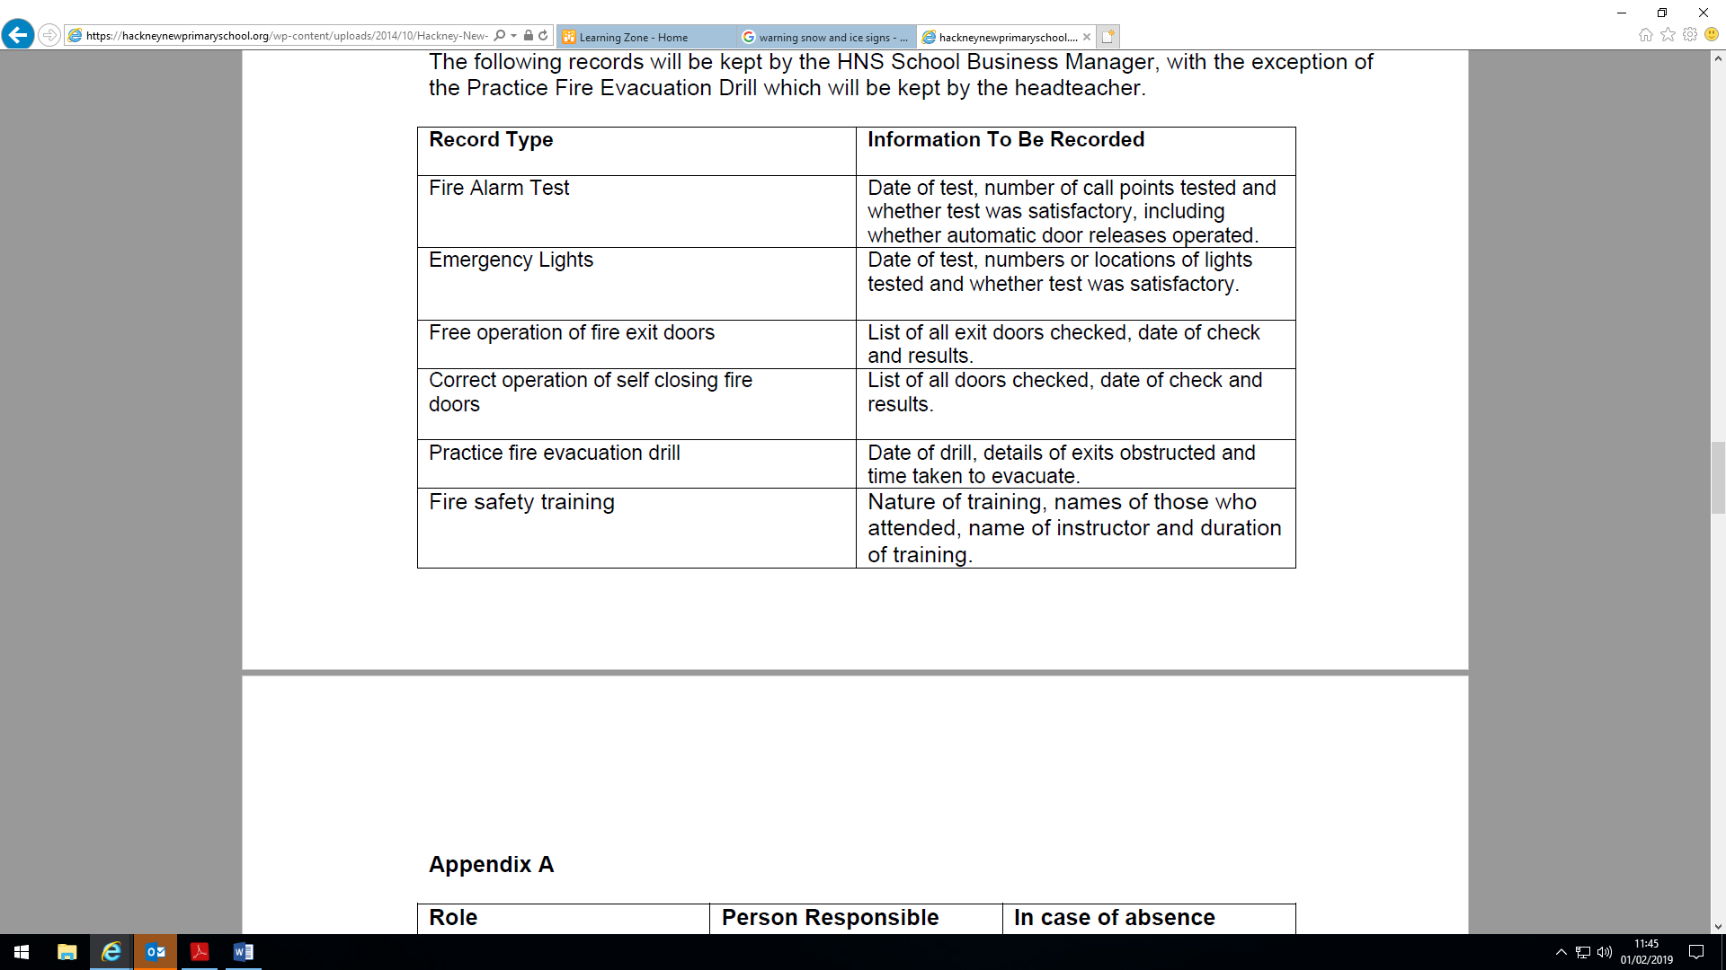

**Appendix A**

|  |  |  |
| --- | --- | --- |
| **Role** | **Person Responsible** | **In case of absence** |
| Fire Safety Manager | Ross Broderick | Katy Tomlinson |
| Fire Marshalls | Office Manager – Lorraine Pilgrim  Main corridor and central toilets – Katy Tomlinson  KS1 Corridor – Liz Hullin  EY toilets and Nursery – Liz Hullin  KS2 Corridor – Ross Broderick  Nursery – Katie Reese | Lisa Pigg  Katy Tomlinson  Lisa Pigg  Hannah Dornan  Tom Johnson  Hannah Dornan |
| Calling the fire brigade | School Business Manager – Lorraine Pilgrim | Karen Davies |
| Meeting the fire brigade | School Business Manager | Karen Davies |

**Appendix B**

**Checklist for First Day Fire Safety Instruction**

Take the new starter through the fire safety procedure as displayed at the fire alarm call points, in particular:

• Show them the location of the fire alarm call point and describe the way it operates.

Emphasise that the first action on discovering a fire is to raise the alarm *even if the fire is small*.

• Describe the sound of the fire alarm and the action to be taken in when it sounds, in particular leaving the building with any pupils for which the staff member is responsible and going to the assembly point.

• Describe and walk the escape routes and alternative escape routes that the member of staff is likely to need to use and show the operation of any push bars or exit fittings.

• Show the new member of staff the location of the fire extinguishers, but emphasise they should only be used if the staff member has been previously trained, if it is safe to do so and the alarm has been raised first and after an evacuation has been started.

**Appendix C**

**Checklist for persons hiring the school premises**

Take the new *hirer* through the fire safety procedure as displayed at the fire alarm call points, in particular:

• Show them the location of the fire alarm call point and describe the way it operates.

Emphasise that the first action on discovering a fire is to raise the alarm *even if the fire is small*.

• Describe the sound of the fire alarm and the action to be taken in when it sounds, in particular leaving the building with any *persons for whom* the *hirer* is responsible and going to the assembly point.

• Describe and walk the escape routes and alternative escape routes that *the hirer* is likely to need to use and show the operation of any push bars or exit fittings.

• Show the new *hirer* the location of the fire extinguishers, but emphasise they should only be used if *he/she* has been previously trained, if it is safe to do so and the alarm has been raised first and after an evacuation has been started.

Explain how to contact the fire brigade that an automatic call is not made and where the nearest telephone point can be found. Give clear instructions of location of school.

**Appendix D** – Fire drill procedure

1. In the event of a fire it is the duty of all concerned to prevent injury or loss of life.

2. For this purpose, you should make certain that you are familiar with all the means of escape in case of fire.

3. If you discover a fire of one is reported to you, you should **SOUND THE ALARM i**mmediately after the alarm has sounded you should;

1. Escort the pupils in your charge from the building by means of the nearest exit ensuring all doors passed through are closed after you and that the pupils exit in a silent and orderly manner.
2. In the event of a fire happening at playtime, staff on duty will usher all children to the bottom playground.
3. Staff not working with the children at the time of the alarm should report to the assembly point for further instructions.
4. On arrival at the assembly point, staff must register their class and report the result to the senior member of staff on duty, then await further instructions.

**Assembly point (see diagram) Reception Classes and all staff:**

Bottom playground on your given number

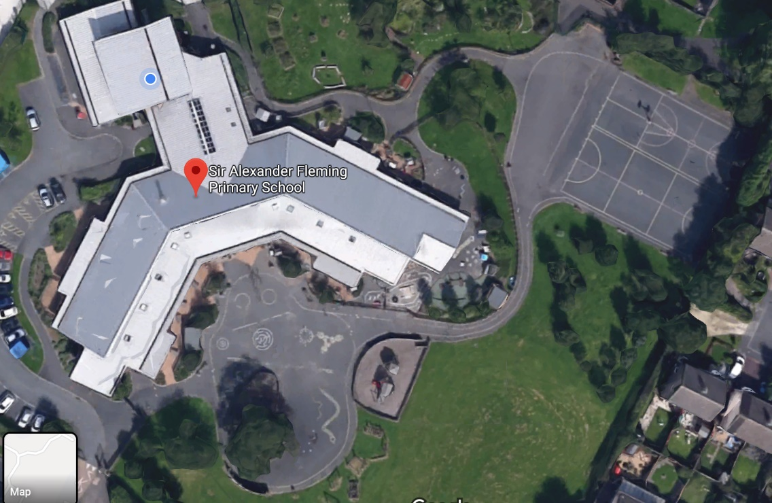

**Fire assembly point**

**Appendix E**

**Staff Induction Confirmation**

I know the location of the fire alarm call point and the way it operates.

I know that my first action on discovering a fire is to raise the alarm *even if the fire is small*.

I have been told the fire alarm is a repeated lesson change bell. When it sounds, I know what action to take, in particular leaving the building with any pupils for which I am responsible and going to the assembly point.

I know and have walked the escape routes and alternative escape routes that the

member of staff is likely to need to use and show the operation of any push bars or exit fittings.

I have been shown the location of the fire extinguishers. I know I should only use them if I have been previously trained, if it is safe to do so and the alarm has been raised first and after an evacuation has been started.

I have been shown Sir Alexander Fleming Primary School’s Fire Safety Policy.

I have received a FIRE INDUCTION and agree to follow Sir Alexander Fleming Primary School’s Fire Safety Policy.

**Appendix F**

