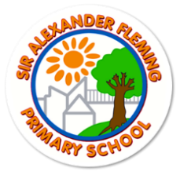

Sir Alexander Fleming Primary School and Nursery

Governor’s Annual Report to Parents and Carers

September 2024

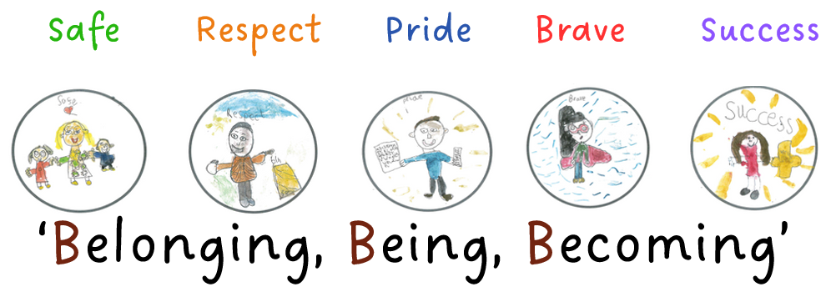

“Support for pupils’ personal development and welfare is a strength of the school. Leaders’ vision for every pupil to have the very best care shines through.” OFSTED, March 2019

The Governing Body at Sir Alexander Fleming Primary School and Nursery continue to have an effective team with a variety of skills and experience which support our school community. Our Governing Body has grown, widening the skills and experience available to the school, and ensuring an in-depth understanding of the school’s work and performance. Our Governing Body hold a wide range of responsibilities for the benefit of our children, parents/carers, staff and the wider community.

Our Governors are robust and rigorous in their role as a ‘critical friend’ and regularly visit the school and nursery to talk with children and teachers, as well as look at the learning environments, lessons, books and data. For example, in July 2024, Governors carried out a learning walk and focused on the behaviour and attitudes demonstrated throughout the school; during this they met with pupils and spoke to them about their learning and observed them in a variety of lessons.

Our governor’s recorded:

**‘the students were ready to learn, they were sitting calmly and the environments that were around them were calm and orderly, which meant there was a sense of being ready to listen and learn’**

**Beckie Dotson**

**‘Children were all engaged and ready to learn in the classes, behaviour and attitudes to learning was exceptional.  The pupils were highly respectful of the teachers, hands were up with no shouting out.’**

**Caroline Riley**

Our March 2019 Ofsted inspection recognised the ‘good’ provision in our school and the outstanding provision within our nursery and Early Years. Governors feel that this judgement is very well deserved and acknowledges the hard work and commitment of pupils, teachers, staff and parents/carers in helping the school to achieve this. We are confident that the school continues to operate at this high level as Governors frequently monitor standards, curriculum, behaviour and well-being. Several independent educational consultants have also verified our findings and we believe that this continues to be the case.

Curriculum progression routes are well defined for all subjects. Staff have been fully involved in the planning process and this has ensured that they have good subject knowledge for the lessons they teach, and they are also aware how the learning fits with prior and future learning. A particularly strong feature of the curriculum offer is the logical sequencing of lessons and the development of vocabulary throughout each subject.

On our school website there is a ‘Governance’ section. If you wish to contact our Governors, please inform the school office on 01952 327820 we are currently in need of a parent governor.

**What were our successes last year?**

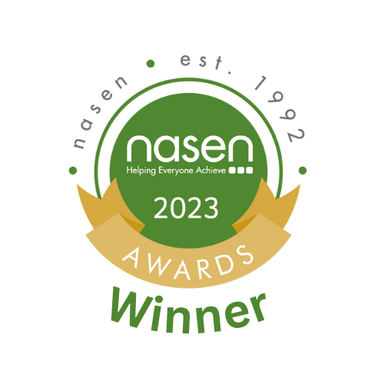**NASEN Primary SEN Provision of the Year**

In October, we were presented with the NASEN SEN Primary provision of the Year Award which recognised our hard-work and dedication to making our school a caring, nurturing and inclusive place to learn.

When we are constantly asked “How do schools provide for children beyond the curriculum to support them socially, emotionally and mentally?” We do this very well and it is a tale of five rooms…

Patch

Our nurture provision is themed around a farm worker who lives and nurtures vegetables and baby animals. In Patch, we offer areas such as role play, reading corners, and sensory areas with the aim to help pupils develop their resilience and independence while building a sense of achievement and growing relationships and friendships within the school community. Children get involved in outdoor learning sessions and PE sessions with their class too. What’s more, Patch is not just here to serve our children. We recently supported two children with complex needs while the local authority found specialist provision places. We always change and adapt to the needs of our children. There is not one year when Patch looks the same as the last.

The Den

In the Den, we offer a safe, calm and nurturing space to give our children the coping strategies to move onto the next step, whatever that may be. The Den caters for children in key stage 2 and is run by a nurture lead and assistant. Each child has four sessions a week in The Den. The children that come in the morning will carry on with their curriculum-based work, but in a smaller and quieter environment with the sessions supporting those who may be falling behind in their work as well as those who may need stretching academically too. The children in the morning are offered a social breakfast, where they work together to make their own breakfast, supporting independence while learning about kitchen safety and hygiene. Those that come to The Den in the afternoon, who would have already completed their core subject work in the morning, take part in curriculum-based activities. For example, this term we are learning about Victorian times and so the children have designed their own gown for Queen Victoria, baked Victoria sponge cakes, and used charcoal to draw a traction engine. Children also get to pick a game for us all to play. This encourages the child to decide independently. I love it when we play set games. I think they are extremely bene­ficial as it teaches children about winning and losing and how we should cope in each scenario.

The Hive

The Hive is our SEND classroom base for children who are working significantly below their peers. Children who work in here will either have an Education, Health, and Care Plan (EHCP) or high needs funding from the local authority. We have a full-time quali­fied and experienced teacher and a teaching assistant who is experienced in working with children with speech and language dif­ficulties, advanced drawing, and who is ELSA-trained (emotional literacy support assistant). The room can go up to 10 children and we work on building their independence and con­fidence of having a go at work that is suitably adapted to their academic ability. In the morning Hive sessions, we teach English, maths, reading and phonics along with any recommendations from the child’s learning support advisory teacher reports, such as non-verbal reasoning skills, and targets on their EHCPs. The children return to their classrooms in the afternoons where they take part in adapted foundation subjects. In the afternoons, the Hive turns into a targeted intervention room for groups that are finding areas of the curriculum challenging but can still access their own year group’s work in the mornings. Here we provide pre-teaching or post-teaching to secure understanding. Some may say that having a class of 10 children would be amazing. It is certainly challenging, rewarding and exhausting all at the same time and most days feels like a class of 30.

TLC

Our TLC room is somewhere our children love visiting, even if they have never had a session there. It is run by our inclusion support assistant who has a first-class degree in psychology and is currently training as a psychotherapist – we are very lucky to have her. She runs different sessions such as Lego therapy, sand therapy and interventions that teach skills for anger management, communication of emotions, and other interventions that are aimed primarily at improving the inclusion of children with challenging behaviour or personal concerns. Here we can support children who have difficulties in forming relationships and children with autism by teaching friendship skills and running activities that are designed to help them understand and manage anxiety. We always use a relatable story that explains anxiety in an age-appropriate manner, allowing children to grasp how it impacts their lives and offering practical tools and strategies to empower children in handling anxiety effectively, promoting relaxation, positive thinking, and problem-solving skills. This is not an exhaustive list either. Our weekly inclusion meetings with the attendance and senior leadership teams may also highlight something that we could offer that is better suited to the needs of the child to support them in our school to have a successful and happy journey. And if children aren’t quite ready to take part in these interventions, if they are too dysregulated, they can use our calm room space that also turns into a soft playroom should we need it. And I can’t forget two members of staff that our children absolutely adore – Bella and her little sister Honey, our dogs!

Rainbow Room

You may think our rainbow room is just that, a brightly coloured room, but it is so much more. The room itself provides a space for children to reflect, read a book, have an informal chat with a member of staff, or offers somewhere to retreat to should a busy, stimulating classroom become too much. Outside of the four walls, it is a walking bus/minibus service helping children to get to school together with a team of staff supporting children and their families with securing school places and signposting to external agencies that offer housing and food crisis support.

**Swimming Pool**

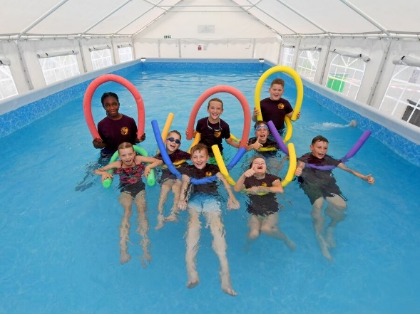Our decision to hire a swimming pool on the playground for Autumn term 1 was a huge success. After reviewing our current swimming offer for our KS2 children and with the increasing costs of hiring coaches, travelling time and teaching swimming ourselves we decided that we were not giving our children the best opportunity to develop their swimming skills. 90% of our children do not attend private swimming lessons so it was our responsibility to at least ensure water safety and water confidence.

We used the Sports PE Funding as we offering a wider swimming offer than we would normally and all children in Years 3 to 6 were having weekly 45 minute swimming lessons with a qualified swimming instructor.

Initially, our children were frightened and some did not want to attend but we supported, encouraged and nurtured them and every child developed their water confidence and understanding of water safety.

Our Year 6 data increased to 30% of children swimming competently, confidently and proficiently over a distance of at least 25 metres and 56% being able to perform self-rescue.

**Shropshire Cricket School of the Year**

We are overjoyed to announce we were the winners of the **‘Primary School of the Year’** award. Awarded by Shropshire Cricket.

Ryan Lockley (Chance to shine cricket coach and member of Shropshire Cricket) said:

“We have delivered two Chance to Shine Whole School Programmes through Youth Strategy initiative, across the entire Sir Alex Fleming Primary School from Reception (age 4/5) through to Year 6 (age 11) with around 28 children in each lesson with all year groups having two classes.

The staff at the school have embraced their cricket sessions, they attended our Telford & Wrekin Teacher CPD event, they entered teams into our Indoor and Outdoor competitions, it was rewarding to see the teachers engaging and leading their respective teams in the inter school environment.

It feels like a real partnership has been built with this school, this community and now the club who are seeing children move into the club environment having had the support of the school, with the community hub giving them the confidence to make that transition. They are a small number at the moment but it is beginning to evolve.

It is key to our success that we have an engaging workforce at the school for us to succeed and with Sir Alex Fleming we certainly feel that. We look forward to continuing to work with this school, teachers, pupils, and community.”

 

**Computing Quality Mark**

We were the first school in Telford and Wrekin to achieve the Computing Quality Mark from the National Centre for Computing Education, recognising the outstanding provision across our school.

A huge well done to Mr Andrew and Mrs Lane for their dedication to gaining this award and to all the teaching team for their amazing provision.

Our children love computing lessons and their knowledge and skills has developed well – it is our future!

We have plans for 2024 to share our computing curriculum with other schools.

**How did the governors help us to achieve this?**

There is a clear vision statement which children, parents/carers, school staff and Governors contributed to, against which all targets and actions are assessed. Throughout the year, the Governors have visited the school to see this vision in practice and have fed back on their observations. The children’s safety, welfare and learning are at the forefront of all our decision making.

Our 2024-2025 Vision Statement and Action Plan can be found on the school’s website. The Governing Body monitored school improvement through regular visits into school with meetings with school leaders, effective training, scrutiny of documentation, rigorous appraisal systems, observations, and interviews with staff and children.

The Governors have worked in 4 main ways to achieve these successes.

* Setting the vision for the school and strategic direction of the school.

This year, Governors have again established clear action plans, targets and staff management procedures so that staff aim high for children to achieve their very best. The Governors have worked with the staff to develop the School Development, which they review each half term. Governors used a range of data and feedback from monitoring to identify the school’s strengths and areas for development. Governors, throughout the year, have attended training courses to improve their skills in order to support the development of the school and ensure that we fulfil our role effectively e.g. Safer Recruitment and Raising Awareness.

* Holding the Head Teacher to account

School leadership has continued to be strong. Governors are fully aware of what the school does well. They engage with senior leaders in setting the vision for the school and subsequent priorities to work on. Throughout the year, Governors requested data regarding attainment and progress at committee meetings and Full Governing Body meetings and questioned the impact of decisions taken. During the year, we have regularly monitored the teaching and learning in school through lesson observations, pupil book scrutiny and consultations with pupils about their learning. The Head Teacher has written termly reports to the Governing Body, which identified attainment and achievement of pupils, quality of teaching, attendance reports and the curriculum offer. We ensure that we can see this in practise.

* Ensuring financial resources are well spent

The Finance Committee meet every half-term where we monitored the school budget and ensured that spending was in line with the ‘best value’ ethos. The Committee identified areas for spending linked to the priorities on the School Development Plan and any other ‘emergency’ spending. The Committee meets regularly with our Local Authority Finance Officer and closed the budget for 2023-2024 and set the budget for 2024-2025 in line with our identified priorities.

The Schools’ Financial Value Standard (SFVS) ensures that our budget is spent wisely and properly, allowing school to optimise resources, and so raise standards and attainment of all our pupils for 2023-2024.

Governors have been trained to ensure that the Pupil Premium Funding has been directed to the targeted children and we have developed and evaluated an action plan for 2023-2024 and identified priorities for 2024-2025 (see school website). We have a dedicated Governor for PPG and she has completed learning walks to identify the impact of the PPG spending.

In addition, Governors have monitored the additional sports funding and met with the PE team to discuss priorities.

Audited School Funds have been presented at the Full Governing Body meeting on an annual basis.

* Ensuring statutory duties are met and priorities approved

The Chair of Governors has met on a regular basis with the Head Teacher and the School Business Manager to ensure all statutory policies, procedures and information are up-to-date and published on the school website. We have carried out a website audit to ensure it is all compliant. Governors met at committee meetings to ensure statutory policies and procedures were fully in place.

Governors continue to give regard to the statutory guidance on ‘Keeping Children Safe in Education 2023’. All Governors have received Prevent training linked to Tackling Extremism and Radicalisation. Throughout the year, the school regularly held fire practices and health and safety audits which Governors from the Health and Safety Committee attended.

Some of the policies agreed in the last academic year:

Special Educational Needs and Disability Policy

Health & Safety Policy

Relationships and Sex Education Policy

Absence Management Policy

Safeguarding/Child Protection Policy

Capability Policy

Code of Conduct Policy

Attendance Policy

Pay Policy

Complaints Policy

**On-going and Future Areas of Involvement**

Governors will be continuing to listen to the views of parents/carers and children through the delivery and analysis of the parent and pupil surveys. Governors are integral in the school’s monitoring and evaluation cycle and will continue to offer challenge and support in their role as a ‘critical friend’. We are fully aware of the development points listed in our School Development and Raising Attainment Plan (September 2024) and in the 2019 Ofsted report. We will be continuing to monitor progress in achieving success in all areas to maintain our ‘good’ judgement and provision.

We have a strong culture of reflection and self-evaluation. We value the views of parents/carers, children and all other stakeholders. The Governing Body, Head Teacher, Senior Management Team and indeed all members of staff fully understand the need not to be complacent and strive for further success for the school and nursery.