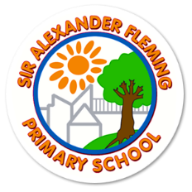

Sir Alexander Fleming Primary School and Nursery

Reviewed: September 2024

**Privacy Notice for Pupils**

This privacy notice tells you what to expect when we collect personal information about our pupils. The information we collect about our pupils include:

• personal information (such as name, unique pupil number and address)

• characteristics (such as ethnicity, language, nationality, country of birth and free school meal eligibility)

• attendance (such as sessions attended, number of absences and absence reasons)

• assessment information, including examination results

• relevant medical information, including allergies and medication

• special educational needs information

• exclusions and behavioural information

We need to collect this information so we can:

• support pupil learning

• monitor and report on pupil progress

• provide appropriate pastoral care

• assess the quality of our services

• comply with laws regarding data sharing

• communicate with our pupils and parents/carers

• provide catering and payment services

• provide library, ICT and information services

• process admissions

• maintain pupil records

• support behaviour management

• safeguard and promote the welfare of students

• assist in the prevention or detecting of crimes

• respond to complaints, grievances and discipline investigations

Whilst the majority of pupil information you provide to us is mandatory, some of it is provided to us on a voluntary basis. In order to comply with the General Data Protection Regulation, we will inform you whether you are required to provide certain pupil information to us or if you have a choice in this.

Record retention

We have a record retention schedule which sets out how long we keep pupil information for:

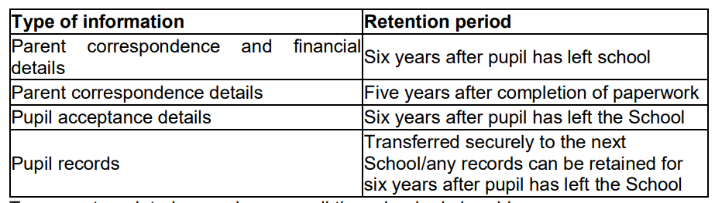

To request a printed copy please email the school admin address.

Our legal basis for processing personal information We will only process your information where we have a lawful reason to do so. In most cases, this will be where it is necessary for us to perform a task in the public interest or exercise our official duties. There may be other times when we need to collect, share or use ‘special’ data (eg health or photographs) about you, in which case we may do so where we are performing our official duties and:

• we have your explicit consent; or

• it is necessary for social protection purposes (eg safeguarding of individuals at risk; protection from unlawful acts; prevention against fraud); or

• we need to comply with a legal obligation under an Act of law (eg The Education Act 1996; Children Act 2004)

Who we share personal information with

We do not share our pupil information with anyone unless we have consent or the law or our policies allow us to do so. We regularly share our information with the following, so we can carry out our official duties as a school:

• the Department for Education (DfE)

• our local authority

• school nursing team

• schools that the pupil attends after leaving us

• examination Boards and moderators

• national Health Service (NHS)

• catering and trip payment service providers

• student and parent communication service providers

• student learning service providers

• parent support services

• IT service providers to enable pupil access to learning services

We are required to share information about our pupils with our local authority (LA) and the Department for Education (DfE) under section 3 of The Education (Information About Individual Pupils) (England) Regulations 2013. To find out more about the data collection and sharing requirements placed on us by the DfE (eg in relation to the school census) go to https://www.gov.uk/education/datacollection-and-censuses-for-schools

The National Pupil Database (NPD)

The NPD is owned and managed by the Department for Education and contains information about pupils in schools in England. It provides invaluable evidence on educational performance to inform independent research, as well as studies commissioned by the Department. It is held in electronic format for statistical purposes. This information is securely collected from a range of sources including schools, local authorities and awarding bodies.

We are required by law, to provide information about our pupils to the DfE as part of statutory data collections such as the school census and early years’ census. Some of this information is then stored in the NPD. The law that allows this is the Education (Information About Individual Pupils) (England) Regulations 2013. To find out more about the NPD, go to https://www.gov.uk/government/publications/national-pupil-database-user-guide-andsupporting-information The department may share information about our pupils from the NPD with third parties who promote the education or well-being of children in England by:

• conducting research or analysis

• producing statistics

• providing information, advice or guidance

The Department has robust processes in place to ensure the confidentiality of our data is maintained and there are stringent controls in place regarding access and use of the data. Decisions on whether DfE releases data to third parties are subject to a strict approval process and based on a detailed assessment of:

• who is requesting the data

• the purpose for which it is required

• the level and sensitivity of data requested: and

• the arrangements in place to store and handle the data

To be granted access to pupil information, organisations must comply with strict terms and conditions covering the confidentiality and handling of the data, security arrangements and retention and use of the data.

For more information about the department’s data sharing process, please visit: https://www.gov.uk/guidance/data-protection-how-we-collect-and-share-research

For information about which organisations the department has provided pupil information, (and for which project), please visit the following website: https://www.gov.uk/government/publications/dfe-external-data-shares

To contact DfE visit: <https://www.gov.uk/contact-dfe>

Privacy Notice – Additional information for children in need and looked-after children

In addition to the details set out in this privacy notice, this section explains how we use information relating to children in need and looked-after children. The categories of children in need and looked-after children information that we collect, hold and share include:

• information relating to episodes of being a child in need (such as referral information, assessment information, Section 47 information, Initial Child Protection information and Child Protection Plan information)

• episodes of being looked after (such as important dates, information on placements)

• outcomes for looked after children (such as whether health and dental assessments are up to date, strengths and difficulties questionnaire scores and offending)

• adoptions (such as dates of key court orders and decisions)

• care leavers (such as their activity and what type of accommodation they have) Why we collect and use this information

• to support these children and monitor their progress

• to provide them with pastoral care

• to assess the quality of our services

• to evaluate and improve our policies on children’s social care

The lawful basis on which we use this information

We will process this information where one or more of the following applies:

• processing is necessary for the performance of a task carried out in the public interest or in the exercise of official authority vested in the controller (ie the school)

• consent has been obtained from the data subject

• processing is necessary for compliance with a legal obligation

• processing is necessary in order to protect the vital interests of the data subject or of another person collecting this information

• Whilst the majority of the information you provide to us is mandatory, some of it is provided to us on a voluntary basis.

In order to comply with the data protection legislation, we will inform you whether you are required to provide certain information to us or if you have a choice in this.

Storing this information

We hold pupil information in line with our record retention schedule.

Who we share this information with:

• Department for Education (DfE)

• Local Authority

• NHS Why we share this information

• We share children in need and looked-after children’s data with the Department for Education on a statutory basis, under Section 83 of 1989 Children’s Act, Section 7 of the Young People’s Act 2008 and also under section 3 of The Education (Information About Individual Pupils) (England) Regulations 2013.

• This data sharing helps to develop national policies, manage local authority performance, administer and allocate funding and identify and encourage good practice.

• We do not share information about our children in need or children looked after with anyone without consent unless the law and our policies allow us to do so.

• Data collection requirements

To find out more about the data collection requirements placed on us by the DfE go to: Children looked after: https://www.gov.uk/guidance/children-looked-after-return - Children in need: <https://www.gov.uk/guidance/children-in-need-census>

Requesting access to your personal data

Under data protection legislation, parents and pupils have the right to request access to information about them that we hold. To make a request for your personal information, or be given access to your child’s educational record, please write to us. Please note, keeping your information secure is our top priority, therefore you may be asked to provide identification of yourself before we can release any records to you. You also have the right to:

• object to processing of personal data that is likely to cause, or is causing, damage or distress

• prevent processing for the purpose of direct marketing

• object to decisions being taken by automated means

• in certain circumstances, have inaccurate personal data rectified, blocked, erased or destroyed; and

• claim compensation for damages caused by a breach of the General Data Protection Regulations

Contact Us

If you would like to discuss anything in this privacy notice, or if you have concerns about the way we are collecting or using your personal data please contact our Data Protection Officer, K Tomlinson at Sir Alexander Fleming Primary School. Alternatively, you can contact the Information Commissioner’s Office at https://ico.org.uk/concern