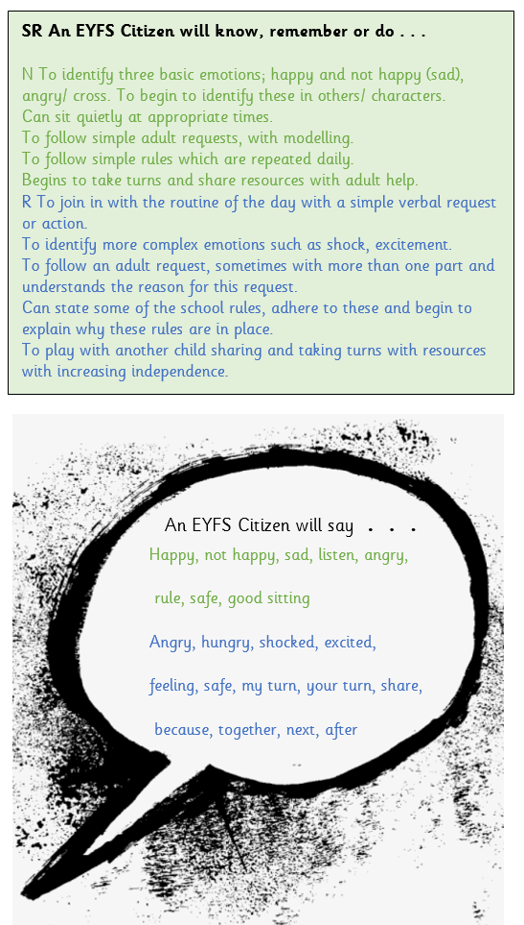Definition (EEF):

“Self-regulation involves a complex range of skills and abilities that enable children to monitor their emotions and thoughts and choose how to adapt their behaviour in different circumstances. It also includes working towards a goal, which may be self-chosen or guided by a suggestion or request from an adult.”

**How do we develop children’s self-regulation in the EYFS?**

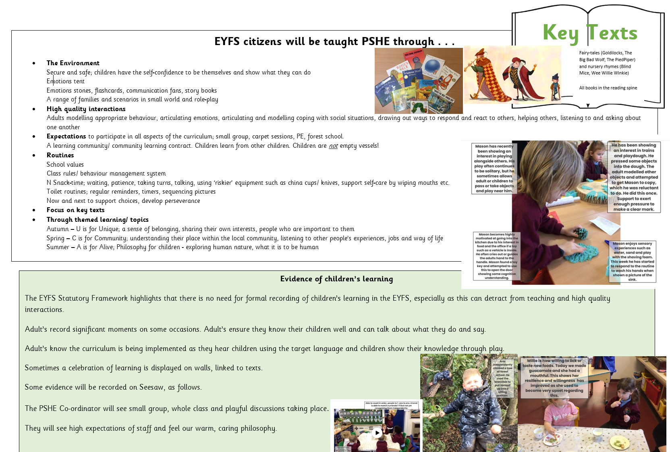This is a part of EVERYTHING we do and forms part of our PSED and behaviour curriculum:

Definition (EEF)

“Executive function can help children resist their impulses and control how they direct their attention. Executive function also helps children to hold information in mind so they can apply it, such as remembering the rules of a game while they play.”

**How do we develop children’s executive function skills in the EYFS?**

* Ensuring children are challenged. That children have time to practise their skills in different contexts.
* Risky play and how adults respond to this; “I wonder if that plank is steady?”
* Caring, empathetic interactions;

Modelling showing and coping with emotions, sharing strategies for this.

Modelling losing in a board game.

Making connections and developing retrieval skills through questioning.

Co-regulation

* Encouraging talk in order to plan/ make choices about their play; Making a choice using a widget board or when junk modelling – “Which materials will you use?”
* Adults encouraging reflection when problems arise in order to develop children to monitor what they are doing.
* Time to reflect; Plan, do, review and planned opportunities to share children’s learning.
* Collaborative play planned for; group work, sharing resources, turn taking, Adventure Time
* Physical Activity; nursery rhyme time, Squiggle While You Wiggle, PE – to be able to remember what they are doing and regulate their behaviour while having fun.