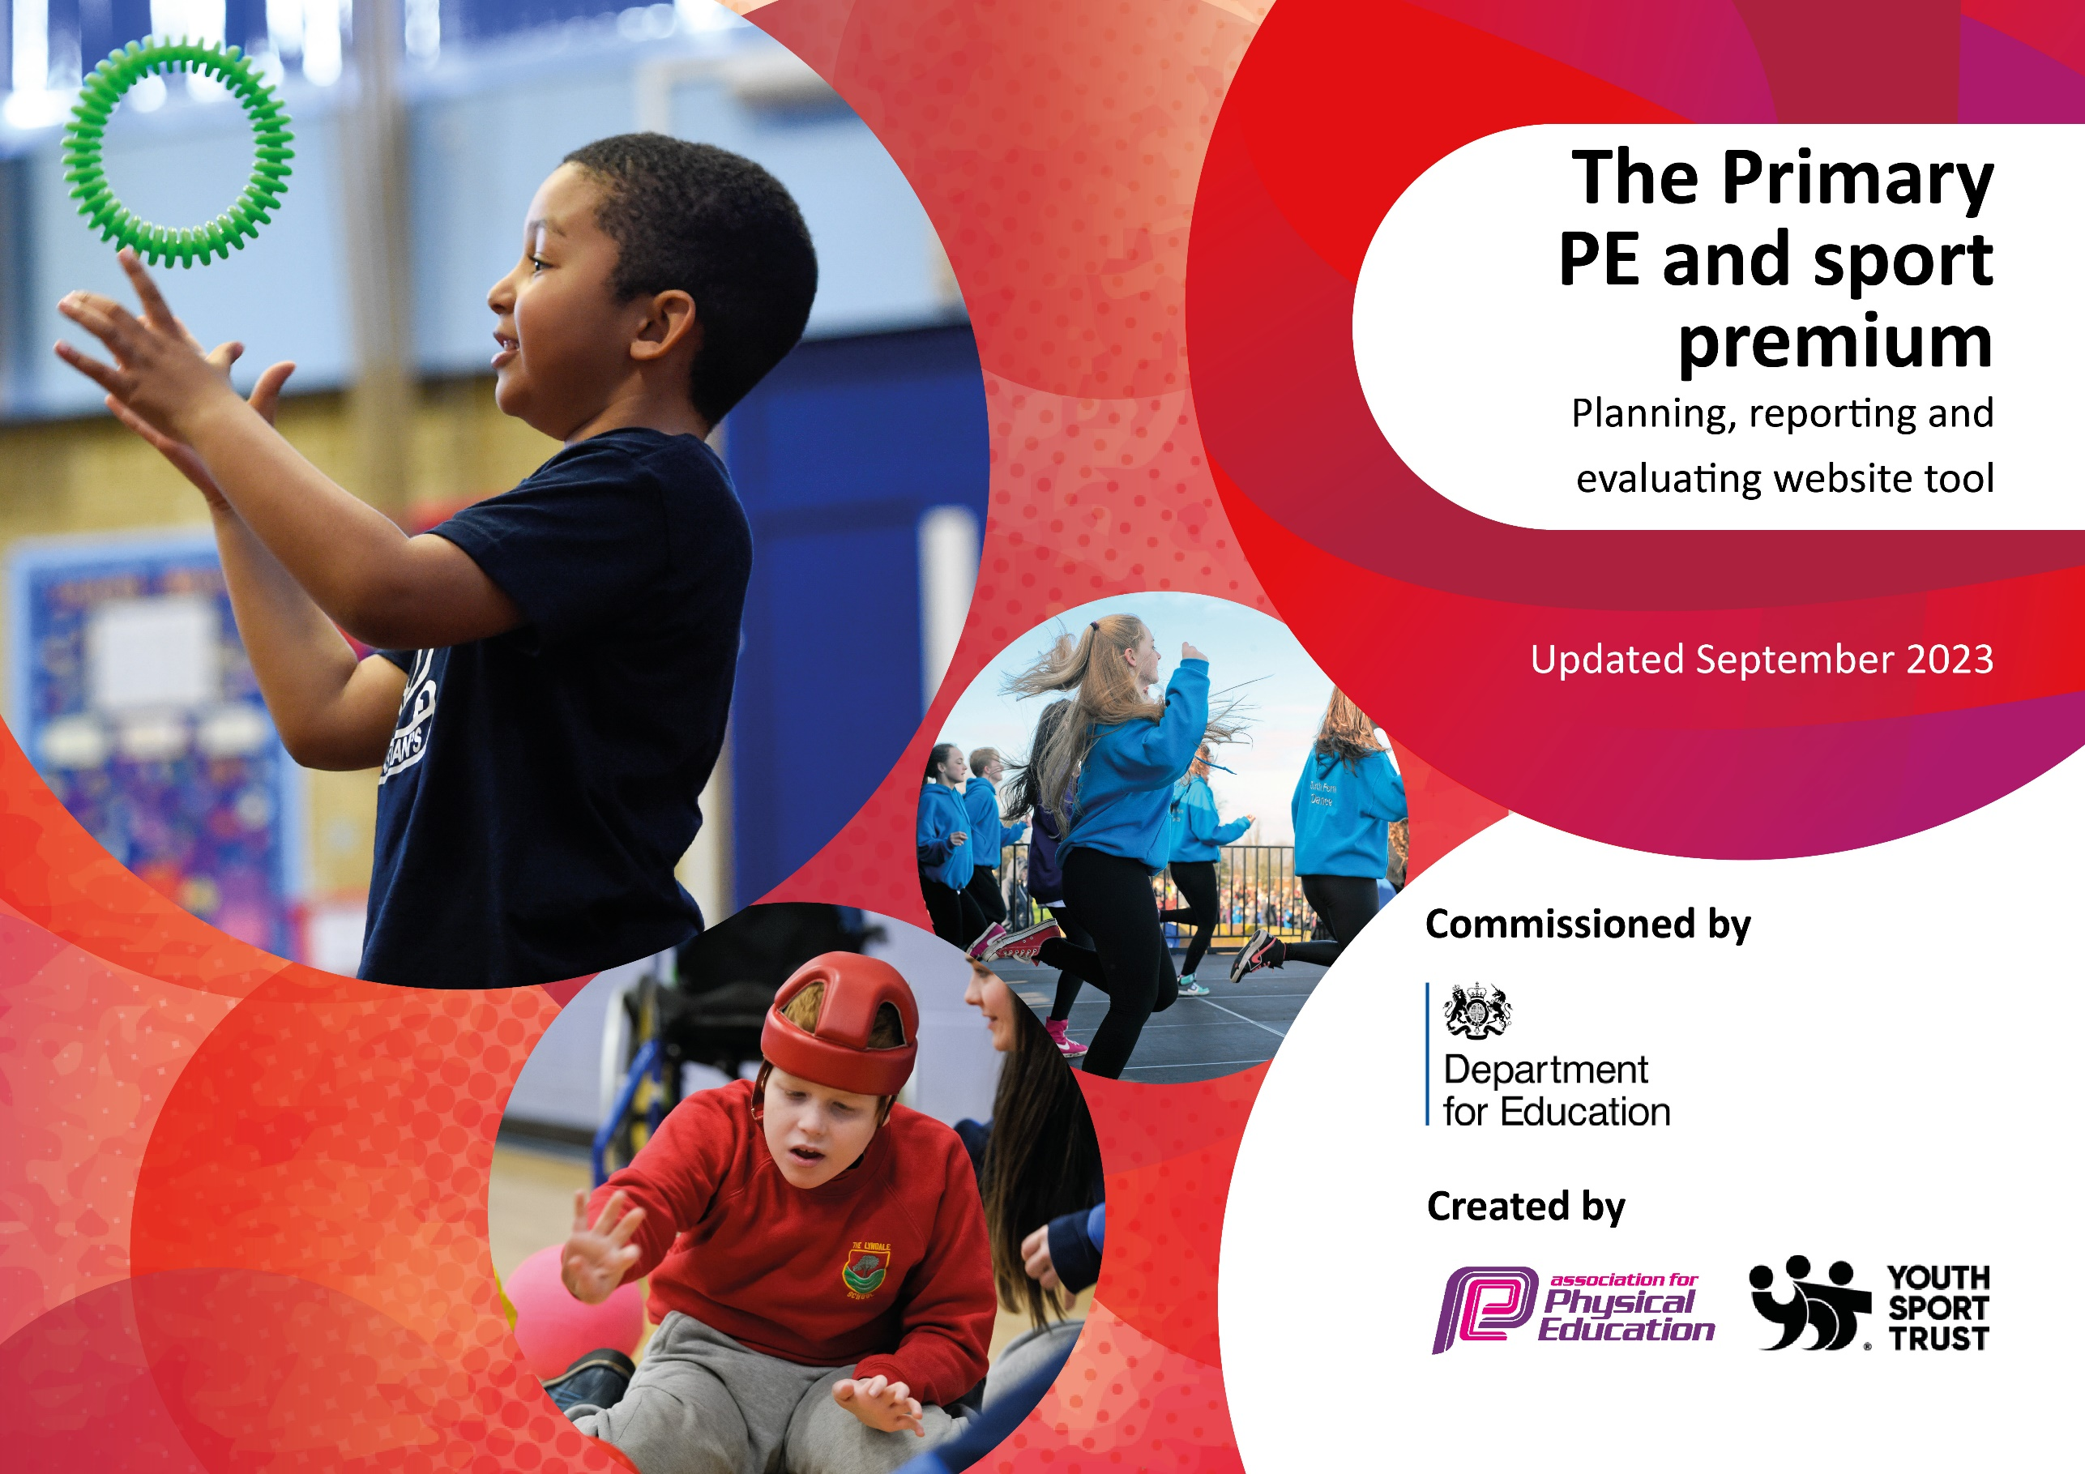

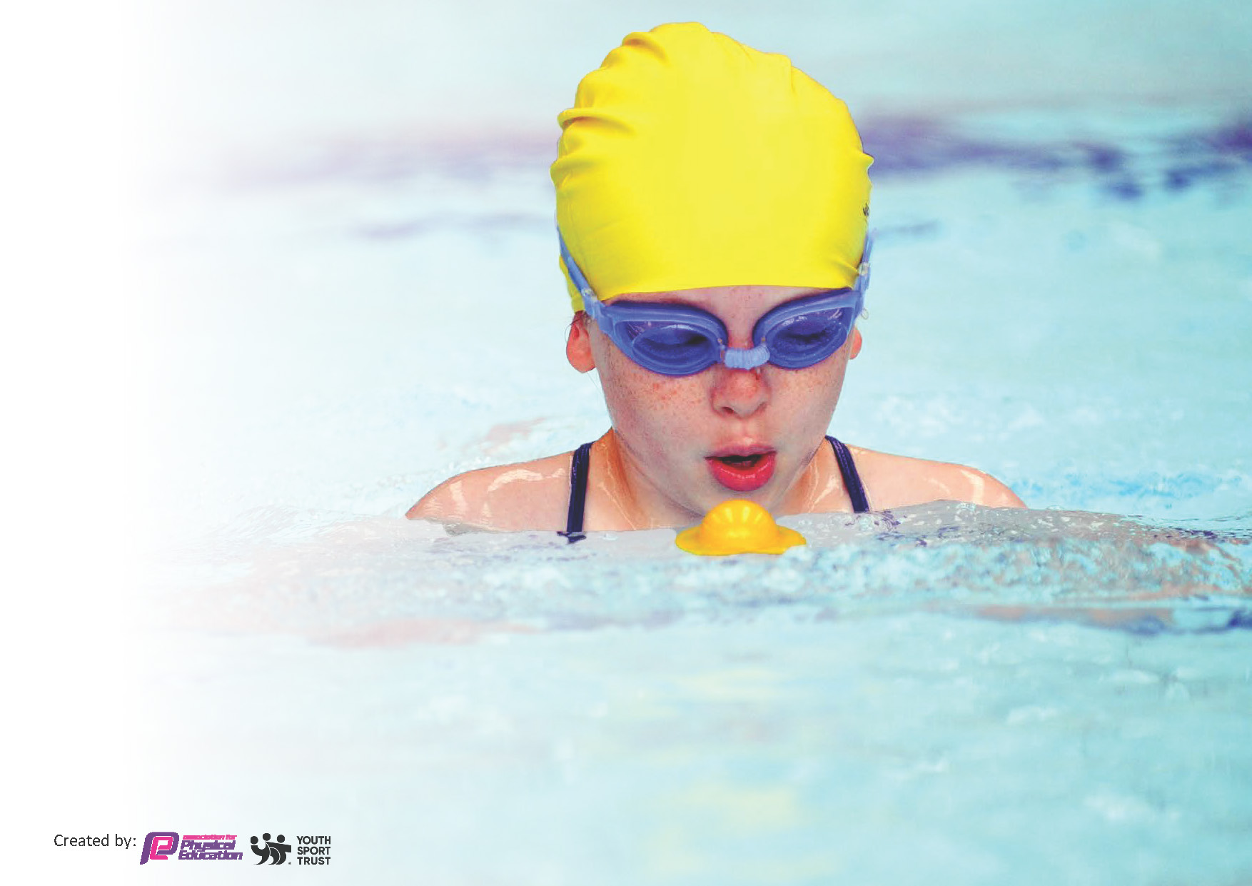
This template can be used for multiple purposes:
by:
- It enables schools to effectively plan their use of the Primary PE and sport premium
- It helps schools to meet the requirements (as set out in guidance) to publish information on their Primary PE and sport premium
- It will be an effective document to support Ofsted inspections enabling schools to evidence progress in Physical Education (PE) and evidence swimming attainment, which forms part of the PE National Curriculum. We would recommend schools consider
the Intent, Implementation and Impact of any spend, as examined within the Education Inspection Framework.

It is important that your grant is used effectively and based on school need.

Schools must use the funding to make additional and sustainable
improvements to the quality of the PE, School Sport and Physical Activity (PESSPA)
they offer. This means that you should use the Primary PE and sport premium to:

- Build capacity and capability within the school to ensure that improvements made now will benefit pupils joining the school in future years
- Develop or add to the PESSPA activities that your school already offers.

The Primary PE and sport premium should not be used to fund capital spend projects; the school’s core budget should fund these. Further detail on capital expenditure can be found in the updated Primary PE and sport premium guidance.

The Primary PE and sport premium guidance, outlines 5 key priorities that funding should be used towards. It is not

necessary that spending has to meet all the key priorities, you should select the priorities that you aim to use any funding towards.

Although completing this template is not a requirement for schools, schools are required to publish details of how they spend this funding. Schools must also outline what the impact this funding has had on pupils’ PE and sport participation and attainment and how any spending will be sustainable in the future. All funding must be spent by 31st July 2024.

The Department for Education has worked closely with the Association for Physical Education (afPE) and the Youth Sport Trust (YST) to develop this template and encourages schools to use it. This template is an effective way of meeting the reporting requirements of the Primary PE and sport premium.
Review of last year’s spend and key achievements (2023/2024) £19,200

We recommend you start by reflecting on the impact of current provision and reviewing your previous spend.

Activity/Action | Impact | Comments
- Swimming pool (pop up pool) with qualified swimming instructor for 6 weeks.  - PE coach employed full time from Marches academy to deliver lessons, attend competitions and after school clubs  - Coaches, trips, visits and minibus cost to attend competitions and sporting events e.g Shrewsbury tennis tournament, Jess Clarke visit  - Bought in to new PE scheme (GEtSEt4PE)  - New sports leader equipment | Smaller groups of children in the pool  All of KS2 accessed 2 X 45 minute swimming lessons a week.  Better quality of swimming lessons  Convenience without time and cost of travel  More children accessed a wider range of after school clubs  Pe curriculum delivered by a specialist PE coach to ensure high quality delivery and consistency  SEND children attended inclusive competitions.  PPG children targeted for additional competitions.  More children attending competitive and inclusive sports.  Progressive  Sequential  Supportive planning  Active lunch times  Wide range of activities on offer | Swimming numbers increase  Swimming and water confidence increased  Water safety.  2 hours of high quality PE for all of Ks1 and KS2  Not used as PPA cover  More competitions attended than ever before.  Wider range of children attending.  PPg and SEND focused

Key priorities and Planning
This planning template will allow schools to accurately plan their spending.

Action – what are you planning to do | Who does this action impact? | Key indicator to meet | Impacts and how sustainability will be achieved? | Cost linked to the action
Further develop lunch time sport sessions/activities for pupils. | Lunchtime supervisors / teaching staff, coaches - as they need to lead the activity  pupils – as they will take part. | Key indicator 2 -The engagement of all pupils in regular physical activity – the Chief Medical Officer guidelines recommend that all children and young people aged 5 to 18 engage in at least 60 minutes of physical activity per day, of which 30 minutes should be in school.  Key indicator 4: Broader experience of a range of sports and activities offered to all pupils. | More pupils meeting their daily physical activity goal, more pupils encouraged to take part in PE and Sport Activities. | £500 costs for additional equipment to support lunchtime sessions.

CPD for teachers.  Ensure high quality swimming lessons with a qualified swimming teacher on offer to all of KS2. (pop up pool)  Purchase a PE scheme to ensure Pe is sequential, progressive and teachers have increased confidence to deliver.  High quality PE coach from Marches academy to deliver after school clubs to children and take children to competitions.  New PE equipment based on safety audits.  Transport, trips and visits costs  Buy new PE kits, sports coats and trainers to ensure all pupils can always access Pe lessons and are provided with appropriate kit to do so.  Summer term  Additional (top up) swimming sessions | Primary generalist teachers.  All KS2 pupils  Pe coaches (CPD)  Teachers  Pupils  Pe coaches  Pupils  Teachers (CPD)  Pupils  Pupils  Pupils  Pupils | Key Indicator 1: Increased confidence, knowledge, and skills of all staff in teaching PE and sport.  Key indicator 5: Increased participation in competitive sport.  Key Indicator 1: Increased confidence, knowledge, and skills of all staff in teaching PE and sport.  Ke indicator 4: Broader experience of a range of sports and activities offered to all pupils.  Key indicator 1: Increased confidence, knowledge and skills of all staff in teaching PE and sport  Key indicator 2: The engagement of all pupils in regular physical activity  Key indicator 3: The profile of PE and sport is raised across the school as a tool for whole-school improvement  Key indicator 5: Increased participation in competitive sport  Key indicator 2  Key indicator 2: The engagement of all pupils in regular physical activity  Key indicator 3: The profile of PE and sport is raised across the school as a tool for whole-school improvement  Key indicator 4: Broader experience of a range of sports and activities offered to all pupils  Key indicator 2  Key indicator 3  Key indicator 4  Key indicator 5  Key indicator 2  Swimming.  Key indicator 2 and 4 | Primary teachers more confident to deliver effective PE supporting pupils to undertake extra activities inside and outside of school, including teaching water safety and swimming and as a result improved % of pupil’s attainment in PE.  Increase water confidence. Increased knowledge of water safety. Develop a love for swimming. Increased opportunity to embed learning and practice. Small 1:10 groups with coach and swim instructor ensures high quality teaching. Lifelong skills built on  Progressive and sequential curriculum  Staff feel confident and supported to deliver PE in absence of PE coach.  Quality of curriculum on offer has improved.  After school clubs on offer. Wide range of activities. Offered and funded for PPG children and SEND. First priority for clubs.  Develop a love for sport and PE  Safe and new equipment  Ensure all children can access a wide range of sports. All activities can be offered.  Raise profile of Pe  Children to have transport costs covered allowing PPG and SEND children to attend competitions and ensure they have an active lifestyle and love for PE.  Trips to stadiums and competitions for 2 year groups to showcase competitive opportunities in sport.  Visitors of prosessionla athletes to inspire and motivate children e.g Jess Clarke  Equal opportunities  Nobody misses Pe  PPG families and children receive extra support  Inclusive school and environment for Pe  Kept in school for sustainability  Ensure more children can leave able to perform a range of strokes, swim 25m and self rescue | £1000 for 3 teachers to undertake CPD.  (EB, RB, DG)  £6,000 for aqualympic pop up pool and swimming instructor for 6 weeks.  £600  £6,000  £1100  £1500  £500  £2000

Key achievements 2024-2025
This template will be completed at the end of the academic year and will showcase the key achievements schools have made with their Primary PE and sport premium spending.

Activity/Action | Impact | Comments

Swimming Data
Meeting National Curriculum requirements for swimming and water safety.
Priority should always be given to ensuring that pupils can perform safe self-rescue even if they do not fully meet the first two requirements of the National Curriculum programme of study

Question | Stats: | Further context  Relative to local challenges
What percentage of your current Year 6 cohort can swim competently, confidently and proficiently over a distance of at least 25 metres? | Autumn term: 19% | High PPG  Very few children have any additional/prior access to swimming  Parents do not have transport or money for swimming lessons.  Large proportion of our children are still scared of the water when reaching KS2.  Local pool is full and can not get space.
What percentage of your current Year 6 cohort can use a range of strokes effectively [for example, front crawl, backstroke, and breaststroke]? | Autumn term: 48% | Current data after autumn term swim  Additional top up sessions

What percentage of your current Year 6 cohort are able to perform safe self-rescue in different water-based situations? | 59% | Use this text box to give further context behind the percentage.
If your schools swimming data is below national expectation, you can choose to use the Primary PE and sport premium to provide additional top-up sessions for those pupils that did not meet National Curriculum  requirements after the completion of core lessons. Have you done this? | Yes | Plan summer term
Have you provided CPD to improve the knowledge and confidence of staff to be able to teach swimming and water safety? | Yes | Both Pe coaches present to observe qualified swimming instructor and support in the pool

Signed off by:

Head Teacher: | Katy Tomlinson
Subject Leader or the individual responsible for the Primary PE and sport premium: | Emily Brown
Governor: | Lisa Pigg
Date: | 23.10.24

