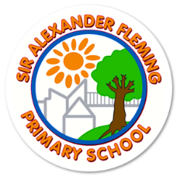

Freedom of Information Act Policy

September 2024

1. Introduction

  - The Freedom of Information Act 2000 (FOIA) was introduced to promote greater openness and accountability across the public sector and requires all maintained schools to be clear and proactive about the information they will make public.

  - As a result Sir Alexander Fleming Primary School has produced a publication scheme, setting out:
The classes of information which we publish or intend to publish;
The manner in which the information will be published; and
Whether the information is available free of charge or on payment.

  - The scheme covers information already published and information which is to be published in the future. All information in our publication scheme is available in paper form, and most is available on our website for you to download and print. Some information which we hold may not be made public, for example personal information.

  - This publication scheme conforms to the model scheme for schools approved by the Information Commissioner.

2. The Aim of the Policy

The school aims to:
Be a place where everyone is treated with dignity, with respect and is of equal worth.
Realise a vision to develop a highly effective learning community.
Develop our key purpose in the construction, delivery and constant improvement of quality learning experiences appropriate to the needs of all our pupils.

3. Procedure

3.1 The publication scheme states the information which we currently publish (or have recently published) or which we will publish in the future. This is split into categories of information known as ‘classes’. These are contained in section 6 of this scheme. The classes of information that we undertake to make available are organised into four broad topic areas:

  - Organisational information

  - Governors’ Documents – information published in the minutes of Governors meetings and in other governing body documents.
  - Students & Curriculum – information about policies that relate to students and the school curriculum.

  - School Policies and other information related to the school – information about policies that relate to the school in general.

4. How to request information

4.1 If you require a paper version of any of the documents within the scheme, the request must be made in writing or by email, fax or letter giving clear details of the information requested. Contact details are set out below or you can visit our website at
https://alexanderflemingprimary.taw.org.uk

Email: office@alexanderfleming.org.uk
Tel: 01952 327820

Contact Address:
Sir Alexander Fleming Primary School
109 Southgate,
Sutton Hill,
Telford,
Shropshire,
TF7 4HG

  - To help us process your request quickly, please clearly mark any correspondence “PUBLICATION SCHEME REQUEST”

  - If the information you’re looking for isn’t available via the scheme and isn’t on our website, you can still contact the school to ask if we have it.

  - Once an FOI request is received it will be logged and passed to the relevant person for a response. All replies will be made within 20 working days.

  - Appeals will be dealt with the Governing Body’s Appeals Committee.

5. Paying for information

5.1 Information published on our website is free, although you may incur costs from your Internet service provider. If you don’t have Internet access, you can access our website using a local library or an Internet café.

  - Single copies of information covered by the publication are provided free. If your request means that we have to do a lot of photocopying or printing, or pay a large postage charge, or is for a priced item such as some printed publications or videos, we will let you know the cost before fulfilling your request.

Freedom of Information: Guide to information available from Sir Alexander Fleming Primary School – Publication Scheme

6. Classes of Information currently published

School website – this section sets out information published on the school website.

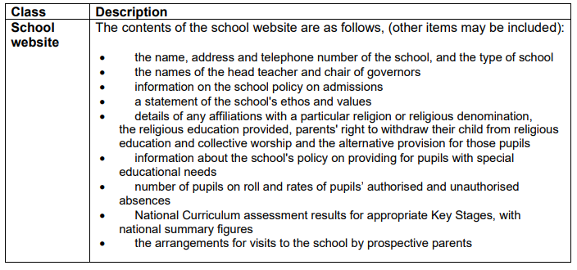

Pupils & Curriculum Policies - This section gives access to information about policies that relate to pupils and the school curriculum.

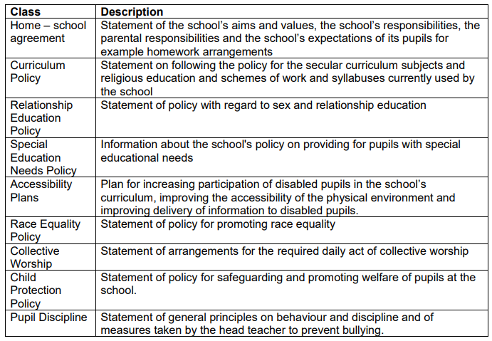

School Policies and other information related to the school - This section gives access to information about policies that relate to the school in general.

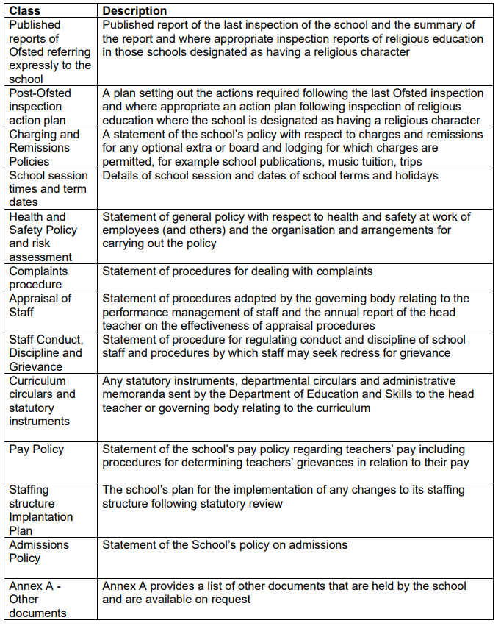

7. Feedback and Complaints

  - We welcome any comments or suggestions you may have about the scheme.

  - If you are not satisfied with the assistance that you get or if we have not been able to resolve your complaint and you feel that a formal complaint need to be made then this should be addressed to the Information Commissioner’s Office. This is the organisation that ensures compliance with the Freedom of Information Act 2000 and that deals with formal complaints.

They can be contacted at:

The Case Reception Unit, Customer Service Team, Information Commissioner’s Office, Wycliffe House, Water Lane, Wilmslow, Cheshire, SK9 5AF.

or

Enquiry/Information Line: 01625 545 700

E Mail: publications@ic-foi.demon.co.uk

Website: www.informationcommissioner.gov.uk

References Freedom of Information Act 2000
HCC Guidance – SC004273 dated 5.1.2009
DfE website

8. Appeals

We will aim to determine all appeals within 20 days of receipt. The school will maintain records of all appeals and their outcome.

If on investigation the school’s original decision is upheld, then the school has a duty to inform the complainant of their right to appeal to the Information Commissioner’s office.

Appeals should be made in writing to the Information Commissioner’s office. They can be contacted at:
FOI/EIR Complaints Resolution Information Commissioner’s Office
Wycliffe House
Water Lane
Wilmslow
Cheshire
SK95AF

Freedom of Information Publication Scheme Annex A – Further documents held by the school

