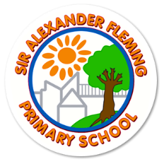
YEAR 2
A Parent’s Guide to Practising Spellings at Home
Why spelling practice matters
In Key Stage 1, the focus is on developing accuracy as well as a range of strategies for spelling including phonics.
Although teachers will highlight spelling errors to children, it is important children recognise for themselves when they have made an error and know a range of strategies for correcting inaccuracies. By this stage, children will have a range of spelling strategies that they will have been taught to draw on. Children will use the strategy which best suits their learning style and works best for them.
Helping at Home
Parents can support children by practising any spelling patterns or spelling investigations which are sent home as part of home learning and also by helping children to read and spell the Y2 word lists (included in this document).
Children will practise these spellings throughout the week in spelling lessons and will be tested on a Friday using some of the words from each week or others with similar spelling patterns.
We will track your child’s progress in spelling through the statutory word lists and half-termly reviews.
Remember to make practising the words enjoyable and not a chore.
The suggestions below may help.

Ideas for how to practise spellings
Make It Daily, Short & Fun  🔁 10–15 minutes a day is ideal  🧠 Little and often works better than long sessions once a week | Start with These Methods  ✍️ Look, Cover, Write, Check  - Look at the word  - Cover it  - Write it  Check it  📌 Repeat 3–5 times for each word | 🔠 Pyramid Words  Build the word letter by letter:  s  sp  spe  spel  spell
🎯 Spelling Target Practice  - Pick 5 tricky words a week  - Write each in a sentence  Say them out loud and spell them aloud | 🌈 Rainbow Write  Choose your 3 favourite crayons to rainbow write your spelling words. Write each word first in pencil then trace over each word three times. Each time you trace, you must use a different colour crayon. | Active Games to Make It Stick  - 🧩 Word Jumble: Mix up the letters of the word – can your child unscramble it?  - ✏️ Hangman: Classic spelling fun  🎵 Silly Songs: Sing the spellings to a tune they know
Link Words to Meaning  Understanding what words mean helps spelling stick.  Try:  - Drawing a picture for each word  - Matching definitions  Using each word in a silly or interesting sentence | Practise in Context  Let them:  - Write short stories or sentences using their spelling words  - Spot spelling words in books or homework  Create their own mini spelling test | Break Tricky Words into Parts  For example:  - environment = en–vi–ron–ment  - necessary = one collar, two sleeves (funny memory tip!)
ABC Order  Write your spelling words in alphabetical order. Be sure to look at the first letter of each word. If the first letter is the same, look at the second letter. | Spelling Paragraph  Write a paragraph using ALL of your spelling words. Be sure to underline your spelling words in your paragraph. | Rhyming Words  Choose eight of your spelling words. First write each spelling neatly. Think of a rhyming word for each spelling word. Write the new rhyming word next to your spelling word. *Example: cries, tries
Spelling Sort  Think of a way to sort your spelling words. Write your word sort neatly. You may want to sort your words by: syllables, beginning sounds, part of speech (nouns, verbs, adjectives, other), vowel sounds The possibilities are endless! Have fun! | Fancy Letters  Write each of your spelling words neatly using fancy letters. Your letters can have curly-q’s or dots, for example. Have fun and be creative! | Parts of Speech  Sort your spelling words according to their part of speech: Noun, adjective, verb, other Make a chart like the one below:  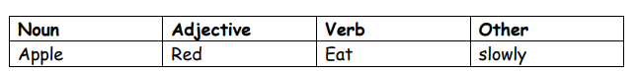
Word Shapes
Draw around the words making a clear distinction in size where there are ascenders and descenders. Look carefully at the shape of the word and the letters in each box. Now try to write the word making sure that you get the same shape.
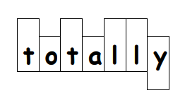

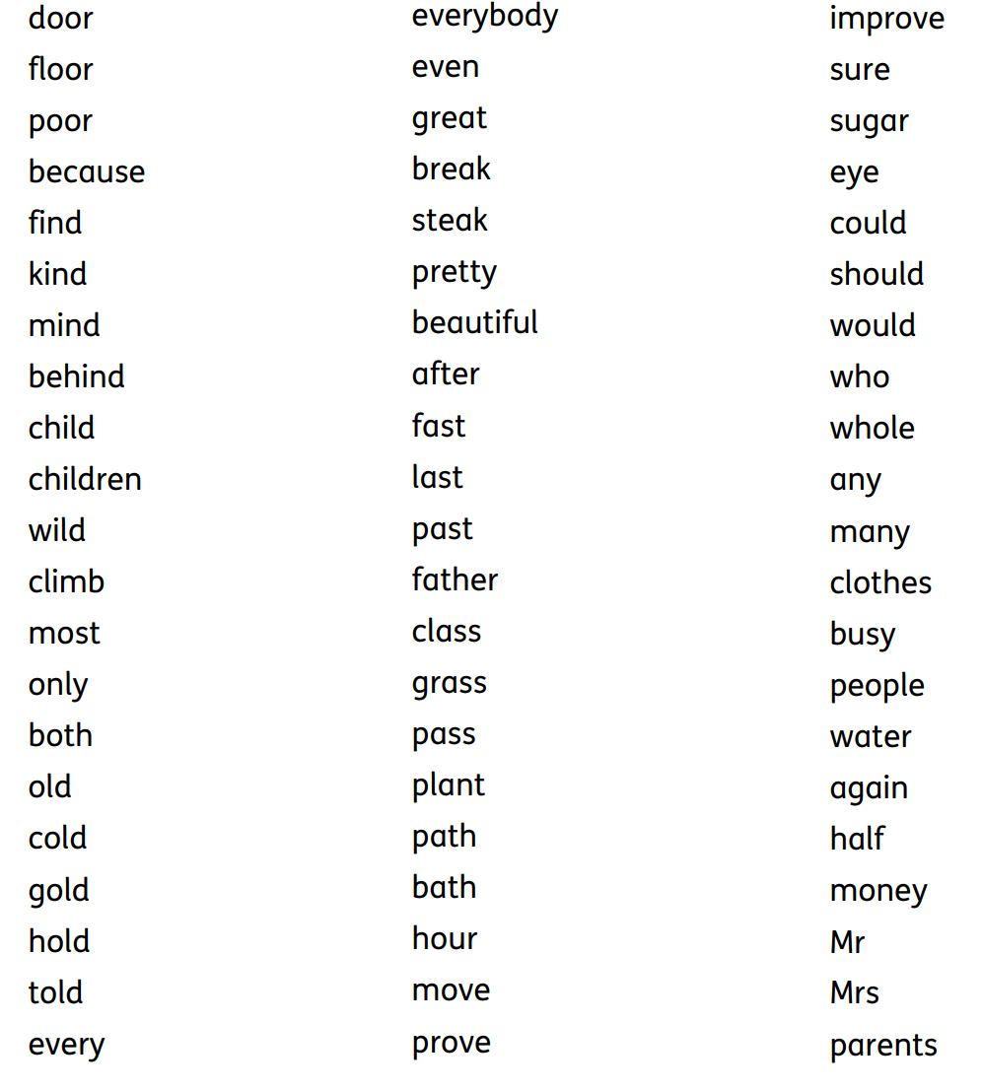
Statutory Spelling Words for Year 2 from National Curriculum

Autumn Term 1
Week 1 | Week 2 | Week 3
Assess and Consolidate steps 1-3 (alternatives) | Soft c /s/ spelt as c before e i and y | Soft g dge ge
 | ice  nice  race  face  space  mice  city  circle  circus  cinema  cereal  bicycle  pencil  December  fancy  juicy  spicy  bouncy  lacy | badge  edge  bridge  fudge  smudge  ledge  hedge  lodge  sledge  wedge  porridge  cage  page  stage  large  huge  change  range  •village
Week 4 | Week 5 | Week 6
Silent b | Silent w wr | /n/ as kn and gn
lamb  comb  climb  crumb  thumb  numb  limb  bomb | write  wrist  wrong  wrap  wreck  wren  wring  wrote  wristwatch  wrinkle  • | knock  knight  knit  knee  knot  knife  know  knitting  knelt  knob  gnome  gnaw  gnat  gnash  gnarly  sign •

Autumn Term 2
Week 1 | Week 2 | Week 3
/l/ as le al il | /or/ after a w as ‘ar’ | Suffixes -es
wriggle  nettle  sizzle  beetle  table  steeple  crumple  candle  middle  tickle  circle  apple  chuckle  trickle  crackle  pickle  medal  capital  hospital  animal  national  fossil  April  pencil | war  warm  ward  warn  worn  warp  wart  swarm•  warmth  warfare  • | boxes  wishes  dishes  glasses  bushes  churches  foxes  buzzes  potatoes  tomatoes•  washes  catches  fixes  misses  pushes  mixes  •
Week 4 | Week 5 | Week 6
Suffixes -es | Suffix -ed -ing | Suffix - er -est
boxes  wishes  dishes  glasses  bushes  churches  foxes  buzzes  potatoes  tomatoes•  washes  catches  fixes  misses  pushes  mixes  • | completed  amazed  smiled  hugged  clapped  planned  sliding  hiking  rubbing  swimming | teacher  farmer  runner  baker  painter  singer  writer  driver  climber  builder  faster  smaller  bigger  taller  shorter  lighter  darker  tallest  smallest  biggest  fastest  slowest  oldest  youngest  coldest  warmest  brightest

Spring Term 1
Week 1 | Week 2 | Week 3
ey plurals | /o/ spelt as a | Suffixes – ment, ness, less
keys  monkeys  donkeys  turkeys  chimneys  valleys  journeys  trolleys  alleys  jerseys | want  watch  wander  wash  was  what  water  wallet  quality  squash | enjoyment  treatment  movement  payment  freshness  sickness  brightness  happiness  painless  fearless  hopeless  useless
Week 4 | Week 5 | Week 6
Suffixes – ly, ful | Contractions –apostrophe | Possessive apostrophe /s/
forgetful  joyful  playful  plentiful  careful  helpful  hopeful  wonderful  useful  joyful  wishful  harmful  beautiful | didn’t  hasn’t  it’s  I’ll  couldn’t  wouldn’t  shouldn’t  haven’t  can't  don't  won't  you've  he'll  you're | sister's  brother's  girl's  child's  man's  boy's  woman's  grandfather's

Spring Term 2
Week 1 | Week 2 | Week 3
-tion endings | Homophones and near homophones | Homophones and near homophones
station  fiction  section  position  relation  fraction  nation  station  direction  lotion  section  potion  motion  emotion | see sea be bee blue blew bare bear one won sun son to too two hear here night knight flower flour  quite quiet there their where wear hear here | see sea be bee blue blew bare bear one won sun son to too two hear here night knight flower flour  quite quiet there their where wear hear here
Week 4 | Week 5 | Week 6
Homophones and near homophones | zhur/shur spelt s | Common Exception Words
see sea be bee blue blew bare bear one won sun son to too two hear here night knight flower flour  quite quiet there their where wear hear here | television  treasure  usual  measure  leisure  pleasure  pressure  unsure  visual  casual | See list at the beginning of the book. How many can your child spell?  Pick 10 and practise these.

Summer Term 1
Week 1 | Week 2 | Week 3
el at the end of words | Endings -ing – ed -er -est -y
Camel  Parcel  Tinsel  Label  Gravel  cancel  funnel  tunnel  chapel  revel  rebel | 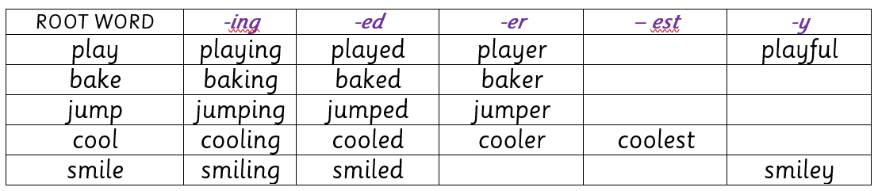
Week 4 | Week 5 | Week 6
‘a’ before l ll | Common Exception Words | Common Exception Words
ball  call  wall  small  tall  walk  talk  calf  half  salad | See statutory word list | See statutory word list

Summer Term 2
Week 1 | Week 2 | Week 3
Prefix dis-, un- | ‘ai’ sound spelt ‘ei’ ‘ey’ ‘aigh’
unhappy  unwell  unclean  unable  unlucky  unfasten  untruthful  unwanted  dislike  dishonest  disobey  disagree  disappoint  discomfort  disappear  disbelieve | they  grey  prey  survey  obey  beige  seize  ceiling  sleigh  neighbour  eight  eighth  weigh  weight  reign  height  vein  rein  neigh  straight | Spelling lessons should now focus on the following:  - Revision of all the content from the Y2 programme  - Securing spelling strategies  - At the point of writing – introducing have-a-go sheets for all writing  - Develop proofreading and checking skills including using a dictionary  Learning spellings through personal spelling journals to reflect growing independence in using taught strategies to learn new words.
Week 4 | Week 5 | Week 6

