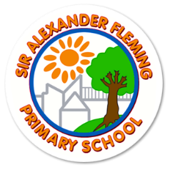
YEAR 3
A Parent’s Guide to Practising Spellings at Home
Why spelling practice matters
In Key Stage 2, the focus is on developing accuracy as well as a range of strategies for spelling.
Although teachers will highlight spelling errors to children, it is important children recognise for themselves when they have made an error and know a range of strategies for correcting inaccuracies. By this stage, children will have a range of spelling strategies that they will have been taught to draw on. Children will use the strategy which best suits their learning style and works best for them.
Helping at Home
Parents can support children by practising any spelling patterns or spelling investigations which are sent home as part of home learning and also by helping children to read and spell the Y3/4 word lists (included in this document).
Children will practise these spellings throughout the week in spelling lessons and will be tested on a Friday using some of the words from each week or others with similar spelling patterns.
We will track your child’s progress in spelling through the statutory word lists and half-termly reviews.
Remember to make practising the words enjoyable and not a chore.
The suggestions below may help.

Ideas for how to practise spellings
Make It Daily, Short & Fun  🔁 10–15 minutes a day is ideal  🧠 Little and often works better than long sessions once a week | Start with These Methods  ✍️ Look, Cover, Write, Check  - Look at the word  - Cover it  - Write it  Check it  📌 Repeat 3–5 times for each word | 🔠 Pyramid Words  Build the word letter by letter:  s  sp  spe  spel  spell
🎯 Spelling Target Practice  - Pick 5 tricky words a week  - Write each in a sentence  Say them out loud and spell them aloud | 🌈 Rainbow Write  Choose your 3 favourite crayons to rainbow write your spelling words. Write each word first in pencil then trace over each word three times. Each time you trace, you must use a different colour crayon. | Active Games to Make It Stick  - 🧩 Word Jumble: Mix up the letters of the word – can your child unscramble it?  - ✏️ Hangman: Classic spelling fun  🎵 Silly Songs: Sing the spellings to a tune they know
Link Words to Meaning  Understanding what words mean helps spelling stick.  Try:  - Drawing a picture for each word  - Matching definitions  Using each word in a silly or interesting sentence | Practise in Context  Let them:  - Write short stories or sentences using their spelling words  - Spot spelling words in books or homework  Create their own mini spelling test | Break Tricky Words into Parts  For example:  - environment = en–vi–ron–ment  - necessary = one collar, two sleeves (funny memory tip!)
ABC Order  Write your spelling words in alphabetical order. Be sure to look at the first letter of each word. If the first letter is the same, look at the second letter. | Spelling Paragraph  Write a paragraph using ALL of your spelling words. Be sure to underline your spelling words in your paragraph. | Rhyming Words  Choose eight of your spelling words. First write each spelling neatly. Think of a rhyming word for each spelling word. Write the new rhyming word next to your spelling word. *Example: cries, tries
Spelling Sort  Think of a way to sort your spelling words. Write your word sort neatly. You may want to sort your words by: syllables, beginning sounds, part of speech (nouns, verbs, adjectives, other), vowel sounds The possibilities are endless! Have fun! | Fancy Letters  Write each of your spelling words neatly using fancy letters. Your letters can have curly-q’s or dots, for example. Have fun and be creative! | Parts of Speech  Sort your spelling words according to their part of speech: Noun, adjective, verb, other Make a chart like the one below:  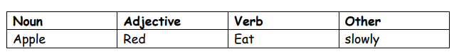
Word Shapes
Draw around the words making a clear distinction in size where there are ascenders and descenders. Look carefully at the shape of the word and the letters in each box. Now try to write the word making sure that you get the same shape.
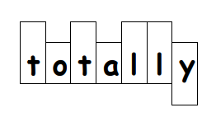

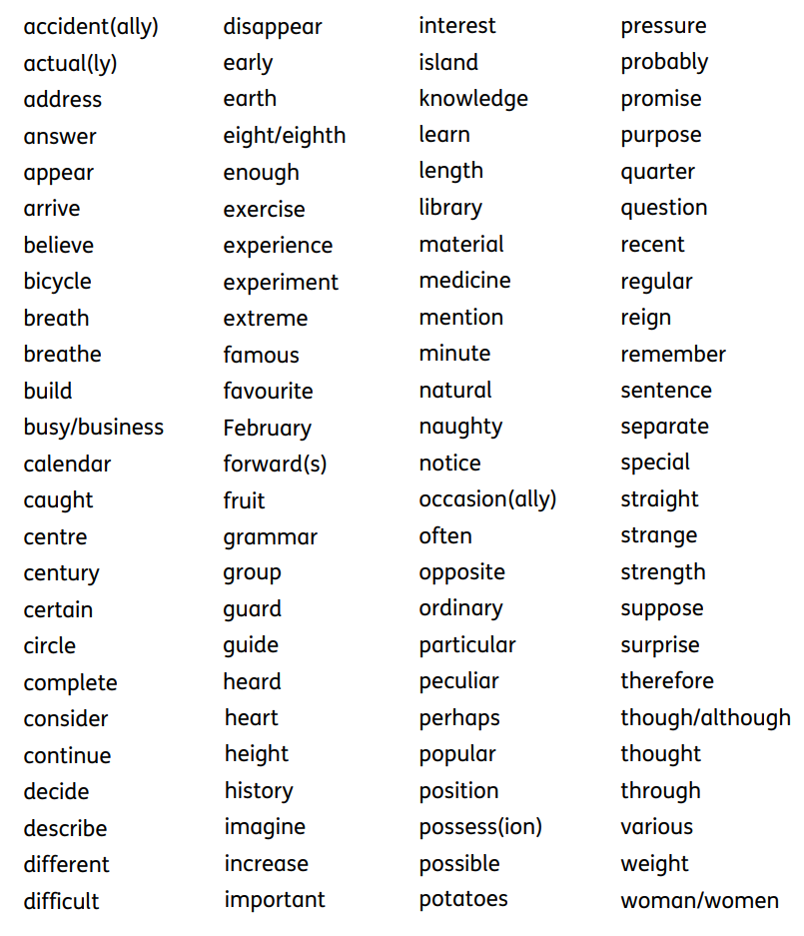
Statutory Spelling Words for Year 3 and 4 from National Curriculum

Autumn Term 1
Week 1 | Week 2 | Week 3
Revise Y2 suffixes (word endings)  -s, -es, -er, -ed, -ing | Revise Y2 suffixes (word endings)  -s, -es, -er, -ed, -ing | Prefix (word beginning) dis-, un-
walks  runs  claps  chats  sings  searches  hopes  waves  reaches  smiles  likes  bakes  dishes  cruises  walked  skipped  chatted  searched  hoped  waved  reached  smiled  liked  baked  planned  floated  clapped | walking  running  skipping  chatting  singing  searching  hoping  waving  reaching  smiling  liking  baking  planning  floating  clapping  running  walker  runner  skipper  chatter  singer  searcher  smiler  baker  planner  floater  clapper  runner | unhappy  unwell  unclean  unable  unlucky  unfasten  untruthful  unwanted  dislike  dishonest  disobey  disagree  disappoint  discomfort  disappear  disbelieve
Week 4 | Week 5 | Week 6
‘ai’ sound spelt ‘ei’ ‘ey’ ‘aigh’ | Homophones (words that sound the same) | Contractions (Using an apostrophe to shorten a word)
they  grey  prey  survey  obey  beige  seize  ceiling  sleigh  neighbour  eight  eighth  weigh  weight  rein  height  vein  rein  neigh  straight | break brake  grate great  eight ate  weight wait  son sun  to two too  there their  hear here  sea see  blue blew  bear bare  one won  night knight  flour flower  right write | I’m  you’re  she’s  he’s  it’s  we’re  they’re  I’ll  he’ll  she’ll  we’ll  they’ll  can’t  don’t  didn’t  isn’t  aren’t  wasn’t  weren’t

Autumn Term 2
Week 1 | Week 2 | Week 3
Homophones | mis- prefix | re- prefix
break brake  grate great  eight ate  weight wait  son sun  to two too  there their  hear here  sea see  blue blew  bear bare  one won  night knight  flour flower  right write | misspell  misplace  mislaid  mislead  misbehave  misfortune  misunderstand  misuse  mishear  mistreat  misread  misjudge | redo  return  replay  refill  revisit  replace  recycle  reappear  rebuild  reposition  rewrite  reread  recount  recommend  reliable
Week 4 | Week 5 | Week 6
Statutory Words | ‘i’ sound spelt ‘y’ | ‘g’ sound spelt -gue  ‘k’ sound spelt -que
See National Curriculum word list attached. | symbol  hymns  crystal  typical  mystery  syrup  myth  lyrics  pyramid  cygnet  Egypt  gym | league  plague  vague  rogue  fatigue  intrigue  catalogue  antique  unique  boutique  mosque  oblique

Spring Term 1
Week 1 | Week 2 | Week 3
Suffix -ness, -ful | Prefix sub- -tele | -anti - prefixes
fearful  playful  beautiful  wishful  hopeful  forgetful  pitiful  hateful  painful  successful  sadness  happiness  brightness  loneliness  fairness  kindness  nastiness  loveliness  fitness  foolishness  tidiness | submarine  submerge  subzero  subheading  subway  subterranean  subsoil  subfolder  subgroup  subtitle  telephone  telegraph  telescope  television  teleport  telepath | antifreeze  antisocial  antiseptic  anticlockwise  antibiotic  antivenom  antigravity
Week 4 | Week 5 | Week 6
‘s’ sound spelt ch, s or ss | -ly suffix (change y to an i) | -ly suffix
chef  shop  sure  mission  special  brochure  sugar | happily  angrily  easily  sensibly  fussily  merrily  greedily  luckily  noisily  busily  clumsily  lazily | quickly  sadly  finally  perfectly  happily  quietly  unfortunately  suddenly  actually  accidently  occasionally

Spring Term 2
Week 1 | Week 2 | Week 3
Prefix -auto -super | Homophones and near homophones | split diagraphs – long vowel sounds
autograph  automobile  automatic  autopilot  autobiography  supermarket  superstar  supercar  supermarket  superman  superwoman  supernatural | accept except  affect effect  ball bawl  berry bury  brake break  fair fare  grate great  groan grown  here hear  heel heal | cake  time  home  complete  arrive  decide  describe  extreme  guide  surprise
Week 4 | Week 5 | Week 6
double consonants | ‘k’ sound spelt ch | -ally suffix
appear  disappear  address  difficult  different  grammar  occasion  opposite  pressure  suppose  rabbit  running  swimming  biggest  hopping  better  letter  dinner  addressed  beginning  occurrence  equipped  committee  accommodation  embarrassment | ache  anchor  Christmas  School  Choir  Chorus  Character  Chemist  Echo  Architect  scheme  orchestra  chaos  mechanic | basically  frantically  comically  energetically  scientifically  terrifically  enthusiastically  magically  logically  physically  practically  automatically  specifically  dramatically

Summer Term 1
Week 1 | Week 2 | Week 3
Review suffixes -ed -ing – s -es -ness -ful -less -ly | -ly suffix (le changed to –ly) | Vowel digraphs  ee ea e-e ie y ey
Use sample of previously taught words listed below | gently  simply  humbly  sensibly  horribly  possibly  terribly  responsibly  probably | See below for sample words
Week 4 | Week 5 | Week 6
in- prefix il- and im- prefixes | ir- prefix | inter- prefix
inactive  incorrect  incapable  indirect  invalid  inaccurate  increase  inaudible  important  immature  impatient  impolite  imperfect  immobile  illegal  illegible  illiterate | irregular  irrelevant  irrational  irresistible  irresponsible | interact  interlock  interview  intermingle  interactive  international  interrupted  interchange  Review and reflect on half term – spelling test

Week 1 words – Review suffixes
-ed | -ing | –s | -es | -ness | -ful | -less | -ly
walked  skipped  chatted  searched  hoped  waved  reached  smiled  liked  baked  planned  floated  clapped | walking  running  skipping  chatting  singing  searching  hoping  waving  reaching  smiling  liking  baking  planning  floating  clapping  running | walks  runs  claps  chats  sings | searches  hopes  waves  reaches  smiles  likes  bakes  dishes  cruises | sadness  happiness  brightness  loneliness  fairness  kindness  nastiness  loveliness  fitness  foolishness  tidiness | fearful  playful  beautiful  wishful  hopeful  forgetful  pitiful  hateful  painful  successful | hopeless  helpless  fearless  careless  endless  homeless  powerless  speechless  thankless  painless | happily  angrily  easily  sensibly  fussily  merrily  greedily  luckily  noisily  busily  clumsily  lazily  quickly  sadly  finally  perfectly  happily  quietly  unfortunately  suddenly  actually  accidently  occasionally
Week 3 - ee ea e-e ie y ey
ee | ea | e-e | ie | y | ey
see  tree  feet  green  sheep  sweet  need  three | sea  eat  each  teacher  bead  dream  meat  clean | these  theme  complete  concrete  athlete  delete  extreme  compete | chief  field  belief  piece  niece | happy  funny  sunny  angry  baby  lucky | key  donkey  monkey  chimney  hockey  turkey

Summer Term 2
Week 1 | Week 2 | Week 3
Revise last half term spelling words | ‘u’ sound spelt ‘ou’ | sion and –tion -ation endings
Practise some spellings from Summer 1 | young  tough  rough  touch  cousin  double  trouble  country  encourage | decision  television  explosion  confusion  tension  possessions  attention  question  mention  position  information  preparation  admiration  sensation  determination  publication  multiplication  operation
Week 4 | Week 5 | Week 6
Homophones | Statutory Word Lists | Statutory Word Lists
fair fare  grate great  groan grown  here hear  heel heal he’ll  rein rain reign  ball bawl  berry bury  brake break  eight ate  weight wait  son sun  to two too  there their  sea see  blue blew  bear bare  one won  night knight  flour flower  right write | Statutory Word Lists | Statutory Word Lists

