**Sir Alexander Fleming Primary School and Nursery**

**‘Belonging, Being, Becoming’**

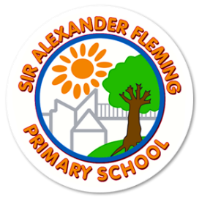

**Art Policy**

Updated: September 2025

Review Date: September 2026

**Our school values**

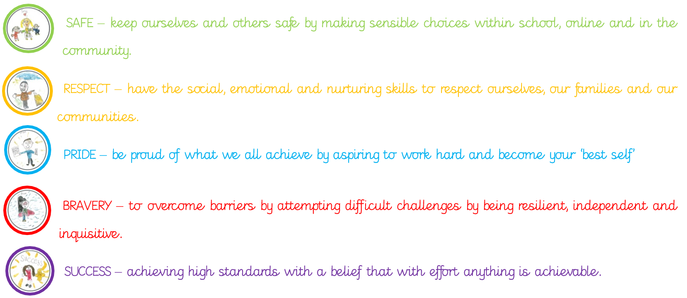

**Purpose of study**

At Sir Alexander Fleming Primary School and Nursery, we embody some of the highest forms of human creativity to develop art and design. We offer a high-quality art and design education that engages, inspires and challenges pupils, equipping them with the knowledge and skills for fluency, experimentation and authenticity. We are enthusiastic that as pupils progress, they should be able to think critically and develop a more rigorous understanding of the formal elements of art and design, as well as being confident to articulate their views and opinions. Pupils are also taught how art and design both reflect and shape our history, and contribute to the culture, creativity and wealth of our nation.

**Aims**

Our aims for art and design are to ensure that all pupils:

* produce creative work, exploring their ideas and recording their experiences
* become proficient in drawing, painting, sculpture and other art, craft and design techniques
* evaluate and analyse creative works using the language of art, craft and design
* know about great artists, craft makers and designers, and understand the historical and cultural development of their art forms
* [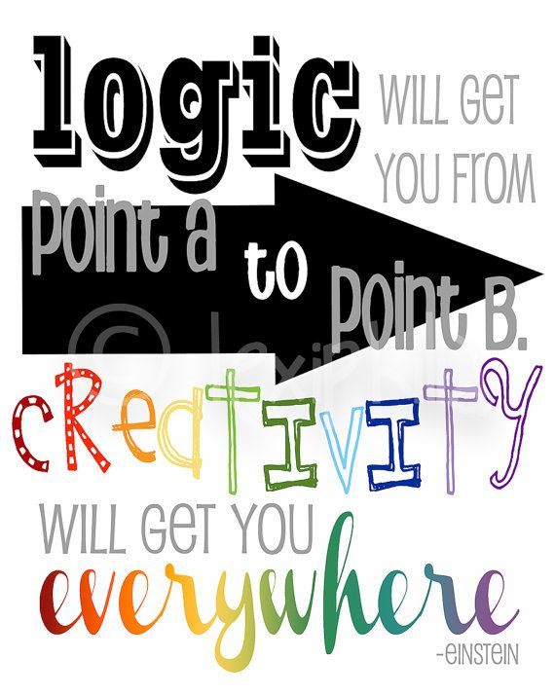](https://www.google.co.uk/url?sa=i&url=https://www.pinterest.com/pin/40602834112278542/&psig=AOvVaw1Hq3Jy4bu1VmZvL2eJtps9&ust=1583244481893000&source=images&cd=vfe&ved=0CAIQjRxqFwoTCMiJvbn7--cCFQAAAAAdAAAAABAE)extend and enrich other curriculum areas through art

[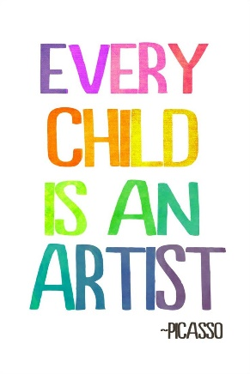](https://www.google.co.uk/url?sa=i&url=https://www.gortskehy.com/2018/05/gortskehy-pupil-art-exhibition/&psig=AOvVaw1OglyptvRKU7N4YWsCSIya&ust=1583244982084000&source=images&cd=vfe&ved=0CAIQjRxqFwoTCNCFmaj9--cCFQAAAAAdAAAAABAU)*“Art is not just a subject to learn, but an activity that you can practise with your hands, your eyes, your whole personality.”*

*Quentin Blake*

**Teaching and Learning**

Our school values are integral factors in the teaching and learning of art and design. Children are encouraged to be **brave** and resilient with new techniques, take **pride** in their authentic pieces of work, use tools **safely**, **respect** their own and others’ work and **successfully** achieve high standards.

By the end of each key stage, pupils are expected to know, apply and understand the matters, skills and processes for art and design.

*The Foundation Stage*

The different aspects of the arts are encompassed within Creative Development in the Foundation Stage Curriculum, however elements can also be found in other areas of learning (physical development, English and Mathematics). This curriculum lends itself to an integrated approach to learning. Nursery and Reception teachers plan quality-learning opportunities for art using the Early Years Curriculum. There is an emphasis on continuous provision, independence and self-initiated learning, which enables foundation stage children to freely explore resources and pursue their own creative interests and talents in addition to the planned, progressive, learning experiences.

*In Key stage 1, pupils will be taught:*

* to use a range of materials creatively to design and make products
* to use drawing, painting and sculpture to develop and share their ideas, experiences and imagination
* to develop a wide range of art and design techniques in using colour, pattern, texture, line, shape, form and space
* about the work of a range of artists, craft makers and designers, describing the differences and similarities between different practices and disciplines, and making links to their own work

*In Key stage 2, pupils will be taught:*

* to create sketch books to record their observations and use them to review and revisit ideas
* to improve their mastery of art and design techniques, including drawing, painting and sculpture with a range of materials, for example, pencil, charcoal, paint and clay
* about great artists, architects and designers in history

**Planning**

Curriculum overviews are completed initially, to identify the skills being taught and how the children are expected to apply those skills. The intended outcomes are clear.

Medium term plans are completed in planning teams, around a topic, with weekly learning objectives and skills that show progression. At Sir Alexander Fleming, we adopt a very cross-curricular approach to teaching, to enrich and develop children’s knowledge and understanding of the world, through the arts. Our pedagogy for progressive teaching and learning involves researching an artist/art movement, teaching skills related to the seven elements; line, shape, tone, colour, texture, form and pattern, giving children the opportunity to apply their knowledge and skills to create an authentic piece and concluding with an evaluation.

**Assessment**

***Formative*** *-* Children’s knowledge, understanding and skills in art are assessed by making observations during lessons; Open ended feedback; Questioning; Self/Peer review; Modelling

***Summative/National*** *-* Reception ELG Expressive Arts and Design/Creating with Materials

***School level*** *-* Year 1 – 6 Art is recorded in sketchbooks; Subject leader monitoring of sketchbooks against progression documents; Pupil voice;

End product produced in Art

**Resources**

The coordinator orders stock for each year group annually, according to the skills being taught on the Long-term plan.

**Extra-Curricular Art Activities**

A specialist artist works throughout the school for one afternoon per week, to extend the children’s mastery of art and design techniques, and to support the teachers and teaching assistants through planned and regular CPD.

Art Club – we offer KS1 and 2 children the opportunity to attend a lunchtime art club. An experienced practitioner leads this club.

Sharing our artwork in the community – we praise and celebrate our children’s work by displaying it in school and in the local community, including the local church, local community centre and Telford Town Centre.

**Recording of Artwork**

The children are encouraged to use high quality cartridge paper to explore, experiment and work on. This is in their sketchbook (Y1-6). Sketchbooks develop critical thinking skills and are very important in tracking progress and the development of both thinking and ideas, and the mastery of techniques.  The use of rubbers is discouraged in order to try and make the sketchbooks a place where it is okay to make mistakes. Final pieces are often completed on larger pieces of quality paper, recorded on Seesaw/a photo in sketchbooks and displayed in the class/around school.

Work should be dated termly.

Recording can take many forms and can be used to:

* practise certain skills and features, and to gather information for use on a larger piece of work
* practise drawing techniques such as shading, perspective and drawing from different viewpoints
* record details about the item being drawn or sketched for future reference
* include sketches and working drawings for ideas of things the children want to make
* gather information to give specific knowledge of how things are made or work

As part of the children’s sketches, we would encourage them to collect:

* Photographs
* Pictures from magazines, comics, cards, calendars, stamps etc
* Samples of textures, fabrics, and other materials
* Lists of resources that the children might need to produce a piece of art
* Colour strips from colour mixing
* Studies of the effects of media on different types of paper
* Evaluations by children of their own and the work of other artists

Where possible the children should be encouraged to comment on the media and techniques used, even at a basic level and quoted by an adult if required e.g. "You smudge it with your fingers" “You add black to a colour to make a shade.”

**Use of Computing**

ICT enhances our teaching of ‘Art and Design’. Children use software to explore shape, colour and pattern in their work e.g. Revelation Art. All children can collect visual information to help them develop their ideas by using the digital cameras, and scanners. They can record their observations and manipulate them through editing or painting software to create their own designs. The children also use the Internet to find out more about the lives and work of famous artists and designers.

**English**

Art and design contributes to the teaching of English in our school by encouraging children to ask and answer questions about the starting points for their work. They can compare ideas, methods and approaches in their own work and that of other children, and to say what they think and feel about them. High expectations for writing are expected when children are completing their artist/art movement study and their evaluations of their work.

**Mathematics**

Art and design contribute to the teaching of mathematics in our school by giving opportunities to develop the children’s understanding of shape and space through work in two and three dimensions. Pattern is always integral in art and design too.

**Spiritual, moral, social and cultural development**

The teaching of art and design offers opportunities to support the social development of our children through the way we expect them to work with each other in lessons. Groupings allow children to collaborate and cooperate and give them the chance to discuss their ideas and feelings. Art respectfully encourages our children to be critical and analytical about their work and the work of others. The children learn to respect and work with each other and with adults, thus developing a better understanding of themselves. They also develop an understanding of different times, cultures and religions through their work on famous artists, designers and craftspeople.

**Health and safety**

Health and safety is important, particularly when working with tools, equipment and resources.

Children need to be taught how to:

* use tools and equipment correctly
* recognise hazards and risk control
* understand how to clean and store materials

**Equal opportunities**

At Sir Alexander Fleming Primary School, we plan to provide for all pupils regardless of gender, ethnicity, socio-economic status, cultural background, academic ability, Special Educational Need/Disability or vulnerability to achieve their full potential. We are committed to ensuring that children and staff are happy and that they enjoy coming to school. This policy will underpin excellent teaching, learning and progress. It will promote the high standards and high expectations set out in the school’s aims and code of conduct. We are committed to meeting the needs of everyone especially those identified in the 2010 Equality Act. In line with our ‘Equal Opportunities Policy’ we are committed to providing a teaching environment that promotes learning. Children are given opportunities to work with others, listen to each other and treat everyone with **respect**.

**Adaptation**

The teaching of art and design needs to consider the varied abilities, attitudes and individual needs of the children. Art lessons can be adapted by outcome however, if a skill or activity is deemed inappropriate for a child or group of children, alternatives will be planned which best suit their needs.

**Inclusion**

Lessons and activities are planned to include all children by using a range of approaches. This includes questioning, use of equipment, and mixed ability grouping to enable children to offer peer support. Lessons are planned to facilitate the identification of children at either end of the ability range within each class.

**Policy Links**

Equal opportunities policy

Marking and feedback policy

SEND policy

Long term overview and progression in Art and Design

Assessment policy