 | AUTUMN |  | SPRING |  | SUMMER
NURSERY | FORM  - Handling, feeling, enjoying and manipulating materials  - Constructing  -Building and destroying  - Shape and model  Understand that artwork isn’t always flat.  Understand that materials may feel different.  Understand that shapes can be used to create different effects.  Recognise that an artist’s work can inspire ours.  Talk like an Artist  “I like…”  Explore, build, construct, roll, shape, pattern, clay.  Andy Goldsworthy (Contemporary Artist)  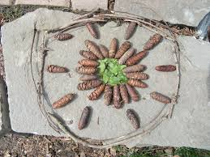 |  | COLOUR  - Experimenting with and using primary colours  - Naming colours - mixing (not formal)  - Learn the names of different tools that bring colour  - Use a range of tools to make coloured marks on paper, e.g.straws, matchsticks, brushes, sponges  Understand we can use a variety of tools to make marks.  Understand that colours can be mixed to create new colours.  Talk like an Artist  “I like…”  Colour names, draw, colour, paint, paintbrush, sponge, mix, pencil, pastel., chalk.  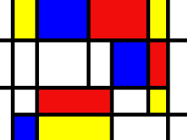  Mondrian (Modern Artist) |  | PRINTING  - Rubbings  - Print with a variety of objects – plus hands, feet and found materials  - Print with block colours  Recognise that prints are made by transferring an image from one surface to another.  Talk like an Artist  “I like…because…”  Print, pattern, repeat, rub, explore.  Ablade Glover – Ghanain landscapes  (Contemporary Artist)  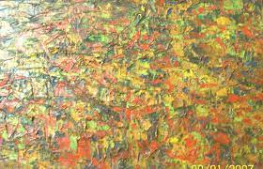
RECEPTION | DRAWING  - Enjoys making marks, signs and symbols with a variety of drawing tools  - Is spontaneously expressive, using marks, lines and curves  - Use drawings to tell a story  - Encourage accurate drawings of people/faces  Understand that drawing is a physical activity to represent something.  Understand that sometimes you need to observe details to draw.  Talk like an Artist  “I like…because…”  Draw, pencil, pen, crayon, paper, line, curve.  Paul Klee ( (Modern)  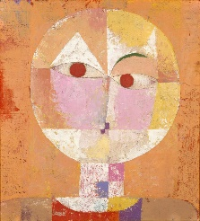 |  | TEXTURE  - Handling, manipulating and enjoying using materials  - Sensory experiences  - Simple collages  - Simple weaving  Understand that materials can be combined to create artwork.  Understand that materials can feel similar or different.  Talk like an Artist  “I like…because…”  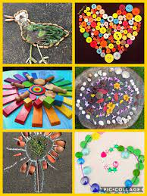  Explore, collage, tissue paper, rip, scissors, feel, glue.  Transient art  (Traditional Art) |  | PATTERN  - Repeating patterns  - Irregular painting patterns  - Simple symmetry  Understand that patterns can be found in our natural environment.  Understand that we can use patterns to create our own artwork.  Talk like an Artist  “I like…because…”  “I dislike…”  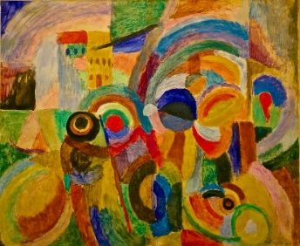  Repeat, pattern, same, paint, explore, natural.  Sonia Delaunay  (Modern Artist)
 | AUTUMN |  | SPRING |  | SUMMER
YEAR 1 | COLOUR  - Name the primary colours  - Explore mixing of colours to identify secondary colours.  - Find collections of colours  - Applying colour with a range of tools  - Make as many tints of one colour as possible (adding white) and shades (adding black)  - Use colour to express feelings  Understand that a sketchbook is for experimentation and exploration.  Understand that colours can be used to express feelings.  Talk like an Artist  “I like…because…”  “I dislike…”  Paint, primary colour, mix, 2D, sketchbook, tints, shades, colour names.  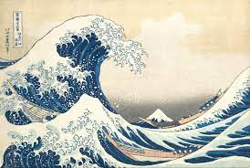  Hokusai  (Traditional  Artist) |  | FORM  - Use materials to construct known objects for a purpose  - Carve, pinch and roll coils and slabs, using a modelling tool  - Make simple joins  - Awareness of natural and man-made forms  - Expression of personal experiences and ideas  - Identify work of famous sculptors  Understand that sculpture is the name sometimes given for artwork which exists in three dimensions.  Know that Giacometti is a sculptor.  Express responses about the work of artists and recognise that this may be different from someone else’s.  Talk like an Artist  “I like…because…”  “I dislike…”  Coil, carve, pinch, roll, model, construct, material, clay, mod-roc, join, manipulate, layer, knead, sculpture, 3D, figure.  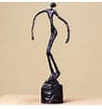  Giacometti  (Modern Artist) |  | PRINTING  - Create patterns and pictures by printing from objects using more than one colour.  - Develop impressed images  - Relief printing – string, card  - Print with a growing range of objects  Understand prints are made by transferring an image from one surface to another.  Understand relief prints are made when we print from raised images (plates).  Talk like an Artist  “I like…because…”  “I dislike…because”  Print, pattern, relief printing, impress printing, roller, ink, polystyrene tile, scrape, layer.  Alma W. Thomas  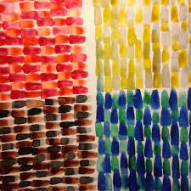  (Modern Artist)
 | AUTUMN |  | SPRING |  | SUMMER
YEAR 2 | DRAWING  - Extend the variety of drawings tools  - Use line to represent objects seen, remembered or imagined  - Observe and draw landscapes  - Observe patterns  - Explore tone using different grades of pencil, pastel and chalk  Understand that we can use different media (sometimes combined in one drawing) to capture the nature of things we want to portray.  Understand that we can hold our drawing tools in a variety of ways, experimenting with pressure, grip and speed to affect line.  Talk about the work of Van Gogh and understand how he takes his inspiration from around his surroundings and experiences.  Talk like an Artist  “I like…because…”  “I dislike…because”  Pastel, charcoal, crayon, drawing, illustration, sketch, sketchbook, detail, tone, shade.  Vincent Van Gogh  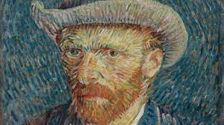  (Modern Artist) |  | PATTERN  - Awareness and discussion of patterns  - Repeating patterns  - Symmetry  - Experiment by arranging, folding, repeating, overlapping, regular and irregular patterning  - Natural and manmade patterns  Know that pattern is a repetition of specific visual elements.  Understand that patterns may be natural or manmade.  Understand that the way each persons’ sketchbook looks is unique to them.  Talk like an Artist  “I like…because…”  “I dislike…because”  Repeat, symmetry, pattern, overlap, regular patterning, irregular patterning.  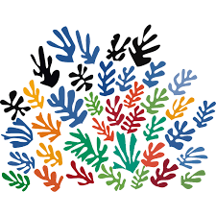  Henri Matisse  (Modern Artist) |  | TEXTURE  - Weaving  - Collage  - Sort according to specific qualities  - How textiles create things - Overlapping and overlaying to create effects  - Use large eyed needles  - Running stitches  - Start to explore other simple stitches  Understand that we can combine collage with other disciplines such as drawing, printmaking and making.  Understand how running stitches are useful in the wider world.  Talk like an Artist  “I like…because…”  “I dislike…because”  “What else could improve this?”  Mosaic, stitch, knot, manipulate, embroidery, join, material, sew, trim.  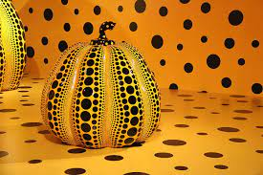  Yayoi Kusama  (Contemporary  Artist)
 | AUTUMN | SPRING |  |  |  | SUMMER
YEAR 3 | PATTERN  - Pattern in the environment  - Design  - Using ICT  - Make patterns on a range of surfaces  - Explore environmental and manmade pattern.  Understand that artists use patterns as decoration, as a technique of composition, or as an entire piece of artwork.  Understand that artists develop their own artistic styles.  Talk like an Artist  “I like…because…”  “I dislike…because”  “What else could improve this?”  Record, media, medium, pattern, features, composition, contrast, natural, man-made, environment.  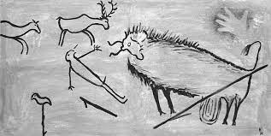  Period - Stone Age Art (Traditional Art) | COLOUR  - Colour mixing  - Name primary and secondary colours.  - Make colour wheels  - Use different types of brushes and techniques  - Apply colour using dotting, scratching, splashing  - Mix tints (add white), tones (add grey) and shades (add black) with hues (pure colours)  - Colour to reflect mood  Know the secondary colours.  Understand how to create tints, tones and shades.  Understand that sketchbooks are places for personal experimentation.  Understand that the way each persons’ sketchbook looks is unique to them.  Talk like an Artist  “I like…because…”  “I dislike…because”  “What else could improve this?”  Hue, shade, tint, media, medium, tone, composition, colour match, wash, watercolour, acrylic, bleed, cool/warm colours, secondary colours, neutral colours, contrast.  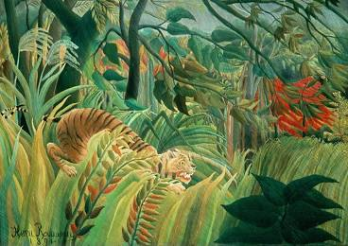  Henri Rosseau  (Modern Artist) |  |  |  | PRINTING  - Recording textures/patterns using relief and impressed printing processes.  - Monoprinting e.g. carbon paper  - Colour mixing through overlapping colour prints  - Symmetrical/asymmetrical prints  - Modify and adapt print  Understand monoprints are prints made by drawing through an inked surface, transferring the marks on to another sheet.  Understand we may all have different responses in terms of our thoughts and the things we make.  Recognise prints are used in our environment – books, pictures, wallpaper, fabrics.  Talk like an Artist  “I like…because…”  “I dislike…because”  “What else could improve this?”  “In my opinion…”  Composition, monoprint, relief prints, impressed printing, texture, pattern, modify, adapt, overlap, symmetrical, asymmetrical  Sarah Jameson  (Contemporary  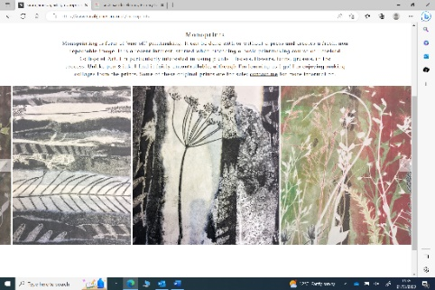  Artist)
 | AUTUMN | SPRING |  |  |  | SUMMER
YEAR 4  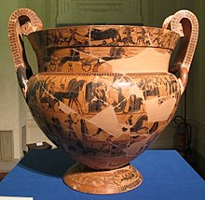 | FORM  - Shape, form, model and construct (malleable and rigid materials)  - Plan and develop  - Understanding of different adhesives and methods of construction  - Experience surface patterns/textures  - Discuss own work and work of other sculptors  Understand that when we make sculpture by moulding with our fingers it is called modelling.  Know that clay and Modroc are soft materials which finally dry/set hard.  Understand that sculptures are challenging to construct and it’s ok to take creative risks.  Talk like an Artist  “I like…because…”  “I dislike…because”  “What else could improve this?”  “In my opinion…”  Shape, form, model, construct, medium, texture, sculptor, natural sculptures, man-made sculptures.  Ergotimos – Greek potter  (Traditional  Artist) | TEXTURE  - Use smaller eyed needles and finer threads  - Weaving  - Use a wider variety of joining techniques, plaiting, pinning, stapling and sewing  - Experimenting with creating mood, feeling and movement, using embellishments  - Compare different fabrics  Know how to thread a needle and use it to connect two or more materials.  Understand that weaving is interlacing two sets of yarns so that cross each other, normally at right angles.  Talk like an Artist  “I like…because…”  “I dislike…because”  “What else could improve this?”  “In my opinion…”  Needle, thread, button, embellish, textiles, stitch, function, weave, fabric.  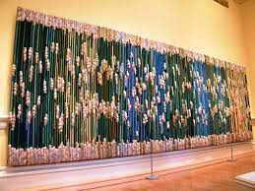  Sheila Hicks  (Contemporary  Artist) |  |  |  | DRAWING  - Explore shading, using different media  - Uses line and tone to represent things seen, observed or remembered  - Draw familiar things from different viewpoints  - Scale and proportion  - Accurate drawings of whole people including proportion and placement  Understand how to portray scale and proportion in art.  Know and describe the scale and proportion of objects in our immediate environment.  Understand what inspired L.S.Lowry and be able to describe his unique style.  Talk like an Artist  “I like…because…”  “I dislike…because”  “What else could improve this?”  “In my opinion…”  “I know that…because I have observed…”  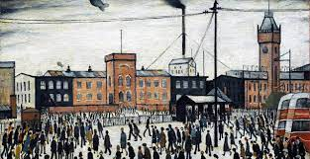  Pencil grade, record, tone, composition, line, horizontal, vertical, scale, proportion, placement, vanishing point, features, silhouette.  L.S.Lowry  (Modern Artist)
 | AUTUMN |  | SPRING |  | SUMMER
YEAR 5 | COLOUR  - Recognise harmonious and complementary colours  - Explore the use of texture in colour  - Colour for purposes  - Colour to express feelings  - Explore tertiary colours on the colour wheel  Know the primary, secondary and tertiary colours.  Understand that colour is the visual element that has the strongest effect on our emotions and used to create mood/atmosphere.  Understand that processes, intentions and visual notes made in a sketchbook help to consolidate own learning and inform choices.  Talk like an Artist  “I like…because…”  “I dislike…because”  “What else could improve this?”  “In my opinion…”  “I know that…because I have observed…”  Light, shade, harmonious colours, complementary colours, hue, shade, tint, tone, tertiary colours.  Nike Davies Okundaye (Contemporary  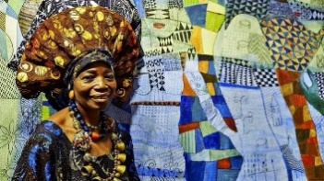  Artist) |  | PRINTING  - Combine prints from different objects to produce an end piece  - Discuss and evaluate own work and that of others  - Build up drawings and images of whole or parts of items using various techniques e.g. card relief  - Explore printing techniques used by various artists  Understand that printing techniques can be combined to create textured effects and that printing involves transfering a design to another surface.  Know and describe the work of the artist Peter Thorpe.  Talk like an Artist  “I like…because…”  “I dislike…because”  “What else could improve this?”  “In my opinion…”  “I know that…because I have observed…”  “I believe there is a pattern of…”  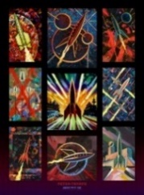  Monoprint, impressed print, relief print, layering print, alter, modify, combine.  Peter Thorpe  (Contemporary  Artist) |  | PATTERN  - Create own abstract patterns to reflect personal experiences and expression  - Create pattern for purposes  - Use knowledge of regular/irregular/symmetrical/overlapping patterns to compose authentic patterns  Understand working with pattern uses lots of different concepts including repetition, sequencing, symmetry.  Understand that patterns can be purely decorative or hold symbolic significance. They can be personal or cultural.  Talk like an Artist  “I like…because…”  “I dislike…because”  “What else could improve this?”  “In my opinion…”  “I know that…because I have observed…”  “I believe there is a pattern of…”  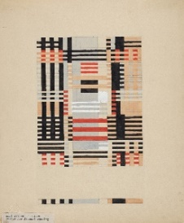  Composition, regular, irregular, symmetry, overlap, tessellation, abstract patterns, repetition, sequencing.  Anni Albers  (Modern Artist)
 | AUTUMN |  | SPRING |  | SUMMER
YEAR 6 | FORM  - Plan and develop ideas  - Shape, form, model and join  - Discuss and evaluate own work and that of other sculptors  - Make imaginative use of acquired knowledge about tools and techniques and materials to express own ideas and feelings  - Look at 3D work from a variety of genres and cultures and develop own response through experimentation  Understand that an armature is an interior framework which support a sculpture.  Know the materials Giacometti used for his sculptures, to make informed decisions with own work.  Understand how to shape, form, model and join malleable and rigid materials.  Understand that artists use art to explore their own experience, and that as viewers we can use our visual literacy skills to learn more about both the artist and ourselves.  Talk like an Artist  “I like…because…”  “I dislike…because”  “What else could improve this?”  “In my opinion…”  “I know that…because I have observed…”  “I believe there is a pattern of…”  “I think this has developed by…”  Manipulate, experiment, mod roc, armature, layer, figures, sculpture, shape, form, model, join.  Alberto Giacometti  (Modern Artist)  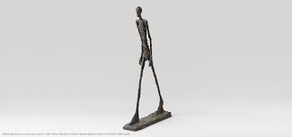 |  | DRAWING  2D to 2D  -Explore graphic design  - Use typography, line, tone, colour, shape and composition to recreate food packaging.  - Turn flat graphics into 3D nets.  - Explore typography and design lettering which is fit for purpose.  - Select appropriate media and techniques to achieve a specific outcome  - Talk about intention and outcome, - Giving and receiving positive feedback from peers  Understand that drawing and making have a close relationship.  Know that drawing can be manipulated to transform a 2D surface to a 3D object.  Understand how line, tone, colour, shape and composition can be used to inform a final product.  Talk like an Artist  “I like…because…”  “I dislike…because”  “What else could improve this?”  “In my opinion…”  “I know that…because I have observed…”  “I believe there is a pattern of…”  “ I think there is a pattern of…”  “How does this technique make you feel?”  Typography, purpose, graphic design, two- dimensional, three-dimensional, composition, net, depth, focal point, emphasis, foreground.  Chip Kidd  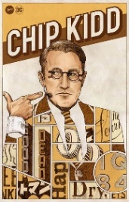  (Modern Artist) | TEXTURE  - Stitching using various needles to produce more complex patterns  - Select and use materials  - Embellish work  - Artists using textiles  - Develops experience in embellishing  - Applies knowledge of different techniques to express feelings  Understand that artists and designers add colour, texture, meaning and richness to our lives.  Understand that artists reinvent. Understand that as artists, we can take the work of others and re-form it to suit us. That we can be inspired by the past and make things for the future.  Talk like an Artist  “I like…because…”  “I dislike…because”  “What else could improve this?”  “In my opinion…”  “I know that…because I have observed…”  “I believe there is a pattern of…”  “ I think there is a pattern of…”  “How does this technique make you feel?”  Pin, running stitch, blanket stitch, applique, needle, thread, cotton, textiles.  Jean Draper  (Contemporary Artist)  