Sir Alexander Fleming Primary School and Nursery
‘Belonging, Being, Becoming’

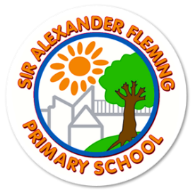
Reading Policy
Updated: September 2025
Review Date: September 2026

Our School Values
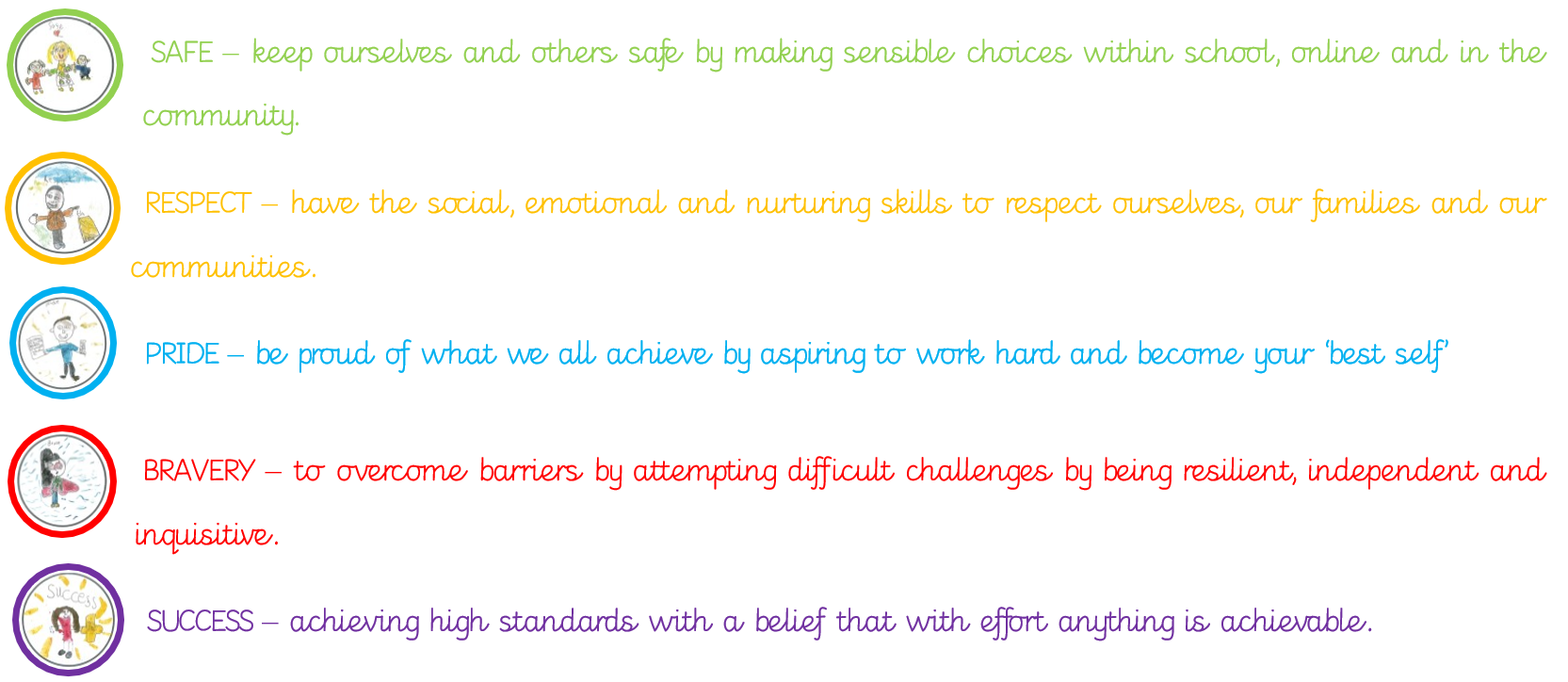
Contents
- Intent
- Our Reading Vision
- Implementation
- Phonics
- Independent Reading
- Teachers Reading to Children
- Drop Everything and Read
- Book Club
- Guided Reading
- Rainbow Reading Domains
- Fluency
- Reading Plus
- Reading Offer in the EYFS
- Progression of knowledge
- Quality texts
- Environment
- Assessment
- Support for children who struggle to acquire the basic skills
- Adaptive teaching
- Parental engagement
- Whole school celebrations, rewards and cultural capital
- Impact
- Equal Opportunities and Inclusion
- Policy Links
- What is the intent of the Reading curriculum at Sir Alexander Fleming Primary School and Nursery?
Reading is a crucial part of our curriculum and a key life skill that children need to become successful. At Sir Alexander Fleming we have a passion and love for reading and children take pride in their learning in this subject. It is our highest priority that children develop reading for pleasure through the rich reading culture we create and that they develop personal tastes and opinions. We aim to create successful, confident readers who enjoy reading aloud and are brave enough to perform reading to others.
Throughout their time at our school children will explore a range of texts which reflect a diverse range of cultures, characters and scenarios. In this way children are developing their understanding and respect for others.
A Sir Alexander Fleming reader will have a secure phonic knowledge and be able to decode words fluently. They will have an extending knowledge of grammar, sentence and text structure and vocabulary. Children will comprehend and be able to understand a range of texts and use skills such as retrieval, prediction and inference.
Children will be thoughtful and critical readers who can analyse and interpret many aspects and view points of texts and distinguish between fact and fiction. They will be able to reflect, question and debate.
Our teaching of reading is underpinned by our belief that reading unlocks children’s potential in all other curriculum areas. It is our long term aim that children will use reading to further their knowledge in other subjects. We also recognise that our whole-school curriculum offer develops our children’s background and contextual knowledge and in turn their comprehension skills.
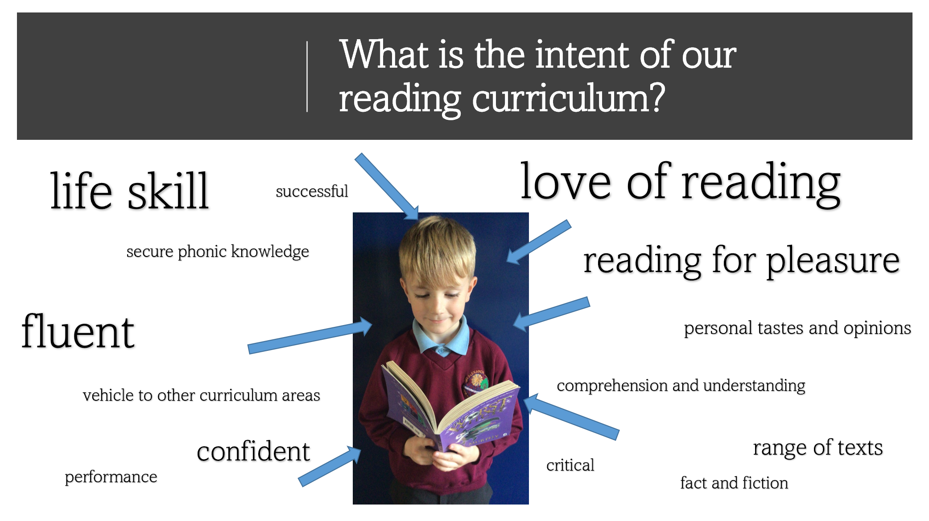
- Our Reading Vision
We want all our children, by the end of the EYFS, to be able to know a range of traditional stories. They will be able to act out stories using props and puppets using their growing spoken language. They will know stories from their reading spine and be able to make attempts at retelling them. They will apply their phonetic knowledge to read phonetically plausible books.
We want all our children, by the end of KS1 to have built up a repertoire of stories including their knowledge of fairy tales and traditional tales. They will be aware of their interests and be able to talk about reasons why they enjoyed a book. Children will be able to innovate stories and create their own. They will be reliable decoders and become fluent and expressive readers.
We want all our children by the end of KS2 to become effective, competent communicators and good listeners. They will be able to read, discuss and respond to a variety of texts at an age appropriate level. They will express opinions, articulate their feelings and formulate their responses to a range of texts of different genres. Children will foster an interest in words and their meanings and develop a growing vocabulary. It is our hope that all children will develop a love of and real eagerness for reading, choosing texts appropriately and sharing them enthusiastically. We will aim to equip all children with the reading skills to access the curriculum and the wider world around them.
- Implementation
How do we teach reading successfully at Sir Alexander Fleming Primary School and Nursery?
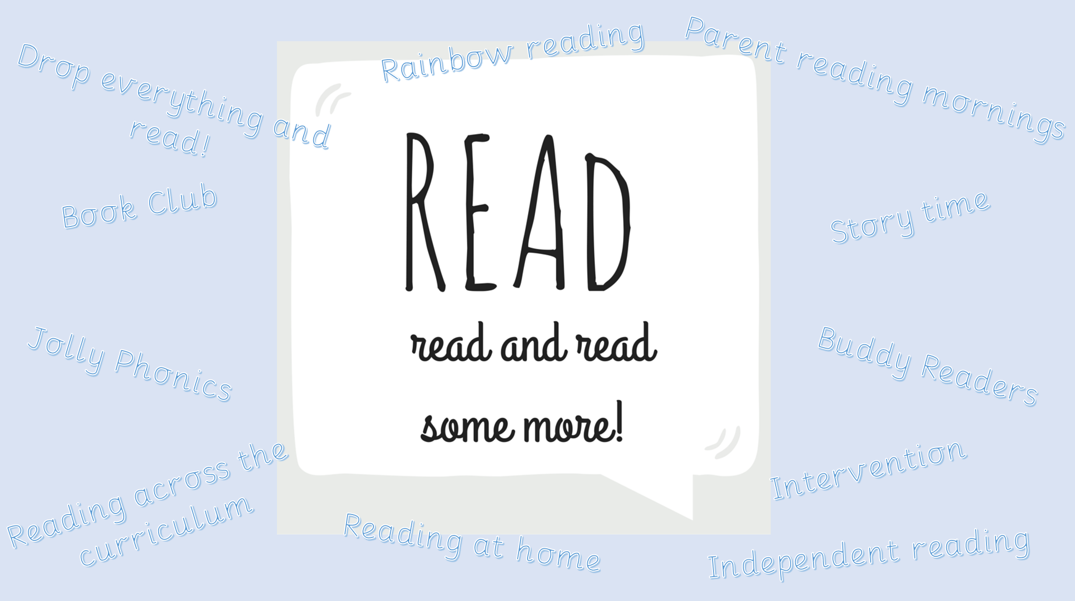
Reading Plus
Author visits and studies
Reading assemblies
Our School Offer
Children are given many opportunities at our school to develop and apply their reading skills. Teaching strategies are used in accordance with pupils’ age and level of attainment and learning needs.
When do you learn to read?
Are you encouraged to read at home?
How often does your teacher read to you?
How often do you read your book to an adult?

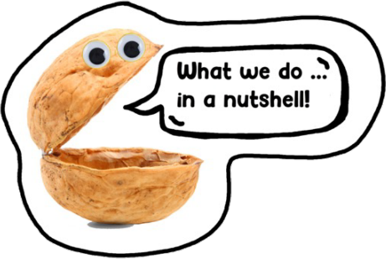
Our School Offer in a nut shell!
- All children read every day.
- Children who find reading challenging read more and participate in extra phonics teaching.
- Children in Year 2 and KS2 participate in four guided reading sessions a week.
- Children in KS2 participate in three Reading Plus sessions a week.
- Children in the EYFS and KS1 participate in five daily phonics sessions a week.
- All children listen to an adult read every day.
- All children participate in buddy reading once a week.
- All children in nursery share a book with an adult twice every day.
- Phonics
Phonics is an integral part of our English Curriculum in which children are taught how to read and write using the 40+ grapheme, phoneme correspondences in the English Language.
We follow a sequenced, Synthetic Phonics programme called Jolly Phonics which is based on the fundamental knowledge of the alphabetic code. Children acquire the main 42 letter sounds and alternatives spellings for these during these lessons.
In the Early Years and KS1 children have discrete, daily Jolly Phonics lessons in which teachers use a range of multi-sensory techniques in order to engage and enthuse our learners. We have many interactive phonics resources such as interactive online resources, songs and rhymes.

Children are taught five key skills during Jolly Phonics lessons;
- letter sounds
- letter formation
- blending for reading
- encoding for writing
- tricky words.
Please see the Jolly Phonics Overview (MTP) which sets out when we teach certain skills and knowledge and shows how our teaching is rigorous, structured and enjoyable.
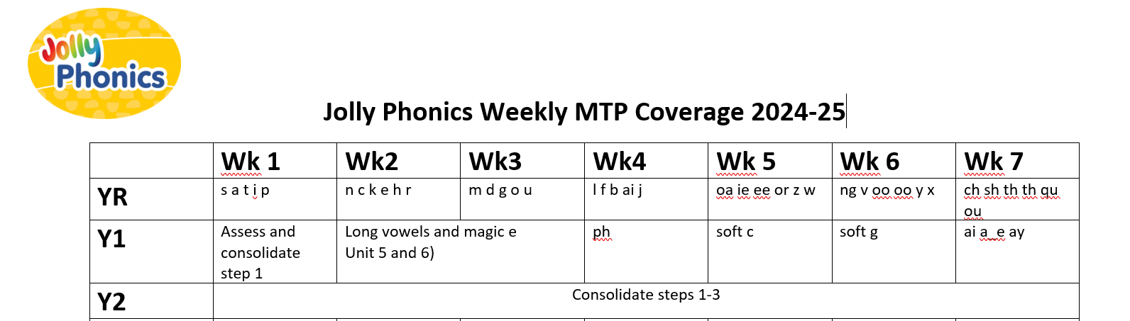
Dictation forms a crucial part of Jolly Phonics teaching and all staff use the same sequence of dictation alongside actions to support children’s understanding of sentence structure and punctuation.
Actions used in dictation include –
- Capital letter
- Finger Space
- A word
- Full stop
As children become more confident they are encouraged to hold a sentence in their head before writing it.
Jolly Phonics Practice
The approved scheme that we follow has a distinct way of teaching children, including the use of teacher terminology. All staff received regular CPD in order that they are Jolly Phonics experts! This CPD is from a Jolly Phonics trainer and the Reading Leader.
goat
Sound buttons are used as a strategy to scaffold understanding.
Clapping and touching the chin is used as a strategy to identify syllables in words.

‘Froggy fingers’ is used to aid children’s pencil grip.
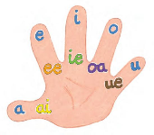
The vowel hand is used to highlight short and long vowels.
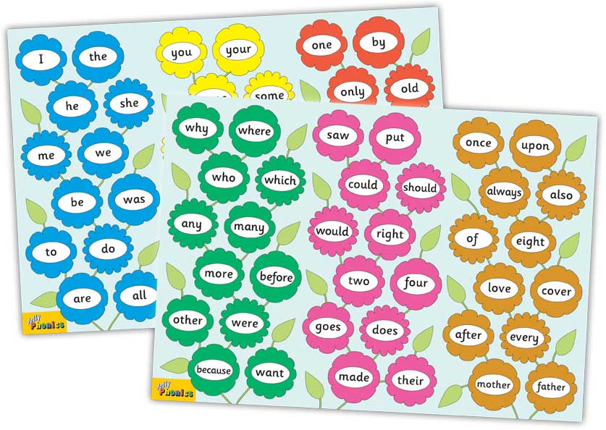
‘Tricky words’ is the term used to describe hugh frequency words which contain GPCs that have not been taught yet within the curriculum.

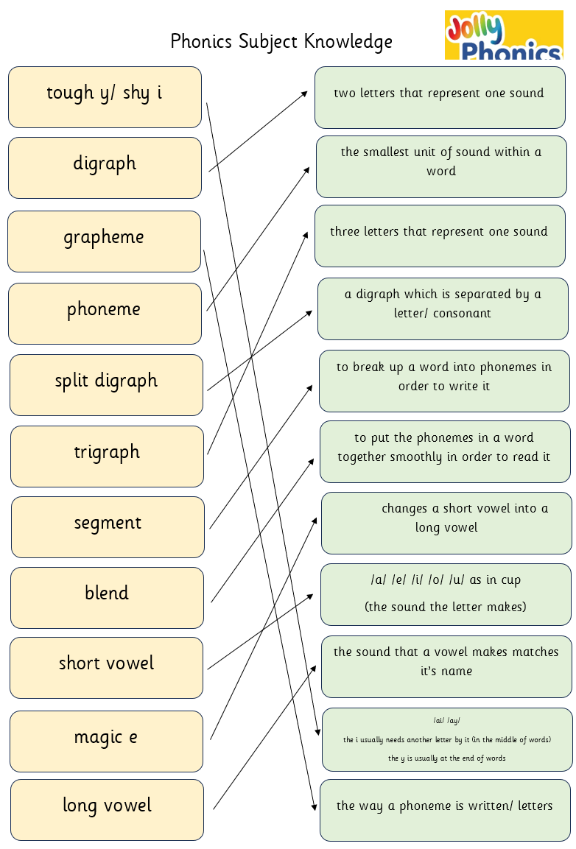
Children read a variety of words, sentences and decodable books during Jolly Phonics teaching. Decodable book reading often takes place in smaller groups, at a different point within the day in order to meet the developmental needs of our children. It enables children to apply their phonic knowledge to read books.
- Independent Reading
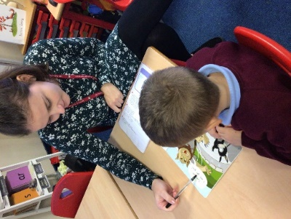
Each week children in Reception to Year 3 read a book which has been matched to their ability, individually to an adult at school. The adult listens to the child read and talks to them about the book.
For children who require it, adults support them to apply their phonic skills in order to decode words. The adult also discusses the content of the text and checks for the child’s understanding by commenting and questioning them. Adult’s develop children’s fluency by helping them to re-read texts and sections of the text and modelling reading fluently.
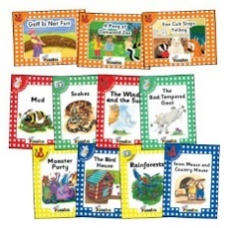
All children in YR-3 read once a week to an adult on a one to one basis.
Children identified as needing extra support, read every day to an adult.
We use Jolly Phonics Reading Scheme at our school. The book read by the child will be selected by an adult which matches the child’s phonic ability and GPCs which have been taught and the child knows.
- Jolly Phonics Decodable Book Group Reading
In R and Y1 children read the decodable book which has been matched to their ability in a group scenario three times a week in order to apply their phonic knowledge to reading and develop automaticity through repeated reading.
Please see the Decodable Book Pedagogy document to see how this is taught in a sequence.
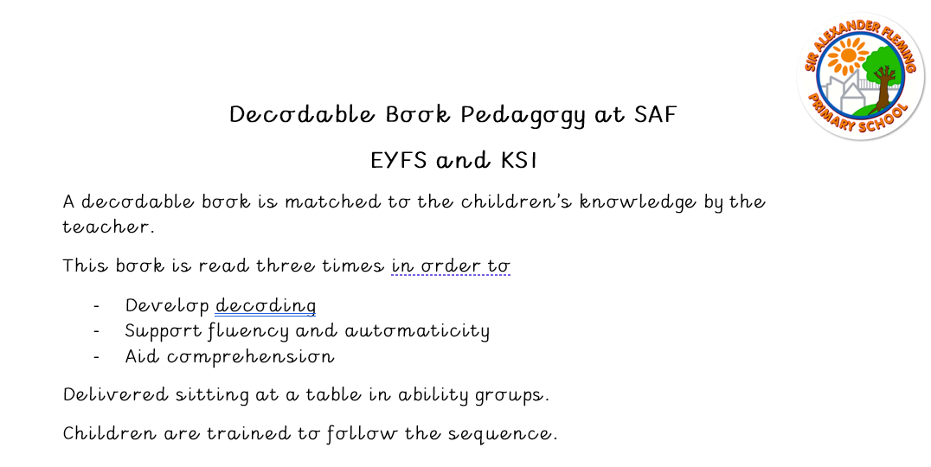
The adult records the child’s independent reading chronologically in their Reading Book or Reading Journey, with a comment regarding the child’s decoding, fluency and comprehension skills.

LO: Apply reading sentences by blending set 1 GPCs.  Text: Insects  Genre: Non-Fiction  Decode  Success criteria:  - Apply strategies. |  |  |  |  | 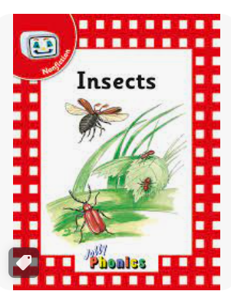
 |  |  |  | 
legs | bug | perched | wings | instinct
Session 1 | Session 2 | Session 3 | Session 4 | Session 5

This book will be sent home in order for children to continue to practise reading.
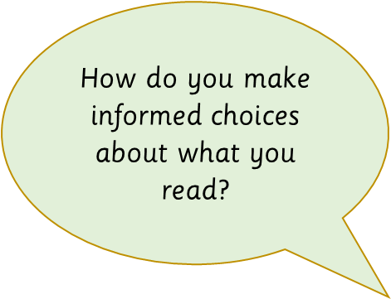
Struggling Readers in KS2 also participate in Decodable Book Group reading as a daily intervention. (Please see Struggling Readers).
When children are assessed by their teacher as being fluent at decoding, they will move to ‘free reader’ books and be able to make choices about the books that they read independently.
Books available to children in KS2 have been colour coded to represent which ages they are appropriate for. Teacher’s coach their students to identify which books offer them appropriate challenge for their current reading ability. Teachers also understand the importance of children developing their own tastes and opinions. Teachers help children to select books they anticipate they will enjoy based on their interests, authors and genres.
- Teachers Reading to Children
Children engage in a timetabled ‘Story-time’ four times a week, in which their teacher reads to them.
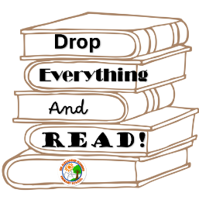
We know that adults modelling reading enthuses children, develops fluency and is a key way to promote reading for pleasure at our school. It supports vocabulary development as children will be exposed to a million more words!
Teachers use their professional judgement to decide which text is read to their class.
They base their choices on the age of their students, their interests and curriculum links.
- Drop Everything and Read
At 1pm every Wednesday the whole school community ‘drops everything and reads!’
Children know this is a great opportunity to practise and enjoy reading. Children in KS2 read their Independent Reading Book and get stuck in! Children in KS1 and EYFS read either their decodable book or a book selected for pleasure, depending on their ability and maturity.

Children who find reading trickier are read to by their peers or an adult to develop their love of reading and aid their comprehension.
- Book Club
Book club is a time in which teachers, who are influencers, share and recommend books to pupils for class reading and reading at home.
It takes place once a week for around twenty minutes. Children draw on children’s interests, previous knowledge and ability in order to support children to make choices about books they read.
Once children can decode and read fluently, selecting books for and with them becomes trickier. This is the time in which they really begin to develop their own tastes and opinions of books. We know children will read more if they think of it as desirable. Book Club is a way to support reading and develop a love of reading.
Book club consists of a range of activities such as:
- Adults recommending books with similar themes, settings and characters: ‘If you liked this book, you might also like ...’
- Showcasing a series of books by the same author or illustrator.
- Promotion of other teachers’ and the headteacher’s suggestions.
- Teacher’s reading a teaser from a book that will be arriving soon.
- Reminding pupils of the books that have been read in story times.
- Revealing the cover, author and illustrator of a book to create anticipation.
- Introduce the type of book commenting on whether it is a short or long read.
- Describing the setting or a few key characters in a book.
- Reading part of the opening, to a point where pupils would want to carry on reading by themselves.
- Read intriguing extracts that might be key to the plot, without giving too much away.
- Asking pupils to provide a two- or three-word book review.

- Guided Reading (Y2 and KS2)
Guided reading is a tutored approach to the teaching of reading which involves fluent decoding and comprehension.
At Sir Alexander Fleming Primary School children participate in 4 sessions a week, which have been sequenced to support the acquisition and progression of skills and knowledge.
Sequence of Guided Reading Lessons
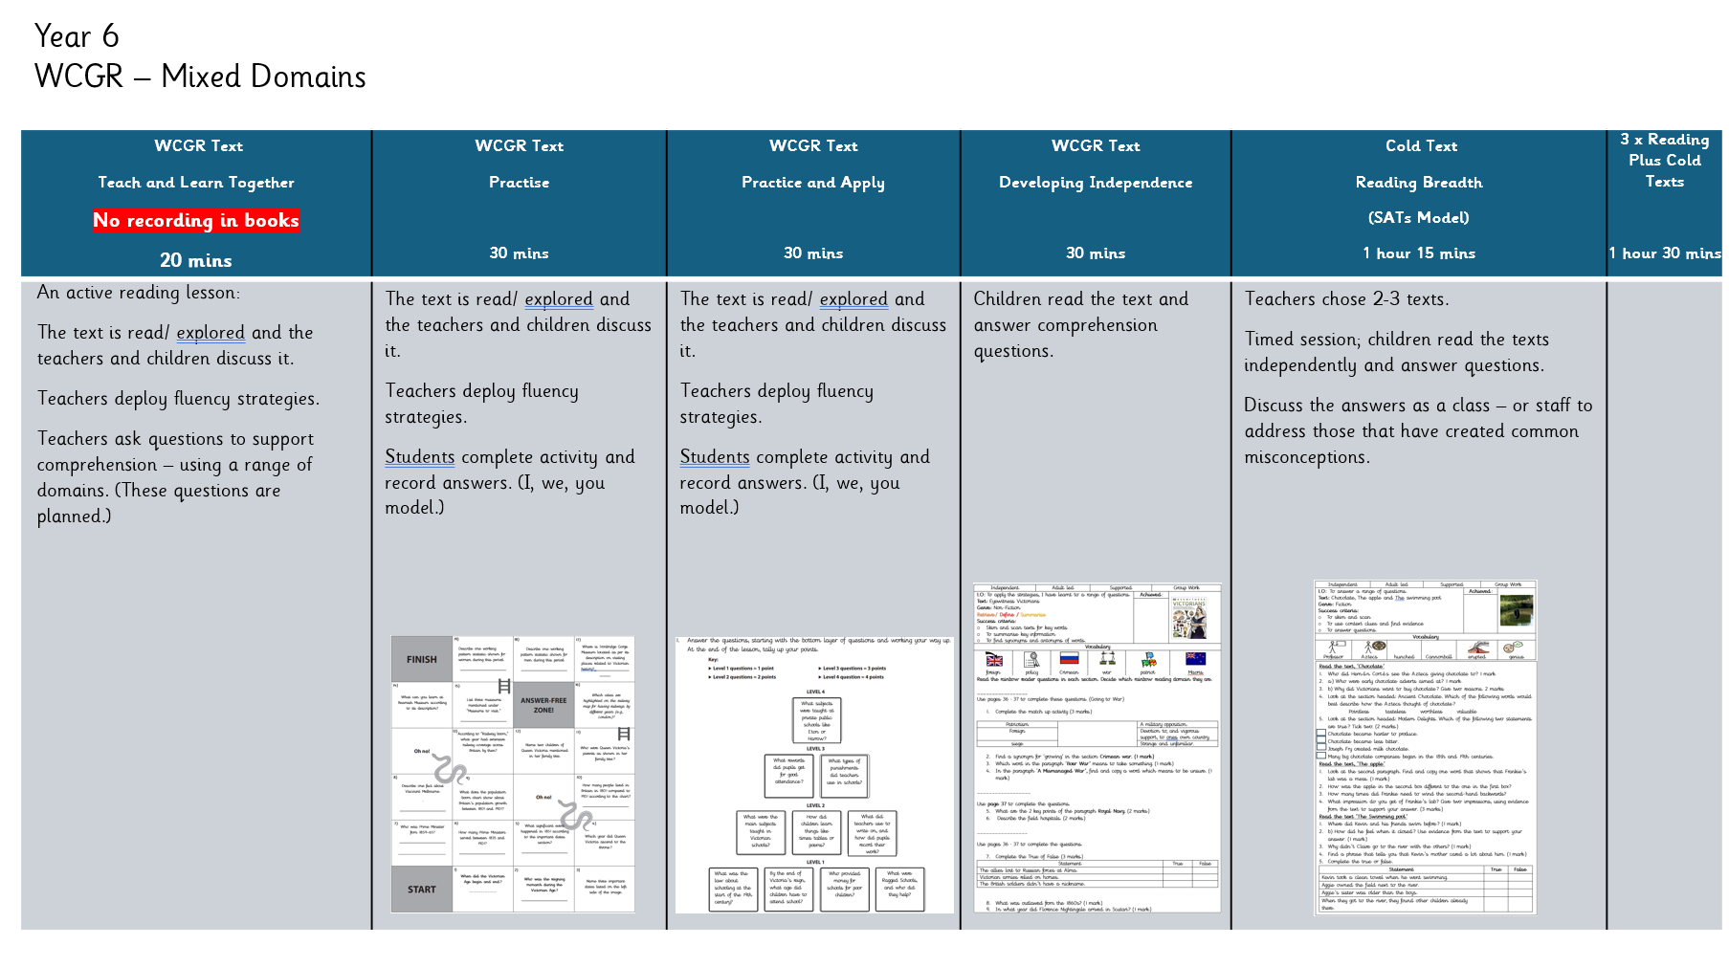
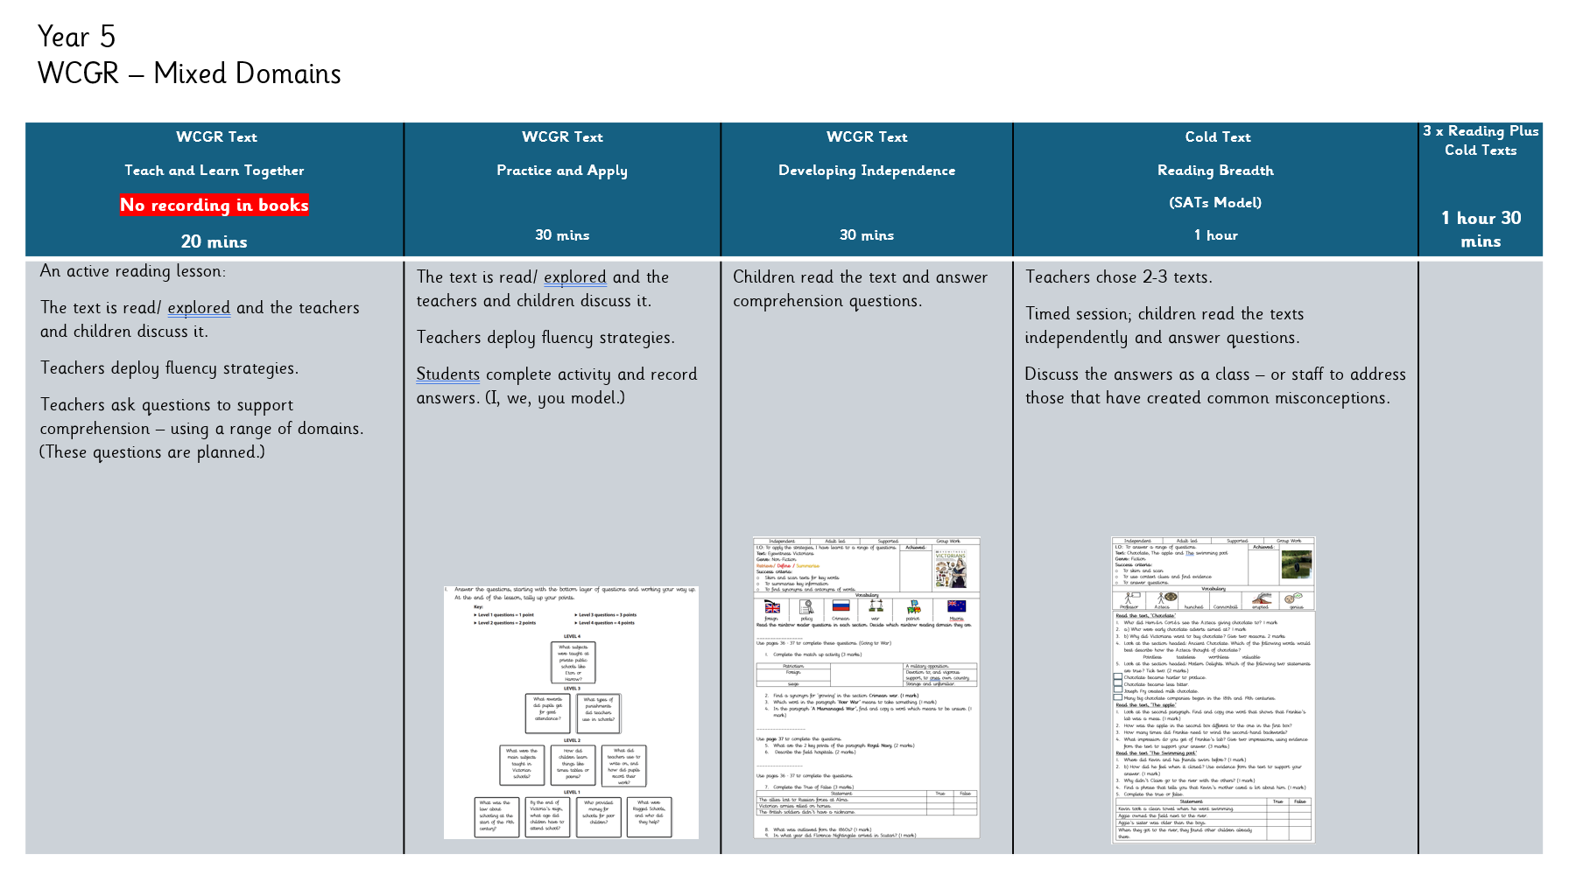
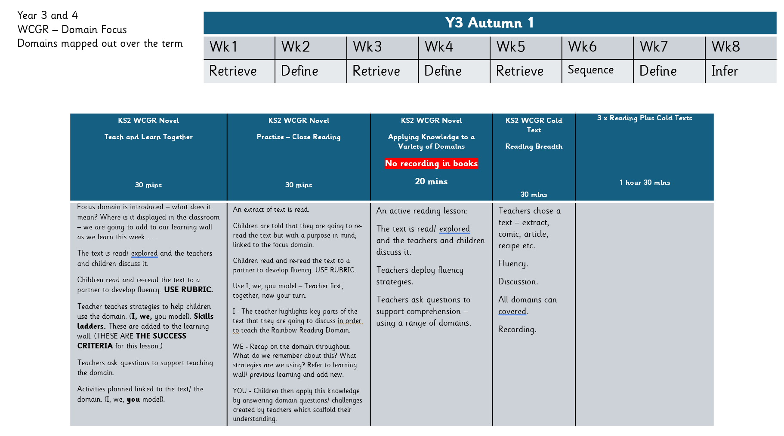
During these sessions teachers use their pedagogical and subject knowledge to model reading skills, discuss ideas and linguistic points within the text and check for understanding. Children participate in both oral and written activities to develop their comprehension skills.
Teachers at Sir Alexander Fleming Primary School and nursery recognise that comprehension is the outcome of good reading. They support children to become amazing readers by employing a range of strategies:

- A mixture of the teacher and children reading
- The type of reading taking place; echo, choral, control the game, paired, repeated, rehearsed etc.
- Adults model, comment, notice (features, plot) and explain (vocabulary, meaning) – comprehension monitoring ‘thinking out loud’
- Discussion, offering ideas, asking/ preparing questions to ask at specific times
- Supporting children to build a mental model
- Developing background knowledge/ making connections

Reading domains provide the basis of teaching for guided reading lessons. The domains are mapped out across year groups, leading to our oldest children in Year 5 and 6 answering comprehension questions covering all of the domains.

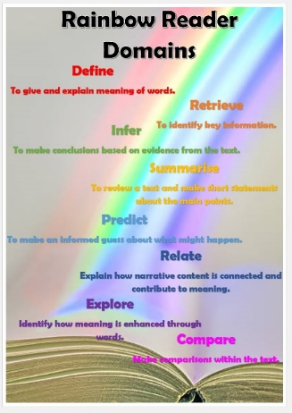
Focus domains are selected due to the children’s needs and the text being covered. Teachers also address all of the domains each week as we recognise that the domains are inextricably linked.

- Rainbow Reading Domains

Reading domains are used to support children’s comprehension skills. Activities
are planned to develop these skills.

KS1 6 Domains
Define, Retrieve, Sequence, Infer, Predict, Decode
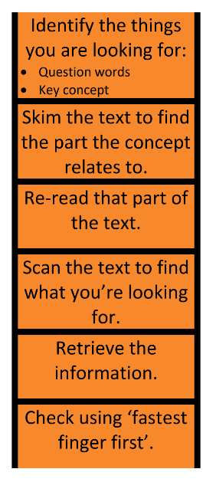
In EYFS and KS1 teachers use the language and skills associated with the domains when
Discussing literature.

KS2 8 Domains
Define, Retrieve, Infer, Predict, Summarise, Explain, Compare, Relate
In guided reading these are all addressed, however some form parts of others. For example,
Explain becomes apart of Retrieve and Infer.
Therefore, the Domains that will be explicitly taught in Year 3 and 4 are
Define, Retrieve, Infer, Summarise.

In lower KS2 children are explicitly taught the domains and the skills during whole class guided
reading sessions.
In upper KS2 lessons use a mixture of domains.

Domains are colour coded in order to teach specific skills and
support children’s memory of these.

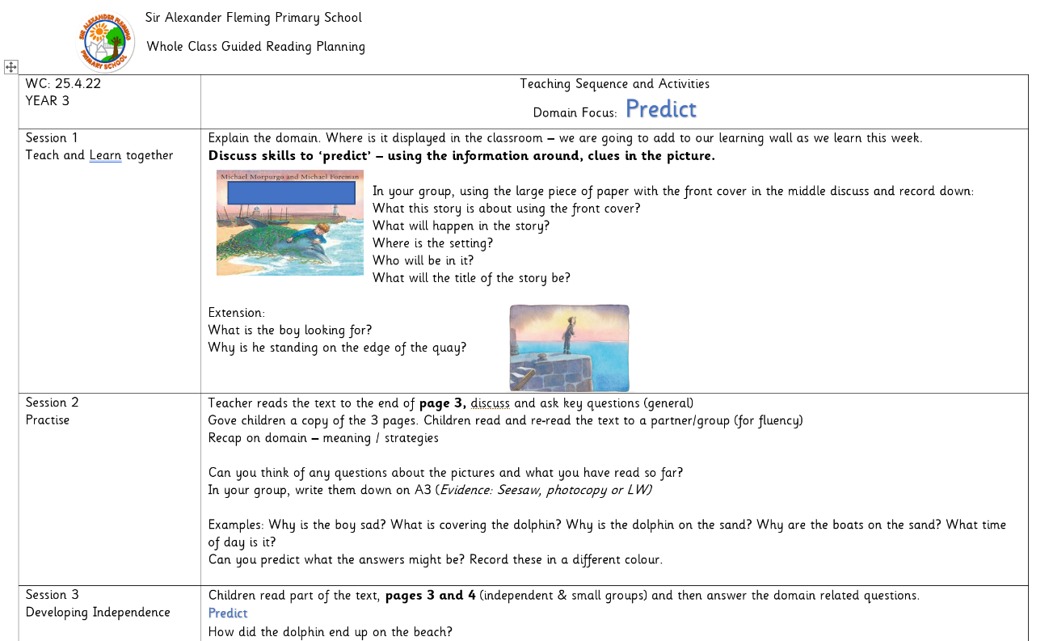

Learning Objectives in lower KS2 are created showing the focus reading domain, for example,
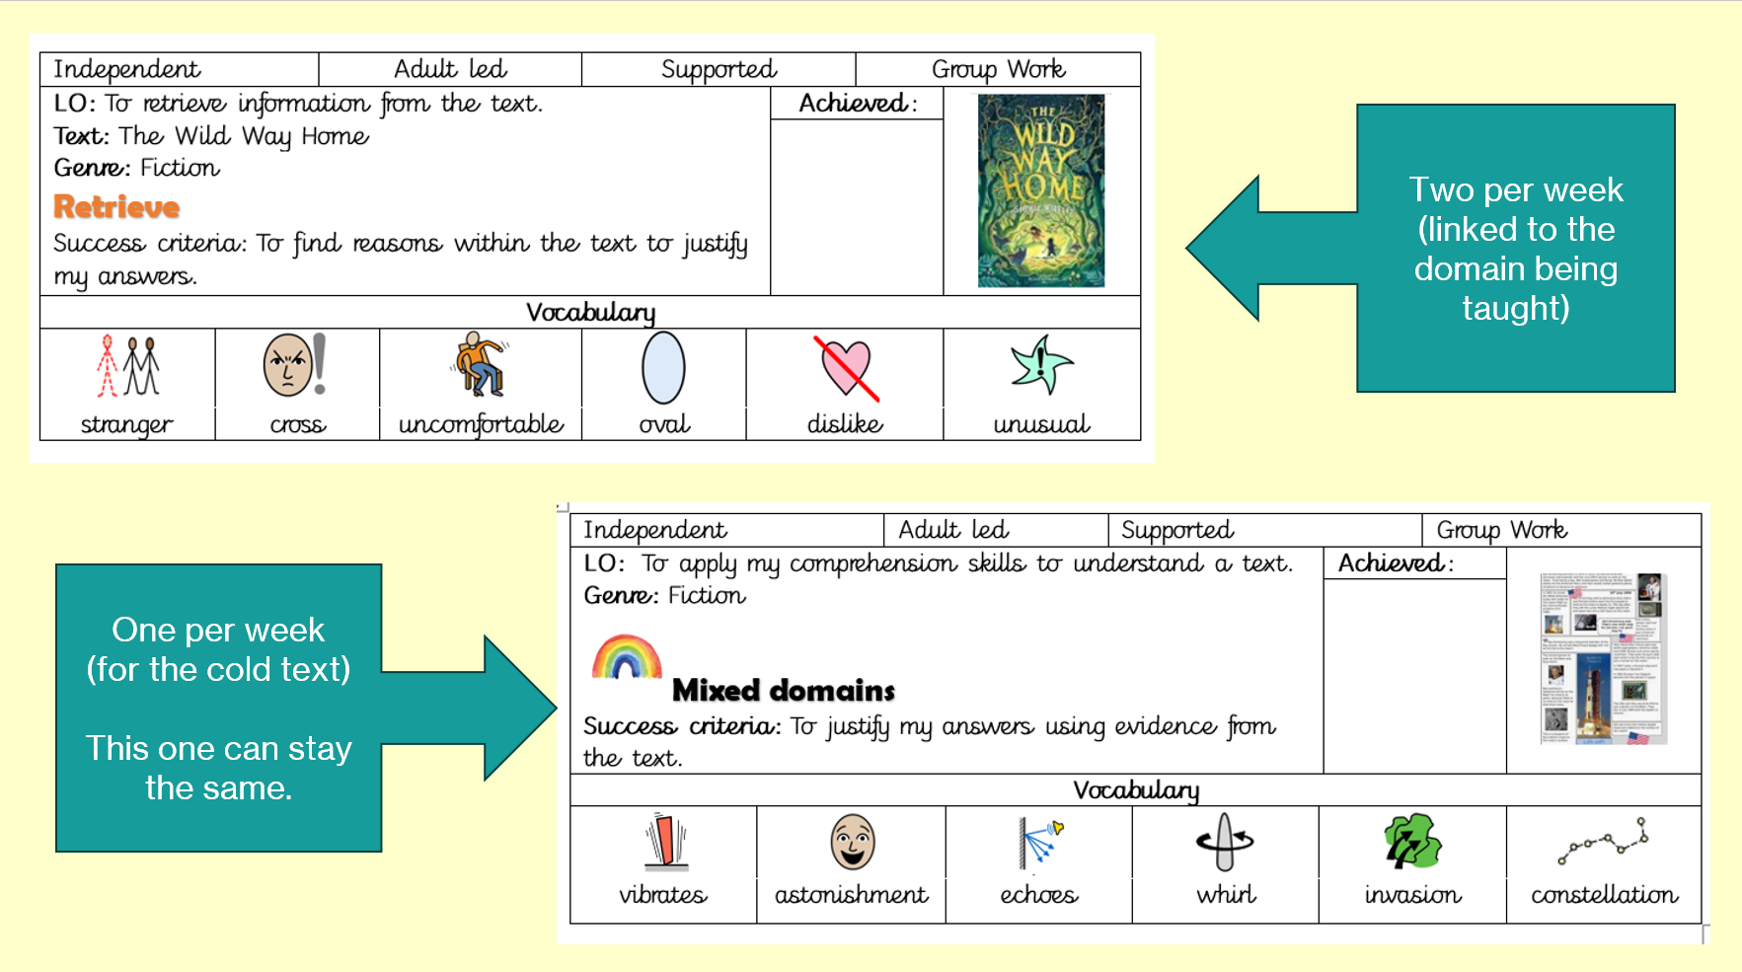
In this way children are given explicit instruction and know what they must do in order to be successful.
Learning Objectives in upper KS2 show mixed domains.
Rainbow Reading Sessions cover non-fiction, fiction, poetry and extracts.
- Fluency
All teachers understand that reading fluently positively impacts on children’s comprehension. Fluency is addressed by teachers every day in every reading context. Teachers employ a range of different strategies such as:

- Children reading a lot!
- Discussing the meaning of words children have decoded to support them to remember the word
- Children listen to outstanding adult models
- Use the reading fluency rubric
- Adults talk about fluency/ plan how they will read a passage
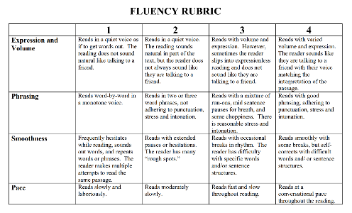
- Re-reading passages of text an adult has read
- Re-read to a partner
- Re-read alone
- Annotate and plan how to read a passage more fluently
- Choral reading
- Re-reading a challenging poem/ song the class know by heart
- Echo reading
- Choral reading

Fluency is formally assessed in year 1 and 2 each half term using a fluency screening. In year 1 children are on track if they can read 50 words per minute by December, 60 words per minute by April and 70 words per minute by July.

Children are on track by the end of year 2 if they can read 90 words per minute.


Teaching is adapted/ a greater focus on fluency and automaticity is ensured to move these learners forward.

Fluency is assessed in KS2 using Reading Plus.

- Reading Plus

Is a digital reading programme which is delivered on iPads/ computers which aids children’s fluency and comprehension skills in KS2.
- Children are assessed three times throughout the year.
- They read texts matched to their ability and answer comprehension questions on a tablet.
- Is used 30 minutes, 3 times a week.
- Children have a discrete vocabulary lesson each week in which they learn the meanings of new words.
- It uses tracking technology in order to support children to focus on the words from left to right in order and at a good speed.
- It generates children’s reading age and speed.
It is used alongside our traditional teacher led reading offer to boost progress with the aim of the % of children at age related expectations would increase.
It is accessed by children at home.
- Our Reading Offer in the EYFS
Context
Our curriculum is built on our fundamental belief that rhymes, stories and literature are crucial in ensuring positive outcomes for our children. We know that our setting is in an area of high deprivation and many children do not have access to books and that our parents may not have the means or understanding that this is important for children’s development.
Implementation
Therefore, we plan key rhymes, stories and texts throughout the year to match the needs of our children and ensure that they know and remember a bank of literature to build on as they move into year 1.
We are also adaptive and use songs, rhymes and stories which we have not planned into the long-term overview due to children’s interests or emerging needs.
In Nursery children listen to and read with an adult in small groups every day. They also listen to an adult read each day too.
In Reception an adult plays in the book corner every day at 8:30am. They target children who are in need of higher amounts of adult interaction and do not read at home.
Staff use the key texts in the long term overview to plan experiences for carpet sessions, continuous provision and small group activities. Staff also plan and deliver a daily story time. They select literature which supports the delivery of curriculum goals. Staff plan a daily nursery rhyme session using the rhymes from the long term overview and others. Staff take as much time as needed to embed the rhyme/ story based on the children’s needs. They return to rhymes children have been previously taught in order to ensure these are not forgotten. They ensure the pace is matched to children’s abilities but that children are also challenged sufficiently.
Parents are encouraged to read with their child every day. We support them to do this by ensuring all children in the EYFS take home a book that their parent can read to them.
We share the focus text and rhymes we are using on Seesaw, the online platform we use. In this way parents can support their children’s recall and understanding of what is being taught in school. They also see how the adult models reading to children in an engaging and developmentally appropriate way.
Alex bear goes home with children in Nursery every two weeks so that they can read him a story!
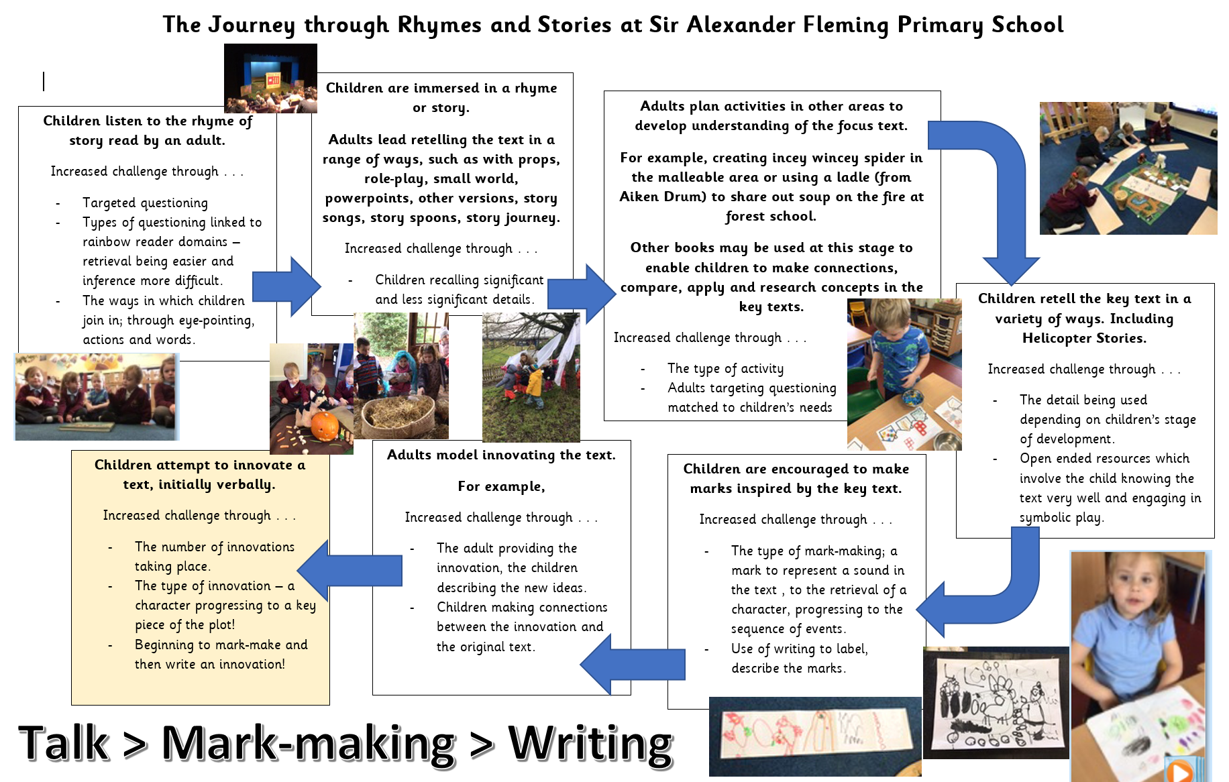

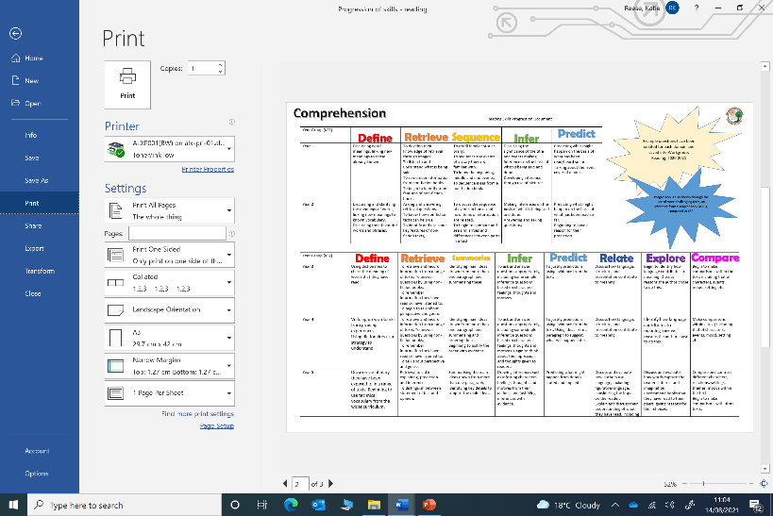
- Progression of Knowledge

The order in which children are taught skills in reading is important. For example, children must be able to identify emotions from picture before inferring why an emotion is felt by a character. The progression of knowledge document outlines which skills should be taught in each year and shows the appropriate sequence for each domain.
- Quality Texts at Sir Alexander Fleming Primary School and Nursery
We teach reading by using quality texts in a range of genres. We select texts that we anticipate will intrigue and interest our learners. They have been chosen by teachers to portray a diverse range of characters, settings, cultures and issues.
They have been chosen using a range of considerations:
- Age appropriateness/ challenge
- Links to the wider curriculum (background knowledge strengthens comprehension)
- Literary techniques
Our Whole School Overview
Teachers use model texts in English lessons to support the teaching of key concepts and linguistic features. Texts inspire children’s writing.
This document highlights which books/ texts have been selected and are being used in English lessons. The texts are sequenced to ensure children are challenged appropriately; they have appropriate background knowledge and reading skills.
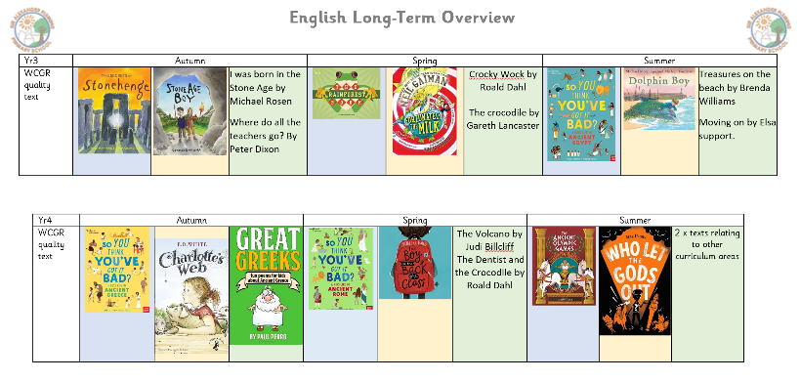
The texts include fiction, non-fiction, poetry, classic and modern literature and graphic novels.
These texts form our School Reading Spine
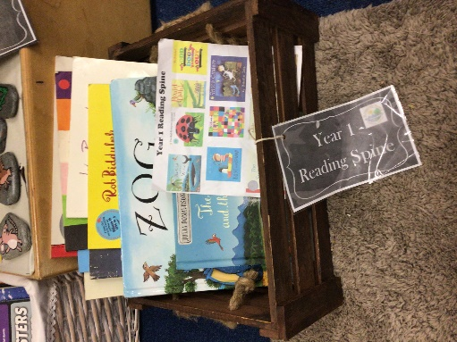
In KS1 and the EYFS teachers have selected key texts for their year group. These texts choices are based on research and experience. The books are age appropriate and intend to meet the interests and needs of the children. We believe the children at our school have a right to know these novels and stories.
Teachers share their reading spine with their class in many ways such as through whole class reading, guided reading and using a text to inform other areas of the curriculum. These books are displayed within the class library.
Our Poetry Reading Spine

Teachers have selected three core poems/ poetry texts for their year group which are key to the successful teaching of reading and enjoyment of reading for children in their classes.
In Y1 and the EYFS The Poetry Basket is used in which children hear and learn poems across the year.
Our Non-fiction Reading Spine
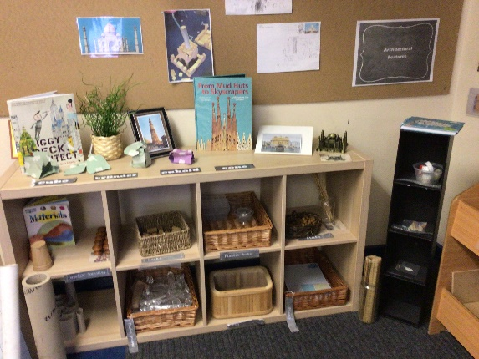
Teachers have selected three core non-fiction texts for their year group which are key to the successful teaching of reading and enjoyment of reading for children in their classes. They support knowledge in other curriculum areas.
Reading across the Curriculum

At Sir Alexander Fleming Primary School we know children learn by making connections between old and new ideas.
We know they need practise to embed knowledge.
Therefore teachers help them to apply reading skills in every subject.
When planning the yearly overview for their year group, teachers identify key texts that will be used to support all areas of the curriculum.
Subject leaders and teachers have identified core texts to support the teaching of skills and knowledge within their subject and these are used to enrich understanding. Reading about a subject or topic gives reading a meaningful, exciting purpose.
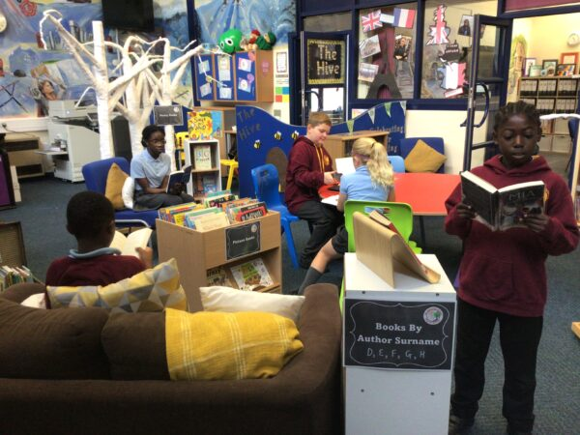
Staff display key texts on interactive displays within their classrooms. For example, in the Biology Area in year 1 non-fiction texts are presented. In this way children learn the importance and uses of reading in many different contexts.
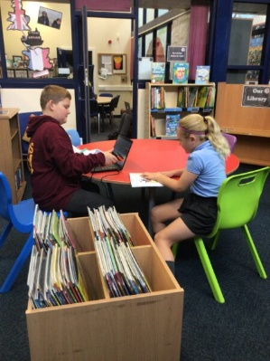
- Environment
Our Whole School Library
Funded by Foyles, our whole school library includes hundreds of new and engaging books that children are able to take home to read. They depict a diverse range of characters and settings. Every child in our school can pick up a book and see themselves reflected in it. They can be the hero, adventurer or sidekick!
We have books for everyone; all ages and abilities are catered for. These texts will develop a life-long love of learning for our children. We also have an online library system to track children’s interests and reading journey.
Our Class Libraries and Story Areas
Teachers create an inviting and stimulating Class Library’s and Story Area’s within their classrooms in order for children to enjoy books and stories and apply their reading skills.
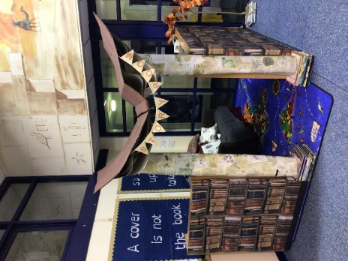
The aim of our Libraries and Story Areas are for children . . .

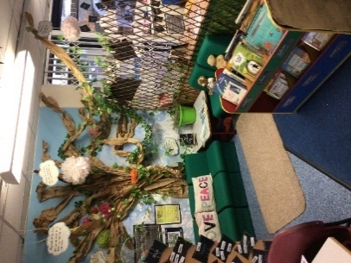
- To apply reading skills.
- To practise reading.
- To make reading a social and enjoyable activity. To read for pleasure and create enthusiasm for reading.
- To expose children to many books and high quality literature.
- To give children time to read alone or with others in a nurturing, homely environment. Book areas are a relaxing place.
- To develop a love of stories and support children to become story-tellers.
- A place where adults can model reading for pleasure and be playful with stories.
- A high quality, classroom resource which children can use to be independent learners; “I’ll grab an information book about animals to try and find out the answer to that question.”
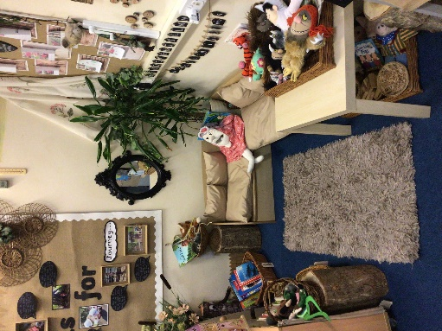
- To promote talk and the use of vocabulary.
- To develop their understanding of plots, characters and vocabulary.
Our Class Libraries and Story Areas are well-resourced and include:
- Age appropriate and challenging texts.
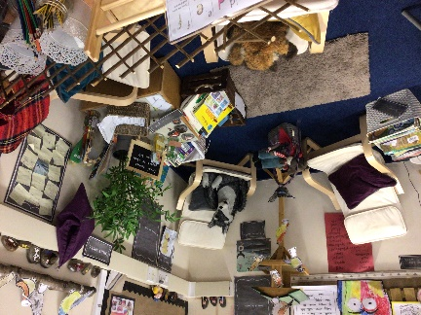
- Books for all children; we consider which books would inspire certain groups.
- Poetry
- Magazines and newspapers
- Fiction and non-fiction texts
- Storytelling resources
- Authors and illustrators
- Our school reading spine

At Sir Alexander Fleming Primary and Nursery School we recognise the importance of Class Libraries being about books! Our Story Areas are kept separately as children can use different skills in this area.

Phonics Walls/ Resources

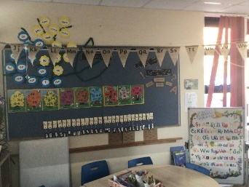
In every EYFS, KS1 and Nurture classroom there are
- JPs Tricky words displayed
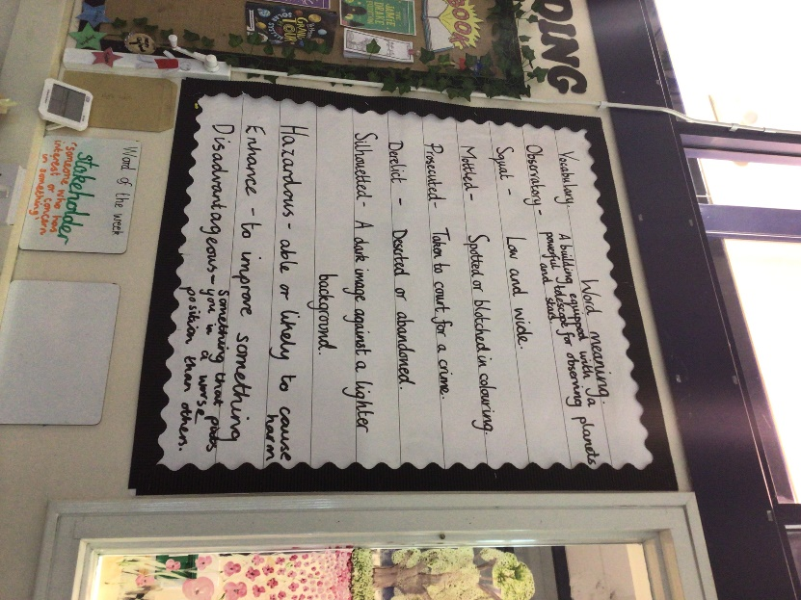
- JPs Alternative graphemes trees
- Jolly Phonics Letter Sound Poster
- Alphabet poster
- Animated phonics mat, Tricky word flower mat

In every KS2 classroom there is
- Plain phonics mat
- Plain tricky word mat

Vocabulary Walls

All classrooms have a Vocabulary Wall that has key words and their definitions identified from the texts being studied and words linked to the curriculum children are immersed within.

- Assessment
Formative Assessment
Teachers at our school are continually assessing and looking for what children know and can do in reading. Teacher’s listen to and observe children reading and this informs their assessment data for the subject.
Teachers’ modify their future reading planning due to assessment, in order to support children’s learning in this subject.
Teachers plan lessons so that children learn new skills and apply them. Teachers endeavour to plan for lessons in which children become independent at applying the skill that has been taught.
The questioning strategies that teacher’s use in the teaching of reading are very important. (Please see Rainbow Readers.) Children need to understand what they are being asked to do in order to answer successfully. We use similar questions throughout school but the texts become progressively harder in order to ensure children progress.
During phonics sessions teachers ensure they know children who have gained the knowledge of the GPC and those who have not and this informs precision teaching interventions for these children.

Summative Assessment

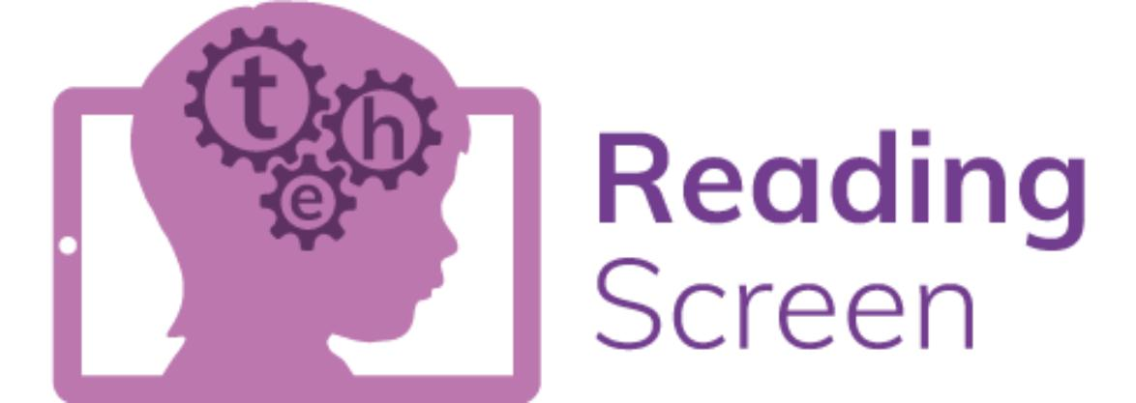
Teachers track children’s phonic ability half-termly using a Jolly Phonics Assessment Checklist. These assessments support teachers to identify any areas of concern children are encountering such as Grapheme Phoneme Correspondence, Blending and Fluency. The results of this assessment informs interventions.

We also use Reading Screen each term in order to assess children’s attainment in reading and progress.

Teachers in R and KS1 know if a child is on track based on the book they are reading at key points in the year.

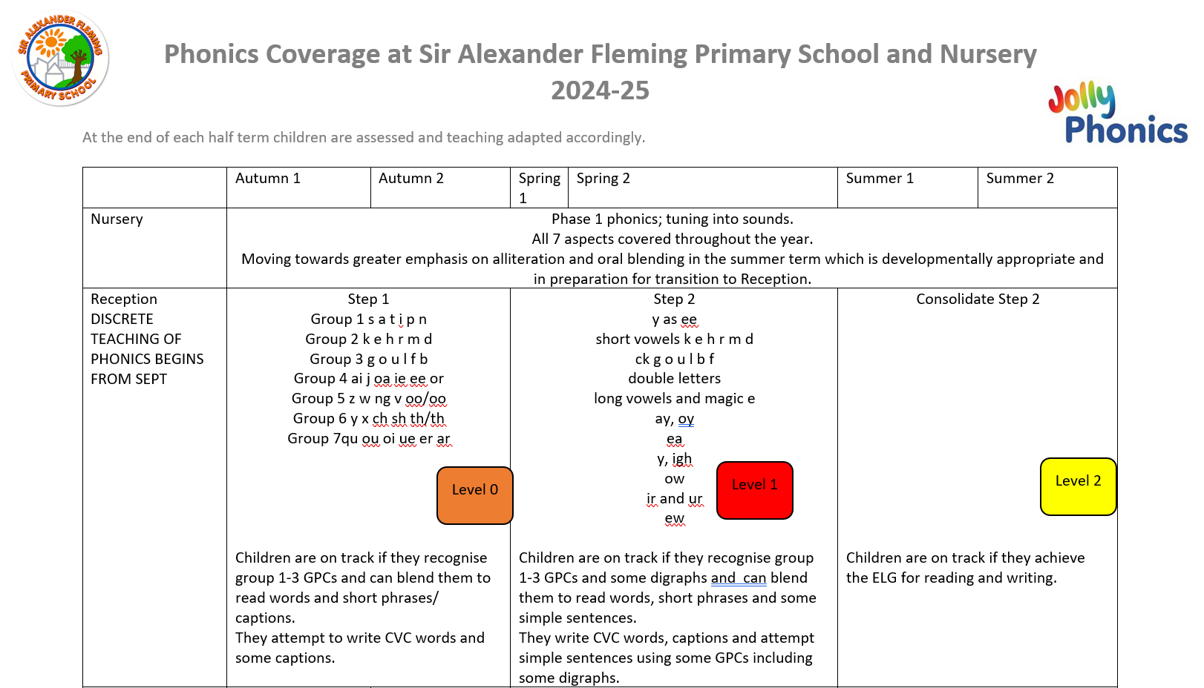

Reading Interventions are a priority at Sir Alexander Fleming Primary School and take place at 8:30am. This is moderated by members of the Senior Leadership Team.

At key points in the school year children undertake an independent NFER assessment. This supports all teachers to know what expected standard is at key points in the term for each year group. It supports the pitch of teaching; appropriate questioning and informs and strengthens our teacher judgements. These assessments are kept for possible scrutiny throughout the year.

All children within school from Reception to Year 6 are assessed using Reading Screen to ensure they have been appropriately identified, if they require greater support with reading.

In KS2 children are assessed 3 times a year using Reading Plus.

Assessment data in reading is reviewed throughout the year to inform bespoke interventions and to also ensure that provision remains well-informed to enable optimum progress and achievement. End of year data is used to measure the extent to which attainment gaps for individuals and identified groups of learners are being closed. This data is used to inform whole school and subject development priorities for the upcoming academic year.

- Support for children who struggle to acquire the basic skills

Following assessment, children who require support are identified and plans made to accelerate progress on our Pupil Progress records.

Children who do not pass the Phonics Screening Test in Year 1 are given extra support through daily Jolly Phonics interventions until they have acquired this knowledge. Leaders track their progress.

Children who struggle to read, read every day at school. We are responsive to each cohort’s needs, each year. Reading interventions take place at 8:30am and 2:45pm. Please see below our current school offer:

YR and Y1
ALL CHILDREN READ TO AN ADULT  3 x decodable book group read  1 x independent read | Struggling readers read at least twice a day  3 x decodable book group read  2 x independent read  (YEAR 1 children attend an after school Phonics Club once a week)  Precision teaching phonics intervention
ALL CHILDREN PARTICIPATE IN
5 x phonics sessions a week
1 x Buddy reading

Y2
ALL CHILDREN READ TO AN ADULT  1 x independent read | Struggling readers read at least twice a day  3 x decodable book group read  2 x independent read  5 x phonics intervention
CHILDREN PARTICIPATE IN
5 x guided reading sessions to aid comprehension
1 x Buddy reading

Y3
ALL CHILDREN READ TO AN ADULT  1 x independent read | Struggling readers read to an adult every day  4 x group read during phonics intervention  1 x independent read
ALL CHILDREN PARTICIPATE IN
5 x WCGR sessions for comprehension (rainbow reading domains)
1 x session of Drop Everything and Read
1 x Buddy reading

Y4, 5 and 6
ALL CHILDREN READ 5 x a week during WCGR sessions | Struggling readers read to an adult every day  4 x group read during phonics/ reading intervention  1 x independent read
ALL CHILDREN PARTICIPATE IN
5 x WCGR sessions for comprehension (rainbow reading domains)
Children read during these sessions every day.
1 x session of Drop Everything and Read
1 x Buddy reading

Children who struggle to read have their reading recorded in their reading book via a tick system. Staff also comment, where appropriate on
- Decoding
- Fluency
- Comprehension, linked to the Rainbow Reading Domains

WB
Reading Intervention
Session 1 | Session 2 | Session 3 | Session 4 | Session 5

Parents are notified that their child needs extra support with reading through discussion with their child’s class teacher, receiving a letter in order to attend a meeting with the Reading Leader, access to their child’s APDR on the Edukey website. We invite parents into class to find out more about how we help their children learn to read.

Children in KS2 who are identified as needing intensive support attend the Hive.
The Hive provision is highly personalised and informed by Educational Specialists such as Educational Psychologists.
Y3 children in the Hive receive daily phonics teaching and read a decodable book every day.
Y4 and Y5 children are taught using T&W Literacy Pathway. The sequence of lessons over a week is as follows:

Literacy Pathway | - Flashcards of common exception words  - Flashcards phonetically decodable words  - Generalisation read | - Flashcards of common exception words  - Flashcards phonetically decodable words  - Generalisation read | - Flashcards of common exception words  - Flashcards phonetically decodable words  - Generalisation read | - Flashcards of common exception words  - Flashcards phonetically decodable words  - Generalisation read | Assess c and p words and adapt provision for the following week

Adaptive Teaching

Teachers ensure all pupils can access a demanding text during Rainbow Reading sessions, even those with less well-developed language or reading skills in ways such as:
- Pre-teaching key vocabulary or background knowledge for a small group of pupils
- Supporting these learners within the session, through targeted questioning or further explanations to ensure all pupils understand
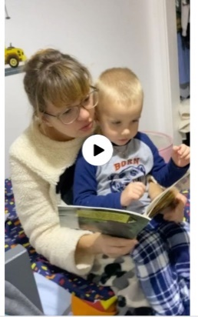
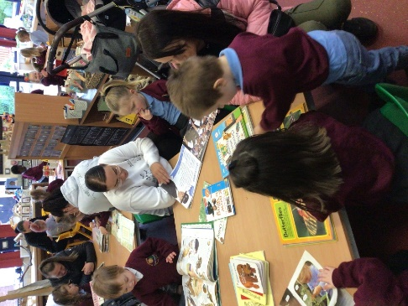
- Small group re-reading the text after the initial reading
- Adaptations to the text
- Visualisers and viewers
- Widgit symbols to aid understanding

- Parental Engagement

Parents receive a letter and short videos explaining the importance of reading with their child and supporting them to know how to do this effectively. They know which books their child will be studying during the year so that they can access these books in order to develop their child’s reading skills.

Parents are encouraged to read with their child as much as possible. Parents log home reading on their child’s Seesaw account. This is monitored by class teachers through a tick-list system. If a parent is not engaging with Seesaw, teachers offer support and in some cases, a paper reading record is given.

Children in KS2 take home a copy of the book they are studying in guided reading and have access to Reading Plus at home, as well as a choice of books from our school libraries.

Our Reading Offer is extensive and all children read every day in school.

Reading mornings in which parents are encouraged to come and read with their child in class, are held each week.

Monday 8:30-9:00am | Tuesday 8:30-9:00am | Wednesday 8:30-9:00am | Thursday 8:30-9:00am
Nursery and Reception | Year 5 and 6 | Year 3 and 4 | Year 1 and 2

Story sessions are planned for the parents of children in the EYFS each year.

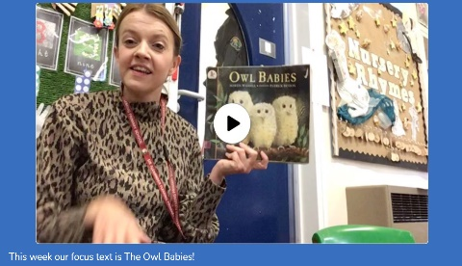
Jolly Phonics sessions are held for parents in the EYFS and KS1 at key points in the year in order to support parents to understand how early reading is taught and develop coherence between home and school. Children take home Jolly Phonics resources weekly in order to further practise letter, sound correspondences.

Teachers and the reading leader create videos to share on Seesaw about the importance of and strategies for teaching reading, throughout the year.

- Whole School Celebrations, Rewards and Cultural Capital
Children develop reading for pleasure at our school in a range of ways.
Buddy Readers
Children participate in ‘Buddy Reading’ sessions each week in which they read to and share texts with another child from a different year group.
Reading Ambassadors
Each class has selected a Reading Ambassador. Their role includes . . .
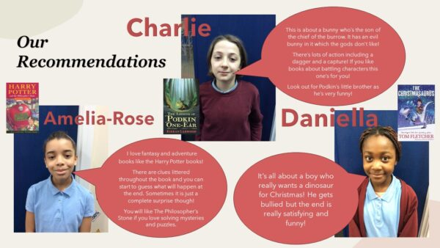
- Being an amazing reading role-models!
- They are enthusiastic about reading and inspire other children to read.
- They look after books in the whole school library.
- They help during reading assemblies.
- They run a reading club at lunchtime on Friday.
- They make recommendations in a termly leaflet and Seesaw post.
Reading Assemblies
Our weekly reading assemblies are planned so that staff address key, global issues and develop children’s understanding of the British Value of tolerance and respect for others. For example, during Earth Day the children read all about Wangari Maathai and how she started the Green Belt Movement in Africa and advocated women’s rights.
This is a time when staff showcase some of the amazing books we have in our school library, specifically the books that show a range of diverse characters.
Class Rewards
We want our children to have an intrinsic motivation to read. Our teacher’s passion and praise enables this.
As an extra motivation individual teachers use their own reward systems in order to encourage reading at home.
Reading Plus rewards are handed out on a half ternly basis.

Book Doors
At key points throughout the year, every class designs and makes a book door to reflect a key text they have been studying.
Visits to the Library
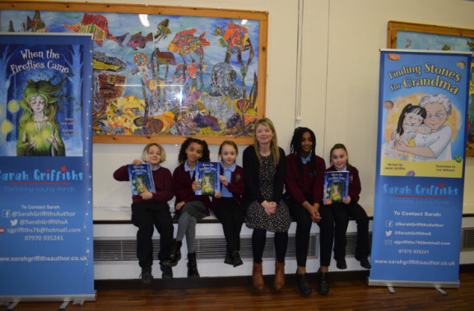
Each class visits Madeley Library once a year. In collaboration with their parents, they are given the opportunity to get a library card and loan books.
Author visits
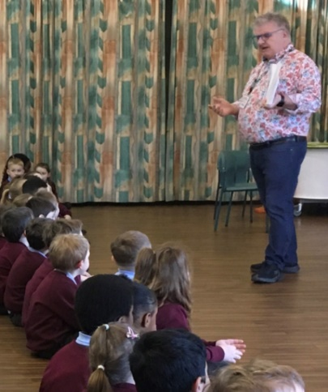
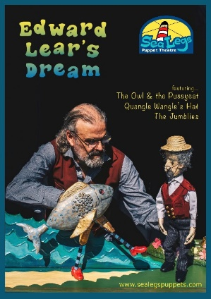
As part of the schools Cultural Capital Offer children receive visits from local authors, watch pantomimes and puppet shows and visit the theatre. These are all linked to books and stories and develop their love of reading further.
- Impact

At Sir Alexander Fleming Primary School we recognise that phonics, spoken language and comprehension are all key in developing successful readers. If any one of these areas is lacking then children will not reach their full potential.
Using our school assessment and pupil progress systems children needing extra support in any of these areas are identified and interventions put in place. These factors ensure that we are able to maintain high standards.

- The reading profile is high in our school and children are interested in reading.
- All children’s books show progress; they show an increase in understanding, independence and knowledge.
- Phonics books show greater accuracy, improved handwriting and greater independence.
- 83.7% of our children passed the Phonics Screening Test in year 1 in June 2025. This data is above National of 81% and shows a continuing positive trend for attainment over the past four years.
- 97.5% of children passed the Phonics Screening Test by the end of year 2, which is above Government aims of 95%. One child who had attended our school for two weeks prior to the test, did not pass.
- Early Years Foundation Stage: Our Reception children achieved 63.7% Good Level of Development. While we were originally at 70.5%, it's important to note that we welcomed 7 new starters during Summer 1, and this naturally impacted our data. 67.8% achieved age related expectations in Word Reading.
- Our KS2 progress measure is green for the year 22-23 at 0.95% compared to national of 0.05%.
- End of KS2 SATs results in July 2024 showed that 61.4% of children passed at an age appropriate level, this is an improvement to the previous year.
- All children, except for one with diagnosed learning needs, are reading more words per minute at a higher level of accuracy within the Literacy Pathway.
- Reading Plus shows that all year groups are making gains in their reading level and word per minute.

PROGRESS
Internal data is submitted and analysed and shows good progress across cohorts for the year 23-24.
The impact of classroom teaching is regularly monitored through use of classroom observations, learning walks, book looks and pupil voice questionnaires.
Children at Sir Alexander Fleming enjoy reading.
- Equal opportunities

At Sir Alexander Fleming Primary School we plan to provide for all pupils regardless of gender, ethnicity, socio-economic status, cultural background, academic ability, Special Educational Need/Disability or vulnerability to achieve their full potential. We are committed to ensuring that children and staff are happy and that they enjoy coming to school. This policy will underpin excellent teaching, learning and progress. It will promote the high standards and high expectations set out in the school’s aims and code of conduct. We are committed to meeting the needs of each individual especially those identified in the 2010 Equality Act. An example of this, with regards to reading may be that teacher’s use the knowledge of their class to pre-teach, adapt questions, adapt amount or part of the text read for children with specific needs.

- Policy Links

This policy should be read in conjunction with:
- Whole School Overview for English
- Progression of Knowledge and Skills Document for Reading
- Jolly Phonics Overview/ MTP
- Decodable Book Pedagogy
- SEND Policy
- Curriculum Policy
- Assessment Policy
- Cultural Capital Offer

