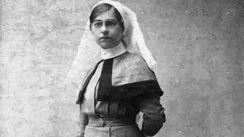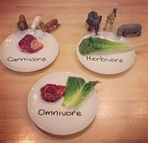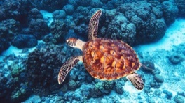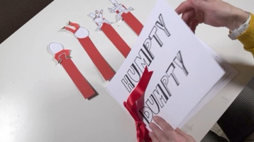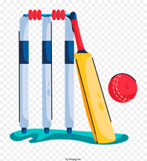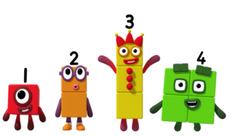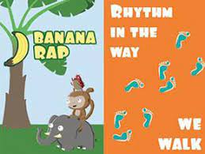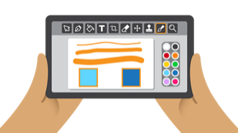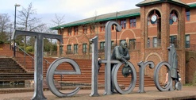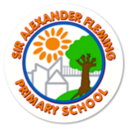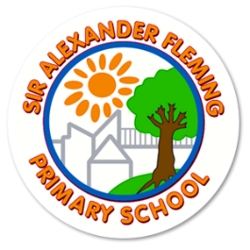

History

Nellie Spindler

Why isn’t Nellie Spindler as well-known as other nurses in history?

Music

Hey You!

Rhythm in the way we

walk

PSHE

Family and Relationships

Health and wellbeing

Science

Animals including

Humans.

Seasons

Mathematics

 Number

Place Value

Addition and Subtraction.

**AUTUMN TERM**

**2025**

Computing

Technology around us

Digital Painting

Geography

Our school, our area.

Art

Colour

ARTIST: Hokusai

**YEAR 1**

A is for animals

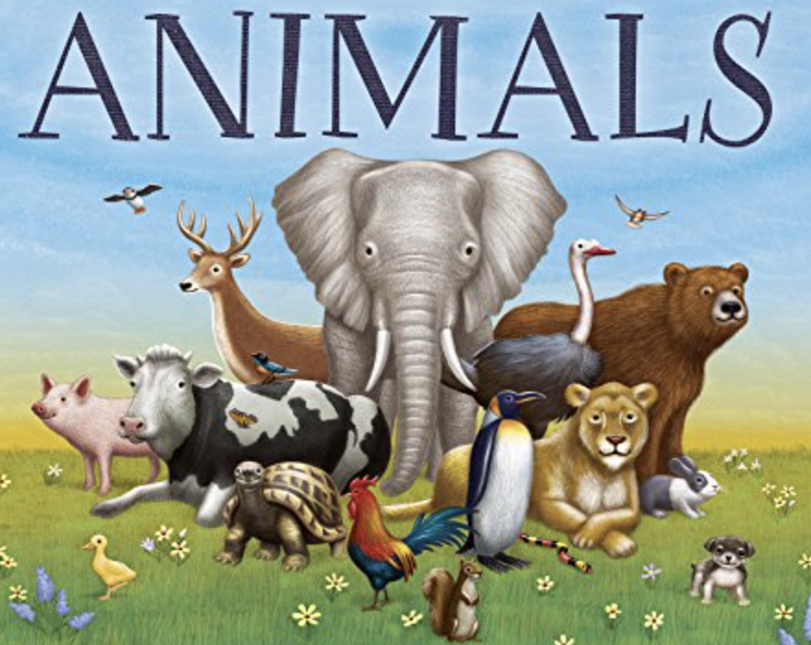

Religious Education

Stories of creation

Islamic and Christian buildings

Design and Technology

Mechanisms –

moving storybooks

PE

Invasion Games

Ball Games

English

Drawing club:

* Fiction
* Non-fiction
* Poetry

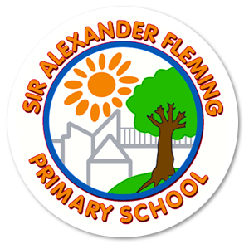

**OUTDOOR LEARNING SESSIONS**

**Outdoor learning sessions will be on a Friday for both Year 1 classes.**

Your child will need to come into school wearing uniform and they will change in school.

Children can bring their wellies, waterproof coats, waterproof trousers/suit for each session and as the weather gets colder to bring hats and gloves. We have plenty of Outdoor learning clothing available in school if needed.

**HOME LEARNING**

We encourage children to read for pleasure at home. Please record your child’s daily reading on seesaw.



**PE DAYS**

PE sessions will be on:

Miss Thomas – **Monday and Tuesday**

Mrs Vickers – **Monday and Tuesday**

Your child will need to come into school wearing uniform and they will change in school.

Children will need to tie their hair up and remove any stud earrings or provide plasters. Hoop earrings are prohibited. It is important that you send your child with the appropriate PE kit, each session; we have a limited number of spare PE kits per class and no spare trainers. PE is a National Curriculum subject.

**HOMETIME**

Your child will be released from their classroom fire door at **3:10pm** promptly. Children will need to be collected by an adult who is registered on your key contacts list.

TRIP

This term we will be going on a trip to the to support our science topics.

More details to follow.

**READING BOOKS**

Your child should bring their book to school **every day.**

In our school we put a huge emphasis on reading and one of our key aims is to promote a love for reading. We would like children to be keen readers, be able to discuss the book and draw inferences, where possible, from within the text.

**Parent reading mornings will take place every Thursday 8.30am-8.45am.**

**WELCOME BACK**

We hope that the children had a brilliant Summer break and we are excited to welcome the children back to school to begin the Autumn term. The children will be learning all about animals, our local area and being part of our world.

Mrs Vickers and Miss Thomas

YEAR 1

AUTUMN TERM NEWSLETTER