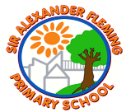
Sir Alexander Fleming primary School’s Writing Curriculum
Year 1 English Long-Term Plan
Reading | Decodable Jolly Phonics Books
Writing | Autumn 1 | Autumn 2 |  | Spring 1 | Spring 2 |  | Summer 1 | Summer 2
Writing | Daily dictation, using the GPCs they know
Quality Text/  Stimulus | Drawing Club  6 texts and daily dictation matched to the GPCs already taught  Narrative: Sentences which retell  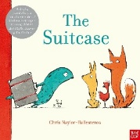  The suitcase  (Chris Naylor-Ballesteros)  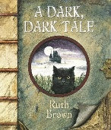  A Dark, Dark Tale  (Ruth Brown)  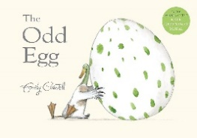  The Odd Egg  (Emily Gravett)  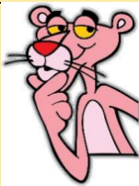  The Pink Panther (Video)  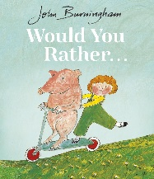  Would You Rather . . .  (John Burningham)  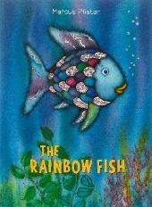  The Rainbow Fish  (Marcus Pfister) | Narrative:  Character Description  2 weeks  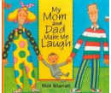  My Mum and Dad Make me Laugh  (Nick Sharratt)  Narrative:  Setting Description  2 weeks  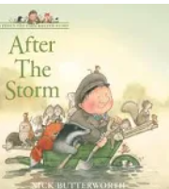  After The Storm  (Nick Butterworth)  Non-fiction: Fact file  1 week  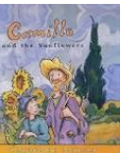  Van Gogh and the Sunflowers  (Laurence Anholt)  Recount:  1 week  Visit to the Sealife Centre (Science)  Lists:  Letter to Santa  1 week  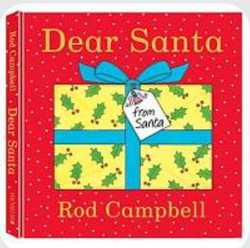  Dear Santa  (Rod Campbell) |  | Non-fiction: Instructions  2 weeks  How to build a windmill  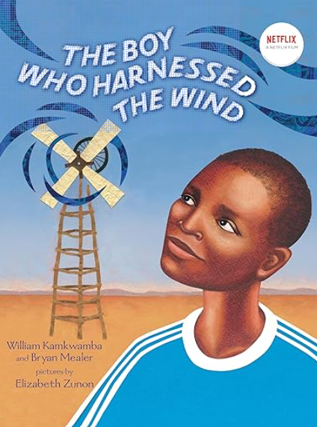  The Boy Who Harnessed the Wind  (William Kamwumba)  Narrative:  3 weeks  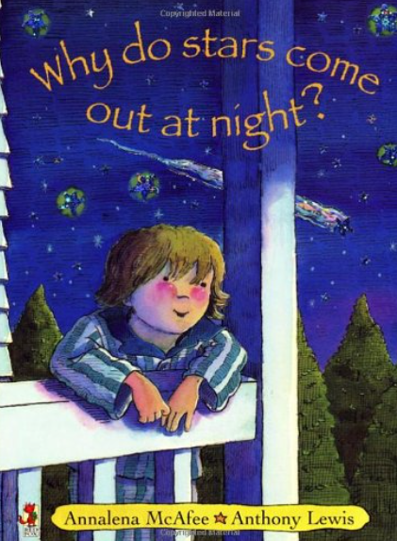  Why do stars come out at night?  (Analena Mcafee)  Recount: Visit to Ironbridge  1 week  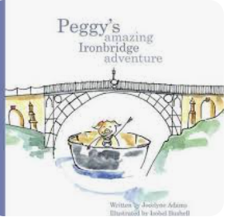  Peggy’s Amazing Ironbridge Adventure  (Jocelynne Adams) | Poetry:  Nursery Rhymes  2 weeks  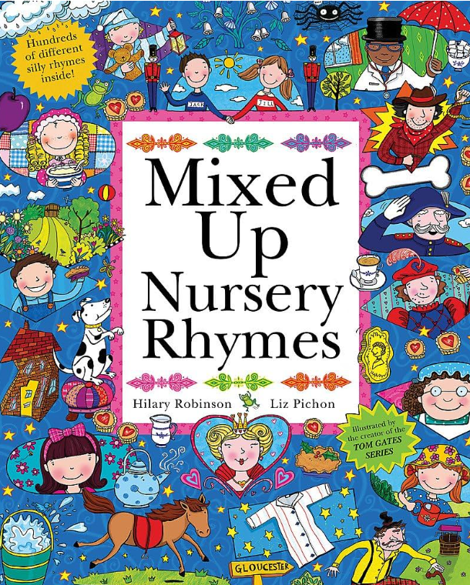  Mixed Up Nursery Rhymes  (Liz Pichon)  Narrative:  Modern Fiction  3 weeks  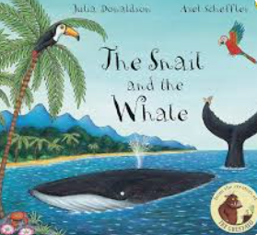  The Snail and the Whale  (Julia Donaldson) |  | Non-fiction: Fact file  2 weeks  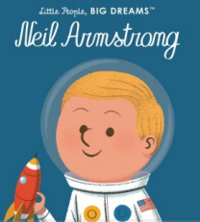  Neil Armstrong  (Maria Isabel Sanchez Vegara)  Narrative: Fairytales  2 weeks  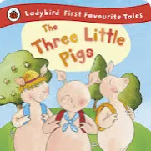  The Three Little Pigs  Poetry: Similes  1 week  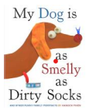  My Dog is as Smelly as Dirty Socks  (Hanoc Piven) | Narrative: Fairytales  3 weeks  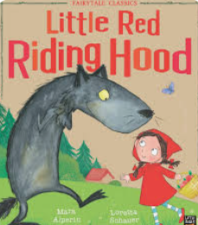  Little Red Riding Hood  (Mara Alpenin)  Recount: Sports Day  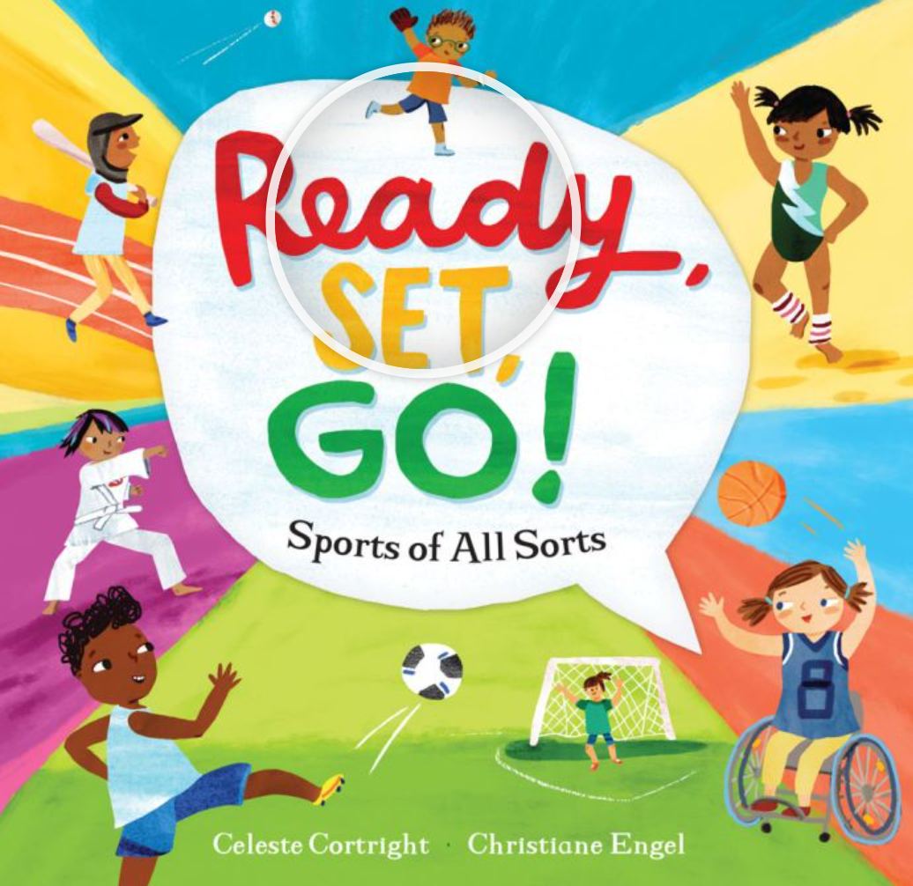  Ready, Set, Go!  (Celeste Cortwright)  Narrative:  Alternative fairytales  3 weeks  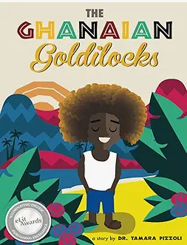  Ghanaian Goldilocks  (Dr. Tamara Pizzoli)
Poetry Basket 2 | Down is the Earth  Many Things, Houses  Owl  Wild Beasts |  | Icicles  Digging  Raindrops  Anger  Confused |  |  | Flowers  Creepy Crawlies  Buster the Fly  Bees

