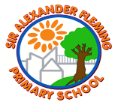
Sir Alexander Fleming primary School’s Writing Curriculum
Year 2 English Long Term Plan
Topic: | The world around me |  | Who’s the king of the castle? |  | Ready, steady, grow!
Writing | Autumn 1 | Autumn 2 | Spring 1 | Spring 2 | Summer 1 | Summer 2
Quality Text/  Stimulus | Non-fiction: Instructions  2 weeks  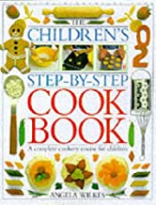  Children’s cook-book  (Angela Wilkes)  Narrative: Quest  3 weeks  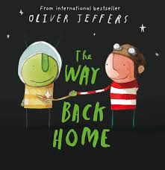  The Way Back Home  (Oliver Jeffers)  Non-fiction: Letters and Postcards  2 weeks  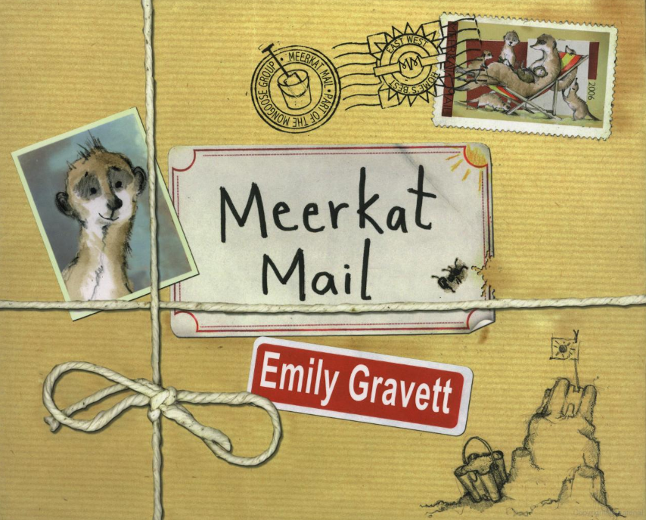  Meerkat Mail  (Emily Gravett) | Narrative:  Picture Books  3 weeks  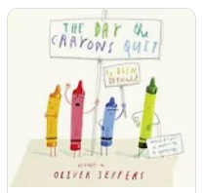  The day the crayons quit  (Oliver Jeffers)  Narrative: Adventure  3 weeks  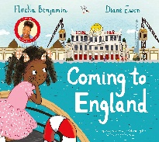  Coming to England by Floella Benjamin  Poetry | Non-fiction: Recounts  2 weeks  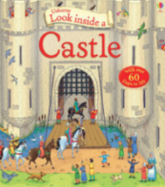  Look inside castles  (Conrad Mason)  Narrative:  Fairytales  3 weeks  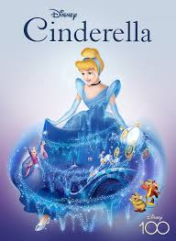  Cinderella / Rapunzel / Sleeping Beauty | Narrative:  Fables  3 weeks  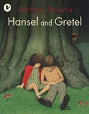  Hansel and Gretel  (Anthony Browne)  Poetry:  Poems with alliteration  1 week  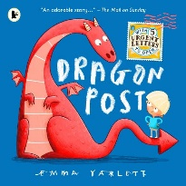  Dragon Post by Emma Yarlett  . | Non-Fiction: Letter Writing  2 weeks  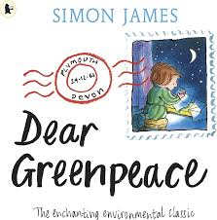  Dear Greenpeace  (Simon James)  Narrative: The Lighthouse Keepers Lunch  3 weeks  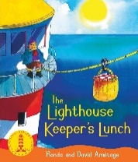  David and Ronda Armitage  Non-Fiction: Explanation  2 weeks  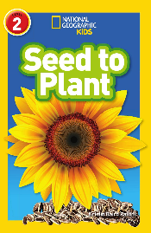 | Information Texts  2 weeks  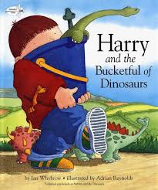  Harry and the Bucketful of Dinosaurs  Narrative:  Familiar settings  3 weeks  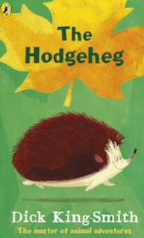  Hodgeheg  (Dick King-Smith  Narrative:  Stories by the same author  3 weeks  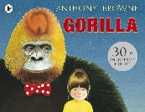  Gorilla  (Anthony Browne)
Oracy projects | Record Instructions | Class Assembly  Christmas Production  Poetry performance | Class Assembly | Poetry Performance |  | Alliteration Poetry Read
Performance Poetry
Poetry Spine  Pie Corbett’s  Poetry Spine  Year 2  Daily Poem | 