
Sir Alexander Fleming primary School’s Writing Curriculum
Year 3 English Long-Term Plan
Reading | 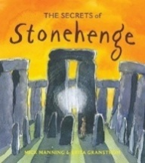 | 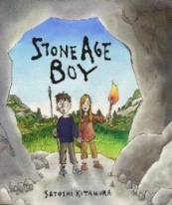 |  | 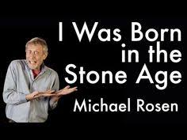 | 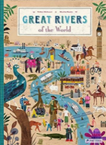 | 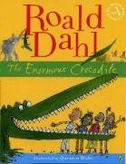 |  | 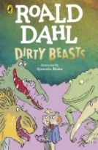 | 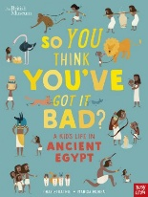 | 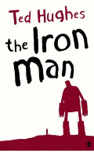 |  | 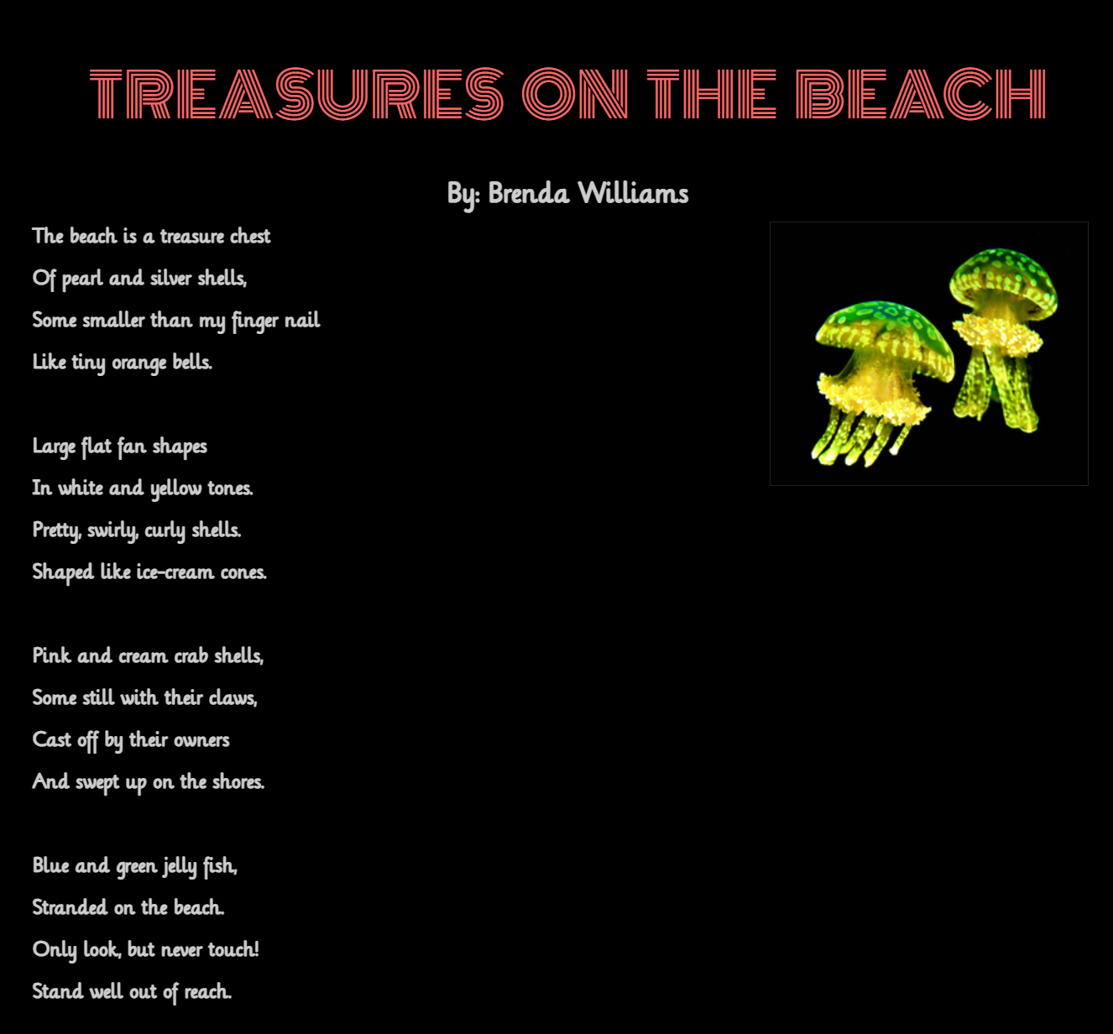
Writing | Autumn 1 |  | Autumn 2 |  | Spring 1 |  | Spring 2 |  | Summer 1 |  | Summer 2
Quality Text/  Stimulus | Non-Fiction: Recount  2 weeks  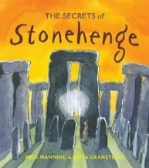  The secrets of Stonehenge  (Mick Manning)  Narrative:  Stories on a theme  3 weeks  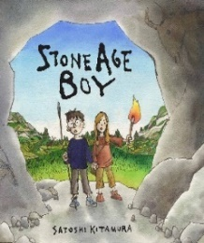  Stone Age Boy  (Satoshi Kitamura)  Non-fiction: Instructions  2 weeks  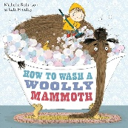  How to wash a woolly mammoth  (Michelle Robinson |  | Narrative:  Stories on a theme  3 weeks  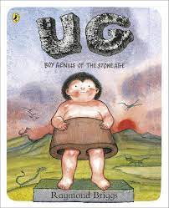  Ug  (Raymond Briggs)  Non-fiction: Report  2 weeks  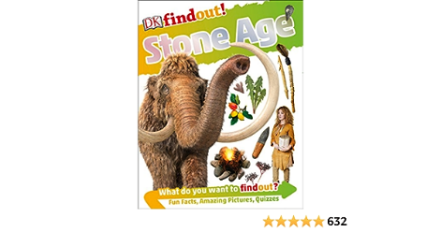  DK: Stone Age (Non Fiction)  Poetry:  Language and imagery  1 week  I was born in the stone age  (Michael Rosen) |  | Non-fiction:  Non-chronological reports  2 weeks  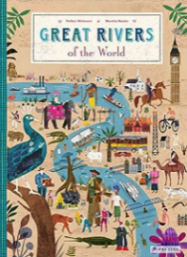  Great rivers of the world  (Volker Mehnert)  Narrative:  Classic fiction  3 weeks  The enormous crocodile  (Roald Dahl)  Narrative: letter writing  Stories that raise issues  2 weeks  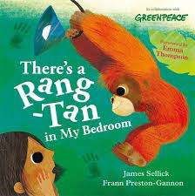  There’s a rang-tan in my bedroom  (James Sellick) |  | Narrative:  Quest stories  3 weeks  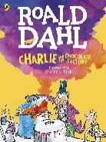  Charlie and the Chocolate Factory  (Roald Dahl)  Non-Fiction:  2 weeks  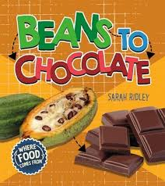  Beans to Chocolate  (Sarah Ridley)  Poetry:  Poems by the same author  1 week  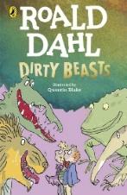  Dirty Beasts  (Roald Dahl) |  | Non-fiction: Explanations  2 weeks  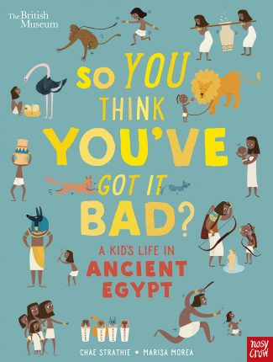  So, you think you’ve got it bad?  (Chae Strathie)  Narrative: Diary entry (Science fiction)  3 weeks  The Iron Man by Ted Hughes |  | Narrative:  Stories from the world  3 weeks  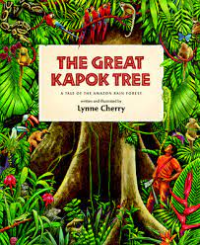  The Great Kapok tree  (Lynne Cherry)  Narrative:  3 weeks  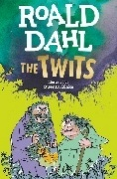  The Twits  (Roald Dahl)  Poetry:  Poems on a theme  1 week  Treasures on the beach  (Brenda Williams
Oracy projects | Sharing Stories with KS1  Class Assembly |  | Class Assembly  Christmas Concert |  | Recorded explanations |  | World Poetry Day performance |  | Record Explanation |  | Sharing stories with KS1
Performance Poetry | 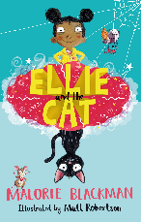  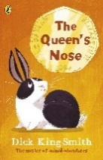  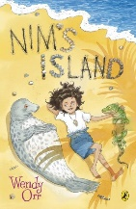  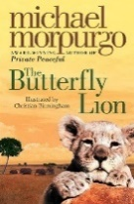  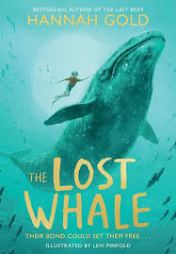
Poetry Spine  Pie Corbett’s  Poetry Spine  Year 2  Daily Poem | 