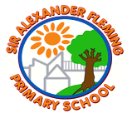
Sir Alexander Fleming primary School’s Writing Curriculum
Year 5 English Long-Term Plan
Reading | 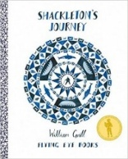 | 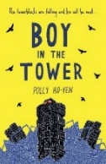 |  | 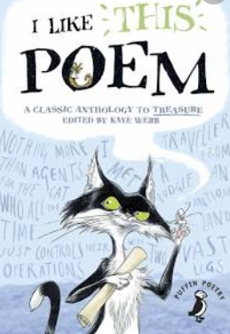 | 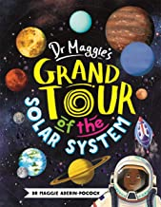 | 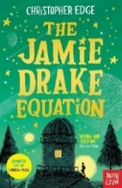 |  | 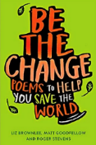 | 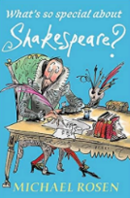 | 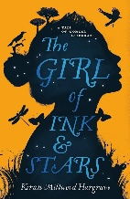 |  | 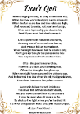  Don’t Quit
Writing | Autumn 1 |  | Autumn 2 |  | Spring 1 |  | Spring 2 |  | Summer 1 |  | Summer 2
Quality Text/  Stimulus | Non-fiction:  Non-chronological reports  3 weeks  Shackleton’s journey  (William Grill)  Narrative:  Stories on a theme  3 weeks  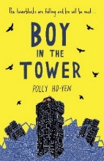  Boy in the tower  (Polly Ho-Yen) |  | Narrative:  Spooky stories  3 weeks  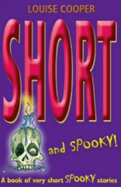  Short and Spooky  (Louise Cooper)  Narrative: environmental issues  3 weeks  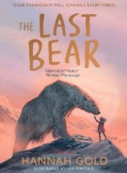  The Last Bear  (Hannah Gold & Levi Pinfold)  Poems on a theme  1 week  I like this poem  (Kaye Webb) |  | Non-Fiction:  2 weeks  Grand tour of the solar system  (Dr Maggie Aderin-Pocock)  Narrative: cosmic adventure  3 weeks  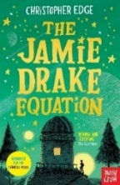  The Jamie Drake equation  (Christopher Edge) |  | Non-fiction:  Travel writing  2 weeks  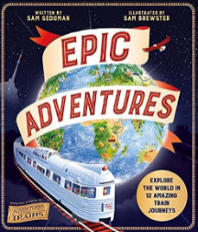  Epic Adventures  (Sam Stedman)  Narrative:  Modern fiction  3 weeks  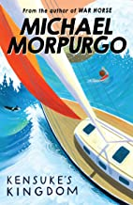  Kensuke’s kingdom  (Michael Morpurgo)  Poetry:  Anthologies  1 week  Be the change  (Liz Brownlee |  | Non-fiction: Persuasive arguments  2 weeks  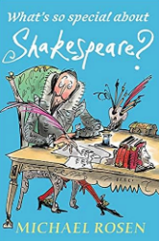  What’s so special about Shakespeare?  (Michael Rosen)  Narrative:  Gothic fiction  3 weeks  The girl of ink and stars  (Kiran Millwood Hargrave) |  | Narrative: magic / folklore  3 weeks  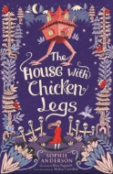  The house with the chicken legs  (Sophie Anderson)  Narrative:  3 weeks  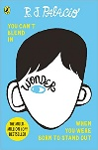  Wonder  (R.J. Palacio)  Poetry:  Aspirational poems  1 week  Don’t quit  (Edgar A. Guest)

