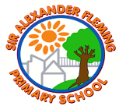
Sir Alexander Fleming primary School’s Writing Curriculum
Year 6 English Long-Term Plan
Reading
Writing | Autumn 1 |  | Autumn 2 |  | Spring 1 |  | Spring 2 |  | Summer 1 |  | Summer 2
Quality Text/  Stimulus | Autobiography  3 weeks  Non-Fiction: Information report  3 weeks  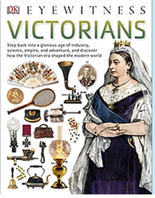  Victorians  (DK Eyewitness)  Narrative: Recount  3 weeks  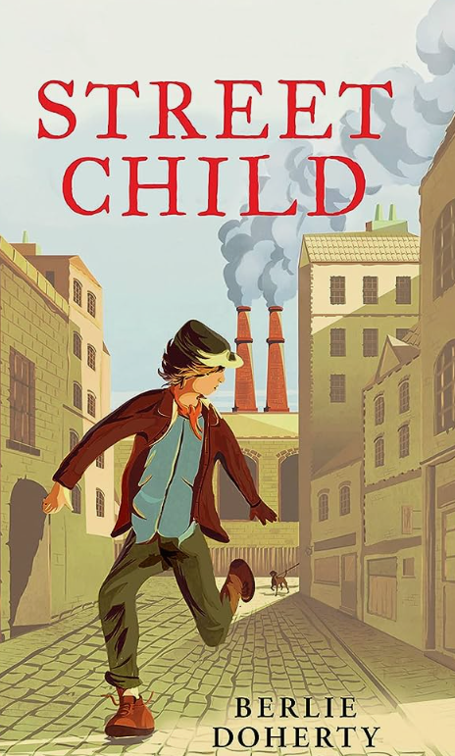  Street child  (Berlie Doherty) |  | Non-fiction:  Persuasive letters  2 weeks  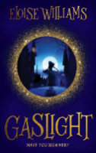  Gaslight  (Eloise Williams)  Narrative: Picture Book / Short Story  3 weeks  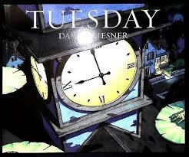  Tuesday  (David Weisner) |  | Narrative:  Historical fiction  3 weeks  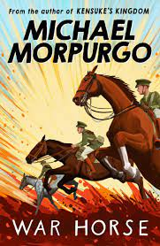  War Horse  (Michael Morpurgo)  Poetry:  Narrative poems  1 week  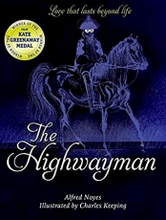  The highwayman  (Alfred Noyes)  Non-fiction:  Persuasive arguments  2 weeks  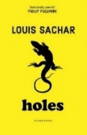  Holes  (Louis Sachar) |  | Narrative:  Quest stories  3 weeks  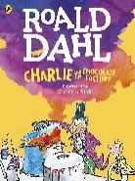  Charlie and the Chocolate Factory - extracts for description  (Roald Dahl)  Narrative: fantasy  3 weeks  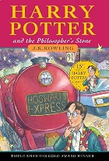  Harry Potter and the Philosopher’s Stone – extract ‘Diagon Alley’  (J K Rowling)  Biography:  2 weeks  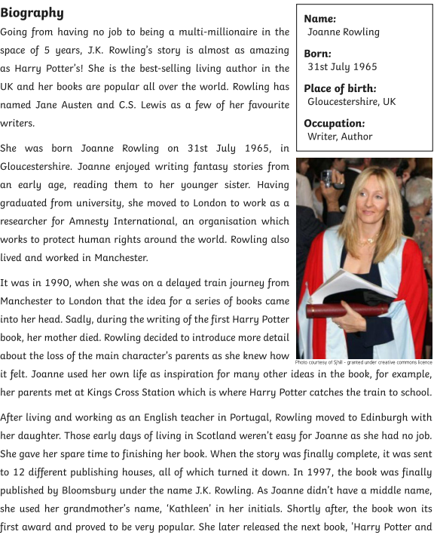 |  | 3 weeks – SATS SPAG revision  SATS WC: 11.5.26  Narrative:  Horror  3 weeks  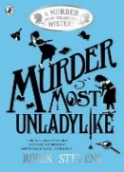  Murder most unladylike  (Robin Stevens) |  | Non-Fiction: Non-chronological report  3 weeks  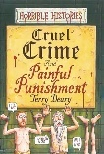  Narrative: horror  3 weeks    Video stimulus
Oracy projects | Sharing Stories with KS1  Class Assembly |  | Class Assembly  Christmas Concert |  | Recorded explanations |  | World Poetry Day performance |  | Record Explanation |  | Sharing stories with KS1
Performance Poetry
Poetry Spine

Pie Corbett’s
Poetry Spine
Year 2

Daily Poem

