Sir Alexander Fleming Primary School and Nursery
Early Years Foundation Stage Policy
Updated September 2025
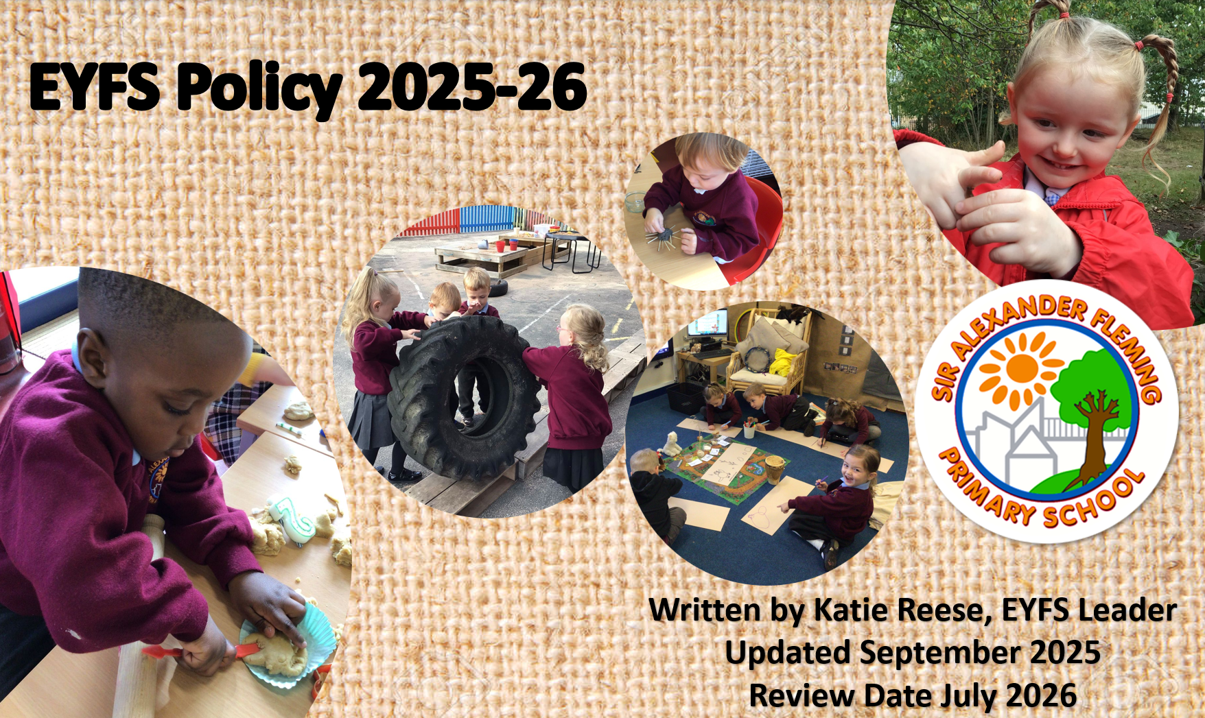
Intent Statement
At Sir Alexander Fleming Primary School and Nursery we feel privileged to work with the families and children in our care.
We recognise that a child’s early opportunities and experiences impact greatly on their future education and life chances. Therefore, their time with us is crucial and we have a great responsibility to ensure that they fulfil their potential, make good progress and be SUCCESSFUL.
“No job is more important than working with children in the early years.” (Development Matters 2021)

Every child deserves the best possible start in life and the support that enables them to fulfil their potential. Children develop quickly in the early years and a child’s experiences between birth and age five have a major impact on their future life chances. (Statutory Framework 2022)
As we are shaping our future generation, we believe and foster an holistic teaching and learning approach in which the ‘whole child’ is considered and supported to develop. We help children to understand and develop their sense of identity through the building of RESPECTFUL relationships and a thoughtful and sequenced curriculum which develops their knowledge of themselves and others.

We know that early teaching and learning opportunities provide ‘building blocks’ for later learning. Therefore the progression of knowledge and skills is considered across all areas of the curriculum. We can ensure that children are secure at the ‘earlier steps’ so that they have the prior knowledge to succeed in their later learning.
We believe in ‘Learning without limits!’ Children do not have a ceiling on their learning here and our environment is set up to foster children at all stages in their learning journey. Children feel SAFE and show what they do. We combine specific resources and scenarios with open-ended ones in order to enable appropriate challenge for all. Our practitioner’s know how to intervene to support and challenge children’s thinking.
We also know that the content of the curriculum must be delivered through strong pedagogical approaches in order to be successful. We focus on The Characteristics of Effective Learning so that children develop good learning behaviours such as BRAVERY, independence, resilience and collaboration. Adults take PRIDE in creating opportunities which interest and inspire children. Children are expected to work hard and try their best through our ‘have a go’ ethos.

We value play! Through this children’s positive attitudes are developed and these good experiences are important in building a life-long love of learning for our children.

Our Philosophy
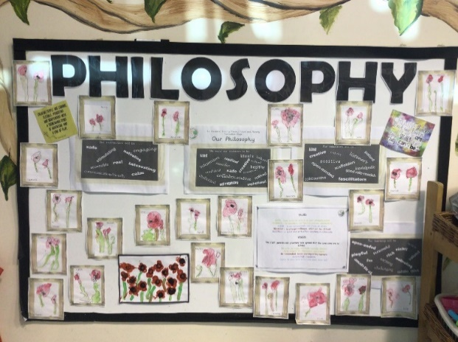

We want our children to be:

Kind, independent, confident, resilient, creative, talkers that are listened to, nurtured, noticed, healthy, investigators, researchers, challenged, safe, self-regulators, collaborative.

Our practitioners will be:

Kind, nurturing, creative, positive, patient, open-minded, knowledgeable, role-models, scaffolders, listeners, collaborative.

Our environment will be:

Safe, stimulating, motivating, engaging, real, interesting, accessible, communication-friendly, calm.

Our learning will be:

Playful, fun, exciting, purposeful, motivating, valued, risky, active, challenging, language and resource rich, analytical, open-ended.
Implementation

Our approach is influenced by the work of educationalists, researchers, psychologists and practitioners who have guided our knowledge of how young children learn and how adults can support their learning.

“Knowledgeable practitioners appreciate that adult-led learning offers a child something different from, but complementary to, child led learning and it is one without the other that leads to an impoverished educational experience.” Fisher, 2016.

At Sir Alexander Fleming Primary School and Nursery provision is underpinned by a complementary relationship between adult led, adult-initiated and child led learning. We are ambitious in our approach using a continuous cycle of observation and assessment, planning/teaching, alongside structured and systematic lessons and guided work.
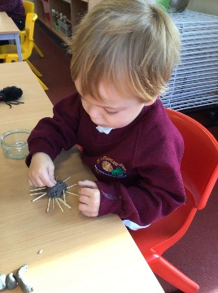
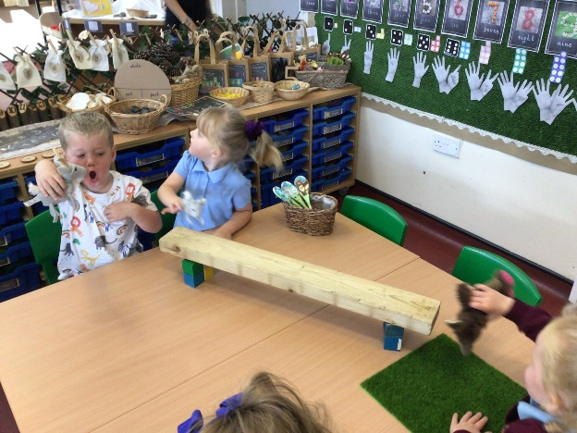
We have a playful approach to all learning within our Early Years Foundation Stage.
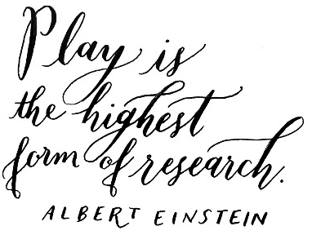
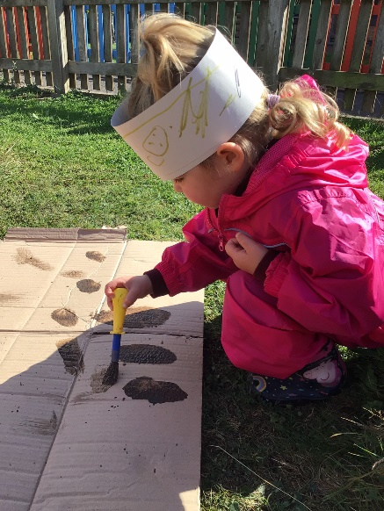
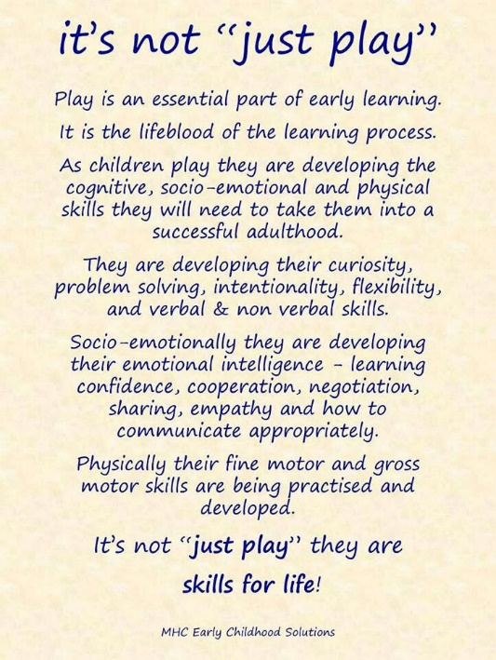
Continuous Provision
This occurs during Adventure Time sessions in which children have access to all areas of our environment. Continuous provision transcends all areas of learning and provides children with the opportunity to demonstrate the three characteristics of effective learning. Children are given the freedom to make independent choices and are encouraged to be active learners and take control of their own learning. Adults play and interact with children and intervene, when necessary, in order to move learning on.
Adult-led Provision
Short focused times are planned for writing, reading and maths. These sessions are planned with care, meeting the needs of all children, using prior knowledge of the child’s learning experiences and the non-statutory guidance from the EYFS document ‘Development Matters’, 2021.
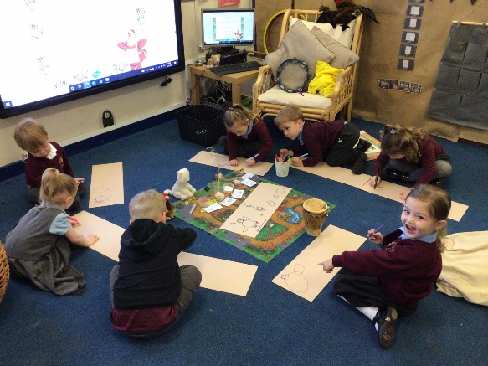
Adults also lead provision during Open Door sessions in which they engage in Project Work. Project work has been planned by practitioners in order to deliver our curriculum goals.
High-quality interacton is crucial in order for all
children to make progress.
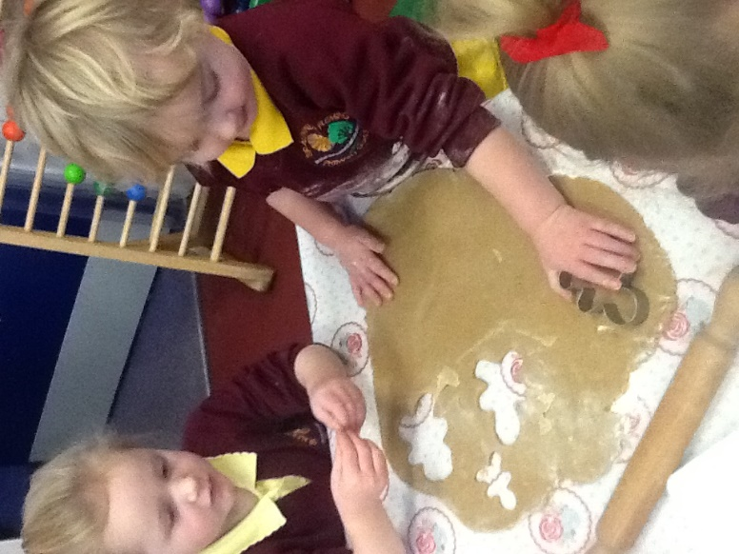
Our practitioners use their knowledge in order to
evoke responses from children which show what they
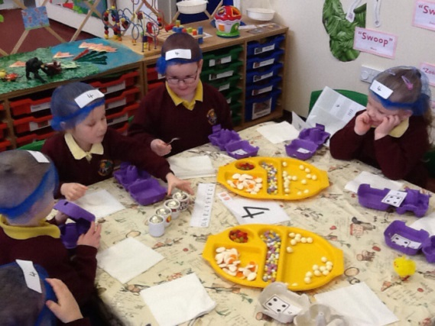
can do.

The Role of the Adult
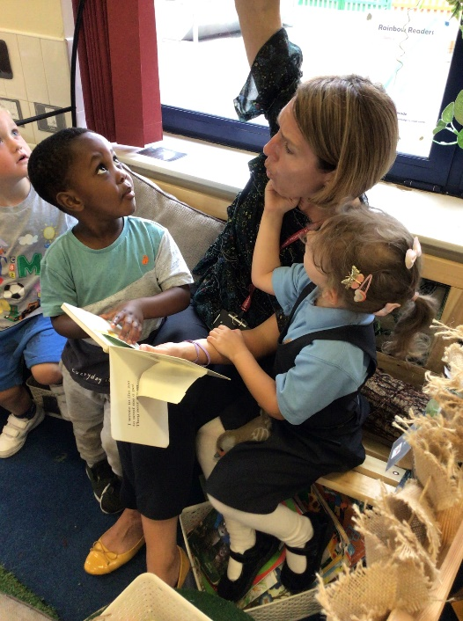
Research shows that progress will be significantly enhanced by the effective support and role models of adults within a high-quality learning environment.
Within our setting interactions between children and adults will look like this:
• Tuning in to what is happening or a child’s thinking.
• Showing genuine interest.
• Respecting children’s own decisions and choices.
• Inviting children to elaborate.
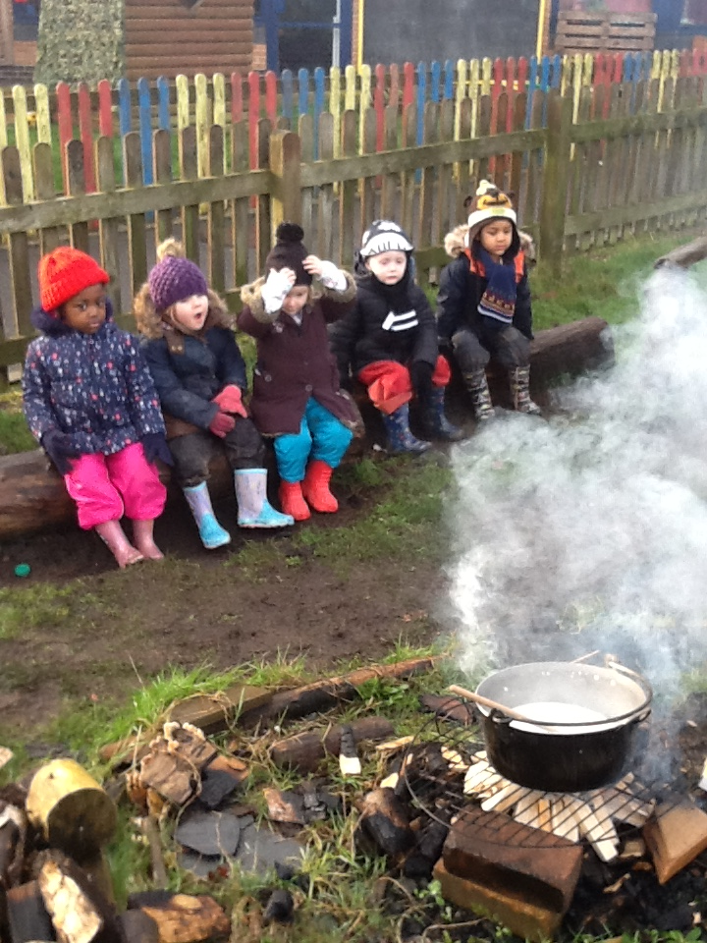
• Recapping on what has happened so far.
• Offering personal experience and modelling
• Clarifying ideas
. • Reminding and making connections explicit
• Using specific praise e.g., that is a good idea because…
• Offering an alternative viewpoint.
• Speculating/ using ‘I wonder if…’
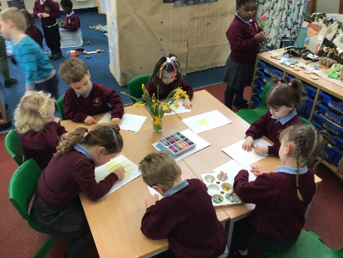
The definition of teaching in the Early Years as stated by OFSTED (2015); Teaching should not be taken to imply a ‘top down’ or formal way of working. It is a broad term which covers the many ways in which adults help young children learn. It includes their interactions with children during planned and child-initiated play and activities: communicating and modelling language, showing, explaining, demonstrating, exploring ideas, encouraging, questioning, recalling, providing a narrative for what they are doing, facilitating, and setting challenges.
It takes account of the equipment they provide and the attention to the physical environment as well as the structure and routines of the day that establish expectations. Integral to teaching is how practitioners assess what children know, understand and can do as well as take account of their interests and dispositions to learning (characteristics of effective learning), and use this information to plan children’s next steps in learning and monitor their progress.
The Role of the Environment
The importance of each adult to support progression is crucial however, we equally understand that in times when a child is on their own independent learning journey the environment plays a significant role in development.
“When it comes to what we have and where we have it, then nothing should be left to chance” Alistair Bryce-Clegg, 2015.
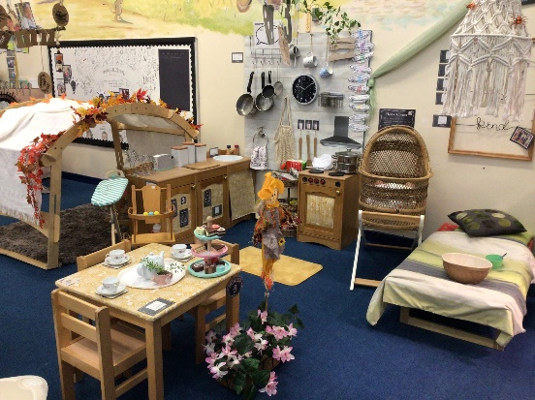
At Sir Alexander Fleming each area of the classroom has been considered thoughtfully in order to engage, inspire and meet the needs and interests of our children. We use all three classrooms in order to ensure our provision is resourced in the best way possible.
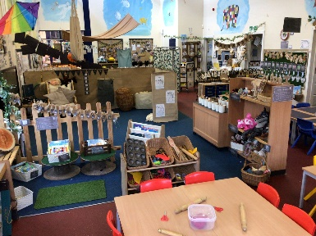
As the needs of the children change, as they grow and develop, so does their learning space. The environment is also enhanced and adapted in order to ensure children are given opportunities to meet our curriculum goals.
Practitioners have considered and anticipated the Common Play Behaviours children will display in each area and resourced it in order for children of all abilities to be challenged. A progression of knowledge and skills has also been created in order that adults can recognise where children are and how to move them on.
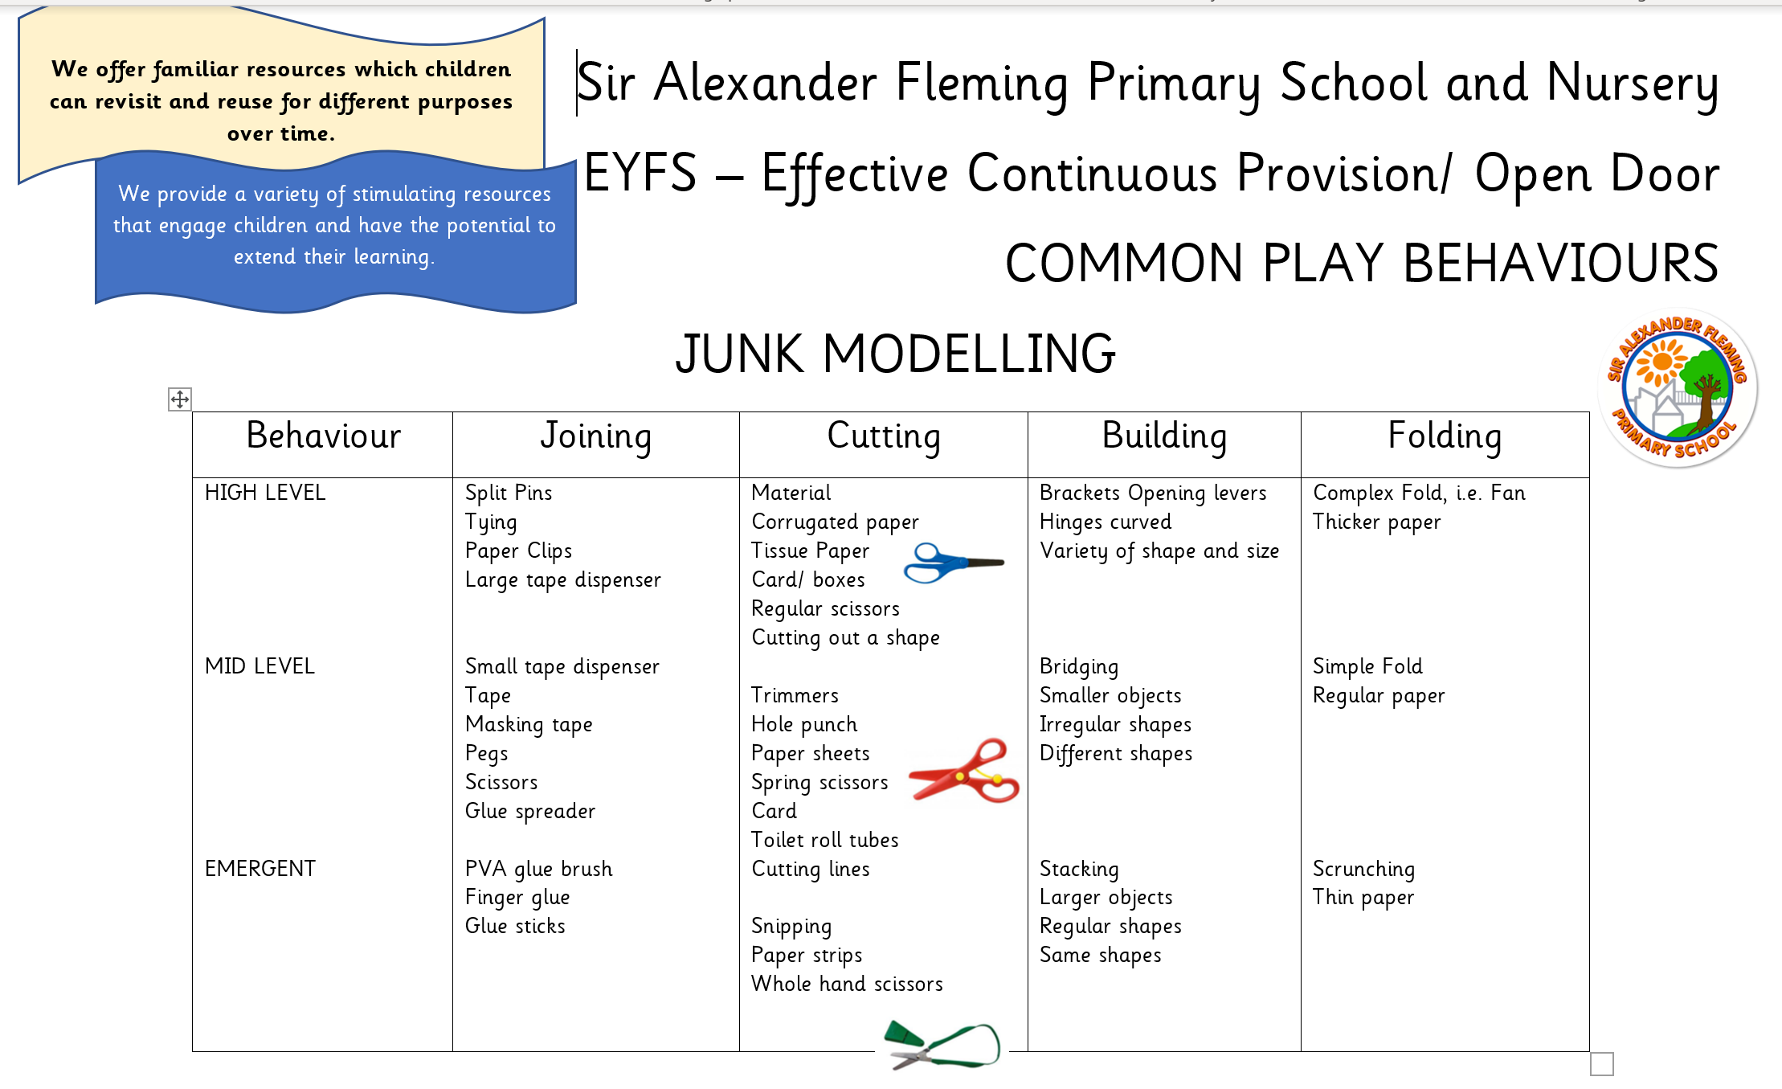
Our timetable allows for long uninterrupted periods of continuous provision that allow the children time to reach a deep level of involvement as they engage, play, investigate and talk.
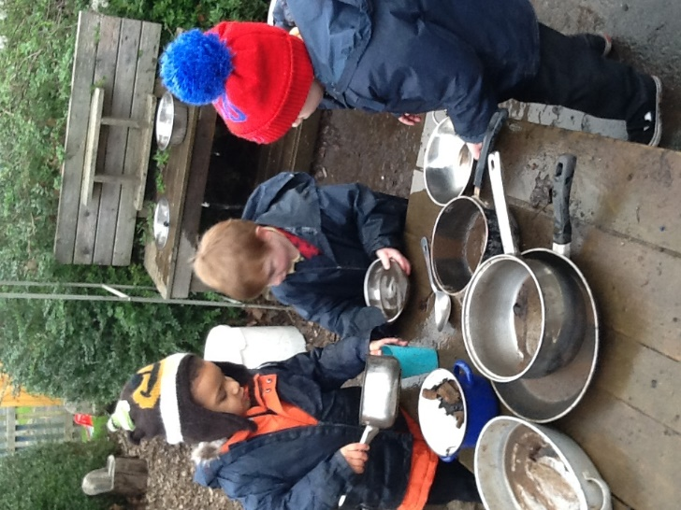
We have a distinctive natural style which is based on the need to create a calm, stimulating and nurturing place which children and parents enjoy coming to. Our setting reflects what we believe our children need and that is bringing the outdoors inside. Research shows that plants and greenery enhances children’s concentration while supporting their mental health.
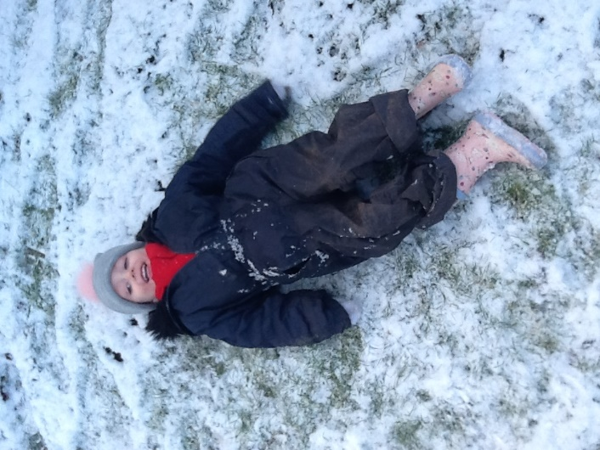
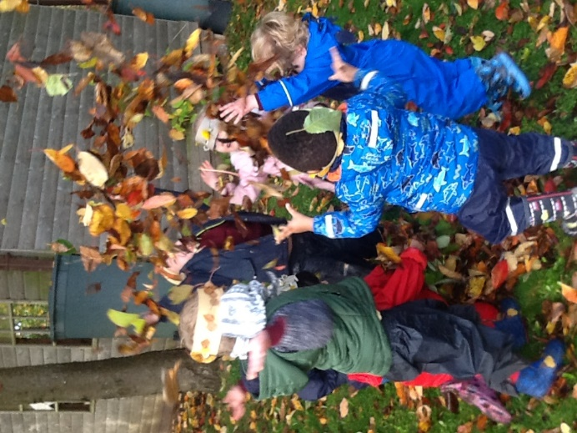
We also use the outdoors as a vehicle for learning during Continuous Provision and Forest School sessions which happen weekly. During these sessions children develop a sense of awe
and wonder at the world around them and begin to ask and answer questions about similarities and change that they notice. They also learn how to become responsible for their own safety and the safety of others.
EYFS 2021
We follow the EYFS Statutory Framework (2021). Within this framework there are four guiding principles which shape are practice. These are:
1. Every child is a unique child, who is constantly learning and can be resilient, capable, confident, and self-assured.
2. Children learn to be strong and independent through positive relationships.
3. Children learn and develop well in enabling environments with teaching and support from adults, who respond to their individual interests and needs and help them to build their learning over time. Children benefit from a strong partnership between practitioners and parents and/or carers.
4. Children develop and learn at different rates. The framework covers the education and care of all children in early years provision, including children with special educational needs and disabilities (SEND).
EYFS learning and development requirements
Our curriculum encompasses seven areas of learning and development. All areas of learning and development are important and interconnected.
Three areas are particularly important for building a foundation for igniting children’s curiosity and enthusiasm for learning, forming relationships, and thriving. These are called the prime areas:
• communication and language
• physical development
• personal, social, and emotional development.
Four areas help children to strengthen and apply the prime areas. These are called the specific areas:
• literacy
• mathematics
• understanding the world
• expressive arts and design
Throughout their time in the Reception Year our children partake in an ambitious curriculum which is designed in a sequential way to ensure progress towards the end of reception goals. These goals are defined as Early Learning Goals (ELGs)
It is also important to highlight that our plans are flexible to allow us to respond quickly to children’s new interests and/or needs.
Weaving throughout the EYFS curriculum at Sir Alexander Fleming are three Characteristics of Effective Learning.
• playing and exploring - children investigate and experience things, and ‘have a go’
• active learning - children concentrate and keep on trying if they encounter difficulties, and enjoy achievements
• creating and thinking critically - children have and develop their own ideas, make links between ideas, and develop strategies for doing things.
These elements underpin how we reflect on each child’s development and adjust our practice accordingly. Supporting children in their individual learning behaviour and observing the context of children’s play is essential.
‘What children learn is important, but how children learn is even more important if they are to become learners in today’s society.’ Helen Moylett How Children Learn, Nancy Stewart (2011)
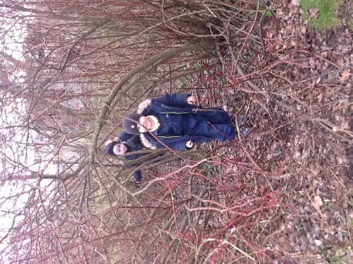
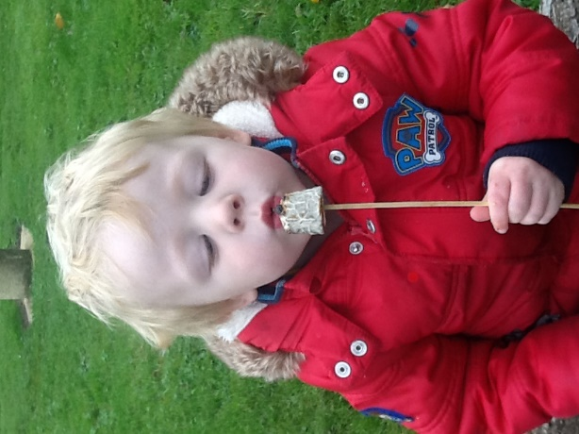
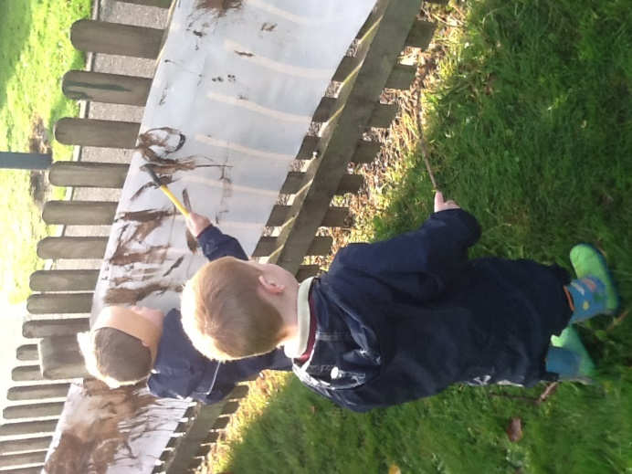

Curriculum
Our EYFS curriculum content is planned by practitioners thoughtfully and reflects the needs of our community. We have a strong rationale for each terms topic.
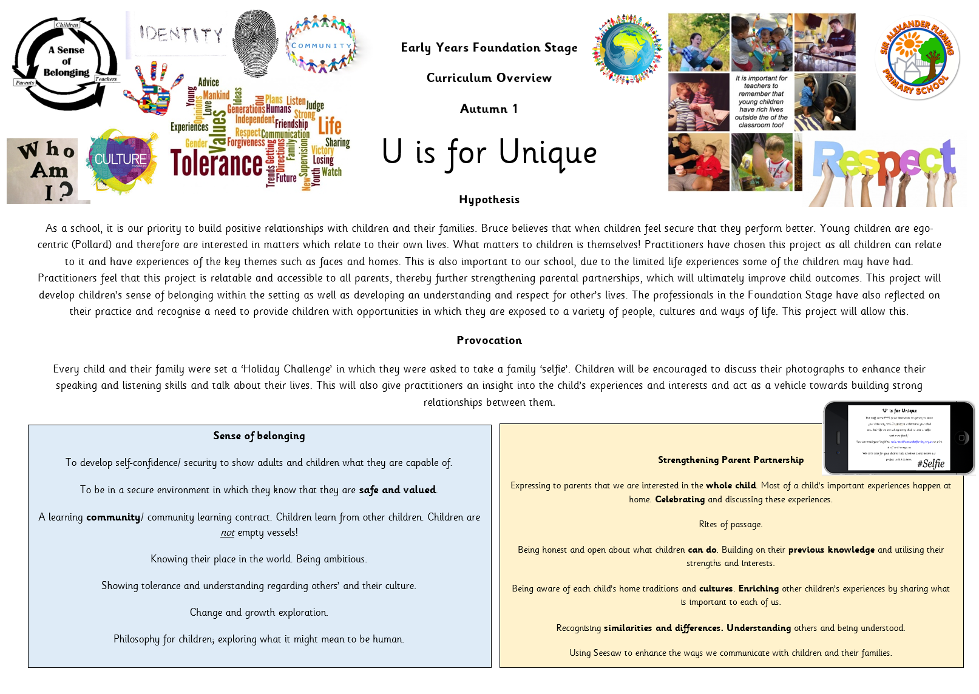
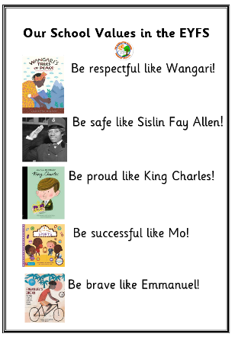
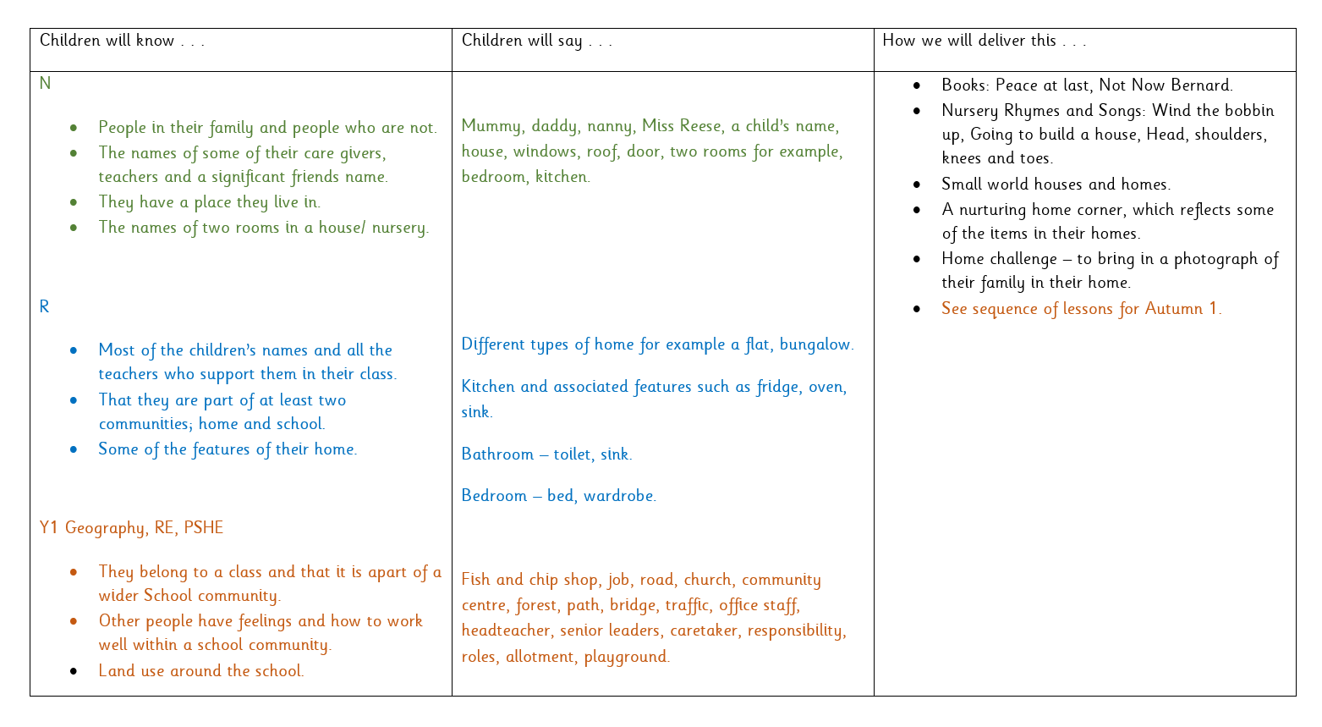
Practitioners map out the key knowledge and vocabulary that will be taught for the whole year. This is built of the school’s curriculum drivers and the prerequisite knowledge children require to access the curriculum at KS1 and 2.
Staff choose key historic figures to enhance children’s subject knowledge and their PSED.
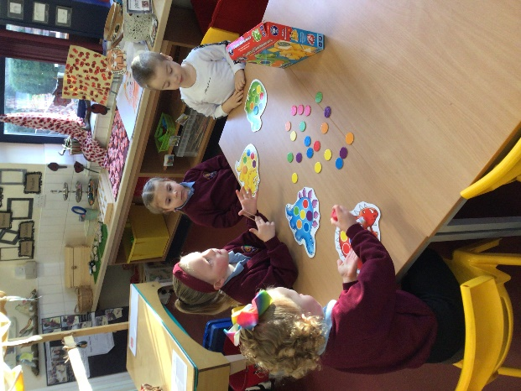
Communication and language Development
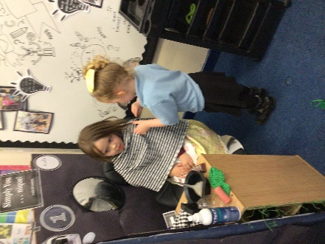
At Sir Alexander Fleming Primary School, we believe the key to success in all areas of learning is communication. Research clearly shows that the level of development in language and communication is the greatest predictor of success in later life. At school children use language to:
• Build strong relationships.
• Communicate their ideas and their feelings.
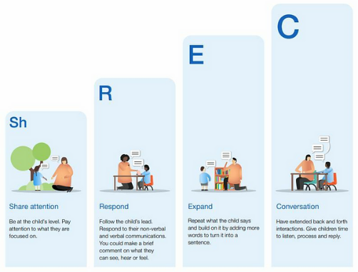
• Think creatively and critically.
• As a tool for learning.
• Become confident with the written word.
(Julie Fisher, 2016) The development of a young child’s communication and language comes primarily from tuning in to conversations that are meaningful to the child.
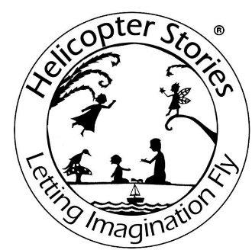
The preparation for all aspects of written language develops through one to one conversation with a responsive adult. Alongside quality interactions, rich and varied experiences ensure language provides the foundation of thinking and learning. Improving young children’s vocabulary is paramount. Exploring and extending pupils’ vocabulary is part of everyday teaching. Lessons are planned to enrich vocabulary and incidental opportunities are exploited. Vocabulary is discussed with the intention of building background knowledge so pupils can comprehend spoken language and later, the content of a text. Our EYFS classrooms have interactive vocabulary displays which are used, referred to and added to in partnership with the children.
Vocabulary is progressive, planned and mapped out across the year.

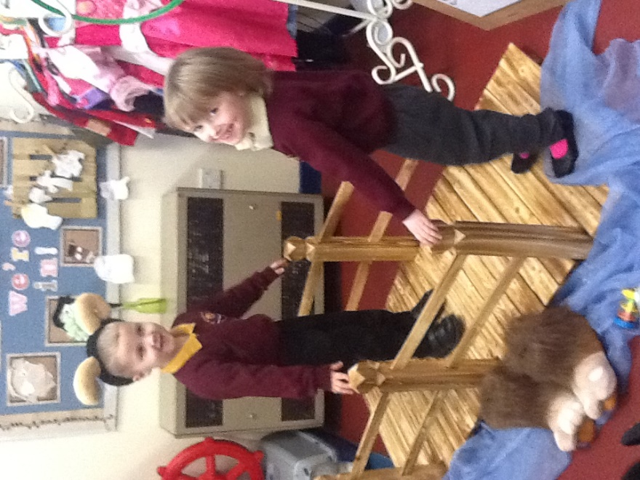
Children also participate in Helicopter Stories sessions once a week in which they listen to, create and act out stories that are verbalised to support their language development. Children participate in Nursery Rhyme Time every day. We also use the Poetry Basket so that children develop their understanding and use of language in a context, while learning about pulse and rhythm. This year Drawing Club will be taught in Reception and children will be explicitly taught 6 new words each week.
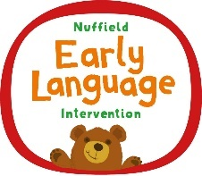
We use published assessments, interventions and make appropriate referrals in order to support children who require further support in this area.

Our staff are trained in Makaton, Neli, Talk Boost and Contrastive Pairs and this is used to support language development and understanding across the EYFS.
Early Reading and Writing
At Sir Alexander Fleming Primary School and Nursery this is taught through a Systematic Synthetic Programme called Jolly Phonics. Please see the Reading Policy for further details.
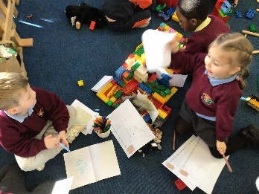
Stories, texts and rhymes are a key aspect of our practice.
We have created an EYFS reading offer as we prioritise this as a fundamental part of our teaching.
Texts are used daily during a story-time, used to inspire mathematics and English activities and during continuous provision.
Throughout the learning environment a range of fiction, non-fiction and poetry books are selected and presented for children to use in appropriate contexts, to further enhance their learning. Texts are also selected to match curriculum content and deliver the specific areas.
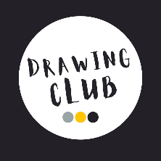
In Reception, children write dictated words and sentences during Phonics lessons.
They participate in a daily Drawing Club in which they develop their ideas and develop the motivation to apply their phonic knowledge and write about characters, settings and events in stories and videos.
A writing focus is planned weekly during Open Door sessions.
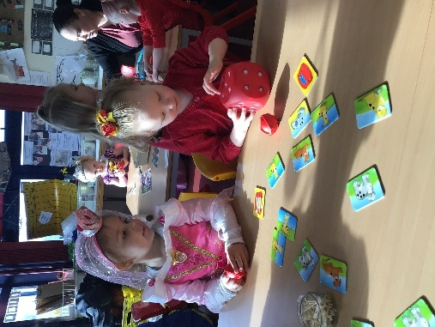
Mathematics
At Sir Alexander Fleming Primary School and Nursery this is taught discretely. The Mastering Number scheme is used in Reception and aspects of this are adapted for nursery provision, alongside approaches highlighted by Karen Wilding. Mathematical challenges are included in Adventure Time to support practise and application of skills. But we also believe that maths is everywhere, especially with knowledgeable adults playing with children! For example, there are endless opportunities in the malleable area alone; arrays in trays, size of cutters, lengths of dough, amounts of decorations, patterns etc.
Projects
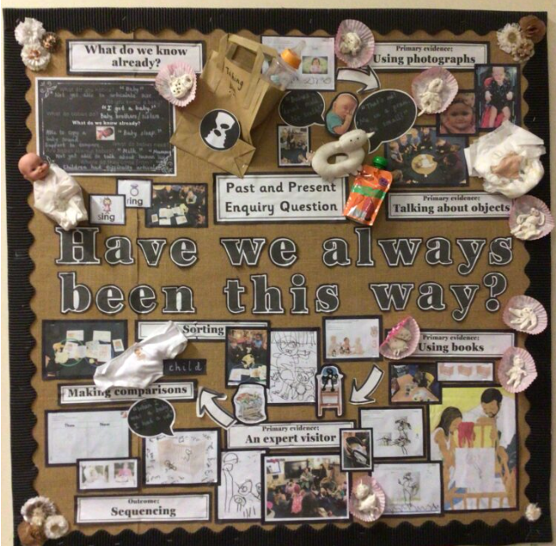
During Open Door children engage in projects which have been planned by the adult due to children’s needs, interests of curriculum goals. Adult’s differentiate and adapt project content to meet the needs of children. This also gives children foundational knowledge in foundation subjects such as History and Geography which links to the whole school curriculum.
The sequence of learning is captured through displays.
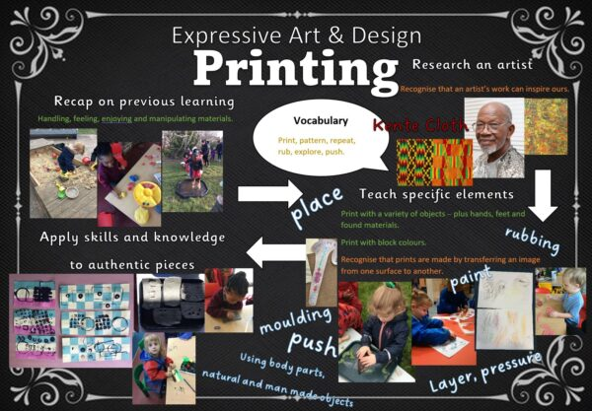
Cultural Capital
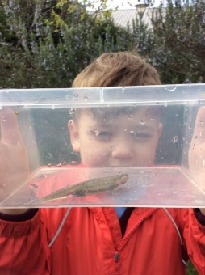
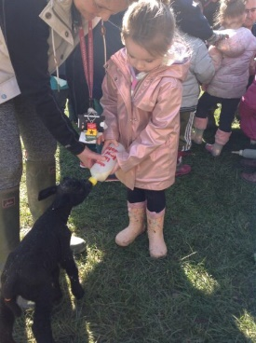
Being within our stimulating, nurturing setting is cultural capital. Children access a range of daily activities such as communal snack using china cups, forest school accredited sessions and access high quality resources on a daily basis. We invest in our environment and resources to ensure it has the most impact upon their learning and development.
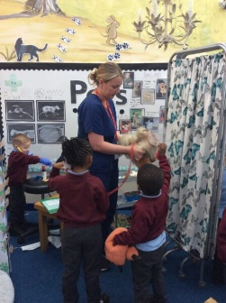
Practitioners plan key visits, visitors and experiences to develop children’s knowledge and enhance the curriculum further. They are timed thoughtfully and act as an inspiration, deepen learning or consolidate it. These experiences develop children’s vocabulary in a meaningful context and ultimately develop them as good, future citizens.

Assessment
Throughout Continuous Provision observation forms a fundamental aspect of the pedagogy of the EYFS at Sir Alexander Fleming Primary School.
“Young children demonstrate language, mathematics, science, creativity, physicality – sometimes all within one activity – and the task of the practitioner is to make sense of what is seen, to recognise any significant steps in learning that may have taken place and to identify where help and support are needed to make further progress” Jan Dubiel, 2014
Observation and responding to children’s thinking inform our planning of experiences and opportunities, how we create our environment for thinking, the strategies the adults use to extend learning (modelling, scaffolding, questioning, discussion, shared sustained thinking) and how we capitalise knowledge of children’s interests to ensure high levels of engagement. All adults take note and sometimes record significant moments when a child does or says something that demonstrates progress or skill in a particular area using Seesaw.
Children in Reception record their learning in Mathematics, Writing and Reading Journals and these are marked in accordance with the whole-school marking policy.
In addition, to the continuous cycle of observation and formative assessment which informs each child’s next steps, summative assessments are carried out for phonic development, number and an assessment of each child’s stage of development for each of the 7 areas of learning. These take place termly and informs planning of subsequent teaching and learning. This then informs planning and teaching.
Progression of Knowledge and Skills
This is considered by all practitioners and used to move learning on appropriately. It is reflected within the resources provided so that children can access play at an appropriate and challenging level.
We have also created ‘Our Journey’ documents to show children’s journeys through all aspects of our provision at Sir Alexander Fleming Primary School and Nursery. We believe that any experience can be adapted to challenge any child.
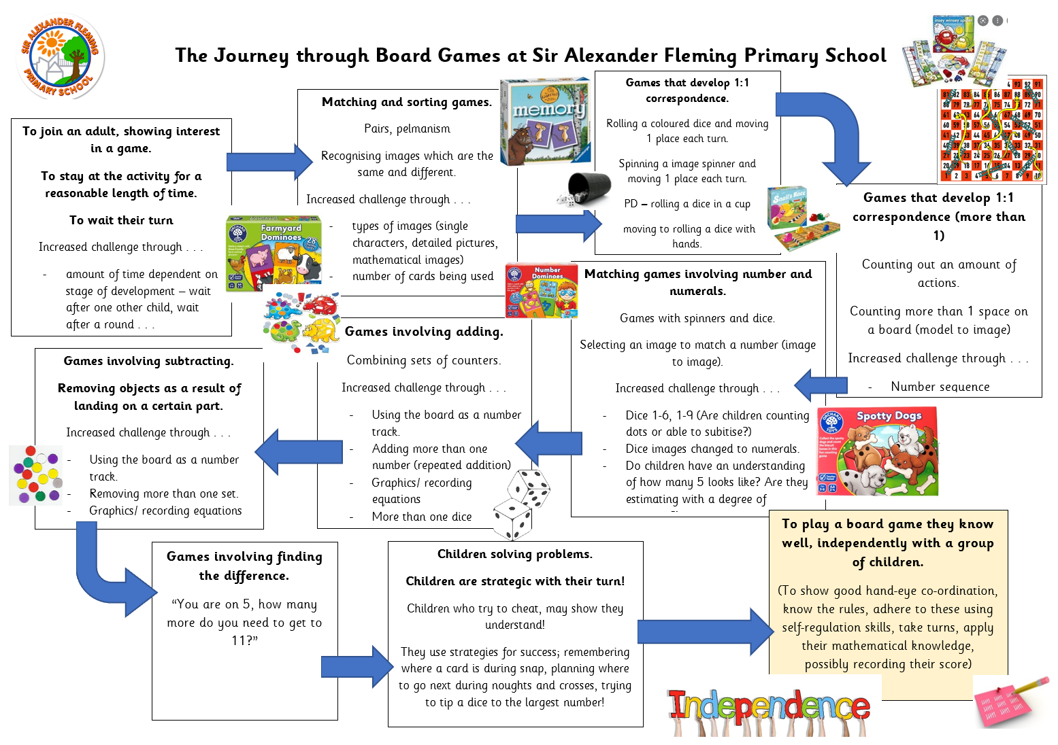

All subject co-ordinators area aware of the EYFS related content and regularly monitor this.
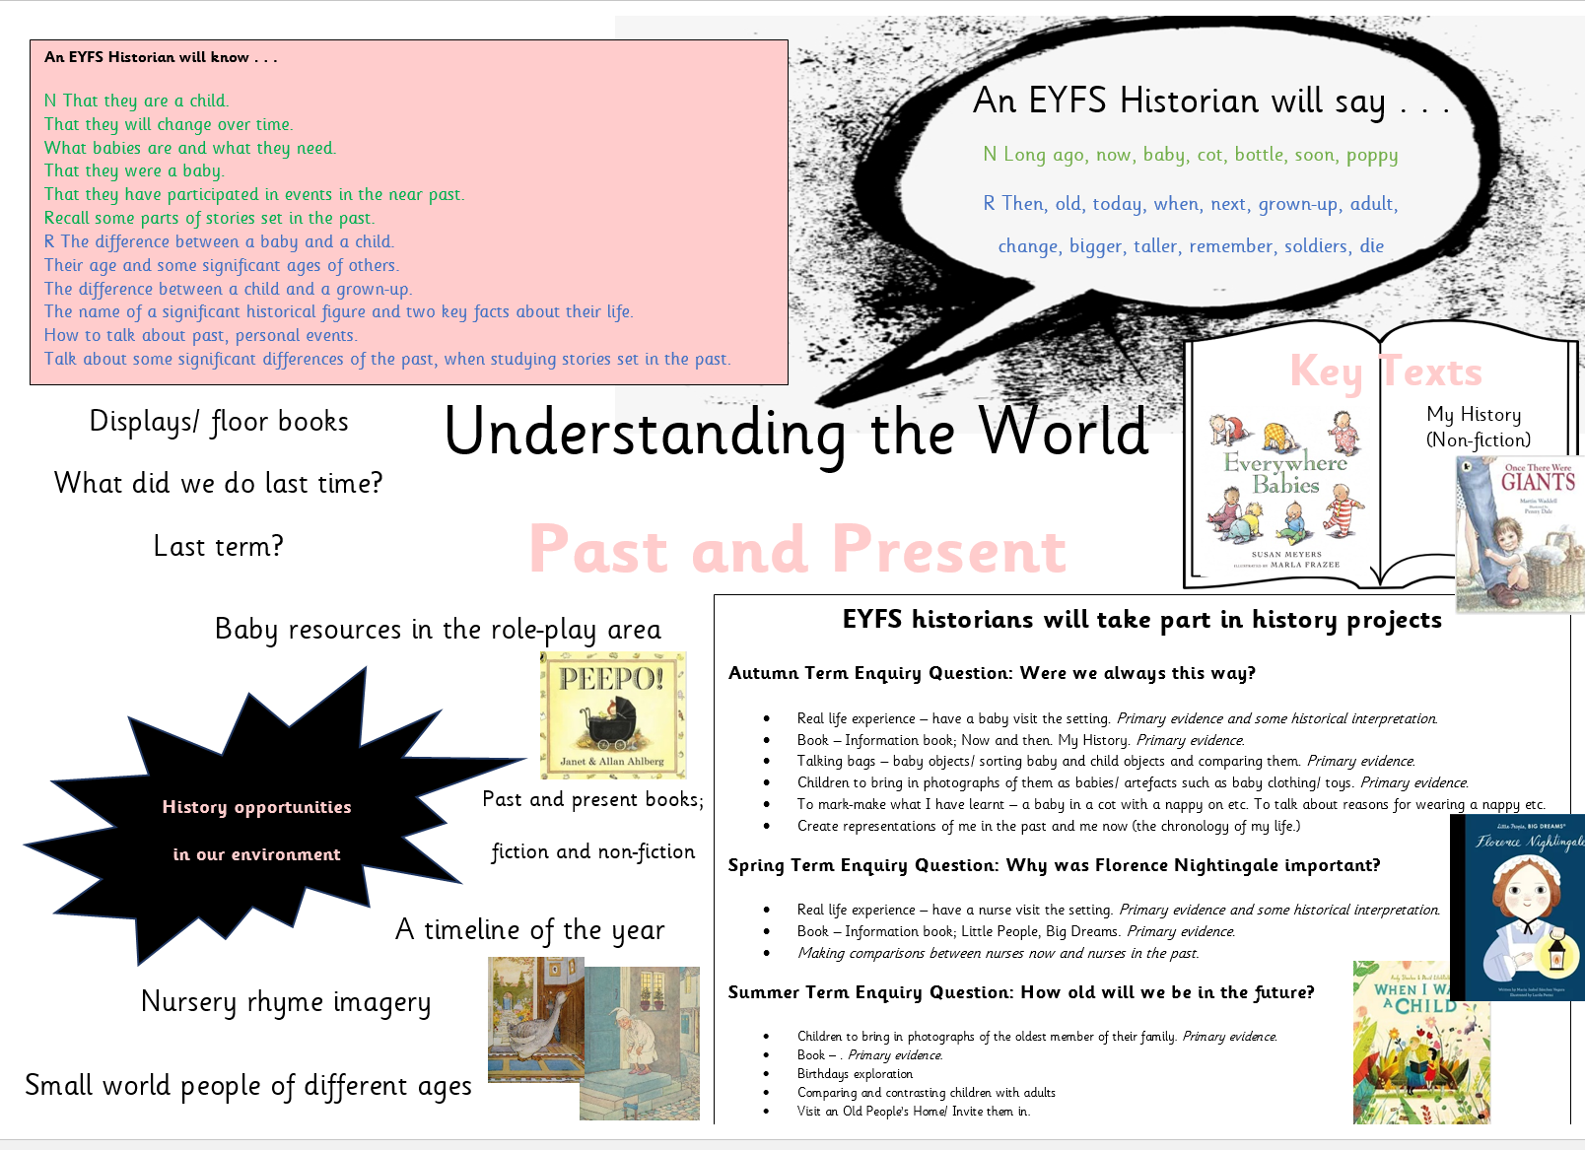

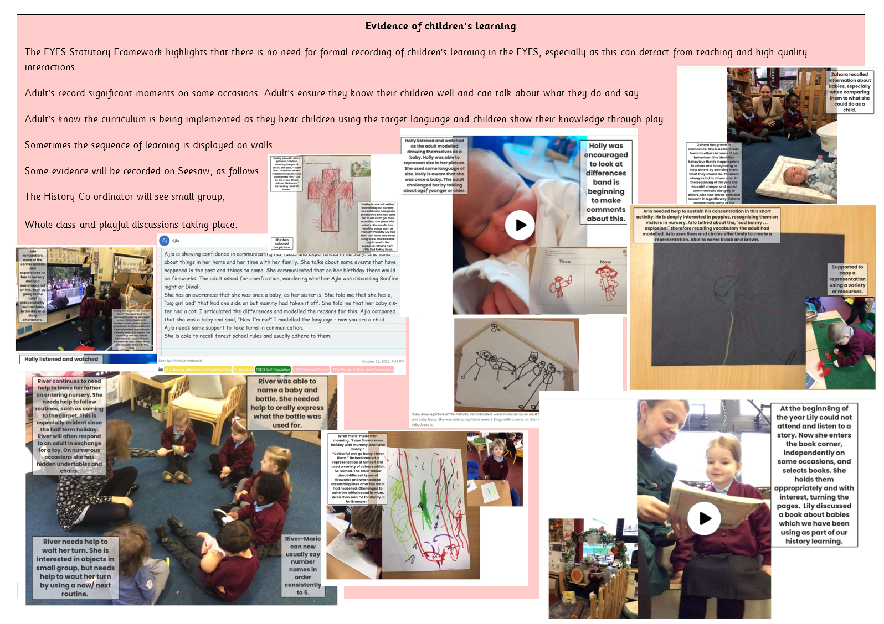

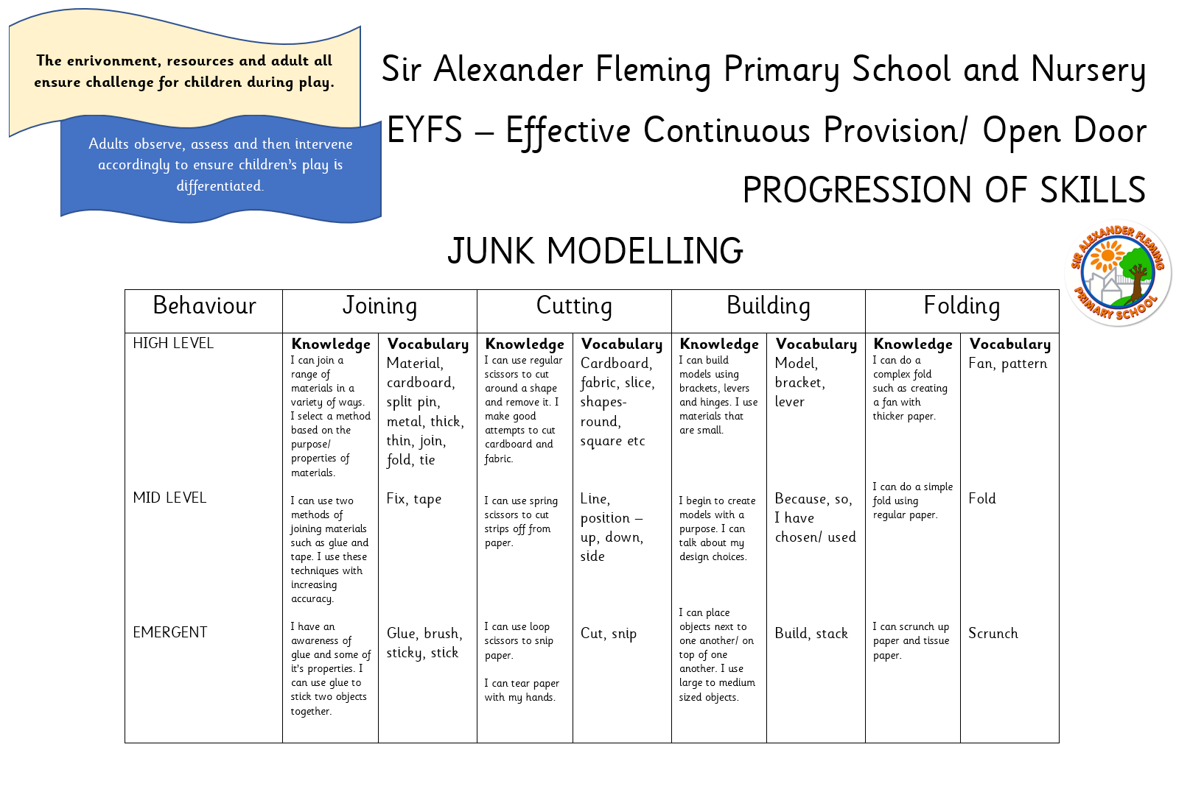
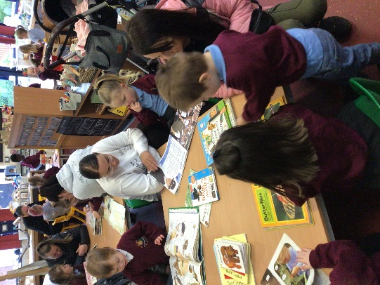
Parental Partnership
Parents are the first and most important influence on their child’s development and future outcomes.
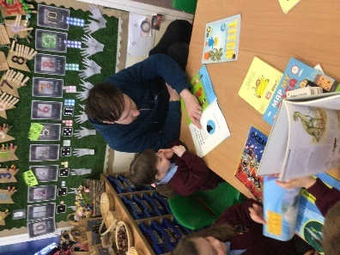
Children have two main educators in their lives – their parents and their teachers. Therefore, the school and the parents all have crucial roles to play. The impact on a child’s education is greater if parents and schools work in partnership.
At Sir Alexander Fleming, parents are invited to be involved in every step of a child’s journey in education. Beginning with home visits for nursery children and a pre- starting school meeting followed by an invitation for their child to attend several ‘transition’ sessions before the Autumn term commences.
We use an online platform, ‘Seesaw’ to record, track and celebrate progress made by each child. Seesaw enhances this special time in a child’s life and captures children's experiences as well as monitors development and learning. Text, images and videos can be uploaded by parents to share learning and experiences from home via PC, tablet or mobile. Every entry helps to create a complete story of a child's time at school. We also encourage parents to engage in a termly ‘Home Learning Challenge’ which involves parents and children talking together about an upcoming project and sharing it with the class in order to inspire future learning.
Throughout the year families are invited to ‘Stay and Play’ sessions, Science days, Forest School sessions, Reading meetings along with many whole school events for example, sports days, reading mornings. We pride ourselves on building positive relationships with the families of Sutton Hill. We create an environment that is conducive to interactions where all feelings can be taken into account. A warm welcome each day often leads to a deeper knowledge and understanding of each child and their family.
“It is knowing the child and family that opens up endless possibilities for interactions that deepen the emotional bonds between a practitioner and a child, and lead, in turn, to educational opportunities to support and extend learning.” (Fisher, 2016)
We also work closely with parents and carers in order to strengthen safeguarding within our setting and support the early identification of barriers to learning for our children.
SEND and Early Intervention
Assessment ensures that practitioners identify children who are not on track for their age or those who have significant needs. Adult’s use termly checkpoints, created from Development Matters (2021). Practitioners use this data within Pupil Progress meetings in which they devise ways forwards to ensure children make progress towards being on track developmentally. In this way staff tailor provision to ‘close the gap’.
Staff also use published assessments such as Stoke Speaks Out Screening Tool, Neli and Elklan ICW’s in order to make appropriate referrals quickly.
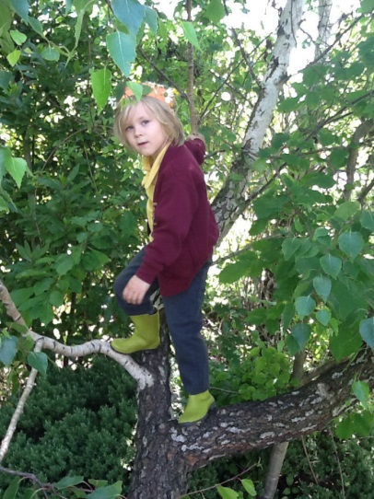
We work closely with the health visitting team, speech and language therapists and the local EYFS SEND team to plan provision for children who require this support.
We work with parents to attend training, share strategies or signpost them to relevant support and services.
Safeguarding
At SAF, safeguarding in the Early Years Foundation Stage (EYFS) is a core priority, in line with the statutory requirements of the EYFS Framework, the Department for Education’s (DfE) Keeping Children Safe in Education (KCSIE), and Working Together to Safeguard Children. We are committed to creating a safe, nurturing and protective environment where every child’s welfare is promoted and protected.
All staff working with children in the EYFS complete statutory safeguarding and child protection training, with refresher training taking place every two years as a minimum. This training includes recognising signs of abuse and neglect, responding appropriately to disclosures, understanding the school’s safeguarding procedures, and knowing how to escalate concerns without delay. All new staff receive safeguarding induction training before taking up duties, and regular updates and briefings are delivered throughout the year to ensure safeguarding knowledge remains current.
All EYFS staff are also required to read and understand Part 1 of Keeping Children Safe in Education and are trained in the use of the school’s safeguarding and child protection policy. Staff know the identity of the Designated Safeguarding Lead (DSL) and Deputy DSLs, and understand their role in reporting concerns appropriately and promptly.
In addition to child protection, EYFS staff are trained in paediatric first aid, ensuring that at least one paediatric first aider is present at all times in the setting, including during trips and outdoor activities, as required by the EYFS statutory framework. Staff also undertake training in food hygiene, choking prevention, hygiene and infection control, intimate care, and positive behaviour management—all of which contribute to a safe and supportive learning environment.
To further support children’s safety and wellbeing, the school has clear policies in place for nutrition, sleep and rest, and intimate care, ensuring consistent and safe practices are followed across all areas of care. These policies are regularly reviewed in line with the most up-to-date government guidance and best practice.
Safeguarding is embedded in our everyday provision, and every member of staff understands their role in ensuring that children in the early years are kept safe, supported, and listened to at all times.

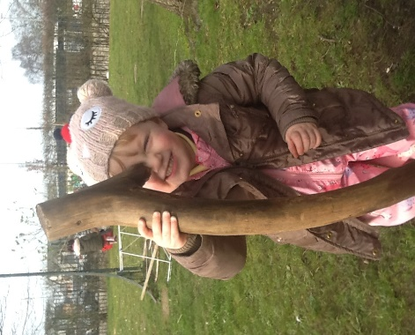
Impact
The EYFS curriculum at SAF is embedded and effective. It is delivered by experienced and passionate practitioners.
All of the children in our care make progress from their starting points. Progress is high.
They know more, remember more and do more!
The most recent statistics show that 64% of our children left the EYFS with a Good Level of Development (GLD) 24-25. This is a significant increase of +40% from their starting points.
Mobility is high at SAF and 7 new children started their learning journey with us in the Summer Term. 71% of children who started in September achieved a GLD, which is above National average.
Cohort | Baseline | July | National GLD
22-23 |  | 67% | 67%
23-24 | 18% | 55% | 68%
24-25 | 24% | 64% | To be published by the DFE.

Broadly, children enter Key Stage One ready to begin the next chapter of the educational journey. The greatest impact our Early Years Provision has is on the prime area of PSED and children leave reception equipped with the learning behaviours to access more formal teaching in year 1. The majority of children leave with the age-appropriate knowledge and skills that provide the right foundation for future progress through school and life.
Neli data shows how children who are identified with communication needs have made significant progress:
 | Sept 23 | July 24
Clear concerns with C+L | 9/40  23% | 1/40  3%
Slight concerns C+L | 10/40  25% | 2/40  6%
 | 48% of cohort | 9% of cohort

The impact of children attending our Nursery is significant:
75% of the children who attended our nursery were on track on entry to Reception.
Year 1
Of those who achieved age related expectations by the end of year 1, 65% of children attended our nursery, compared to 53% of children who did not attend.
Year 2
Of those who achieved age related expectations by the end of year 2, 67% of children attended our nursery, compared to 48% of children who did not attend.
Year 6 23-24
Of those who achieved age related expectations by the end of year 6, 63% of children attended our nursery, compared to 53% of children who did not attend.
Year 6 24-25
Of those who achieved age related expectations by the end of year 6, 57% of children attended our nursery, compared to 48% of children who did not attend.
In terms of reading, 68% of children who attended our nursery achieved age related expectations compared to 59% of children who did not attend nursery.
Phonics Screening – 23-24
15 % of all children did not pass, only 5% of children who did not pass attended our nursery. 10% did not attend nursery, which equates to double the amount.
Phonics Screening – 24-25
By the end of year 2, 100% of children who attended SAF nursery passed the Phonics Screening Test.
This shows that there is a positive correlation between attending our nursery and educational outcomes.
‘Children who attend SAF nursery, achieve better than those children who do not.’

Practitioners know our provision is making a difference because
- Internal data shows progress
- ADPRs showing small incremental, sustained steps in progress
- Progress is captured on seesaw and shows individualised journeys
- Progress is identified on funding reviews and corroborated by the LA Send Team
- SaLT reports for individual children highlight progress made
- Increased scores on Stoke Speaks Out Assessment Tool
- Pupil progress shows progress
- Lessons have been observed to be good and outstanding by the SIP at regular intervals throughout the year
- Learning behaviour of children is good, and outstanding compared to their starting points

In 2017, a ‘Study of Early Education and Development: Good Practice in Early Education’ was published which outlined 3 themes that underpin effective practice that are aligned with our ethos and development.
At Sir Alexander Fleming we;
1. Tailor practice to the needs of the children - the child is at the centre of our practice. We have a clear vision of what we want to achieve for the children in our care, and these clear goals inform all areas of our practice.
2. Are committed to developing skilled and experienced staff - that support children to reach their full potential.
3. Operate an open and reflective culture – our culture is driven by continuous improvement. We seek out other settings and professionals to learn from, share and reflect practice. We recognise the knowledge and expertise of our own staff and value open discussion and staff consultation; and embedded within our school is a culture of self-evaluation as a means of driving continuous improvement

