Sir Alexander Fleming Primary School and Nursery
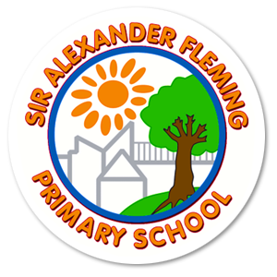
Nutrition Policy
Written September 2025
Review Date: September 2026

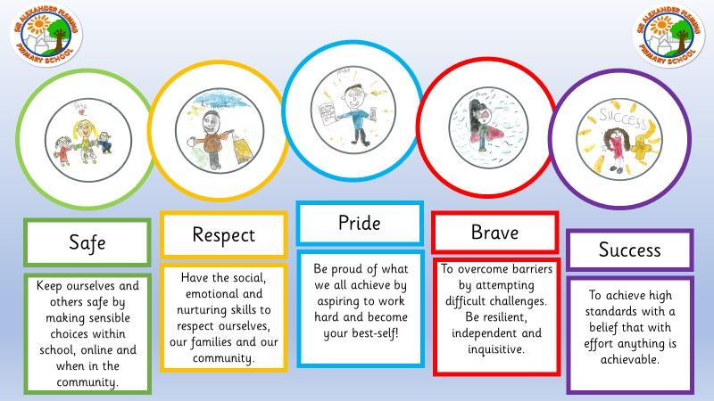
At Sir Alexander Fleming Primary School and Nursery, our nutrition policy is deeply rooted in our core values of Safe, Respect, Pride, Brave, and Success. We ensure our children stay safe by providing nutritious meals that support physical and mental well-being and by teaching them to make sensible food choices both in school and in the wider community. Our approach fosters respect by encouraging social and cultural awareness through a diverse and inclusive menu, while also promoting self-respect through healthy eating habits. We instil a sense of pride in pupils by helping them understand how good nutrition contributes to personal growth, energy, and learning, empowering them to become their best selves. Our policy encourages children to be brave by trying new foods and embracing healthier options, building resilience and independence around their food choices. Ultimately, we support every child on their journey to success by fuelling them with the nourishment they need to achieve their full potential—because with the right support and effort, anything is achievable.

1. Policy Statement
At Sir Alexander Fleming Primary School and Nursery, we recognise the vital role nutrition plays in the physical health, emotional well-being, behaviour, concentration, and academic achievement of our children. In line with the Department for Education's (DfE) updated nutrition guidance (September 2025) and the School Food Standards, our school is committed to promoting a whole-school approach to healthy eating. This policy sets out our expectations for all food and drink provided to children and reinforces our school values of Safe, Respect, Pride, Brave, and Success in all aspects of school life.

2. Aims and Objectives
Our Nutrition Policy aims to:
- Ensure that all food and drink provided at school is healthy, balanced, and nutritious, in line with current DfE statutory guidance and regulations.
- Promote positive attitudes towards food, nutrition, and a healthy lifestyle through the curriculum and school environment.
- Provide age-appropriate portion sizes, meeting the dietary needs of all children, including those with allergies or cultural requirements.
- Support children in making informed, independent food choices for lifelong healthy habits.
- Involve the whole school community—pupils, parents, staff, and catering providers—in promoting a healthy food culture.

3. Alignment with School Values
Our Nutrition Policy supports our school’s core values:
- Safe: We keep ourselves and others safe by offering nutritious meals that promote physical and emotional well-being. Children are taught to make safe, sensible food choices at school, online, and in the community.
- Respect: We respect diverse dietary needs and cultural practices, and we help children build self-respect by encouraging healthy eating habits.
- Pride: We take pride in creating a positive food culture and celebrating achievements related to healthy choices and cooking skills.
- Brave: We encourage children to be brave by trying new, healthy foods and building resilience through positive changes in eating habits.
- Success: We support every child in achieving success by providing food that fuels learning, concentration, and emotional regulation.

4. Food and Drink Provision
All food and drink provided in school, nursery, or during wraparound care complies with the latest DfE and School Food Standards:

4.1 Meals
- Meals are freshly prepared and follow a balanced menu that includes:
  - Daily vegetables and/or salad
  - A variety of fruits and vegetables each week (minimum 3 of each)
  - Wholegrain starchy options (e.g. brown bread, pasta, rice)
  - Protein-rich foods (meat, fish, eggs, beans)
  - Milk and dairy options
  - Vegetarian options daily
- Deep-fried or pastry-based items limited to twice a week.

4.2 Snacks and Breaks
- Healthy snacks (e.g. fruit, raw vegetables) are provided during breaks for Nursery and Reception children.
- Children in KS1 and KS2 are encouraged to bring in a healthy snack for break time. Fresh fruit is provided by Tesco daily for all.

4.3 Drinks
- Water is freely available throughout the day.
- Only water or milk is served at snack and meal times.
Parents and Carers
We work closely with parents to ensure that we are aware of children’s dietary requirements, allergies and intolerances.
This begins through our Admissions sequence; During home visits parents are asked about children’s dietary needs. This is also apart of our Admissions form.
Staff work with medical professionals to create allergy plans where required. Karen Davies is named at the person responsible for Allergy Procedures in school.
All children’s dietary needs are recorded in a central location that is available to all staff. They are also displayed in each classroom.
Children in KS1 and KS2 have a specific lanyard at snack and lunchtime to alert staff. In Nursery and Enhanced Provision rooms children have a lunch mat which outlines their dietary needs.
During home visits and throughout their time at our school teachers have ongoing discussions with parents and/or carers about the stage their child is at in regard to introducing solid foods, including to understand the textures the child is familiar with. Assumptions are not be made based on age. Kitchen staff and teaching staff prepare food in a suitable way for each child’s individual developmental needs, working with parents and/or carers to help children move on to the next stage at a pace right for the child.

5. Early Years Foundation Stage (Nursery)
In line with EYFS and DfE September 2025 guidance:
- All meals for Nursery children are balanced and age-appropriate, including the four required food groups:
  - Fruit and vegetables
  - Starchy foods
  - Protein sources
  - Milk and dairy
- Food is prepared to suit the specific needs of younger children, including appropriate textures and portion sizes and follow appropriate safety measures such as the ways in which they are cut.
6. In line with the Early Years Foundation Stage (EYFS) Statutory Framework and Nutrition Guidance and the latest government safety advice, we have clear procedures in place to minimise the risk of choking and to support safe eating habits.

Key Safeguarding and Safety Measures:

Katy Tomlinson, Headteacher is responsible for ensuring that staff within the Kitchen prepares food in line with Government Legislation.
- Supervision: All children, especially those in Nursery, Reception and Year 1, are supervised closely while eating. Staff remain alert and present at all times. A qualified first aider is present in the room during meals and snack times. Children are always within sight and hearing of that member of staff when eating.
- At each mealtime and snack time the supervising member of staff is responsible for checking that the food being provided meets all the requirements for each child.
- Seated Eating: Children must be seated and calm when eating. Walking, playing, or running with food is not permitted.
- Safe Food Preparation: Foods that pose a choking risk are prepared according to government guidelines. This includes:
  - Cutting small round foods (such as grapes, cherry tomatoes and strawberries) lengthways into quarters
  - Slicing hard fruit and vegetables (e.g. apples, carrots) into thin batons or strips
  - Removing stones or pips from fruit
  - Softening raw vegetables where needed (e.g. by steaming)
  - Cutting bread and similar items into narrow strips rather than chunks
- Food Restrictions: Certain foods are not permitted for Nursery, Reception and Year 1 pupils, including:
  - Raw or partially cooked eggs (unless British Lion-stamped)
  - Dried fruit as a snack (e.g. raisins)
  - Foods high in salt, sugar or saturated fat; marshmallows
  - Sugary drinks, including juice and squash
  - Foods which may cause choking hazards such as popcorn and seeds
7. Staff Training
All staff involved in the preparation, handling, or supervision of food receive appropriate training to ensure the highest standards of safety and care. This includes:
- Food hygiene training to ensure safe storage, preparation, and serving of food in line with health and safety regulations.
- Training in choking prevention and safe eating practices, particularly for younger children.
- Allergy awareness, including recognising signs of allergic reactions and understanding individual dietary needs. All staff have received EpiPen training.
- Awareness of safe food preparation techniques for young children, as outlined in national nutrition and choking prevention guidance.
Staff are regularly updated on best practice and expected to follow school procedures at all times to safeguard children's health and wellbeing during mealtimes.
In the event of a child experiencing a choking incident that requires intervention, first aiders record details of where and how the child choked and ensure parents and/or carers are made aware. The records are reviewed periodically to identify if there are trends or common features of incidents that could be addressed to reduce the risk of choking. Appropriate action will be taken to address any identified concerns.

8. Curriculum Integration
Nutrition is integrated into:
- Science, PSHE, and Design & Technology lessons (e.g. food groups, cooking, digestion).
- Healthy lifestyle education, reinforcing the Eatwell Guide, balanced diets, and the impact of nutrition on mental and physical health.

9. Special Dietary Needs
We cater for:
- Medical diets (e.g. allergies, intolerances) with individual health plans where necessary.
- Religious and cultural preferences, in consultation with families.
- The catering team and staff who provide snacks and meals receive training on food allergies and food hygiene.

10. Packed Lunches
We encourage parents to provide packed lunches that align with the school’s healthy eating ethos. Guidance is shared with families on:
- Including balanced food groups
- Avoiding high-sugar, high-fat, and processed items
- Providing only water
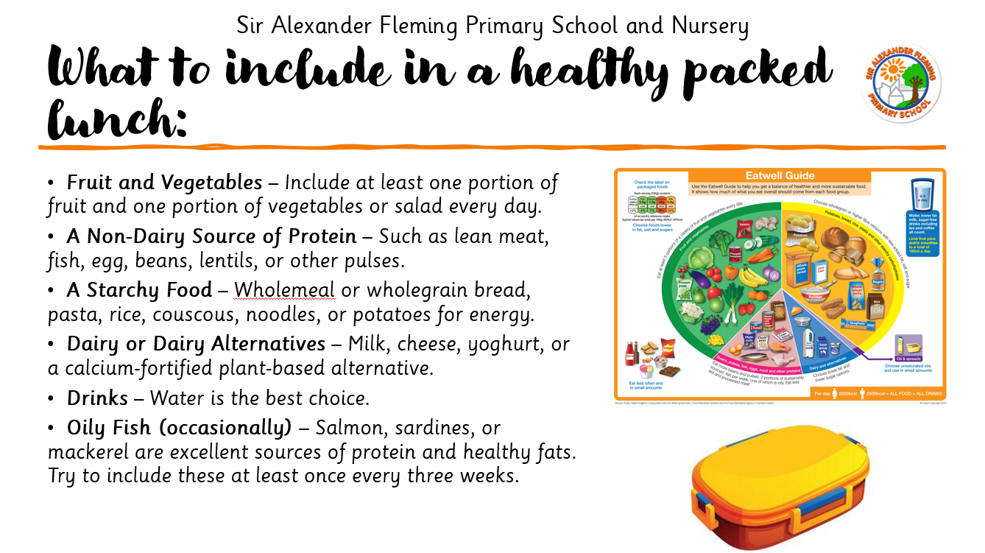

11. Celebrations and Rewards
- Birthdays and celebrations may involve non-food-based rewards or healthy treats.
- On special occasions, such as Christmas celebrations, children may be offered a small portion of a less healthy treat, as part of a balanced diet and in recognition of the celebration.
- As part of the schools fundraising efforts, biscuits and sweet treats may be sold on occasion. Parents can opt out of this.

12. Monitoring and Evaluation
- Katy Tomlinson, Headteacher is responsible for ensuring that staff within the Kitchen prepares food in line with Government Legislation.
- The Senior Leadership Team, in partnership with catering providers, monitors food provision and compliance with this policy.
- At each mealtime and snack time the supervising member of staff is responsible for checking that the food being provided meets all the requirements for each child.
- The school regularly reviews menus and food environments using DfE and School Food Standards checklists.
- The policy is reviewed annually and updated as required to reflect government guidance and school needs.

13. Communication and Involvement
- The policy is shared with parents via the school website and newsletters.
- Menus are posted on the school website and via Seesaw termly.
- Pupils are involved through School Council and food-based activities.
- Staff receive regular training and updates on healthy eating policies and practices.

Policy Links
This policy should be read in conjunction with:
- DfE Nutrition Guidance (September 2025)
- School Food Standards (DfE)
- EYFS Statutory Framework
- School Allergy & Health Care Policy
- PSHE and Science Curriculum Maps
- Our planned, seasonal menu

