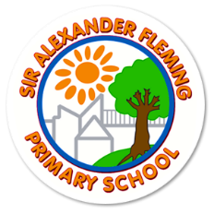
Sir Alexander Fleming Primary School and Nursery
Headteacher: Katy Tomlinson
109 Southgate, Sutton Hill, Telford, TF7 4HG –  01952 327820
 siralexanderflemingprimaryschool.org.uk  Sir Alexander Fleming Primary School

All children return to school on
Wednesday 2nd September @ 8.30am.

School Expectations for 2026

At Sir Alexander Fleming Primary School and Nursery, we believe children should feel a sense of pride in being a member of our school family. This is reflected in the pride they show when wearing our school uniform.
We commit to our duty to make sure that our uniform is affordable, in line with statutory guidance from the Department for Education on the cost of school uniform. We try to ensure that uniform is available at a reasonable cost and that it provides the best value for our parents and carers.
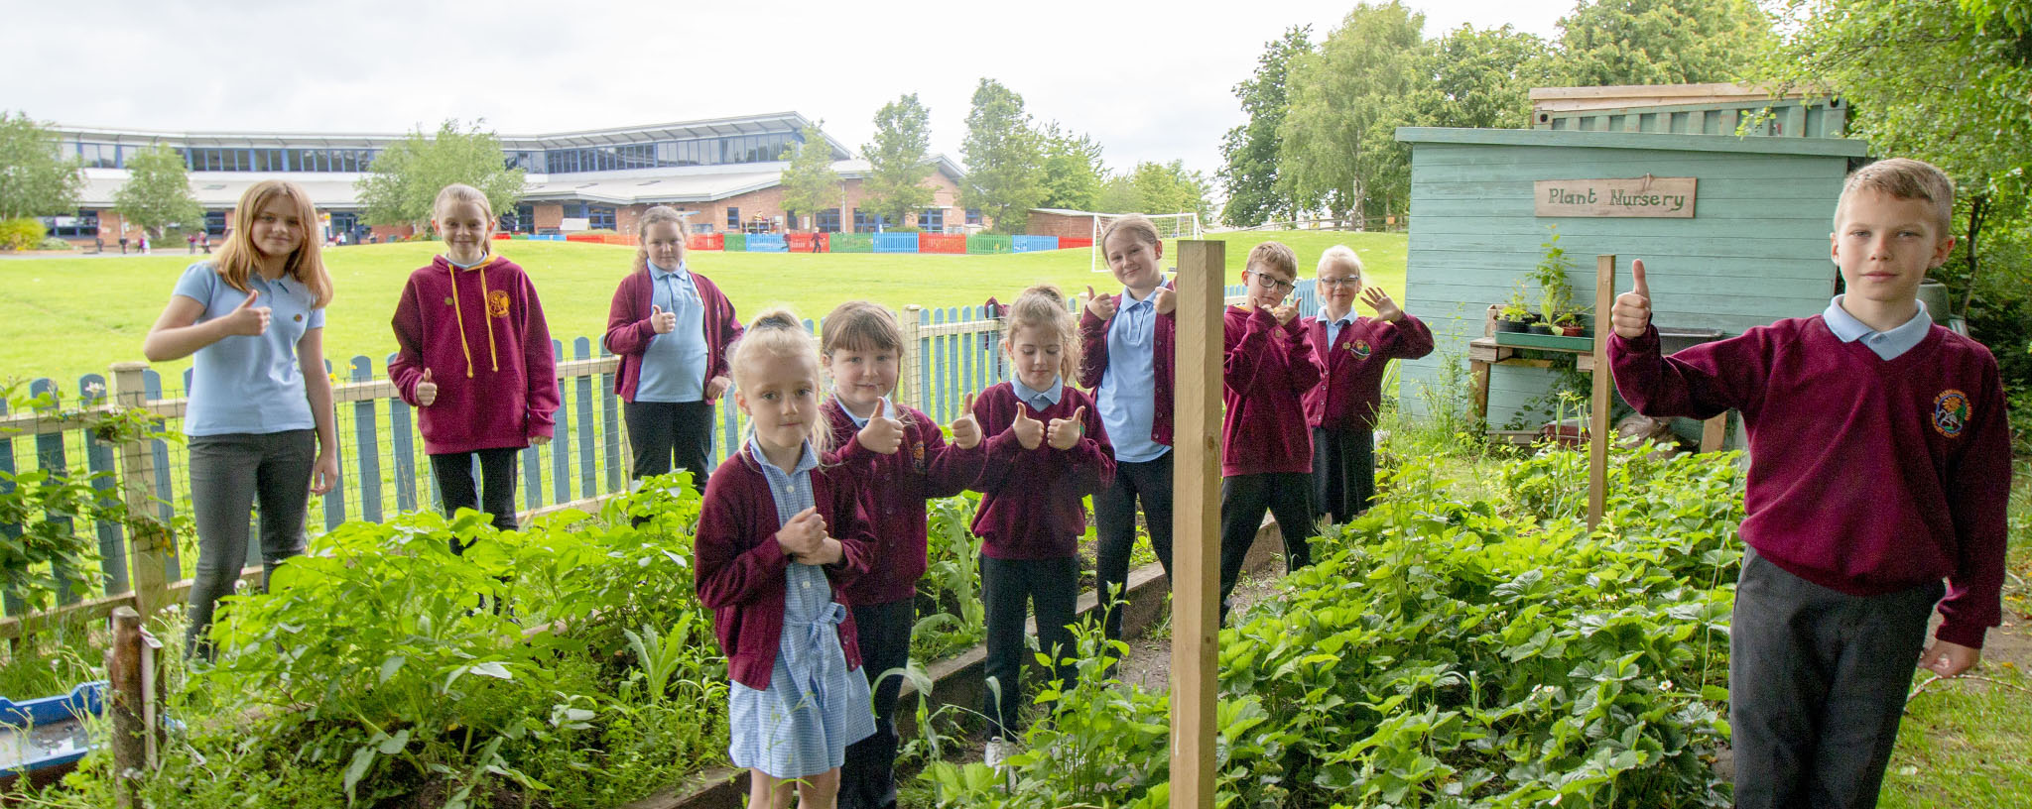
We are happy to take clean pre-loved uniform and will pass these on to families that need it – please ask if you need any, we are here to help!

UNIFORM
The school uniform colour is as follows:
burgundy with blue

- Plain burgundy sweatshirt or cardigan (with or without school logo)
- Blue polo t-shirts (with or without school logo)
- Black or grey trousers/leggings
- Black or grey skirt
- Grey or black tights / socks
- Black shoes / plain black trainers /appropriate smart black boots (no heels, fluffy boots)

Last year, we allowed trainers to be worn throughout the school day as they lasted longer than shoes, could be used for PE and playtime and were therefore a money saver to families. However, we will be strict on ensuring that they are plain black with NO colour on. We will be focusing on presentation in Autumn 1 to ensure all children and families are following our expectations. In the summer, blue school summer dresses and knee length black / grey tailored shorts are permitted. Children are not permitted to wear cycling shorts / hot pants to school.
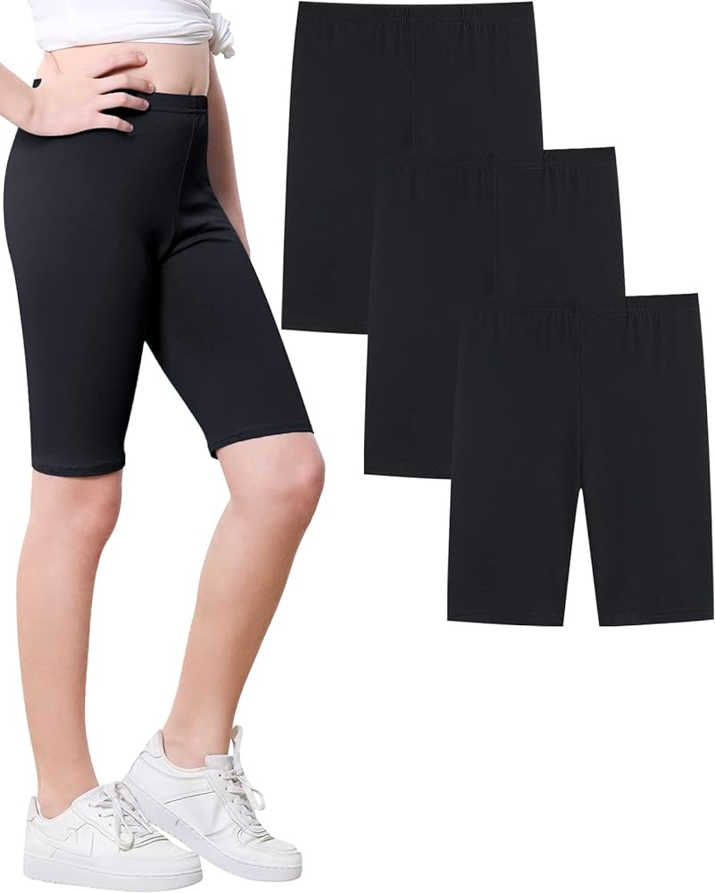
MUFTI-DAYS
On occasion, we will have a non-school uniform day at school, usually as a fundraising activity. We would expect children to come to school dressed appropriately wearing smart clothes e.g. no crop tops, hotpants, flipflops, sliders.

Children will need PLAIN BLACK trainers when required for outdoor PE.
During the colder months, children can wear: Black leggings, black jogging bottoms Plain grey hooded jumper (with or without school logo).

JEWELLERY
If earrings are worn, these must be small, plain, flat studs and restricted to one only in each ear lobe. Hooped earrings are not permitted for health and safety reasons. Children will be asked to remove these if they are not appropriate. Earrings must be removed / taped over during PE and the children must provide their own tape / plasters.

Children are permitted to wear a wristwatch (not smart technology) but the school takes no responsibility if the item is lost or broken. Bracelets and necklaces are not permitted. If, for religious reasons, jewellery must be worn, this should initially be discussed and agreed with the Headteacher.

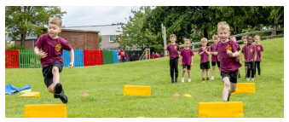
PE KITS
All classes will now have 2 sessions of PE per week. PE kits should be in school all week so that they are not forgotten. For PE activities, the children are required to wear:
Plain burgundy t-shirt (with or without school logo)
Plain black shorts.

MAKEUP
Makeup is not permitted in school unless stated by a medical practitioner for cosmetic purposes. If children arrive wearing makeup, they will be asked to remove it using baby wipes.
False nails and nail varnish are not allowed.

HAIR
All children with long hair, must ensure that it is always tied back and particularly for PE. The school strongly discourages children coming into school with ‘extremes’ of hair styles/hair colours – whilst we fully appreciate children want to follow fashion trends, this is not appropriate for school and can often lead to children being upset / self-conscious.

Children can wear small bows in their hair, however, bows larger than 5cms are not permitted. Headbands can be worn but these must be plain, burgundy or black.

HAIR COVERINGS
Children may wear on faith grounds a blue or white head covering. Headscarves must be small, shoulder length and an appropriate colour.

WINTER COAT SCHEME
We have access to the Telford Winter Coat and Shoe Support scheme. If you are struggling with either of these items, we can make an application on your behalf.
Please do not hesitate to get in touch with us. We are here to help.

LOST PROPERTY
Naming all items of clothing reduces the risk of items becoming lost! Please name items of clothing with first name and surname. We do keep lost property for a reasonable time but is often difficult to identify items that are not labelled.
If your child has lost something, then please check in their classroom first. At the end of each week, any uniform that is not claimed is put out the front of school in the black lost property box.

OUTDOOR LEARNING: Years R - Year 6
For our outdoor sessions the children will need suitable clothes and footwear. They will need ready for September:
- A pair of wellies
- Waterproof trousers to go over the top of their uniform
- Waterproof jacket to go over the top of their uniform
- Gloves/ hat as the weather gets colder
Please note these will get muddy/ wet as we will be engaging in lots of active tasks in all weathers- so they do need to be waterproof! Being outside is so important for our mental and physical wellbeing and we link the learning to our curriculum. It is a wonderful opportunity for ALL our children.

Kind regards,

Senior Leadership Team

