Sir Alexander Fleming Primary School
Art Long Term Curriculum Overview 2026-2027
Year | Autumn | Spring | Summer
THEMES | U is for Unique | C is for Community | A is for Alive
Nursery | FORM  - Handling, feeling, enjoying and manipulating materials  - Constructing  -Building and destroying  - Shape and model  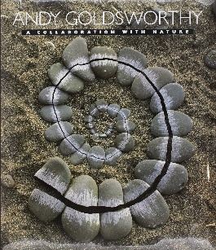  Application of skills:  Creating 3D forms in our natural environment  Clay models of our mouths  Construction area – Adventure time | COLOUR  - Experimenting with and using primary colours  - Naming - mixing (not formal)  - Learn the names of different tools that bring colour  - Use a range of tools to make coloured marks on paper, e.g. straws, matchsticks, brushes, sponges  Application of skills:  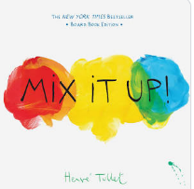  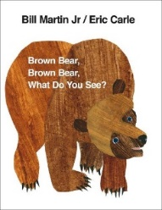  Applying knowledge of colour to own Mondrian piece. | PRINTING  - Rubbings  - Print with a variety of objects – plus hands, feet and found materials  - Print with block colours  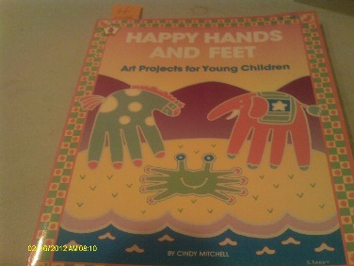  Application of skills:  Printing with a range of objects to explore different effects
 | U is for Unique | C is for Community | A is for Alive
Reception | DRAWING  - Enjoys making marks, signs and symbols with a variety of drawing tools  - Is spontaneously expressive, using marks, lines and curves  - Use drawings to tell a story  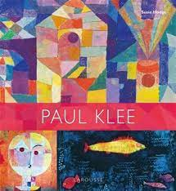  - Encourage accurate drawings of people/faces  Application of skills:  Observing/drawing mouths  Oil pastel pictures (Paul Klee) | TEXTURE  - Handling, manipulating and enjoying using materials  - Sensory experiences  - Simple collages  - Simple weaving  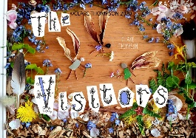  Application of skills:  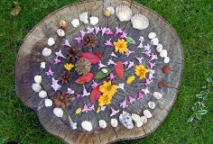  Creating Sutton Hill – maps – Geography link.  Transient art. | PATTERN  - Repeating patterns  - Irregular painting patterns  - Simple symmetry  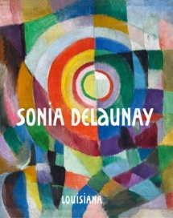  Application of skills:  Sonia Delaunay study – create own cat prints.  Symmetrical butterflies.
 | U is for Unique | W is for What if… | A is for Alive
1 | COLOUR  - Name the primary colours  - Mixing of colours  - Find collections of colours  - Applying colour with a range of tools  - Make as many tones of one colour as possible (using white)  - Use colour to express feelings  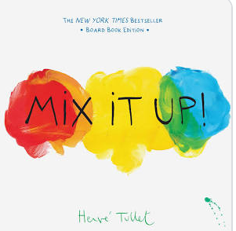  Application of skills:  Primary colours – exploring tones  Japanese artist - Hokusai – The Great Wave – applying skills learnt about colour. | FORM  - Construct  - Use materials to make known objects for a purpose  - Carve, pinch and roll coils and slabs using a modelling tool  - Make simple joins  - Awareness of natural and man-made forms  - Expression of personal experiences and ideas  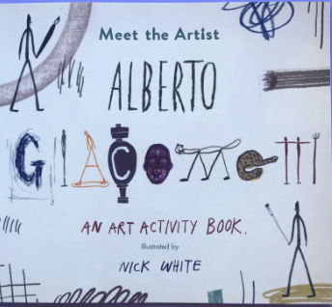  - Identify work of famous sculptors  Application of skills:  Create figures in the style of Giacommeti. | PRINTING  - Create repeat prints  - Create symmetrical or sequenced prints  - Relief printing  - Print with a growing range of objects  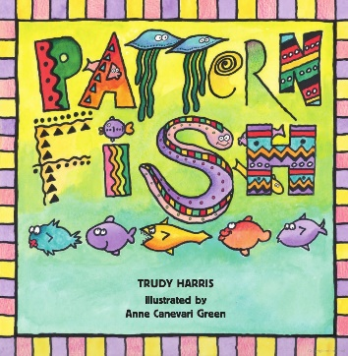  Application of skills:  Printing using two colours.  Mr Farlow pm.
 | Me in my World… | Who’s the King of the Castle? | Ready, Steady, Grow!
2 | DRAWING  - Extend the variety of drawings tools  - Use line to represent objects seen, remembered or imagined  - Observe and draw landscapes  - Observe patterns  - Observe anatomy (faces, limbs)  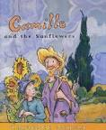  - Explore tone using different grades of pencil, pastel and chalk  Application of skills:  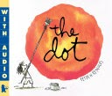  Studying Van Gogh. Children learning about line and tone to create their own authentic piece in the style of Van Gogh. | PATTERN  - Awareness and discussion of patterns  - Repeating patterns  - Symmetry  - Experiment by arranging, folding, repeating, overlapping, regular and irregular patterning  - Natural and manmade patterns  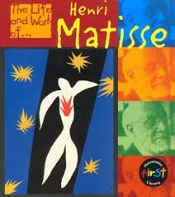  Application of skills:  Matisse style authentic piece. | TEXTURE  - Weaving  - Collage  - Sort according to specific qualities  - How textiles create things  - Overlapping and overlaying to create effects  - Use large eyed needles  - Running stitches  - Start to explore other simple stitches  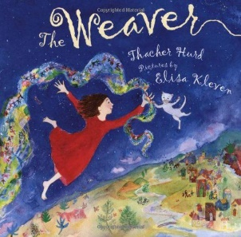  Application of skills:  Use texture to create authentic piece of work. Evaluate.
 | Stone Age | A Tropical Rainforest | Natural World
3 | PATTERN  - Pattern in the environment  - Design  - Using ICT  - Make patterns on a range of surfaces  - Explore environmental and manmade patterns  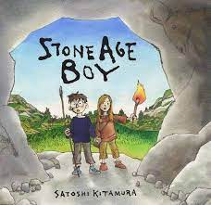  Application of skills:  Explore environmental patterns from the Stone Age. | COLOUR  - Colour mixing  - Make colour wheels  - Use different types of brushes and techniques  - Apply colour using dotting, scratching, splashing  - Colour mixing and matching; tint, tone, shade  - Explore primary and secondary colours  - Colour to reflect mood  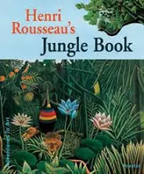  Application of skills:  Studying Henri Rosseau and his use of colour. Learn skills to apply to own piece of work. | PRINTING  - Recording textures/patterns using relief and impressed printing processes.  - Monoprinting e.g. carbon paper  - Colour mixing through overlapping colour prints  - Symmetrical/asymmetrical prints  - Modify and adapt print  Application of skills:  Explore/print own natural patterns.  Sarah Jameson.  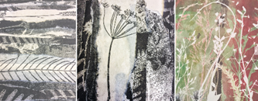
 | Ancient Greece | The Romans | Where is home?
4 | FORM  - Shape, form, model and construct (malleable and rigid materials)  - Plan and develop  - Understanding of different adhesives and methods of construction  - Experience surface patterns/textures  - Discuss own work and work of other sculptors  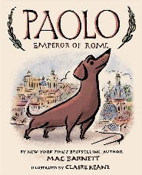  - Analyse and interpret natural and manmade forms of construction  Application of skills:  Mod-roc/clay urns | TEXTURE  - Use smaller eyed needles and finer threads  - Weaving  - Use a wider variety of joining techniques, plaiting, pinning, stapling and sewing  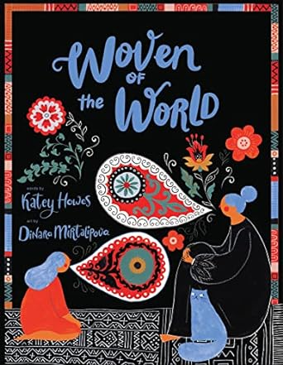  - Experimenting with creating mood, feeling and movement, using embellishments  - Compare different fabrics  Application of skills:  Roman weaving – adding embellishments.  Mr Farlow – pm. | DRAWING  - Explore shading, using different media  - Uses line and tone to represent things seen, observed or remembered  - Draw familiar things from different viewpoints  - Scale and proportion  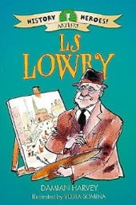  - Accurate drawings of whole people including proportion and placement  Application of skills:  Studying Lowry. Learn about perspective, line, tone and shade to create own authentic piece.
 | Beyond Earth: Unravelling Mysteries | Where in the World? | Tudor Tales by the Riverside
5 | COLOUR  - Explore hue, tint, tone and shade  - Explore the use of texture in colour  - Colour for purposes  - Colour to express feelings  - Explore tertiary colours on the colour wheel  Application of skills:  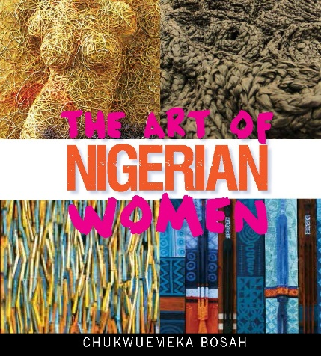  Teach colour skills to enable children to apply their knowledge to a final piece - Birch trees. Evaluate. | PRINTING  - Combine prints from different objects to produce an end piece  - Discuss and evaluate own work and that of others  - Build up drawings and images of whole or parts of items using various techniques e.g. card relief  - Explore printing techniques used by various artists  Application of skills:  Learning about abstract space artist Peter Thorpe. Applying some of his skills to create own prints.  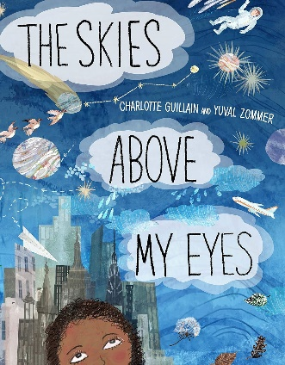 | PATTERN  - Create own abstract patterns to reflect personal experiences and expression  - Create pattern for purposes  - Use knowledge of regular/irregular/symmetrical/overlapping patterns to compose authentic patterns  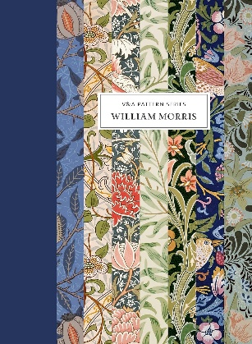
 | The Victorians | Britain at War | Madeley
6 | FORM  - Plan and develop ideas  - Shape, form, model and join  - Discuss and evaluate own work and that of other sculptors  - Make imaginative use of acquired knowledge about tools and techniques and materials to express own ideas and feelings  - Look at 3D work from a variety of genres and cultures and develop own response through experimentation  Application of skills:  Study Giacometti. Create own Victorian tiles – architecture - making decisions about tools, techniques, shape and form. Evaluate.  Mr Farlow – pm. | DRAWING  -Explore graphic design  - Use typography, line, tone, colour, shape and composition to recreate food packaging.  - Turn flat graphics into 3D nets.  - Explore typography and design lettering which is fit for purpose.  - Select appropriate media and techniques to achieve a specific outcome  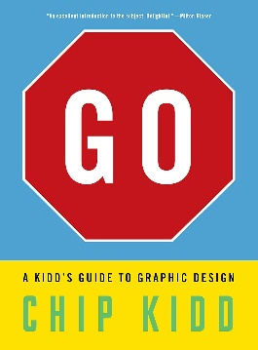  - Talk about intention and outcome, - Giving and receiving positive feedback from peers.  Application of skills:  Design and make food packaging – DT link. | TEXTURE  - Stitching using various needles to produce more complex patterns  - Select and use materials  - Embellish work  - Artists using textiles  - Develops experience in embellishing  - Applies knowledge of different techniques to express feelings  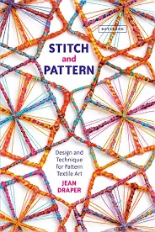  Application of skills:  Sewing a war garment/artefact.

