

Sir Alexander Fleming Primary School and Nursery
Behaviour Policy

Reviewed September 2026
Next Review September 2027 (inline with KCSiE)


‘Keep your thoughts positive because your thoughts become your words. Keep your words positive because your words become your behaviour.’

Mahatma Gandhi

What do our children think about our Behaviour Systems?

“Opportunities can never be reached unless you are well-behaved”

“Our rocket system works well as it shows the children that they have supportive steps”

“The teachers are fair and follow through with the supportive steps”

“It is a good system because there are lots of people to talk to who support you, like the SLT, Rainbow Room, Mrs Fisher, behaviour mentors”

“You can go to the calm room if you feel stressed or worried”



Our Values and Vision

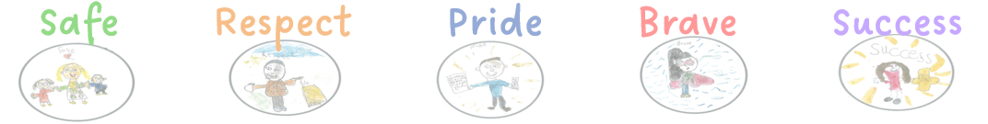

Shine, Achieve, Flourish – The SAF Way!

Our School Values
Our values underpin everything we do and guide the way we learn, work, and interact. Rules are presented positively and explained clearly so that everyone understands why they matter:
- To keep everyone safe.
- To show respect for others and their property.
- To ensure the smooth running of our school community.

Every child has the right to feel safe and valued. At Sir Alexander Fleming Primary School and Nursery, we are committed to protecting every child from harm and promoting equality. Everyone is of equal worth, regardless of:
- Disability or additional needs
- Ethnicity, culture, or language
- Religious affiliation or belief
- Gender or gender identity
- Sexual identity

It is everyone’s responsibility to help make our school a happy, inclusive place where all can succeed. Respectful behaviour enables teachers to teach and children to learn. We expect positive behaviour both offline and online, and we celebrate it as something to be proud of.

When behaviour communication arise, we respond with supportive strategies and restorative approaches, ensuring that learning continues for all. Parents are kept informed about expectations and involved in working together to help children succeed.

Aims of the Policy
- Create a welcoming, safe, and inclusive learning environment where every child feels valued and supported to achieve their best.
- Develop a fair and consistent approach across the school, ensuring that expectations are clear, understood, and communicated in ways that meet the needs of all learners.
- Foster an atmosphere that celebrates social, moral, spiritual, and cultural values, promoting respect, empathy, and understanding of diversity, with a strong emphasis on shared values that help our community thrive.

Our Shared Expectations
At our school, we work together to create a safe, respectful, and inclusive environment where everyone can thrive. We expect and encourage everyone in our community to:
- Aim high and believe in their ability to succeed.
- Show respect and kindness to each other in words and actions.
- Develop an understanding of fairness and empathy, learning from mistakes and celebrating progress.
- Collaborate and support one another, recognising that teamwork helps everyone achieve.
- Celebrate achievements, both big and small, and value the efforts of others.
- Be reliable and responsible, knowing that we can trust each other to do our best.
- Act safely and thoughtfully, considering the wellbeing of ourselves and others.
- Care for our environment and resources, showing pride in our school.
- Look after personal belongings and respect those of others.
- Use courteous language and manners, creating a positive atmosphere for all.
- Show through our actions that we value our school community and the people within it.
- Treat others as we would like to be treated, fostering a culture of respect and inclusion.

Promoting Positive Behaviour
Positive behaviour is nurtured when we work together to create an environment where every child feels safe, understood, and supported. Our approach focuses on collaboration, encouragement, and clear communication:
- Staff prioritise positive behaviours, noticing and praising effort and progress in a meaningful way.
- All staff maintain a calm and supportive approach, working together to help children succeed.
- We uphold a no-shouting ethos, ensuring interactions remain respectful and reassuring.
- Expectations are explained clearly and consistently, using language that helps children understand what success looks like.
- When behaviour needs addressing, this is done discreetly and with empathy, focusing on problem-solving rather than blame.
- Children are supported to remember and practise expectations, with opportunities to revisit and reinforce routines.
- School and classroom expectations are fair, consistent, and co-created with pupils, so they feel ownership and understanding.
- Expectations are regularly reviewed together, allowing children to share their thoughts and feel heard.
- Responsibilities and activities are adapted to meet individual needs, recognising different strengths and challenges.
- Parents/carers are informed and involved in celebrating positive behaviour and achievements, fostering a strong home-school partnership.
- Examples of excellent work and effort are celebrated, promoting pride and confidence.
- Across the curriculum, children learn why positive behaviour matters, how it supports their wellbeing and relationships, and how it benefits the wider community.
- In assemblies, children are encouraged to reflect on kindness, empathy, and respect, with achievements celebrated in ways that build self-esteem.
- In all subjects, we teach and model skills such as resilience, resourcefulness, reciprocity, and reflectiveness, helping children develop lifelong habits.

Our Behaviour Curriculum – The Aims
Our behaviour curriculum is designed to create a positive, inclusive school culture where every child feels safe, respected, and supported. We believe that successful relationships are built on trust, empathy, and understanding, and we work together to uphold these values.
We aim to:
- Foster a culture of positive behaviour that supports learning, community, and life skills.
- Promote kindness, care, respect, acceptance, and empathy, helping children understand and value differences.
- Empower learners to take ownership of their behaviour, with guidance and support to make positive choices.
- Celebrate diversity and encourage active citizenship, so pupils contribute positively to their community and society.
- Build habits through practice and reinforcement, so positive behaviours become part of everyday life.
- Create an environment of trust and understanding, where pupils feel confident, valued, and ready to learn.

Teaching the Behaviour Curriculum
- Positive behaviours are taught explicitly and revisited regularly, ensuring all pupils understand expectations in a clear and supportive way. We use consistent language and visual prompts to help every child succeed.
- The curriculum is introduced during the first week of the Autumn term alongside core subjects and reinforced throughout the year to maintain clarity and confidence.
- Children are supported to learn and practise the content, so they can recall expectations and apply them in real-life situations. This includes modelling, guided practice, and opportunities for reflection.
- Teachers model behaviours and provide structured opportunities for practice, especially during the first few days of term and at key transition points. We recognise that some pupils may need additional time, visual aids, visual schedules, countdown timers or sensory breaks to embed routines.
- Our approach is collaborative and inclusive, ensuring that expectations are adapted where needed to meet individual needs while maintaining a positive and respectful learning environment.
The process for teaching behaviour explicitly

- IDENITIFY the behaviour we expect
- Explicitly TEACH behaviour
- MODEL the behaviour we are expecting
- PRACTISE behaviour
- NOTICE excellent behaviour
- CREATE conditions for excellent behaviour

It is important that all school staff know the details of this curriculum, teach it explicitly to children and continuously maintain the high standards we set. By doing so we support each other to create a culture where pupils feel safe and are able to learn in an optimised environment and where teachers are free to teach.
We recognise that neurodivergent pupils may experience the school environment differently. Our approach prioritises understanding, flexibility, and co-regulation strategies to support their success.

We will encourage children to reflect on their behaviour using the language of:
Be ready | Be respectful | Be safe
- We arrive at school on time, every time  - We get to lessons on time.  - We wear the correct uniform with pride and have the right clothes for PE and playing outdoors.  - We make sure we have the right equipment for the day.  - We take part fully in lessons and show resilience. | - We always listen when an adult is talking.  - We always listen to pupils in our class giving ideas and feedback.  - We are polite and show good manners to everyone.  - We respect difference and know we are all equal.  - We look after our equipment and share it.  - We look after our environment and never drop litter.  - We respect the law and the rules of school and society | - We follow instructions -first time, every time. We do not tolerate bullying of any kind.  - We walk sensibly around our school.  - We line up sensibly.  - We know who to go to for help and support.  - We stay safe online and outside school.  - We use equipment safely.

Behaviour Curriculum for Pupils

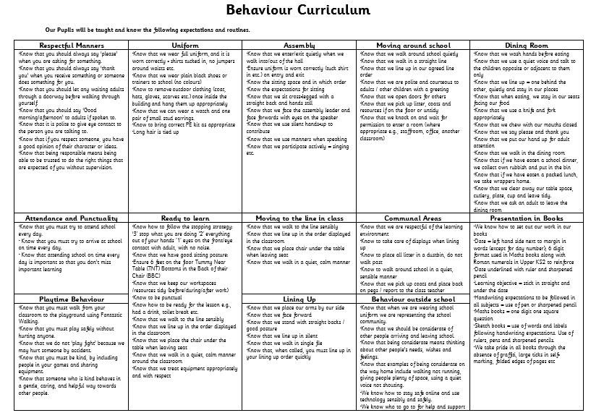

Behaviour Curriculum for Adults

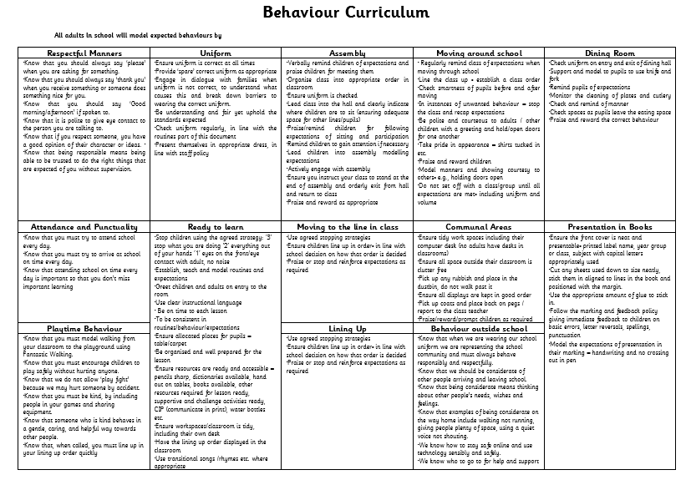

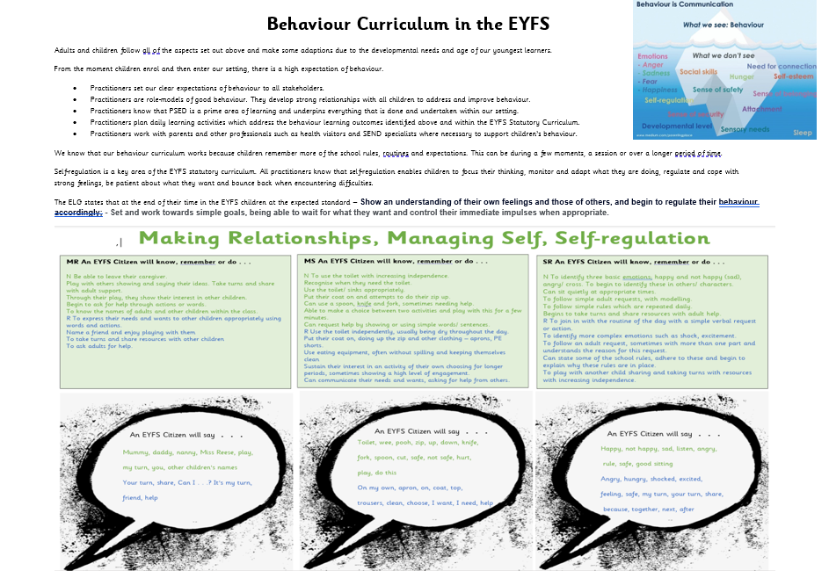

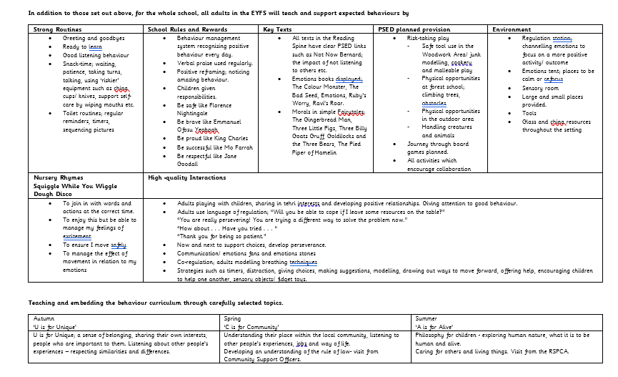

Celebrating Positive Behaviour
We believe that recognising and celebrating positive behaviour helps children feel valued and motivated. Our approach focuses on encouraging effort, progress, and personal growth, rather than relying solely on external rewards. We aim to nurture self-motivated learners who feel proud of themselves and their achievements.

Our principles for celebrating behaviour:
- Praise is specific, sincere, and focused on effort, not just outcomes.
- Recognition is inclusive and fair, ensuring all children have opportunities to feel successful.
- Celebrations are designed to boost confidence and wellbeing, not create pressure or comparison.

Examples of ways we celebrate positive behaviour:
- Verbal praise and encouragement – acknowledging effort and progress (“I noticed how you worked hard on that task”).
- Head Teacher and Class Teacher stickers for exceptional effort or kindness.
- Class rewards such as ‘Behaviour of the Week’ trophy and bear for teamwork and respect.
- Golden Time for consistent positive choices.
- Points systems (e.g., Good to be Green) used positively to encourage progress.
- Celebration Assembly nominations, with achievements shared in newsletters.
- Special awards for PE, attendance, and other areas of effort.
- House points for collaboration and contribution.
- Postcards home to share success with families.
- Inclusive lunchtime rewards such as VIP tables for showing respect and kindness.

Our goal is to ensure that every child feels recognised for their efforts and understands that positive behaviour benefits themselves and the whole school community.

Behaviour Support Systems
Our behaviour support systems are designed to guide and encourage positive choices, while recognising that every child is unique and may need different levels of support. We focus on helping children regulate, reflect, and succeed, rather than using punitive measures. Children will have access to sensory tools, movement breaks, and calming spaces as part of proactive regulation strategies. Visual schedules, countdown timers, and clear step-by-step instructions will be used to support transitions.

Use of Regulating Spaces and Deprivation of Liberty Safeguards
At Sir Alexander Fleming Primary School, calm rooms, the sensory room, and other regulating spaces are provided as supportive, optional environments to help children regulate. These spaces must never become restrictive or deprive a child of their liberty.
To ensure compliance with the 2024 DfE Behaviour Guidance and Ofsted expectations:
- Pupils must always be able to exit these spaces freely.
- Any situation where an adult prevents a child from leaving must be exceptional, risk-led, and used only to prevent immediate harm.
- Any prevented exit must be:
  - time-limited
  - continuously supervised by an adult
  - proportionate and the least restrictive option
  - recorded on CPOMS with rationale and duration
  - reported to parents/carers the same day
- Staff use de-escalation and co-regulation first, with physical restriction/intervention only as a last resort where safety is at risk.
- Regulating spaces are never used as isolation or punishment.
- Children should have access to regulation spaces as part of their SEND, SEMH or sensory support, without restriction unless immediate risk is present.

Reception and Year 1
In Reception and Year 1, we use a visual system to celebrate positive behaviour and provide gentle reminders when needed. Each child starts the day on Sunshine, representing a fresh start and positive expectations.
- When a child demonstrates exceptional effort or kindness, they move to Rainbow, and parents are informed so achievements can be shared and celebrated.
- If a child needs support to make better choices, they receive a ‘Stop and Think’ prompt, giving them time to reflect and reset.
- If further support is needed, the child may move to Cloud, and we work together to help them regulate. This may include a short break or calming activity, never as a punishment but as a way to restore readiness for learning.
- For ongoing challenges, we involve the Early Years Leader or Phase Leader and collaborate with parents to create a supportive plan.
- If patterns persist, a Report Card may be introduced as a positive monitoring tool, with the Behaviour Mentor providing additional guidance.

Years 2–6
In KS2, we use the ‘Good to be Green’ system, which encourages consistency and celebrates effort:
- All children start the day on Green, representing readiness and positive expectations.
- Gold is awarded for exceptional effort, kindness, or progress.
- If a child needs support, they receive a Yellow Card 1 as a reminder to reflect and reset.
- If further help is needed, Yellow Card 2 may involve a short, planned intervention (e.g., calming time or restorative conversation).
- Red Card signals that additional support and collaboration with parents is required. This is never about punishment but about working together to help the child succeed.

Celebrating Outstanding Behaviour
Children who consistently demonstrate positive choices and effort may be recognised on our ‘Out of This World’ board, celebrating their achievements in a way that builds confidence and pride.

Supporting Children with Challenging Behaviour
We approach challenging behaviour proactively and compassionately, recognising that behaviour is a form of communication. Our goal is to understand the underlying needs and provide strategies that help children regulate and succeed.

- We identify triggers and patterns that may lead to challenging behaviour and work with the child to develop supportive strategies.
- Support may include Nurture provision, pastoral care, sensory breaks, movement opportunities, calming spaces or personalised plans to help children feel safe and regulated.
- We distinguish between minor incidents and more serious concerns, responding in a way that prioritises safety and wellbeing for all.
- If a child needs immediate support, staff use the emergency card system to request assistance without leaving the classroom, ensuring safety and calm.
- All incidents are recorded on CPOMS, and parents/carers are involved in a collaborative approach to support the child.
- Where needed, outside agencies may be engaged to provide additional expertise and guidance.
- Our approach focuses on restorative conversations, helping children reflect on their actions, repair relationships, and learn positive strategies.
- We encourage integration and inclusion, supporting both the child and any peers affected to rebuild trust and positive interactions.
- All staff play an active role in praising positive behaviour and supporting improvement, recognising that every child can succeed with the right support.

Key principles:
- Responses are private, calm, and non-confrontational.
- Behaviour systems (e.g., visual prompts, reflection time) are used as support tools, not punishments.
- If ongoing support is needed, we work with families to create a personalised plan, which may include a Report Card as a positive monitoring tool.
- The Calming Room is available as a safe space for regulation, never as a punitive measure.
- Exclusion is considered only as a last resort, and every effort is made to avoid this through proactive and supportive strategies.

Risk Assessment and Least-Restrictive Practice
When considering any practice that temporarily restricts a pupil’s freedom of movement for safety reasons, staff must follow least-restrictive principle guidance.
All risk assessments relating to behaviour or safety must include:
- the immediate risk being managed
- why restriction was necessary and proportionate
- de-escalation strategies attempted beforehand
- alternative options considered or tried
- the shortest expected duration
- supervision requirements
- arrangements to ensure the child’s emotional safety and dignity
- parent/carer consultation and agreement, where appropriate
- a clear review date and criteria for reducing/removing restrictions
Risk assessments will be updated following any significant incident or change of need, ensuring decisions remain evidence-based and in the child’s best interests.

Responding to Behaviour Communication
Our approach to behaviour is rooted in support, reflection, and restoration, rather than punishment. When difficulties arise, we aim to help children understand expectations, regulate emotions, and make positive choices.
- Minor behaviour concerns are addressed by the class teacher or support staff in a calm, caring, and fair manner, with flexibility for age, developmental stage, and individual needs.
- Each situation is treated individually, focusing on understanding the cause and supporting the child to succeed.
- Children are reminded that their actions have an impact, and we work together to find solutions that help them move forward.

Tiered Support Steps:
- Gentle Reminder – A calm, private prompt to help the child refocus.
- Supportive Conversation – If needed, a short discussion using positive language to help the child reflect and reset.
- Additional Strategies – For ongoing challenges, we may introduce personalised support such as movement breaks, sensory tools, or a calming space.
- Collaborative Planning – If difficulties persist, we work with parents/carers and staff to create an individualised plan that supports regulation and success.
- Offer choices during challenging moments (e.g., where to sit, which calming strategy to use).
- Adults will model calm regulation techniques and support children to use them.

Our goal is always to restore relationships, rebuild confidence, and help children learn strategies for self-regulation. Restorative strategies are never about punishment—they are about providing structure and support so every child can thrive.

What’s the matter?
“I can see you’ve had a problem with…”
“I’ve noticed that you…”
Explain why:
“You know our expectations of…”
Remind of previous good behaviour:
“Do you remember…?”
Explain the outcome:
“I will need you to…because I’ve reminded you X times and I know that you can…”
Tell them you understand:
“It’s alright to think that.”
Remind of previous good behaviour and leave.

Supportive Responses to Behaviour Communication
When additional support is needed, we use strategies that help children reflect, regulate, and re-engage with learning. These responses are always applied with empathy, fairness, and consideration of individual needs.

Examples of supportive steps may include:
- Gentle verbal reminders, linked to our School Values, to help the child refocus.
- Calm reflection time in a different classroom or safe space, framed as an opportunity to reset rather than a punishment.
- Adjustments to privileges will be considered only when they do not remove essential regulation opportunities (e.g., movement breaks, sensory time). These changes will always be explained and agreed upon with the child in a supportive way.
- Collaborative conversation with parents/carers to share strategies and agree on next steps.
- Meeting with a senior member of staff for restorative discussion and planning.
- Involvement of pastoral staff or external support teams where additional expertise is needed.
- Positive monitoring tools, such as a Report Card, used to track progress and celebrate improvements.
- Internal support sessions with the Headteacher, Assistant Headteachers, or pastoral team to provide guidance and reflection.
- Calming Room access as a safe space for regulation, never as a punitive measure.
- Suspension (internal, fixed-term, or permanent) is considered only as a last resort when all supportive strategies have been exhausted, and safety cannot be maintained.

Additional considerations:
- For KS2 pupils, a short reflective session (maximum 10 minutes) may be used to help the child prepare for a fresh start the next day.
- For Year 6 pupils, with parental agreement, an after-school reflection session may be offered, aligned with local secondary school practices.

Our aim is always to restore relationships, rebuild confidence, and help children learn strategies for success, rather than punish mistakes.

How Adults at Sir Alexander Fleming Enable Positive Behaviour
At our school, we believe that positive behaviour is best promoted through strong relationships, clear expectations, and a nurturing environment. Adults play a key role in modelling and reinforcing these principles every day.

We do this by:
- Greeting families and children warmly each morning, creating a sense of belonging and safety.
- Delivering high-quality learning experiences that engage and meet the needs of every child.
- Providing regular, constructive feedback to help children recognise progress and feel motivated.
- Using positive praise and recognition to celebrate effort, kindness, and achievement.
- Maintaining clear and consistent expectations, while adapting approaches to support individual needs.
- Avoiding unnecessary attention for negative behaviour, focusing instead on guiding children back to success.
- Ensuring a secure, happy, and stimulating learning environment where every child feels valued.
- Offering a broad and balanced curriculum, enriched with extra-curricular opportunities to develop confidence and social skills.
- Holding high expectations for effort, attitude, and respect, while supporting children to meet these expectations.
- Encouraging positive relationships and open communication between staff, pupils, and families.
- Providing a support system, including behaviour mentors and personalised plans, to help children regulate and thrive.

Unacceptable Behaviour
Our aim is to support every child in meeting expectations through positive strategies. We recognise that behaviour is a form of communication, and we always seek to understand the underlying reasons before responding.

Children will always be given:
- Opportunities to reflect on their behaviour in a calm, supportive way.
- Guidance to repair relationships (e.g., making apologies or taking restorative actions).
- Encouragement to demonstrate they can meet expectations and move forward positively.

If persistent challenges occur:
- Parents/carers will be invited to collaborate with the class teacher and Behaviour Mentor to agree on supportive strategies.
- Individualised plans, such as Report Cards, may be introduced to monitor progress and celebrate improvements.
- For serious concerns, parents/carers may be asked to meet with the Headteacher promptly to ensure a coordinated response.

Behaviours requiring immediate attention include:
- Actions that disrupt learning for others.
- Aggressive or violent behaviour towards peers or adults.
- Use of offensive or abusive language.
- Deliberate defiance or disrespect.
- Bullying (online or offline).
- Vandalism or theft.
- Harassment, including racism, homophobia, sexism, or any discriminatory behaviour.
- Sexual harassment or inappropriate conduct.
- Drug-related behaviour or possession of prohibited items.
- Carrying anything considered a weapon.
- Unsafe behaviours, such as spitting or coughing deliberately at others.
- Poor behaviour in the community that impacts safety or the school’s reputation.

Our response will always prioritise:
- Safety and wellbeing for all.
- Restorative approaches to repair harm and rebuild trust.
- Collaboration with families and external agencies where needed.
- Avoiding punitive measures unless absolutely necessary for safety.

Safeguarding and Child-on-Child Abuse
All staff must remain vigilant to the fact that safeguarding concerns can present as child-on-child abuse. This may include, but is not limited to:
- Bullying, including cyberbullying.
- Physical harm, such as hitting, kicking, biting, hair pulling, or other aggressive actions.
- Sexual violence or harassment.
- Sharing of sexual imagery (sexting or youth-produced sexual content).
- Initiation or hazing rituals that cause harm or distress.

Staff should be fully aware of the school’s Child-on-Child Abuse Policy (2025) and follow procedures promptly and consistently.

If a child’s behaviour falls into any of these categories:
- The incident must be recorded on CPOMS as a confidential concern.
- A detailed record of the incident should be made.
- The Headteacher will be notified immediately.
- Parents/carers will be contacted to discuss the situation with the child’s teacher and a member of SLT.
- Appropriate safeguarding actions will be taken in line with statutory guidance.

Our priority is always to protect all children, respond promptly, and provide support for both the child affected and the child displaying harmful behaviour, ensuring restorative and protective measures are in place.

Modified Timetables
In some cases, where a child’s engagement with learning or wellbeing is significantly affected, we may agree on a Modified Timetable for a short period. Modified timetables will never be used as punishment but as a supportive measure to reduce stress and re-engage the child gradually.”

- Modified timetables are individualised, carefully planned, and regularly reviewed.
- Parents/carers are fully involved in the process, ensuring transparency and collaboration.
- During this time, the school provides appropriate learning activities for home and ensures the child remains connected to school life.
- This strategy often helps children rebuild confidence, regulate emotions, and gradually return to full participation.

Suspensions
Suspensions are considered only when all supportive strategies have been exhausted and behaviour continues to pose a serious risk to safety or learning.
- During suspension, the school provides learning activities for home to maintain continuity.
- Parents/carers are invited to a formal meeting to discuss next steps and agree on a reintegration plan.
- The Local Authority and Governing Body are informed, and all procedures follow statutory guidance.
- Our focus remains on restoring relationships and supporting the child’s successful return to school.

Permanent Exclusion
Permanent exclusions are extremely rare and only considered in cases of severe, persistent behaviour or an isolated incident of extreme harm.
- Before exclusion, the school must demonstrate that all possible support strategies have been tried.
- Parents/carers have the Right of Appeal, and all decisions follow Local Authority protocols.
- Even in these cases, our priority is to ensure the child’s safety and access to education.

Searching and Confiscation
The Headteacher and SLT have a statutory duty to act if a child is suspected of carrying prohibited items (e.g., weapons, drugs). Searches are conducted:
- Respectfully and proportionately, prioritising the child’s dignity.
- In line with legal requirements and safeguarding protocols.

Physical Intervention
Physical intervention is only used as a last resort to prevent harm to the child or others.
- Any intervention is minimal, proportionate, and recorded on CPOMS.
- Staff trained in safe techniques will act calmly and professionally.

Lunchtimes
We aim to make lunchtimes positive and inclusive:
- Children are supported to follow expectations through clear routines and positive reinforcement.
- Supervised lunchtime clubs are available to promote social skills and wellbeing.
- SLT are present to provide support and ensure a safe, happy environment.

Leaving the Classroom or School Grounds Without Permission
Our priority is always the safety and wellbeing of the child. If a pupil leaves the classroom or school grounds without permission, staff will act calmly and follow agreed procedures:
- Do not chase the child, as this may escalate the situation. Instead:
  - Alert the Headteacher or a member of SLT immediately.
  - Send a message to the office for additional adult support.
- A responsible adult may observe the child from a safe distance to monitor their safety without provoking further flight.
- If the child leaves the school premises:
  - Parents/carers will be contacted immediately.
  - If parents cannot be reached or the child is at risk, the police will be informed.
- All actions will be recorded, and safeguarding procedures followed.
Preventative measures:
- Ensure registers are accurate and up to date.
- Identify children who may be at higher risk and implement individualised strategies (e.g., visual schedules, safe spaces, trusted adults).
- Work with families to develop proactive plans for children who may attempt to leave.
If a child goes missing:
- Make all reasonable efforts to locate the child before contacting the police.
- If risks are identified, parents should be advised to inform the police immediately.
- All missing children will be reported to the police by the end of the school day if not located.
Our approach is always calm, consistent, and focused on safety, while working to understand and address the underlying reasons for the behaviour.

Any temporary restriction to prevent unsafe exit must follow the school’s Deprivation of Liberty safeguards: exceptional, least-restrictive, supervised, time-limited, and recorded.

If a child is identified as missing during the school day, we will complete the following checklist:

Name of pupil……………………………………. D.O.B……………………

Action
Ensure the child is not on the school premises
(And that reception staff alert you immediately they receive any information).
Check when they were last seen.

Contact the child’s parents/carers and advise they should contact the police if they have any concerns.
Contact absent parents (unless they are not allowed contact with the child).

Contact any emergency contacts from the child’s records.

If the child is subject to a Child Protection Plan or is a Child in Need inform the key social worker or if unavailable the team leader.
If the child is a child “at risk/vulnerable” report immediately to social care and the Police (ensure any health concerns are communicated).
If you are unsure if the child should be reported to the police, have an informal discussion with them. Ask to speak to a Police supervisor on 0300 333 3000.
If the child is still missing by the end of the school day and you have been unable to talk to the parents/carers, report them as missing to the police.
When the child is located, explore reasons for them being missing.

Date checklist completed………………………………………… (copy to appropriate file)

Equal Opportunities
At Sir Alexander Fleming Primary School and Nursery, we are committed to ensuring that every child is valued equally and has the opportunity to achieve their full potential. We celebrate diversity and actively promote inclusion, regardless of:
- Gender or sexual orientation
- Learning abilities, including gifted and talented pupils and those with SEND
- Disabilities or additional needs
- Social and cultural background, including pupils who are Pupil Premium, Looked After Children, or subject to safeguarding
- Ethnicity, language, or heritage
We recognise differences, adapt provision to meet individual needs, and take positive action to ensure equal access to educational opportunities. Regular monitoring ensures that every child can thrive.
All staff and Governors understand their responsibilities under the Equality Act and Disability Discrimination Act. We take a proactive stance against bullying and discrimination, maintaining clear records of incidents and reporting racist incidents through IRIS. Our approach prioritises education, prevention, and restorative action, helping children understand the serious nature of these behaviours and promoting respect for all.

Homophobic and Transphobic Bullying
Our school takes a proactive approach to preventing homophobic and transphobic bullying. Through RSHE and PSHE lessons, children learn about different types of families and the importance of acceptance and respect for all.
- All staff and parents are aware that homophobic and transphobic bullying are serious and reportable offences.
- Any incident will be recorded in the bullying log, and parents/carers of all involved will be informed promptly.
- Our response prioritises support for those affected, restorative action, and education to prevent recurrence.

Behaviour Beyond the School Gate
Our responsibility to promote positive behaviour extends beyond the school premises. We may respond to poor behaviour or bullying that occurs:
- During school-organised activities.
- While travelling to or from school.
- When wearing school uniform or otherwise identifiable as a pupil.
We may also act if behaviour:
- Impacts the orderly running of the school.
- Threatens the safety of others.
- Damages the school’s reputation.

In such cases:
- The Headteacher will gather statements from witnesses.
- Parents/carers will be invited to discuss the matter.
- Restorative strategies will align with those used during the school day, and parental support will be sought.
- If behaviour is criminal or poses a serious risk, the Police or Community Support Officers will be informed.
- Safeguarding procedures will be followed if there is any concern about harm or risk.

Additional Supportive Actions
Instead of, or alongside, disciplinary measures, we may implement:
- Staff consultations (Headteacher, SENCO, Inclusion Leaders, Nurture Team).
- Individual Risk Assessments.
- Early Help Meetings.
- External behaviour support or specialist advice (e.g., CAMHS, BSAT).
- Modified timetables or managed moves.
- Referral to Fair Access Panel or Pupil Referral Unit.
- Consideration of an Education Health Care Plan.
- School-based support plans, developed collaboratively with parents/carers.
- Formal multi-agency meetings where appropriate.

Outcomes and Impact
Our ultimate goal is to ensure that children and staff feel happy, safe, and valued. This policy underpins excellent teaching and learning, promotes high standards, and ensures that every child’s individual needs are met.

All staff will receive training in neurodiversity awareness, trauma-informed practice, and co-regulation strategies to ensure consistent, inclusive support.

Appendix 1

Sensory Room / Calm Room - Code of Use
The sensory room is a therapeutic, child-led environment designed to support regulation, emotional safety, and sensory needs. To prevent unintentional restriction and ensure safe, consistent practice:
Purpose
- To reduce anxiety and support sensory regulation.
- To provide a quiet, supervised environment for children who require it.
Supervision
- Children access the sensory room with adult awareness and appropriate supervision.
- Staff remain nearby and monitor pupil wellbeing while promoting autonomy.
Exit Expectations
- Children may leave freely at any time.
- No adult should prevent exit except in immediate, high-level risk situations.
- Any prevention of exit must follow DoL and safeguarding protocols.
Duration
- Typical use: 5–15 minutes, depending on the child’s needs.
- Longer periods are part of a planned SEND or regulation plan.
Planning and OT Involvement
- Individual sensory plans are reviewed by the SENCO and, where relevant, OT professionals.
- Strategies used must match the child's sensory profile and support needs.
Recording and Review
- Any incident where a child’s movement was restricted must be recorded on CPOMS.
- Reviews of sensory use occur termly or after any significant behavioural event.

