



Sir Alexander Fleming Primary School and Nursery

Procedures for managing low-level concerns or allegations against staff (including supply staff, contractors and volunteers)

Commitment to review

These procedures will be flexible to change and will be reviewed on an ongoing basis to reflect where there are any changes in government legislation or any changes in the duty of statutory agencies in child protection and/or the wider safeguarding agenda. If it is not appropriate to refine the procedures during the year, then this will be done as a matter of course on yearly basis by a named person responsible below, who shall be accountable for that action.

Procedures for managing low-level concerns or allegations against staff (including supply staff, contractors and volunteers) - Document Status
Date published by Telford and Wrekin Council: | April 2021 | Authors: | Telford & Wrekin Council, Education Safeguarding Team
Date of policy creation: | April 2021 | Person responsible for creation: | Scott Thomas-White
Date of policy adoption by Governing Body | 1.9.26
Date of policy review | 1.9.26 | Person responsible for review: | Joanne Hanslip

Introduction

This policy reflects the statutory requirements for schools and colleges set out in part four, Keeping Children Safe in Education, 2026.

This policy sets out the procedures for dealing with safeguarding concerns or allegations against those working in or on behalf of the school/ college in a paid or unpaid capacity, i.e. members of staff, including supply teachers, trainee teachers, volunteers and contractors.

This policy has two sections covering the two levels of concerns and allegations:

1. Concerns / allegations that may meet the harm threshold.

2. Concerns / allegations that do not meet the harm threshold – referred to for the purposes of this policy as ‘low-level concerns.

For staff working with children in the Early Years Foundation Stage (EYFS), this policy aligns with the statutory requirements of the EYFS framework 2026.

This policy should be read in conjunction with part four KCSIE 2026, Keeping children safe in education 2026 (comes into force from 1 September 2026)

Working Together to Safeguard Children 2026 - Working together to safeguard children 2026

Early Years Foundation Stage Framework 2026- EYFS statutory framework for group and school-based providers

Part four, Section 1.14 ‘Allegations against Staff or Volunteers’ of the West Midlands procedures http://westmidlands.procedures.org.uk/ and Guidance for Safer Working Practice for professionals working in education settings.

This policy is consistent with Telford and Wrekin Safeguarding Partnership, local safeguarding procedures and practice guidance.

The purpose of this procedure is to create and embed a culture of openness, trust and transparency. We expect our school’s values and expected behaviour as set out in our staff code of conduct are constantly lived, monitored and reinforced by all staff. The DSL will have oversight of all low-level concerns records to help identify patterns, trends, or cultural issues, and advise when concerns may have reached the harm threshold

We aim to create a culture in which all concerns about adults (including allegations that do not meet the harms threshold) are shared responsibly and with the right person, recorded and dealt with appropriately. This should encourage an open and transparent culture; enable us to identify concerning, problematic or inappropriate behaviour early; minimise the risk of abuse; and ensure that adults working in or on behalf of our school are clear about professional boundaries and act within these boundaries, and in accordance with the ethos and values of the institution.

It is important to recognise that, in practice, the words ‘allegation’ and ‘concern’ can be and are used interchangeably by different people. Sometimes individuals may shy away from the word ‘allegation’ and express it as a ‘concern’ instead. The crucial point is that whatever the language used, the behaviour referred to may, on the one hand, be capable of meeting the harm threshold (and hence be referable), or, on the other, it does not meet the harm threshold (in which case it should be treated as a low-level concern). Our focus will not be on the language used by the person disclosing it; the focus will, instead, be on the behaviour being described. Concerns relating to behaviour inside or outside work, including incidents occurring outside the United Kingdom, will be considered when determining suitability to work with children.

Where there is uncertainty about whether a concern relates to staff capability, performance, conduct, disciplinary matters, a low-level concern, or an allegation that may meet the harm threshold, safeguarding considerations will always take precedence. Advice will be sought from the DSL and, where appropriate, the LADO. Concerns will be assessed on their individual circumstances and managed under the appropriate procedure, ensuring that any potential safeguarding risk to children is identified and addressed promptly.

We will implement this procedure by:
- ensuring our staff are clear about what appropriate behaviour is, and are confident in distinguishing expected and appropriate behaviour from concerning, problematic or inappropriate behaviour, in themselves and others;
- empowering staff to share any low-level safeguarding concerns;
- addressing unprofessional behaviour and supporting the individual to correct it at an early stage;
- providing a responsive, sensitive and proportionate handling of such concerns when they are raised; and,
- identifying any weakness in our school safeguarding systems.

We also aim to create an environment where staff are encouraged and feel confident to self-refer, where, for example, they have found themselves in a situation which could be misinterpreted, might appear compromising to others, and/or on reflection they believe they have behaved in such a way that they consider falls below the expected professional standards.

Anonymous allegations will be assessed in the same way as allegations from identified sources and will not be disregarded solely because the source is anonymous

Whistleblowing Protections

Staff who raise safeguarding concerns are protected under the Public Interest Disclosure Act 1998. Concerns should be raised without fear of victimisation, and confidentiality will be maintained wherever possible.

The following diagram will help staff to be clear about what appropriate behaviour is, and be confident in distinguishing expected and appropriate behaviour from concerning, problematic or inappropriate behaviour, in themselves and others.

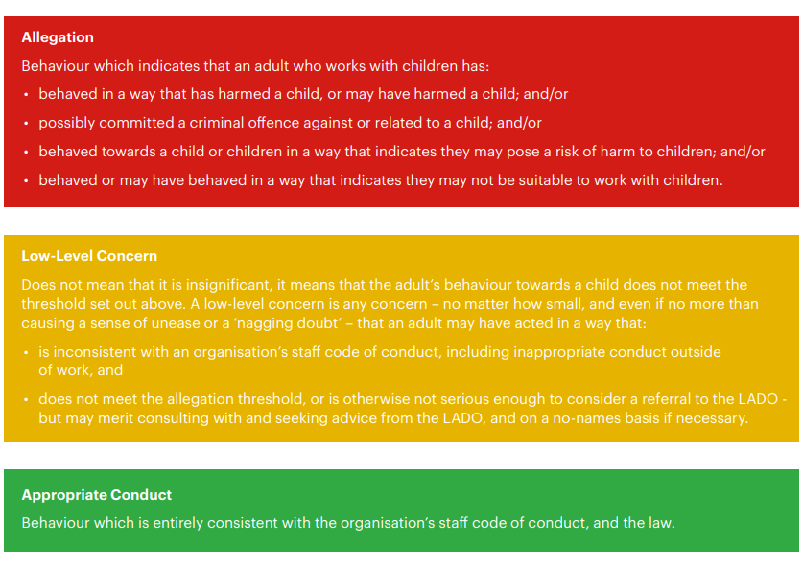

Developing and implementing a low-level concerns policy, September 2021, FARRER & Co

Low-level concerns

The term ‘low-level’ concern does not mean that it is insignificant; it means that the behaviour towards a child does not meet the harm threshold. A low-level concern is any concern – no matter how small, and even if no more than causing a sense of unease or a ‘nagging doubt’ - that an adult working in or on behalf of our school may have acted in a way that:
- is inconsistent with the staff code of conduct, including inappropriate conduct outside of work; and
- does not meet the allegations threshold or is otherwise not considered serious enough to consider a referral to the LADO.

Such behaviour can exist on a wide spectrum, from the inadvertent or thoughtless, or behaviour that may look to be inappropriate, but might not be in specific circumstances, through to that which is ultimately intended to enable abuse.

Our low-level concerns policy is set out within our staff code of conduct and safeguarding policies. It is important that all staff share low-level concerns. Low-level concerns will be reviewed termly to identify patterns. Where patterns emerge, action will be taken within 10 working days

We understand concerns may arise in several ways and from a number of sources. For example, suspicion, complaint or concern shared by a child, parent or other adult within or outside of the organisation; or as a result of vetting checks undertaken.

All low-level concerns will be recorded in writing. The record should include details of the concern, the context in which the concern arose, and action taken (an example of a low-level concern reporting form is available in Appendix E, Developing and implementing a low-level concerns policy, September 2021, FARRER & Co). The name of the individual sharing their concerns will be noted; if the individual wishes to remain anonymous then this will be respected as far as reasonably possible. These records will be kept confidentially, held securely and comply with the Data Protection Act 2018 and the UK General Data Protection Regulation (UK GDPR).

The Governing Body/Trust Board will receive anonymised safeguarding assurance information relating to allegations and low-level concerns, this will include the number of allegations; number of low-level concerns; any themes and trends; and lessons learned, this will enable effective governance oversight.

Records will be reviewed so that potential patterns of concerning, problematic or inappropriate behaviour can be identified. Where a pattern of such behaviour is identified, we will decide on a course of action, either through our disciplinary procedures or where a pattern of behaviour moves from a concern to meeting the harms threshold, in which case it will be referred to the LADO. Consideration will also be given to whether there are wider cultural issues within our school that enabled the behaviour to occur and where appropriate policies could be revised or extra training delivered to minimise the risk of it happening again. Records will be retained at least until the individual leaves their employment. Learning arising from allegations, low-level concerns and investigations will be used to inform staff safeguarding training and professional conduct training.

Sharing low-level concerns (LLCs) – action required by staff, Headteacher/Principal (H/P) or Safeguarding Lead (SL), values guardians (VGs)/safeguarding champions (SCs). If member of staff has what they believe to be a concern that does not meet the harm threshold – i.e. LLC – they should take the below action. We will manage low-level concerns in accordance with the below.

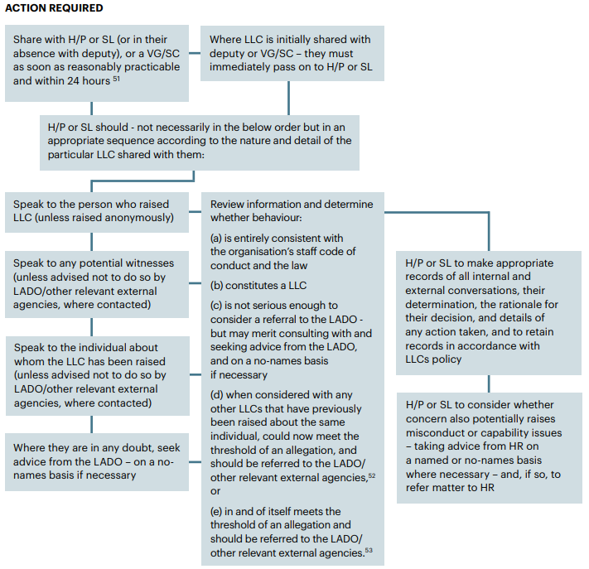

Managing allegations

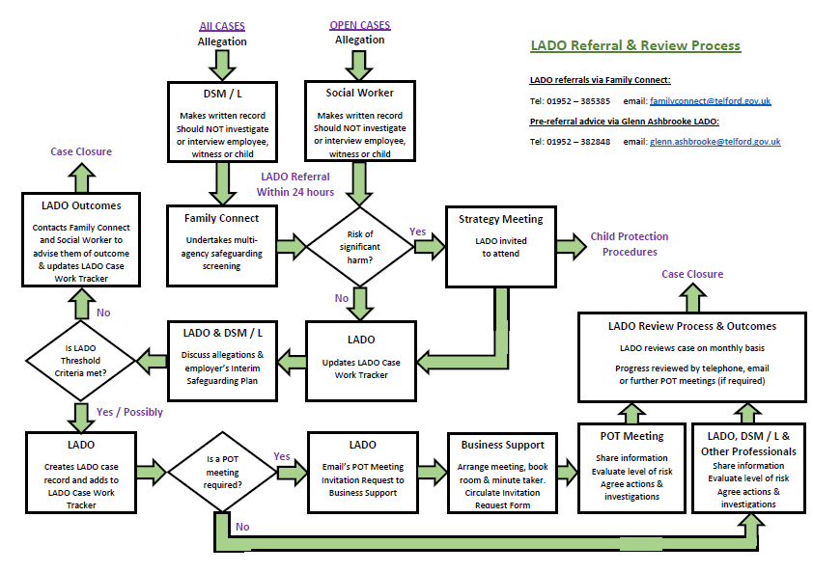
Telford & Wrekin Council procedures:
LADO Referral & Review Process
LADO referrals via Family Connect:
Tel 01952 385385 email: familyconnect@telford.gov.uk

These procedures should be read in line with our child protection & safeguarding policy.

Duties as an employer and an employee

We have a duty as an employer to manage cases of allegations that might indicate a person would pose a risk of harm if they continue to work in regular or close contact with children in their present position, or in any capacity with children in a school or college. We will use this policy, alongside other guidance and requirements, where it is alleged that anyone working in the school or college that provides education for children under 18 years of age, including supply teachers and volunteers has:
- behaved in a way that has harmed a child, or may have harmed a child;
- possibly committed a criminal offence against or related to a child;
- behaved towards a child or children in a way that indicates he or she may pose a risk of harm to children; or
- behaved or may have behaved in a way that indicates they may not be suitable to work with children.

If we receive allegations against a teacher who is no longer teaching, then this will be referred to the police. Historical allegations of abuse will also be referred to the police.

We have a duty of care to our employees. We provide effective support for anyone facing an allegation and provide them with a named contact if they are suspended. Where we are the employer of an individual we still have responsibility to ensure allegations are dealt with appropriately and we will liaise with relevant parties It is essential that we deal with any allegation of abuse made against a teacher or other member of staff or volunteer very quickly, in a fair and consistent way that provides effective protection for the child and, at the same time supports the person who is the subject of the allegation.

Supply teachers

It may be necessary for us to consider an allegation against an individual not directly employed by the school, where the school’s employee disciplinary procedures do not fully apply, for example, supply teachers provided by an employment agency or business or third party contracted staff (referred to as agency staff). Allegations concerning agency staff arising inside or outside of the workplace must still be managed where safeguarding suitability is affected and the employer will be notified of any concerns raised.

Whilst we are not the employer of supply teachers, we will ensure allegations are dealt with properly. In no circumstances will we decide to cease to use a supply teacher due to safeguarding concerns, without finding out the facts and liaising with the local authority designated officer (LADO) to determine a suitable outcome. The governing body/proprietors will discuss with the agency whether it is appropriate to suspend the supply teacher, or redeploy them to another part of the school, whilst they carry out their investigation.

We expect agencies to be fully involved and co-operate in any enquiries from the LADO, police and/or children’s social services. We will usually take the lead because agencies do not have direct access to children or other school staff, so they will not be able to collect the facts when an allegation is made, nor do they have all the relevant information required by the LADO as part of the referral process. Supply teachers, whilst not employed by us, are under the supervision, direction and control of our governing body/proprietor when working in the school/college. We will advise them to contact their trade union representative if they have one, or a colleague for support. The LADO Position of Trust (POT) meeting which is often arranged by the LADO should address issues such as information sharing, to ensure that any previous concerns or allegations known to the agency are taken into account by us during the investigation.

When using an agency, we will inform the agency of our process for managing allegations. This will include inviting the agency’s human resource manager or equivalent to meetings and keeping them up to date with information about our policies.

Initial considerations

We will apply the procedures for dealing with allegations with common sense and judgement. Many cases may well either not meet the criteria set out above, or may do so without warranting consideration of either a police investigation or enquiries by local authority children’s social care services. In these cases, we will follow the local arrangements to resolve cases without delay.

Some rare allegations will be so serious they require immediate intervention by children’s social care services and/or police. The designated officer(s) will be informed of all allegations that come to our attention and appear to meet the criteria so they can consult police and children’s social care services as appropriate.

We will use the following definitions when determining the outcome of allegation investigations:
- Substantiated: there is sufficient evidence to prove the allegation;
- Malicious: there is sufficient evidence to disprove the allegation and there has been a deliberate act to deceive;
- False: there is sufficient evidence to disprove the allegation;
- Unsubstantiated: there is insufficient evidence to either prove or disprove the allegation. The term, therefore, does not imply guilt or innocence;
- Unfounded: to reflect cases where there is no evidence or proper basis which supports the allegation being made.

The Headteacher/principal or where the Headteacher/principal is the subject of an allegation, the chair of governors/the chair of the management committee/proprietor (the ‘case manager’), will discuss the allegation immediately with the designated officer(s). Where the allegation concerns the Chair of Governors, the concern should be reported directly to the LADO and the Vice Chair (or equivalent governance lead)

The initial sharing of information and evaluation may lead to a decision that no further action is to be taken in regard to the individual facing the allegation or concern, in which case this decision and a justification for it will be recorded by the case manager and should be recorded by the designated officer(s), and agreement reached on what information should be put in writing to the individual concerned and by whom. The case manager should then consider with the designated officer(s) what action should follow both in respect of the individual and those who made the initial allegation.

The case manager will inform the accused person about the allegation as soon as possible after consulting the designated officer(s). The case manager will provide them with as much information as possible at that time. However, where a strategy discussion is needed, or police or children’s social care services need to be involved, the case manager will not do that until those agencies have been consulted and have agreed what information can be disclosed to the accused. We will consider carefully whether the circumstances of a case warrant a person being suspended from contact with children at the school or whether alternative arrangements can be put in place until the allegation or concern is resolved. All options to avoid suspension will be considered prior to taking that step.

If there is cause to suspect a child is suffering or is likely to suffer significant harm, the local authority can convene a strategy discussion. Where it is clear that an investigation by the police or children’s social care services is unnecessary, or the strategy discussion or initial evaluation decides that is the case, the designated officer(s) should discuss the next steps with the case manager. In those circumstances, the options open to us depend on the nature and circumstances of the allegation and the evidence and information available. This will range from taking no further action to dismissal or a decision not to use the person’s services in future. Suspension will not be our default position: an individual will only be suspended if there is no reasonable alternative.

In some cases, further enquiries will be needed to enable a decision about how to proceed. If so, the designated officer(s) should discuss with the case manager how and by whom the investigation will be undertaken. In straightforward cases, the investigation will normally be undertaken by a senior member of the school’s/college’s staff. A written safeguarding risk assessment will be completed where required to identify and manage any ongoing risk to children pending the outcome of investigations

However, in other circumstances, such as lack of appropriate resource within the school/college, or the nature or complexity of the allegation, the allegation will require an independent investigator. We will contact Telford & Wrekin Council to buy in the facility to provide an independent investigation of the allegations.

Supporting those involved

We have a duty of care to our employees. We will act to manage and minimise the stress inherent in the allegations process. We understand support for the individual is vital to fulfilling this duty. Individuals will be informed of concerns or allegations as soon as possible and given an explanation of the likely course of action, unless there is an objection by the children’s social care services or the police. The individual will be advised to contact their trade union representative, if they have one, or a colleague for support. They will also be given access to welfare counselling or medical advice.

The case manager will appoint a named representative to keep the person who is the subject of the allegation informed of the progress of the case and consider what other support is appropriate for the individual. As a maintained school, this will include support via the local authority occupational health and employee welfare arrangements. We will ensure particular care is taken when employees are suspended to ensure that they are kept informed of both the progress of their case and current work-related issues. We will not prevent social contact with colleagues and friends unless there is evidence to suggest that such contact is likely to be prejudicial to the gathering and presentation of evidence.

Parents or carers of the child or children involved will be told about the allegation as soon as possible if they do not already know of it. However, where a strategy discussion is required, or police or children’s social care services need to be involved, the case manager will not do so until those agencies have been consulted and have agreed what information can be disclosed to the parents or carers. Parents or carers will also be kept informed about the progress of the case, and told the outcome where there is not a criminal prosecution, including the outcome of any disciplinary process. The deliberations of a disciplinary hearing, and the information taken into account in reaching a decision, cannot normally be disclosed but the parents or carers of the child will be told the outcome in confidence.

Parents and carers will also be made aware of the requirement to maintain confidentiality about any allegations made against teachers whilst investigations are ongoing as set out in section 141F of the Education Act 2002 (see paragraphs 233-234). If parents or carers wish to apply to the court to have reporting restrictions removed, they will be told to seek legal advice.

Confidentiality

We will make every effort to maintain confidentiality and guard against unwanted publicity while an allegation is being investigated or considered.

The case manager will take advice from the designated officer(s), police and children’s social care services to agree the following:
- who needs to know and, importantly, exactly what information can be shared;
- how to manage speculation, leaks and gossip;
- what, if any, information can be reasonably given to the wider community to reduce speculation; and
- how to manage press interest if, and when, it should arise.

Managing the situation and exit arrangements

Resignations and ‘settlement agreements’

If the accused person resigns, or ceases to provide their services, this will not prevent an allegation being followed up. A referral to the DBS will be made, if the relevant criteria are met. We will also consider whether a referral to the Secretary of State is appropriate. If the accused person resigns or their services cease to be used and the criteria are met, it will not be appropriate for us to reach a settlement/compromise agreement.

We understand it is important and will make every effort to ensure conclusion is reached in all cases of allegations bearing on the safety or welfare of children, including any in which the person concerned refuses to cooperate with the process. Wherever possible, the accused will be given a full opportunity to answer the allegation and make representations about it. But the process of recording the allegation and any supporting evidence and reaching a judgement about whether it can be substantiated based on all the information available, will continue even if that cannot be done or the accused does not cooperate. It may be difficult to reach a conclusion in these circumstances, and it may not be possible to apply any disciplinary sanctions if a person’s period of notice expires before the process is complete, but we do understand it is important to reach and record a conclusion wherever possible.

‘Settlement agreements’ will not be used in cases of refusal to cooperate or resignation before the person’s notice period expires.

Record keeping

Details of allegations that are found to have been malicious will be removed from personnel records. However, for all other allegations, a clear and comprehensive summary of the allegation, details of how the allegation was followed up and resolved, and a note of any action taken and decisions reached, will be kept on the confidential personnel file of the accused, and a copy provided to the person concerned.

The purpose of the record is to enable accurate information to be given in response to any future request for a reference, where appropriate. It will provide clarification in cases where future DBS checks reveal information from the police about an allegation that did not result in a criminal conviction and it will help to prevent unnecessary re-investigation if, as sometimes happens, an allegation re-surfaces after a period of time.

References

Where appropriate and in accordance with KCSIE and data protection requirements, relevant safeguarding information may be included in references. Cases in which an allegation was proven to be false, unsubstantiated or malicious will not be included in employer references. A history of repeated concerns or allegations which have all been found to be false, unsubstantiated or malicious will also not be included in any reference.

Timescales

We believe it is in everyone’s interest to resolve cases as quickly as possible and is consistent with a fair and thorough investigation.

The LADO should be contacted within 24 hours of when the Headteacher/ Chair of Governors has been informed of the allegations.

Where a strategy meeting is held the LADO will attend where there is a possible LADO element in relation to allegations. Where a strategy meeting is held the Headteacher/ Chair of Governors should speak to the LADO prior to the strategy meeting, in order to gain the settings context of the member of staff i.e. history of their conduct, previous concerns etc as well as jointly agree a possible option for an interim safeguarding plan regarding the member of staff, pending the outcome of any investigations. The LADO will then inform the strategy meeting of this information, to assist them in the planning of any investigation which may be undertaken.

Where the initial consideration decides that the allegation does not involve a possible criminal offence we will deal with it, although if there are concerns about child protection, we will discuss them with the designated officer(s). In such cases, if the nature of the allegation does not require formal disciplinary action, we will instigate appropriate action within three working days. If a disciplinary hearing is required and can be held without further investigation, the hearing will be held within 15 working days.

Suspension

The possible risk of harm to children posed by an accused person will be evaluated and managed in respect of the child(ren) involved in the allegations. In some rare cases that will require the case manager to consider suspending the accused until the case is resolved. Suspension will not be an automatic response when an allegation is reported: all options to avoid suspension will be considered prior to taking that step. Where the case manager is concerned about the welfare of other children in the community or the teacher’s family, those concerns will be reported to the designated officer(s), children’s social care or the police as required.

Suspension will be considered only in a case where there is cause to suspect a child or other children at the school/college is/are at risk of harm or the case is so serious that it might be grounds for dismissal. In cases where we are made aware that the Secretary of State has made an interim prohibition order in respect of an individual who works at the school/college, immediate action will be taken to ensure the individual does not carry out work in contravention of the order.

The case manager will also consider whether the result that would be achieved by immediate suspension could be obtained by alternative arrangements. If the designated officer(s), police and children’s social care services have no objections to the member of staff continuing to work during the investigation, the case manager will be as inventive as possible to avoid suspension. Based on assessment of risk, the following alternatives will be considered by the case manager before suspending a member of staff:
- redeployment within the school/college so that the individual does not have direct contact with the child or children concerned;
- providing an assistant to be present when the individual has contact with children;
- redeploying to alternative work in the school/college so the individual does not have unsupervised access to children;
- moving the child or children to classes where they will not come into contact with the member of staff, making it clear that this is not a punishment and parents have been consulted; or
- temporarily redeploying the member of staff to another role in a different location, for example to an alternative school/college or work for the local authority/academy trust.

The case manager will consider the potential permanent professional reputational damage to employees that can result from suspension where an allegation is later found to be unsubstantiated or maliciously intended.

If immediate suspension is considered necessary, the rationale and justification for such a course of action will be agreed and recorded by both the case manager and the designated officer(s). This should also include what alternatives to suspension have been considered and why they were rejected.

Where it has been deemed appropriate to suspend the person, written confirmation will be dispatched within one working day, giving as much detail as appropriate for the reasons for the suspension. We will not leave a person who has been suspended without any support. The person will be informed at the point of their suspension who their named contact is within the organisation and provided with their contact details.

On conclusion of a case

If the allegation is substantiated and we dismiss the person or ceases to use the person’s services, or the person resigns or otherwise ceases to provide his or her services. The designated officer(s) should discuss with the case manager and their personnel adviser whether will decide to make a referral to the DBS for consideration of whether inclusion on the barred lists is required. In the case of a member of teaching staff at a school or sixth form college, we will also determine whether to refer the matter to the TRA to consider prohibiting the individual from teaching.

Where it is decided on the conclusion of a case that a person who has been suspended can return to work, the case manager will consider how best to facilitate that. Most people will benefit from some help and support to return to work after a stressful experience. Depending on the individual’s circumstances, a phased return and/or the provision of a mentor to provide assistance and support in the short term may be appropriate. The case manager will also consider how the person’s contact with the child or children who made the allegation can best be managed if they are still a pupil or student at our school.

In respect of malicious or unsubstantiated allegations

Allegations found to be deliberately false will be addressed appropriately, but all disclosures will be treated seriously and investigated fairly. If an allegation is shown to be deliberately invented or malicious, the Headteacher/principal or chair of governors/proprietor will consider whether any disciplinary action is appropriate against the pupil or student who made it; or whether the police should be asked to consider if action might be appropriate against the person responsible, even if he or she were not a pupil or student.

