Aims
The sleep policy aims to provide a clear framework to ensure the health, safety and wellbeing of all children who require support to sleep or rest whilst at nursery.
Legislation
This policy is based on the requirements of the Early Years Foundation Stage (EYFS) statutory framework (2025) and reflects current NHS safer sleep guidance as referenced within the EYFS.
Principles
At Sir Alexander Fleming we promote healthy and safe practices in helping children sleep and rest.
We will ensure:
• Supporting children’s sleep is the responsibility of all DBS checked and approved staff for children in their care.
• Children’s individual needs are identified and met.
• Children’s right to health, safety and wellbeing are met.
• Family’s cultural preferences are considered.
• Sleeping and resting in nursery is a positive experience, both the child and the family feel supported throughout.
• Communication between the Nursery and the family is promoted and this starts prior to child starting nursery so information shared and routines established and agreed.
• Consistency of care as far as possible.
• Families are provided with information or signposted to sources of further information or services to support sleep and bedtime routines if required.
- Children who are sleeping or resting are always cared for in a way that prioritises their safety and wellbeing and remain within sight and hearing of staff at all times.
Early Years Responsibilities
The Early Years will ensure that anyone who supports a child sleeping or resting in nursery or Year R is an employee of the school and has had appropriate safeguarding checks and is aware of procedures and responsibilities for supporting children’s sleep.
All Early Years staff receive regular safeguarding training, which includes awareness of safer sleep guidance and the school’s procedures for supervising sleeping children.
All staff are aware of the need for confidentiality. Personal and sensitive information will only be shared with those who need to know.
The employees will act according to Sir Alexander Fleming Primary School and Early Years safeguarding policy and procedures if there are any concerns for the child’s wellbeing. At all times the child’s safety, dignity and wellbeing is promoted. Leaders will ensure that suitable facility and equipment are provided or designated places for sleep and rest. The Early Years staff work closely with parents to support children’s sleep care, routines and rest so that continuity of support can be maintained between home and Early Years. Staff will provide a positive climate to encourage parents to share information openly around the child’s developing sleep needs or if a child is having difficulty with sleeping at home and this is impacting on their daily wellbeing in nursery.
Prior to starting nursery we discuss children’s sleeping needs and routines with families to provide consistency for the child. Information is recorded on their ‘All about me’ forms and internal records. As the child continues and progresses in their development in Early Years, staff will continue to discuss and update the child’s routine with the parent/carer.
Written records are kept of all support for sleeping.
Sleeping children are always within sight and hearing of staff and are frequently checked to ensure their safety and wellbeing. Children are physically checked by staff at a minimum of every ten minutes. The time a child is put down to sleep, the time they wake, and each ten-minute check are recorded.
The time a child is put down to sleep, when they wake and ten minute monitoring checks are recorded by staff.
This information is available to parents/ carers at all times and will be checked periodically by the class teachers and EYFS leader.
Families are supported by staff to understand the Early Years health and safety procedures for supporting rest and sleep. Staff will always try to take account of Parents wishes when dealing with sleeping children. However, unreasonable requests by parents/carers will be discussed with the Managers and alternatives sought e.g. Children going to sleep with bottles. We will not carry out requests of parents/carers if they feel that it could put the child in any danger. Staff will not leave children to sleep with bottles as this provides danger of choking and does not promote good dental health.
Staff will encourage children to sleep in designated areas or quiet areas. Sir Alexander Fleming Primary School promotes the use of beds for sleeping for children.
If a child falls asleep in the room, staff will aim to make them comfortable and safe without disturbing them.
Staff will not normally leave children to sleep for periods longer than one and a half hours.
The Early Years staff will take into account the religious views, beliefs and cultural values of the child and their family as far as possible when supporting children with sleep.
Safe Sleep Practice (3–5-year-olds)
Children who require rest or sleep are supported to do so on low-level beds or mats in designated quiet areas. Sleep spaces are free from hazards and allow staff to clearly observe each child’s position, breathing, and overall wellbeing.
Children are supported to rest or sleep in safe, age-appropriate positions, and are not left unattended at any time. (See Appendix 3).
Early Years responsibilities for supporting parents with children’s sleep
For some parents/carers and families developing sleep routines so the child has adequate rest can be daunting and difficult and can impact on the child’s wellbeing at nursery. Parents will be provided with information or signposted to support such as Health visitors.
Early Years staff responsibilities in supporting positive self esteem
Early Years staff will work with the child to promote a positive self- esteem and independence with sleep as far as is appropriate and practical. Early Years staff will remain calm and offer a supportive approach to children at all times. Staff will approach children quietly and calmly regarding the need to sleep being mindful of the child’s engagement in play. Staff will be alert and responsive to a child’s needs if showing signs of tiredness. All staff should promote regular encouragement for a child needing and settling to sleep and ensure the child is praised for following routine, helping and cooperating and being independent in getting ready for sleep or on rising.
Governor Responsibilities
To ensure sufficient staff are trained to meet early years ratios and the developing needs of young children. The governing body will ensure this policy is monitored and reviewed at least every three years.
Parent/ Carer Responsibilities
Parent /Carers must ensure they provide all relevant information with regards sleep for their child on entry to Early Years and as the child develops, so the child’s needs can be met. This includes information about how long the child is to sleep, any routines for going to sleep or rising, any comforters requested, details of any health care professionals involved in supporting sleep or any problems or health care difficulties with sleep. If the child requires a comforter this must be in a labelled with the child’s name. Parents/carers should work with their child’s Key Person towards a shared and agreed plan which is recorded for care and support. Parents/carers must ensure that the Early Years always has their emergency contact details.

Appendix 1
Enabling Environment Equipment procedures
When supporting children who need to sleep Early Years staff will ensure:
• Provision of beds – low beds
• Quiet areas where children can rest if they fall asleep in 3-4 year old room and year R

Appendix 2
Health and safety procedures
When supporting children who require a sleep staff will ensure the following health and safety measures are followed:
- Low beds are cleaned with antibacterial wipes once a child has been removed.
- Ensuring sleeping children remain within sight and hearing of staff at all times and are supervised in line with EYFS safeguarding requirements.
- To complete regular 10 minute checks of children and their breathing.
- As with the Safeguarding Policy, a paediatric first aider is on site at all times.

Appendix 3
Age-appropriate sleep / rest positions for 3–5-year-olds
For children aged 3–5, the safer-sleep focus is supervision, visibility, and comfort, rather than the strict positional rules used for babies. The following positions are considered age-appropriate and acceptable in EYFS settings:
Appropriate positions
- Lying on their back
- Lying on their side
- Comfortable self-chosen position (including curling slightly or changing position during sleep)
Children at this age should not be repositioned unless there is a clear safety concern. The key requirement is that staff can clearly see the child’s face and breathing and that the child can move freely.
What matters most
- The child is on a firm, flat surface (e.g. low bed or mat)
- The child’s airway is unobstructed
- Staff can see the child’s face and chest
- The child is within sight and hearing of staff at all times
- The child is not restricted or restrained in any way
Not appropriate (for 3–5 year olds)
- Face-down (prone) sleeping where breathing cannot be clearly observed
- Being propped, restrained, or wedged into position
- Sleeping with bottles, cords, or loose items near the face
- Being left unattended or out of staff sight
“Children can choose a comfortable position — our job is to make sure we can see them, hear them, and keep them safe.”

Appendix 4 Poster
Safer Sleep & Rest – 3–5 Year Olds
This guidance applies to all children aged 3–5 years during rest or sleep times.

AGE-APPROPRIATE SLEEP POSITIONS
Children may sleep or rest in any comfortable position they choose, including:
- On their back
- On their side
- Curled or changing position naturally during sleep
✔ Children do not need repositioning unless there is a safety concern.
Key principle: Staff must be able to clearly see the child’s face and breathing at all times.

SUPERVISION – ALWAYS
- Sleeping children must remain within sight and hearing of staff at all times
- Never leave a sleeping child unattended
- At least one member of staff must be supervising the sleep area

REGULAR CHECKS
- Children are checked every 10 minutes
- Checks include:
  - Breathing
  - Position
  - Comfort and wellbeing
- All checks are recorded on the Sleep Log

SAFE SLEEP ENVIRONMENT
- Low-level beds or mats only
- Firm, flat surface
- Clear space around the child’s head and face
- No bottles, cords, or loose items near the child

NOT ACCEPTABLE PRACTICE
- Face-down sleeping where breathing cannot be clearly seen
- Restraining or wedging children into position
- Letting children sleep out of staff sight or hearing
- Leaving children with bottles
- Ignoring sleep checks or failing to record them

REMEMBER
Children choose how they sleep – adults ensure they sleep safely.
If you are unsure or concerned at any point, seek support from a senior member of staff immediately.

This poster reflects EYFS safeguarding requirements and current safer sleep expectations for Early Years settings.
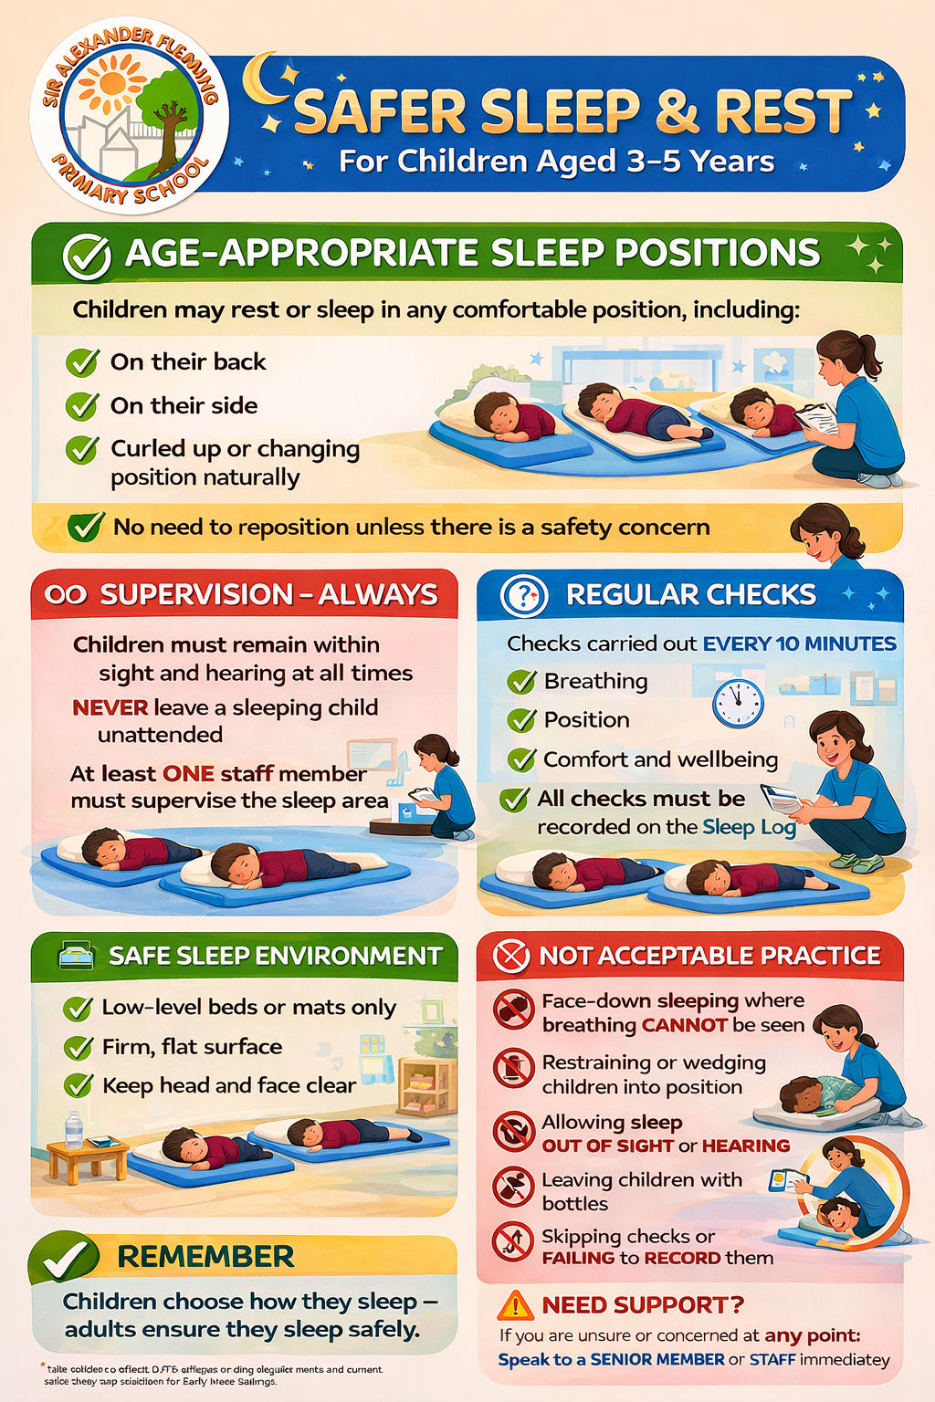Appendix 4
Sleep Log
Date and time child put down to sleep | Name of child | Staff Member | Time checked | Action taken, if required

