

Sir Alexander Fleming Primary School and Nursery

Attendance Policy

Written: September 2026
Next Review: September 2027

Guidance taken from: Working Together to Improve School Attendance – July 2026.

Senior Attendance Champion: Katy Tomlinson
Governor Attendance Champion: Teresa Adams

This policy applies to all children at Sir Alexander Fleming Primary School & Nursery including non-compulsory pupils (where appropriate)

Our attendance as a whole school September 2025 – July 2026 was 96.6% (excluding nursery). This compares favourably with national figures which stand at 94%

Introduction
Sir Alexander Fleming Primary School and Nursery is committed to providing outstanding educational opportunities for all our pupils. We recognise the importance of regular attendance in maximising the benefit of any educational opportunity. Encouraging and supporting excellent attendance is a crucial part of supporting our pupils and students to learn effectively.

Improving attendance is everyone’s business. Good attendance begins with school being somewhere pupils want to be and therefore the foundation of securing good attendance is that school is a calm, orderly, safe, and supportive environment where all pupils are keen and ready to learn.

The school recognises that absence is often a symptom of wider needs and vulnerabilities rather than a standalone issue. Attendance concerns will therefore always be considered alongside safeguarding, SEND, mental health and family circumstances. Some pupils find it harder than others to attend school and therefore at all stages of improving attendance, schools and partners should work in partnership with pupils and parents collaboratively to remove any barriers to attendance by building strong and trusting relationships and working together to put the right support in place. Securing good attendance cannot therefore be seen in isolation, and effective practices for improvement will involve close interaction with schools’ efforts on curriculum, behaviour, bullying, special educational needs support, pastoral and mental health and wellbeing, and effective use of resources, including pupil premium. It cannot solely be the preserve of a single member of staff, or organisation, it must be a concerted effort across all teaching and non-teaching staff in school, the trust or governing body, the local authority, and other local partners.

The importance of regular school attendance cannot be overestimated. Regular attendance at school is vital for children to be successful and to achieve their full potential; it MUST be a high priority for schools, governors, LAs, parents and the pupils themselves. By not attending school regularly pupils decrease the value of the education provided for them; they may also damage the learning of others because fluctuations in the size of pupil group may restrict the scope for effective teaching. Poor attendance can present a safeguarding concern to schools.

Aims
This policy aims to show our commitment to meeting our obligations with regards to school attendance, including those laid out in the Department for Education’s (DfE’s) statutory guidance on working together to improve school attendance (applies from 19 August 2024), through our whole-school culture and ethos that values good attendance, including:

- Setting high expectations for the attendance and punctuality of all pupils
- Promoting good attendance and the benefits of good attendance
- Reducing absence, including persistent and severe absence
- Ensuring every pupil has access to the full-time education to which they are entitled
- Acting early to address patterns of absence
- Building strong relationships with families to make sure pupils have the support in place to attend school
Legislation and guidance
This policy is based on the Department for Education’s (DfE’s) statutory guidance on working together to improve school attendance (applies from July 2026) and school attendance parental responsibility measures. The guidance is based on the following pieces of legislation, which set out the legal powers and duties that govern school attendance:

- School Attendance (Pupil Registration) (England) Regulations 2024 (this replaces The Education (Pupil Registration) (England) Regulations 2006
- Working Together to Improve Schools attendance – DfE July 2026 statutory guidance
- The National Framework for Penalty Notices – August 2024

Roles and responsibilities
The governing board
The governing board is responsible for:
- Setting high expectations of all school leaders, staff, pupils and parents
- Making sure school leaders fulfil expectations and statutory duties, including:
o Making sure the school records attendance accurately in the register, and shares the required information with the DfE and local authority
o Making sure the school works effectively with local partners to help remove barriers to attendance, and keeps them informed regarding specific pupils, where appropriate

- Recognising and promoting the importance of school attendance across the school’s policies and ethos
- Making sure the school’s attendance management processes are delivered effectively, and that consistent support is provided for pupils who need it most by prioritising staff and resources
- Making sure the school has high aspirations for all pupils, but adapts processes and support to pupils’ individual needs
- Regularly reviewing and challenging attendance data and helping school leaders focus improvement efforts on individual pupils or cohorts who need it most
- Working with school leaders to set goals or areas of focus for attendance and providing support and challenge
- Monitoring attendance figures for the whole school and repeatedly evaluating the effectiveness of the school’s processes and improvement efforts to make sure they are meeting pupils’ needs
- Where the school is struggling with attendance, working with school leaders to develop a comprehensive action plan to improve attendance
- Making sure all staff receive adequate training on attendance as part of the regular continued professional development offer, so that staff understand:
o The importance of good attendance
o That absence is almost always a symptom of wider issues
o The school’s legal requirements for keeping registers
o The school’s strategies and procedures for tracking, following up on and improving attendance, including working with partners and keeping them informed regarding specific pupils, where appropriate

- Making sure dedicated training is provided to staff with a specific attendance function in their role, including in interpreting and analysing attendance data
- Holding the headteacher to account for the implementation of this policy

- The named safeguarding governor will: Meet with the headteacher every half term
- Monitor attendance data for the whole school and emerging patterns for groups of children or individuals

The headteacher
The headteacher is responsible for:
- The implementation of this policy at the school
- Monitoring school-level absence data and reporting it to governors
- Supporting staff with monitoring the attendance of individual pupils
- Monitoring the impact of any implemented attendance strategies Issuing fixed-penalty notices, where necessary, or authorising the school business manager to be able to do so Working with the parents of pupils with special educational needs and/or disabilities (SEND) to develop specific support approaches for attendance for pupils with SEND, including where school transport is regularly being missed, and where pupils with SEND face in-school barriers
- Communicating with the local authority when a pupil with an education, health and care (EHC) plan has falling attendance, or where there are barriers to attendance that relate to the pupil’s needs
- Communicating the school’s high expectations for attendance and punctuality regularly to pupils and parents through all available channels

When attendance difficulties relate to SEND, disability, medical needs or mental health, the school will consider and implement reasonable adjustments in accordance with the Equality Act 2010.

The designated senior leader responsible for attendance
The designated senior leader (also known as the ‘attendance champion’) is responsible for:
- Leading, championing and improving attendance across the school
- Setting a clear vision for improving and maintaining good attendance
- Evaluating and monitoring expectations and processes
- Having a strong grasp of absence data and oversight of absence data analysis
- Regularly monitoring and evaluating progress in attendance
- Establishing and maintaining effective systems for tackling absence, and making sure they are followed by all staff
- Liaising with pupils, parents/carers and external agencies, where needed
- Building close and productive relationships with parents to discuss and tackle attendance issues
- Creating intervention or reintegration plans in partnership with pupils and their parents/carers Delivering targeted intervention and support to pupils and families

The designated senior leader responsible for attendance is the headteacher and can be contacted via school office.

Class Staff
Class staff are responsible for recording attendance for both morning and afternoon sessions on a daily basis, using the correct codes (see Appendix 1), and submitting this information to the school office:
- Morning registration must be completed by 8.40am
- Afternoon registration must completed by 1.00pm
- Contribute to and support the continued development of the warm, welcoming, exciting and safe environment for all children
- Welcome each child into the class by name and with a smile
- Promote and reward good attendance at all opportunities;
- Welcome children who have been absent with warmth – “it's great to see you – we have missed you and I am really pleased you are better/back” and never say “Where have you been? You have missed so much work….”
- Be aware of absences of each child or patterns in absence in their group and make sure the child is supported in catching up missed work
- Support children with attendance targets by completing daily sticker charts
- Communicate with colleagues where necessary if there are any issues resulting from the absence that other staff should know (concern about work missed, response of other children, possible responses of colleagues) but also where there are possible safeguarding concerns reporting to the school’s DSL
- Notify the KS lead and Headteacher if there is any suggestion of term time holiday

Office Staff
Office staff will:
- Take calls from parents/carers about absence on a day-to-day basis and record it on the school system
- Notify the DSL if there are any contextual safeguarding issues which might explain erratic or poor attendance
- Contribute to and support the continued development of the warm, welcoming, exciting and safe environment for all children
- Greet the children by name and always with a smile and a greeting
- Make a special effort to provide a warm welcome to children returning with anxiety issues
- If necessary, walk the child to the lesson/assembly etc. if this is a cause of anxiety
- Reassure families that the school will monitor the child’s welfare carefully during the course of the day and communicate with the family if there are any issue

Parents
Where this policy refers to a parent, it refers to the adult the school and/or local authority decides is most appropriate to work with, including:
- All natural parents, whether they are married or not
- All those who have parental responsibility for a child or young person
- Those who have day-to-day responsibility for the child (i.e. lives with and looks after them)

Parents are expected to:
- Make sure their child attends every day on time
- Call the school to report their child’s absence before 9am on the day of the absence and each subsequent day of absence, and advise when their child is expected to return.
- Provide the school with more than 1 emergency contact number for their child
- Ensure that, where possible, appointments for their child are made outside of the school day. Where not possible, inform the school of the child’s absence in advance by emailing or phoning the school office.
- If their child’s absence rates are increasing and are causing concern, an attendance contract may be used to support parents to make improvements.
- Keep to any attendance contracts that they make with the school and/or local authority
- Seek support, where necessary, for maintaining good attendance, by contacting headteacher, DSL, SENCO.

Pupils
Pupils are expected to:
- Attend school every day, on time

Recording Attendance
Attendance register
We will keep an electronic attendance register and place all pupils onto this register.

We will take our attendance register at the start of the first session of each school day and once during the second session. It will mark, using the appropriate national attendance and absence codes from the School Attendance (Pupil Registration) (England) Regulations 2024, whether every pupil is:

- Present
- Attending an approved off-site educational activity
- Absent
- Unable to attend due to exceptional circumstances

Any amendment to the attendance register will include:
- The original entry
- The amended entry
- The reason for the amendment
- The date on which the amendment was made
- The name and position of the person who made the amendment

See Appendix 1 for the DfE attendance codes.

We will also record:
- Whether the absence is authorised or not
- The nature of the activity, where a pupil is attending an approved educational activity
- The nature of circumstances, where a pupil is unable to attend due to exceptional circumstances

We will keep every entry on the attendance register for 6 years after the date on which the entry was made.
The school day starts at 8.30am and ends at 3.10pm.
Pupils must arrive in school between 8.30am and 8.40am on each school day.
The register for the first session will be taken at 8.40am.
The register for the second session will be taken at 1pm.

Attendance registers are taken simultaneously for all pupils at the start of the morning session and during the afternoon session in accordance with Working Together to Improve School Attendance 2026.

Unplanned absence
The pupil’s parent must notify the school of the reason for the absence on the first day of an unplanned absence by 9am, or as soon as practically possible, by calling the school office staff.

We will mark absence due to physical or mental illness as authorised, unless the school has a genuine concern about the authenticity of the illness. The school may request reasonable medical evidence where there are concerns regarding the authenticity of an illness, where patterns of absence emerge, where illness is prolonged or recurring, or where evidence is required to support appropriate adjustments and support.

If the school is not satisfied about the authenticity of the illness, the absence will be recorded as unauthorised and parents will be notified of this in advance.

Planned absence
Attending a medical or dental appointment will be counted as authorised as long as the pupil’s parent notifies the school in advance of the appointment.
- Parents can notify the school of a medical or dental appointment by calling or emailing the school office
- Notify the school of:
o the reason for the absence
o The length of their absence
o When the child is expected to return to school

However, we encourage parents to make medical and dental appointments out of school hours where possible. Where this is not possible, the pupil should be out of school for the minimum amount of time necessary.

The pupil’s parent must also apply for other types of term-time absence as far in advance as possible of the requested absence. Go to section 5 to find out which term-time absences the school can authorise.

Lateness and punctuality
A pupil who arrives late:
- After the register has closed (9.41am) will be marked as absent, using the appropriate code (L)

Incidents of lateness are reported to the headteacher daily. Patterns of lateness are tracked weekly and reported to the governing body termly.

Parents of pupils who have patterns of lateness will be contacted to discuss the importance of punctuality and how this might be achieved:
- Parents will be invited to a meeting to discuss the cause of lateness with the headteacher and support will be offered.
- If a child has 10 or more sessions of unauthorised absence due to lateness recorded in any 10 week period, a penalty notice will be issued in accordance with Telford and Wrekin’s Code of Conduct for issuing penalty notices for non-attendance

Parents must collect their child promptly at the end of the school day:
- Where late collection is persistent and/or significantly after 3.10pm, the school is obliged to take any uncollected pupil to a place of safety and share concerns, as necessary, with other agencies.
- If no one is available, the school will place a child into the after school club and provide the parent/carer with the bill.
- If a child is not collected by 5.30pm, and a parent cannot be contacted, the school will contact Children’s Services as this is a safeguarding concern.

Following up unexplained absence
Where any pupil we expect to attend school does not attend, or stops attending, without reason, the school will:
- Call the pupil’s parent on the morning of the first day of unexplained absence to ascertain the reason.
- If the school cannot reach any of the pupil’s emergency contacts, the school may complete a home visit, contact Children’s Services or the police.
- Identify whether the absence is approved or not
- Identify the correct attendance code to use and input it as soon as the reason for absence is ascertained – this will be no later than 5 working days after the session(s) for which the pupil was absent
- Call the parent on each day that the absence continues without explanation, to make sure proper safeguarding action is taken where necessary.
- Where appropriate, offer support to the pupil and/or their parents to improve attendance Identify whether the pupil needs support from wider partners, as quickly as possible, and make the necessary referrals
- Where support is not appropriate, not successful, or not engaged with: issue a notice to improve, penalty notice or other legal intervention as appropriate

Reporting to parents
The school will regularly inform parents about their child’s attendance and absence levels:
- Half-termly attendance updates via the newsletter, website, Seesaw app:
- Red - Severe Absence = 50% attendance or below.
- Orange – persistent absence, 10% or more, serious concern
- Amber – cause for concern, 4% - 9% - requires immediate improvement
- Green – good attendance, 0% - 3%
- Parent Consultations held in October and March
- End-of-year report

Leave in term time

In July 2026 the DfE reviewed and amended the ‘Working Together to Improve School Attendance’ statutory guidance. This guidance sits alongside the ‘National Framework for Penalty Notices’ which the Government introduced in August 2024 and ‘The School Attendance (Pupil Registration) (England) Regulations 2024’ and the Education (Penalty Notices) (England) Regulations 2007.

In Telford & Wrekin it is the delegated responsibility of the Attendance Support Team to issues Penalty Notices following referrals from schools, and only they can issue Penalty Notices relating to school absence.

It is only the Headteacher (or delegated member of School Staff) who has the discretion to authorise any request for leave in term time and it is also they that decide the duration of that leave. Parents must submit a request for leave in term time to the school, allowing ample time for consideration to be given. Any circumstances that parents wish to be considered should be included in the request. Holidays should not be booked before permission is granted. The legislation does not allow for any school to adopt a blanket ban, all requests for leave in term time will be considered to determine if there are exceptional circumstances and parents must be notified of that decision.

The government introduced changes in legislation from August 2024 that parents need to be aware of:
- If your child has 10 sessions of unauthorised absence in a 10 school week rolling period, you may be issued with a Penalty Notice. These 10 sessions may include any unauthorised absence, including leave in term time and sessions do not have to be consecutive.
- If in an individual case the local authority believes a Penalty Notice would be appropriate, they retain the discretion to issue one before the threshold is met, so for eight sessions of unauthorised absence. This might apply for example, when parent(s) are deliberately or purposefully avoiding the national threshold by taking several term time holidays below threshold, or for repeated absence for events such as birthdays and taking their child out of school, or when there are only four pupil days in school and the fifth day is for example a PD day or bank holiday
- Penalty Notices increased to £160 from August 2024. This can be reduced to £80 but only for the first Penalty Notice issued, if paid within 21 days – this reduction does not apply to any subsequent Penalty Notice.
- Any 2nd Penalty Notice, to the same parent for the same child, issued within three years of the date of the first Penalty Notice will be charged at a flat rate of £160
- A third Penalty Notice will not be issued within a three-year rolling period, to the same parent for the unauthorised absence of the same child, - alternative action or legal measures will be utilised for subsequent offences.
- Penalty notices are intended to prevent the need for court action and should only be used where it is deemed likely to change parental behaviour and support to secure regular attendance has been provided and has not worked or been engaged with, or would not have been appropriate in the circumstances of the offence (e.g. as is usually the case for an unauthorised holiday in term time).
- In some circumstances a ‘Notice to Improve’ may be issued – However, a Notice to Improve will only be used in cases where support is appropriate. They will not be issued in cases of unauthorised leave in term time for holidays, where information for parents is included in schools’ attendance policy and on school’s website, or a warning by the school that a Penalty Notice could be issued if unauthorised leave in term time is taken will suffice.

‘Parents should always apply to the Headteacher for any request for leave in term time by completing a request form available from the school. (DfE guidance states schools should not authorise leave retrospectively so any leave in term time taken without a request being submitted will be unauthorised absence)’.

In developing and publishing the National Framework, the Government renewed appeals to parents not to take their children out of school during term time. The Governors and Headteacher of this school support this initiative. The legislation does not allow for blanket bans, therefore all requests for leave in term time will be considered. However, in line with the Education (Penalty Notices) (England) Regulations 2007, The School Attendance (Pupil Registration) (England) Regulations 2024, DfE guidance ‘Working Together to Improve School Attendance - July 2026, National Framework for Penalty Notices 2024 and local Code of Conduct, students will only be given permission to take leave in term time if there are exceptional circumstances. The DfE Guidance- Working Together to Improve School Attendance (amended July 2026) states that: Generally, the DfE does not consider the need or desire for a holiday or other absence for the purpose of leisure and recreation to be an exceptional circumstance. (Paragraph 37.)

Each application for leave in term time will be considered and if it is agreed and authorised the Headteacher will determine the duration of any leave. However, if the application is not agreed and the absence occurs the dates will be unauthorised. Parents will be notified of any decision in writing. This notification may be hand delivered directly to the parent, emailed to the registered email address of the parent held on school records or posted to the parents’ home address.

As a school we are asked to inform you that in line with Telford and Wrekin Council Policy, if your child is absent for 10 school sessions within a 10 week rolling period and that absence is unauthorised, you may be subject to a Penalty Notice fine, criteria is as detailed above.

Please follow the links below for more detailed information:
Working together to improve school attendance: July 2026

The Education (Penalty Notices) (England) Regulations 2007

https://www.childrenscommissioner.gov.uk/back-into-school/resources-for-families/

Leave of Absence Leaflet - Sept 26 Updated RG draft v7.pdf

Strategies for promoting attendance
The foundation for good attendance is a strong partnership between the school, parents and the child.

To help us all to focus on this we will:
• Provide information on all matters related to attendance in our regular newsletter and on our website;
• Report to you how your child is performing in school, what their attendance and punctuality rate is and how this relates to their attainment;
• Set targets for the school and display these in the newsletter;
• Deliver a stimulating and engaging curriculum that encourages children’s enjoyment of school;
• Run events when parents, pupils and staff can work together on raising attendance levels across the school

Supporting pupils who are absent or returning to school
Pupils absent due to complex barriers to attendance
- Headteacher, parents, class teacher and SENCO will meet to identify the barriers to good school attendance. If appropriate, the child’s views will also be gathered.
- An attendance contract may be put in place to support progress towards improved attendance.
- School-based interventions may be offered: ELSA, Den, Patch, a consultation with Primary Behaviour Support, soft starts, protected play, a time-limited part-time timetable so the child can build success, Emotionally-based School Avoidance resources, animal-assisted education sessions
- External Interventions may be offered: referrals to Primary Behaviour Support, Educational Psychologist, CAMHS, Family Help/Family First Partnerships
- A home-school book will be established to maintain clear communication between the parents and the class staff
- Guardian Angel: a child will be appointed as their guardian angel. The guardian angel will support the child through the day with academic and social interactions.

Pupils absent due to mental or physical ill health or SEND
- Headteacher, parents, class teacher and SENCO will meet to identify the barriers to good school attendance. If appropriate, the child’s views will also be gathered.
- If appropriate, the attendance policy will be implemented alongside the Children with Health Needs who cannot attend School and Children with Medical Conditions policies.
- Identify a key adult to work with the child and the family using Hampshire’s Emotionally-based School Avoidance resources to explore the positive and negative influences on absenteeism and build resilience.
- School-based interventions may be offered: ELSA, Thrive, a consultation with Primary Behaviour Support, soft starts, protected play, animal-assisted education sessions, a timelimited part-time timetable so the child can build success External Interventions may be offered: referrals to Primary Behaviour Support, Educational Psychologist, CAMHS, Family Help/Family First Partnerships
- A home-school book will be established to maintain clear communication between the parents and the class staff Parents will be signposted to the parent support circle
- Buddy: a child will be appointed as their guardian angel. The guardian angel will support the child through the day with academic and social interactions.

Where a pupil has an education health and care (EHC) plan and their attendance falls, or the school becomes aware of barriers to attendance that related to the pupil’s needs, the school will inform the local authority.

Pupils who are Young Carers
The school recognises that young carers may experience additional responsibilities at home which can impact upon their attendance, punctuality, emotional wellbeing and educational outcomes.
Where a child is identified as a young carer, the school will:
- Work sensitively with the child and their family to understand any barriers to attendance.
- Monitor attendance, punctuality and wellbeing closely.
- Consider reasonable adjustments and additional support where appropriate.
- Work alongside the Designated Safeguarding Lead, Family Help services and external agencies to provide coordinated support.
- Refer families to the Telford & Wrekin Young Carers Service where appropriate.
- Ensure that attendance concerns are addressed through supportive intervention before considering enforcement action.
- Seek the child's views and involve them in decisions about support.
We recognise that young carers may require flexibility and additional pastoral support at times of family difficulty and will work collaboratively with families and partner agencies to promote good attendance and positive outcomes.

Pupils returning to school after a lengthy or unavoidable period of absence
- As soon as parents have informed the school of the expected date of return: Class teacher will organise a welcome pack back for the child to receive before they return. It may include: messages from the class, timetable for their first day back, a reading book
- Headteacher will meet with the parents (and child if appropriate) in advance of the first day to discuss expectations, reasonable adjustments and individual health care/My Support Plans that may be in place
- Soft start: parents/child will be given the option to arrive through the school office, where the child will be welcomed by an adult known to them.
- Guardian Angel: a child will be appointed as their guardian angel. The guardian angel will support the child through the day with academic and social interactions.
- A home-school book will be established to maintain clear communication between the parents and the class staff ELSA or Thrive sessions will be available to support the child’s return.

Remote Education
Remote education will only be considered in exceptional circumstances where a pupil is temporarily unable to attend school in person. The school recognises that remote education is not a substitute for full-time school attendance and will only be used as part of a wider support and reintegration plan.

Where remote education is provided, the school will:
- Work in partnership with parents, carers, the pupil and relevant professionals.
- Ensure remote education is time-limited and regularly reviewed.
- Maintain regular contact with the pupil and family.
- Continue to monitor attendance, engagement, wellbeing and safeguarding.
- Identify and address barriers preventing a return to school.
- Implement reasonable adjustments where appropriate.
- Develop a clear reintegration plan aimed at supporting a return to full-time education as soon as possible.

Remote education will not be used as a long-term solution for attendance concerns and will only be considered after other support strategies and reasonable adjustments have been explored

Attendance monitoring
Monitoring attendance
The school will monitor attendance and absence data (including punctuality) half-termly, termly and yearly across the school and at an individual pupil, year group and cohort level.
Specific pupil information will be shared with the DfE on request. The school has granted the DfE access to its management information system so the data can be accessed regularly and securely.

Data will be collected each term and published at national and local authority level through the DfE's school absence national statistics releases. The underlying school-level absence data is published alongside the national statistics.

The school will benchmark its attendance data at whole school, year group and cohort level against local, regional, and national levels to identify areas of focus for improvement and share this with the governing board.

Analysing attendance
The school will:
- Analyse attendance and absence data regularly to identify pupils, groups or cohorts that need additional support with their attendance, and Identify pupils whose absences may be a cause for concern, especially those who demonstrate patterns of persistent or severe absence
• SEND
• Pupil Premium
• Children with a Social Worker
• Looked After Children
• Previously Looked After Children
• Young Carers
- Conduct thorough analysis of half-termly, termly, and full-year data to identify patterns and trends
- Look at historic and emerging patterns of attendance and absence, and then develop strategies to address these patterns

Using data to improve attendance
The school will:
- Develop targeted actions to address patterns of absence (of all severities) of individual pupils, groups or cohorts that it has identified via data analysis
- Provide targeted support to the pupils it has identified whose absences may be a cause for concern, especially those who demonstrate patterns of persistent or severed absence, and their families (see section 8.4 below)
- Provide regular attendance reports to class teachers to facilitate discussions with pupils and families, and to the governing board and school leaders (including special educational needs co-ordinators, designated safeguarding leads and pupil premium leads)
- Use data to monitor and evaluate the impact of any interventions put in place in order to modify them and inform future strategies
- Share information and work collaboratively with other schools in the area, local authorities and other partners where a pupil’s absence is at risk of becoming persistent or severe, including keeping them informed regarding specific pupils, where appropriate

Reducing persistent and severe absence
Persistent absence is where a pupil misses 10% or more of school, and severe absence is where a pupil misses 50% or more of school. Reducing persistent and severe absence is central to the school’s strategy for improving attendance.

The school will:
- Analyse attendance data to find patterns and trends of persistent and severe absence regularly to identify pupils, groups or cohorts that need additional support with their attendance, and Identify pupils whose absences may be a cause for concern, especially those who demonstrate patterns of persistent or severe absence
• SEND
• Pupil Premium
• Children with a Social Worker
• Looked After Children
• Previously Looked After Children
• Young Carers

- Use attendance data to find patterns and trends of persistent and severe absence
- Consider potential safeguarding issues and, where suspected or present, address them in line with Keeping Children Safe in Education
- Hold regular meetings with the parents of pupils who the school (and/or local authority) considers to be vulnerable or at risk of persistent or severe absence, or who are persistently or severely absent, to:
o Discuss attendance and engagement at school
o Listen, and understand barriers to attendance
o Explain the help that is available
o Explain the potential consequences of, and sanctions for, persistent and severe absence
o Review any existing actions or interventions
- Provide access to wider support services to remove the barriers to attendance, in conjunction with the local authority, where relevant
- Consider alternative support that could be put in place to remove any barriers to attendance and re-engage these pupils. In doing so, the school will sensitively consider some of the reasons for absence
- Implement sanctions, where necessary (see section 5.2, above)

Appendix 1: attendance codes
The following codes are taken from the DfE’s guidance on school attendance.

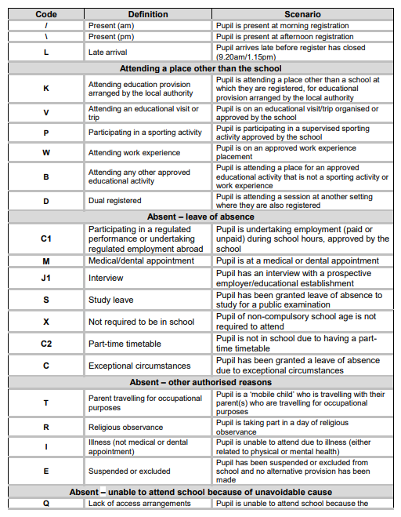

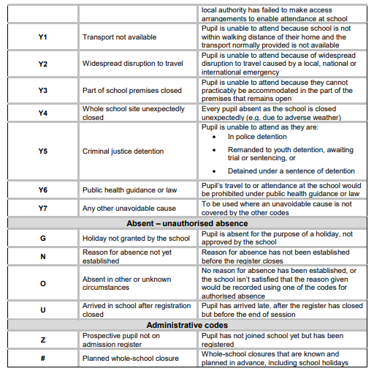

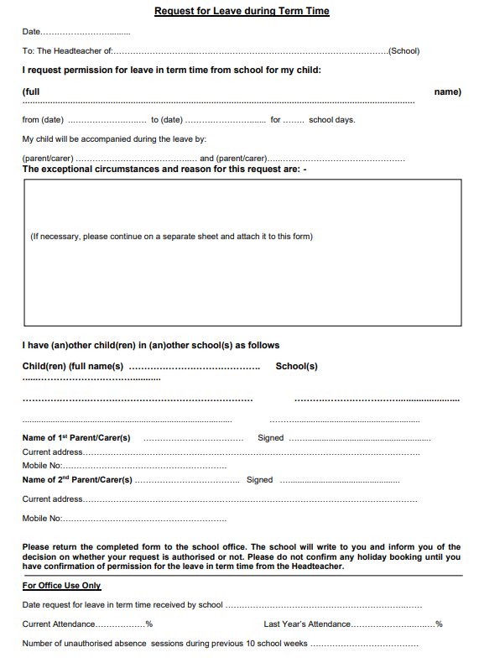

Information to add to schools Attendance Policy, School website & correspondence regarding leave in term time

In July 2026 the DfE reviewed and amended the ‘Working Together to Improve School Attendance’ statutory guidance. This guidance sits alongside the ‘National Framework for Penalty Notices’ which the Government introduced in August 2024 and ‘The School Attendance (Pupil Registration) (England) Regulations 2024’ and the Education (Penalty Notices) (England) Regulations 2007.

In Telford & Wrekin it is the delegated responsibility of the Attendance Support Team to issues Penalty Notices following referrals from schools, and only they can issue Penalty Notices relating to school absence.

It is only the Headteacher (or delegated member of School Staff) who has the discretion to authorise any request for leave in term time and it is also they that decide the duration of that leave. Parents must submit a request for leave in term time to the school, allowing ample time for consideration to be given. Any circumstances that parents wish to be considered should be included in the request. Holidays should not be booked before permission is granted. The legislation does not allow for any school to adopt a blanket ban, all requests for leave in term time will be considered to determine if there are exceptional circumstances and parents must be notified of that decision.

The government introduced changes in legislation from August 2024 that parents need to be aware of:
- If your child has 10 sessions of unauthorised absence in a 10 school week rolling period, you may be issued with a Penalty Notice. These 10 sessions may include any unauthorised absence, including leave in term time and sessions do not have to be consecutive.
- If in an individual case the local authority believes a Penalty Notice would be appropriate, they retain the discretion to issue one before the threshold is met, so for eight sessions of unauthorised absence. This might apply for example, when parent(s) are deliberately or purposefully avoiding the national threshold by taking several term time holidays below threshold, or for repeated absence for events such as birthdays and taking their child out of school, or when there are only four pupil days in school and the fifth day is for example a PD day or bank holiday
- Penalty Notices increased to £160 from August 2024. This can be reduced to £80 but only for the first Penalty Notice issued, if paid within 21 days – this reduction does not apply to any subsequent Penalty Notice.
- Any 2nd Penalty Notice, to the same parent for the same child, issued within three years of the date of the first Penalty Notice will be charged at a flat rate of £160
- A third Penalty Notice will not be issued within a three-year rolling period, to the same parent for the unauthorised absence of the same child, - alternative action or legal measures will be utilised for subsequent offences.
- Penalty notices are intended to prevent the need for court action and should only be used where it is deemed likely to change parental behaviour and support to secure regular attendance has been provided and has not worked or been engaged with, or would not have been appropriate in the circumstances of the offence (e.g. as is usually the case for an unauthorised holiday in term time).
- In some circumstances a ‘Notice to Improve’ may be issued – However, a Notice to Improve will only be used in cases where support is appropriate. They will not be issued in cases of unauthorised leave in term time for holidays, where information for parents is included in schools’ attendance policy and on school’s website, or a warning by the school that a Penalty Notice could be issued if unauthorised leave in term time is taken will suffice.

‘Parents should always apply to the Headteacher for any request for leave in term time by completing a request form available from the school. (DfE guidance states schools should not authorise leave retrospectively so any leave in term time taken without a request being submitted will be unauthorised absence)’.
In developing and publishing the National Framework, the Government renewed appeals to parents not to take their children out of school during term time. The Governors and Headteacher of this school support this initiative. The legislation does not allow for blanket bans, therefore all requests for leave in term time will be considered. However, in line with the Education (Penalty Notices) (England) Regulations 2007, The School Attendance (Pupil Registration) (England) Regulations 2024, DfE guidance ‘Working Together to Improve School Attendance - July 2026, National Framework for Penalty Notices 2024 and local Code of Conduct, students will only be given permission to take leave in term time if there are exceptional circumstances. The DfE Guidance- Working Together to Improve School Attendance (amended July 2026) states that: Generally, the DfE does not consider the need or desire for a holiday or other absence for the purpose of leisure and recreation to be an exceptional circumstance. (Paragraph 37.)

Each application for leave in term time will be considered and if it is agreed and authorised the Headteacher will determine the duration of any leave. However, if the application is not agreed and the absence occurs the dates will be unauthorised. Parents will be notified of any decision in writing. This notification may be hand delivered directly to the parent, emailed to the registered email address of the parent held on school records or posted to the parents’ home address.

As a school we are asked to inform you that in line with Telford and Wrekin Council Policy, if your child is absent for 10 school sessions within a 10 week rolling period and that absence is unauthorised, you may be subject to a Penalty Notice fine, criteria is as detailed above.
